*Seyedamin Seyedmahmoudian*

*040813340 | CST8333 Programming Language Research Project*

*PORTFOLIO END USER*

Figure 1 File Dialog 3

Figure 2 File Dialog expanded with correct location 4

Figure 3 Combo box containing location from the file 4

Figure 4 Information printed to console 4

Figure 5 Two new FILES created 5

Figure 6 Inside the Excel file 6

Figure 7 Graph of growth 7

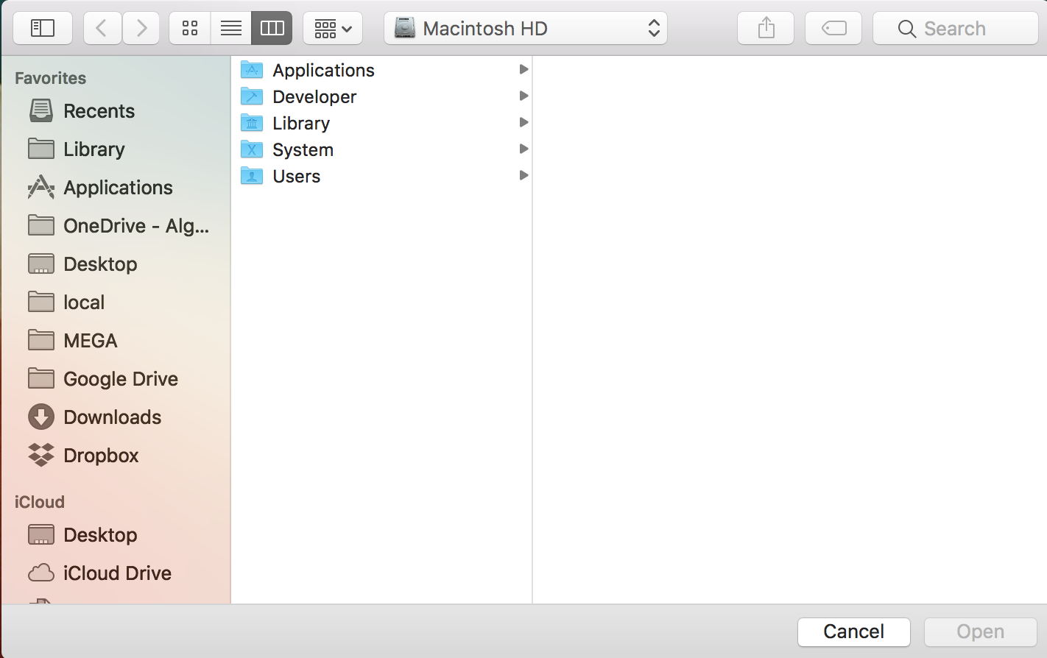

Figure 1 File Dialog

Figure 1 File Dialog: this window will be created as the startup pointing to the root of the file system helping the user navigate in the computer and open the file.

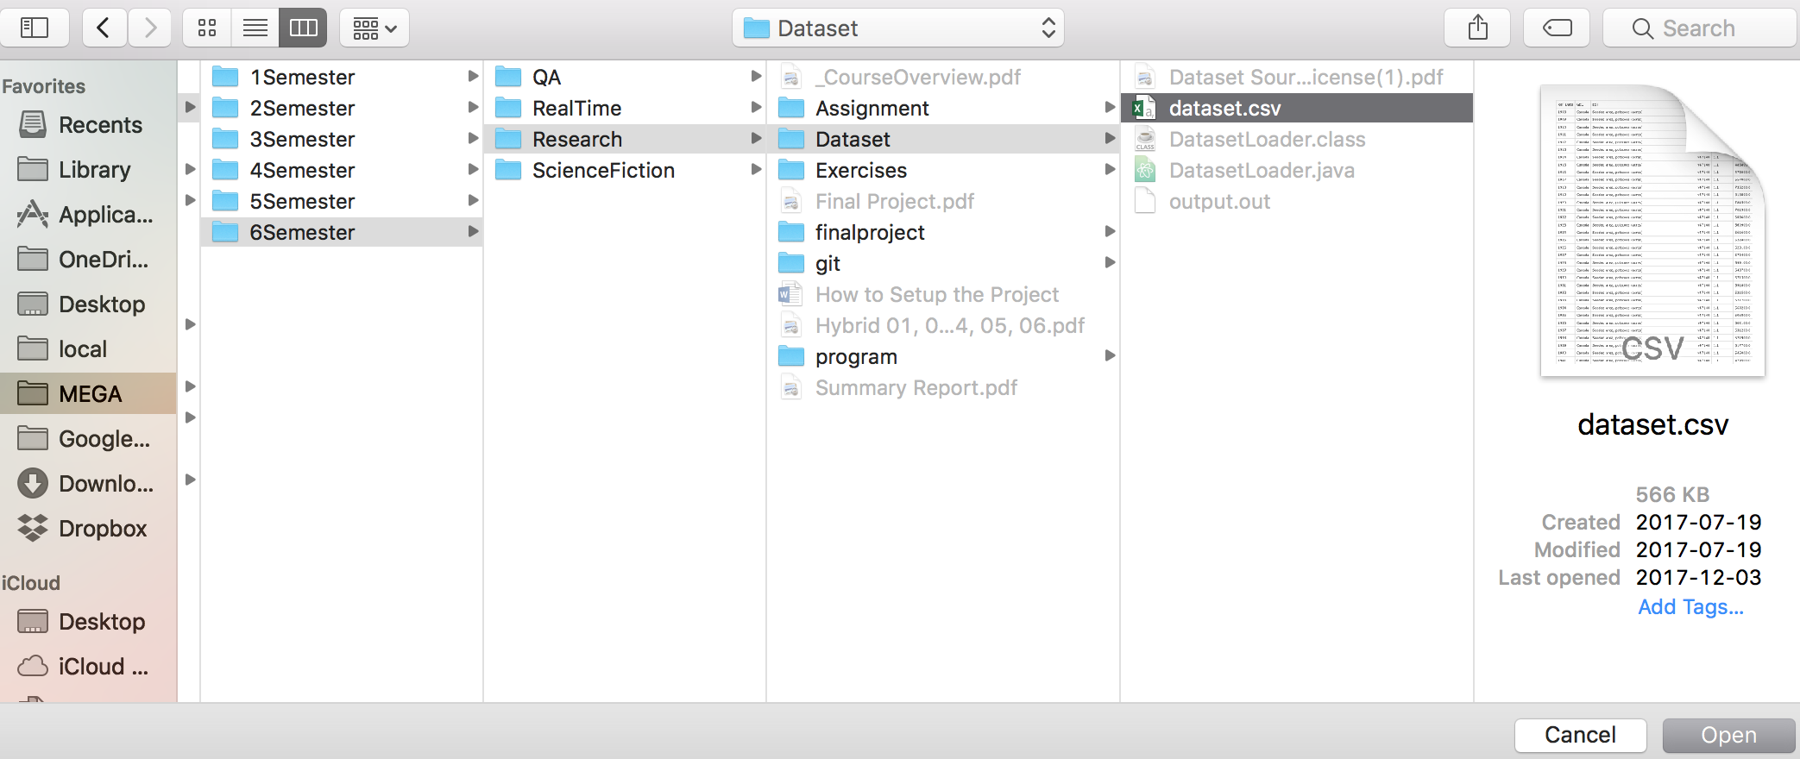

Figure 2 File Dialog expanded with correct location

Figure 2: Use navigate to the location which contain the .csv file, as you can see only csv file are being accepted by the program to minimize corrupt data.

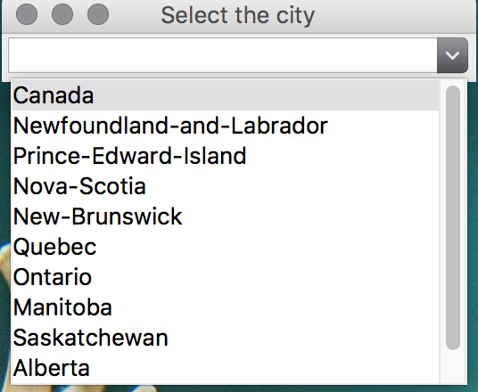

Figure 3 Combo box containing location from the file

Figure 3: Drop Down menu created base on the GEO column of the file.

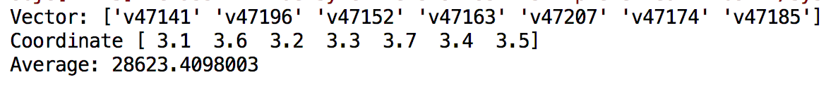

Figure 4 Information printed to console

Figure 4: All the necessary information gets printed to console such as array of Vector, Coordinate, and also and average which it was calculated from the values.

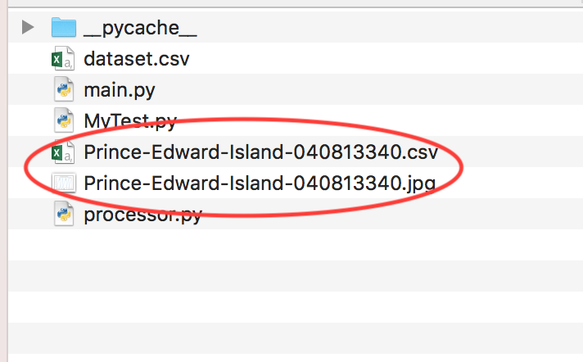

Figure 5 Two new FILES created

Figure 5: Two new file was created named base on the geolocation and my student number, one is the Excel file which contain all the information taken from the original file filtered by selected geolocation, the second one is jpg file which contain the graph created by the application.

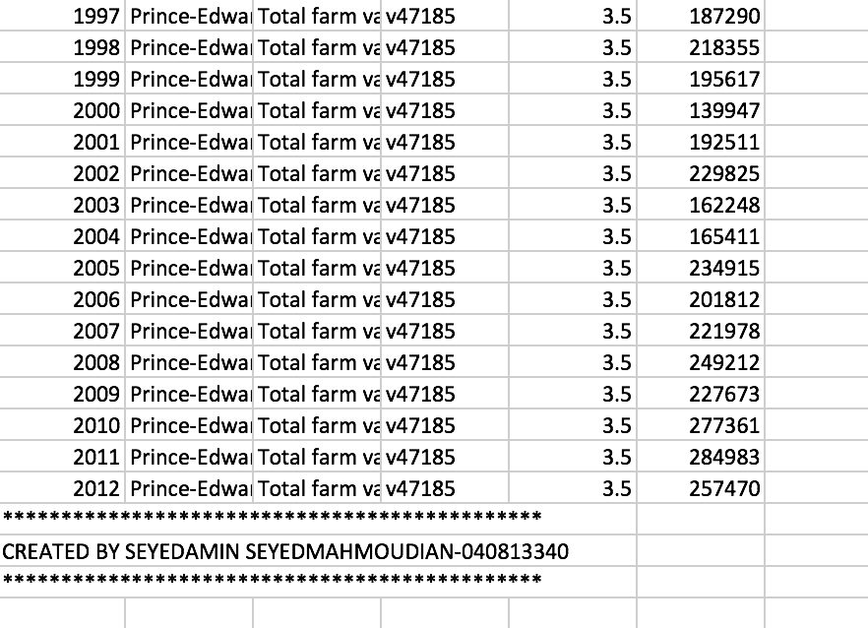

Figure 6 Inside the Excel file

Figure 6: The Excel file which has all the information of the selected location, at the end of the file is my name and student number printed. Information are sorted base on of the date.

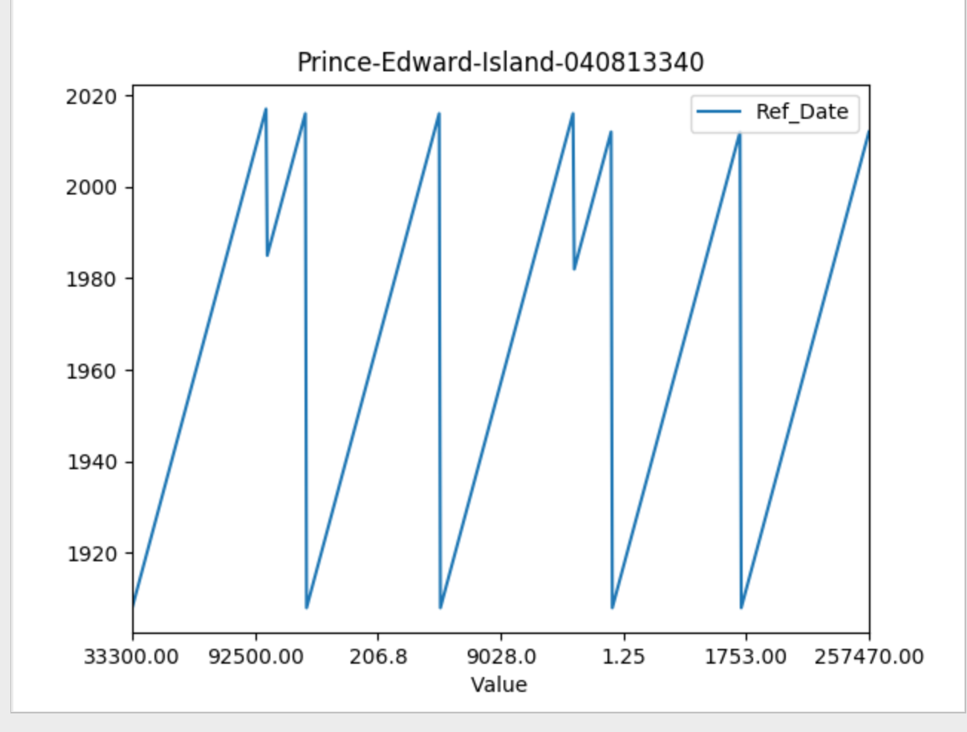

Figure 7 Graph of growth

Figure 7: This is the second file which contain the graph of the growth of the selected location.

On the top is the name of the location with my student number. On the x-axis is the values and on the y-axis, are the years.