*Seyedamin Seyedmahmoudian*

*040813340 | CST8333 Programming Language Research Project*

*Portfolio unit test*

Figure 1 Unit test class 3

Figure 2 Function that being test 3

Figure 3 Result of the unit test 3

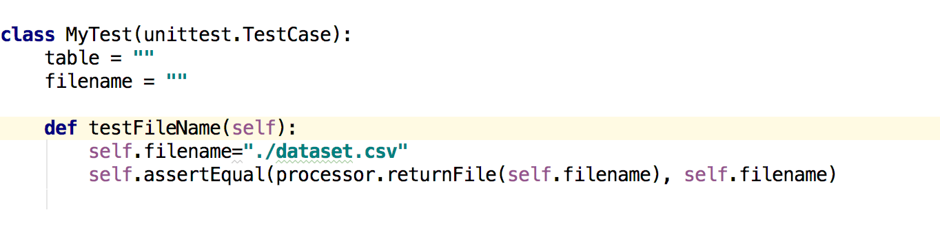

Figure 1 Unit test class

Figure 1: unit test class which check for the file name is correct. This test is to check if sending file from one class to another is being done successfully.

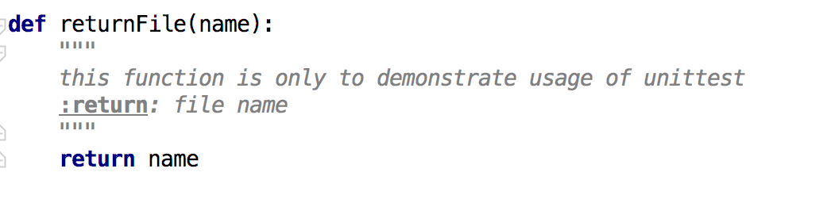

Figure 2 Function that being test

Figure 2: This function gets the file name and return it to unit test class.

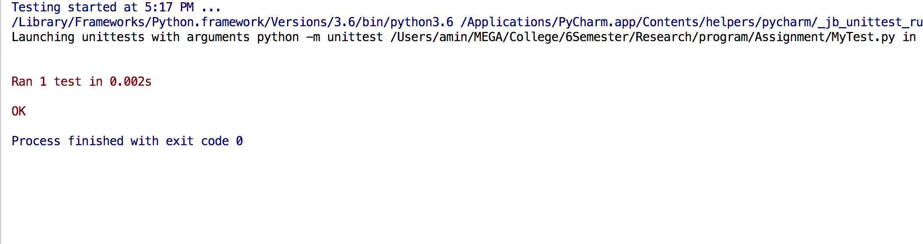

Figure 3 Result of the unit test

Figure 3 : We were successfully able to send the file from one program to another.