Seyi Ariyo

**ACME Video Rental**

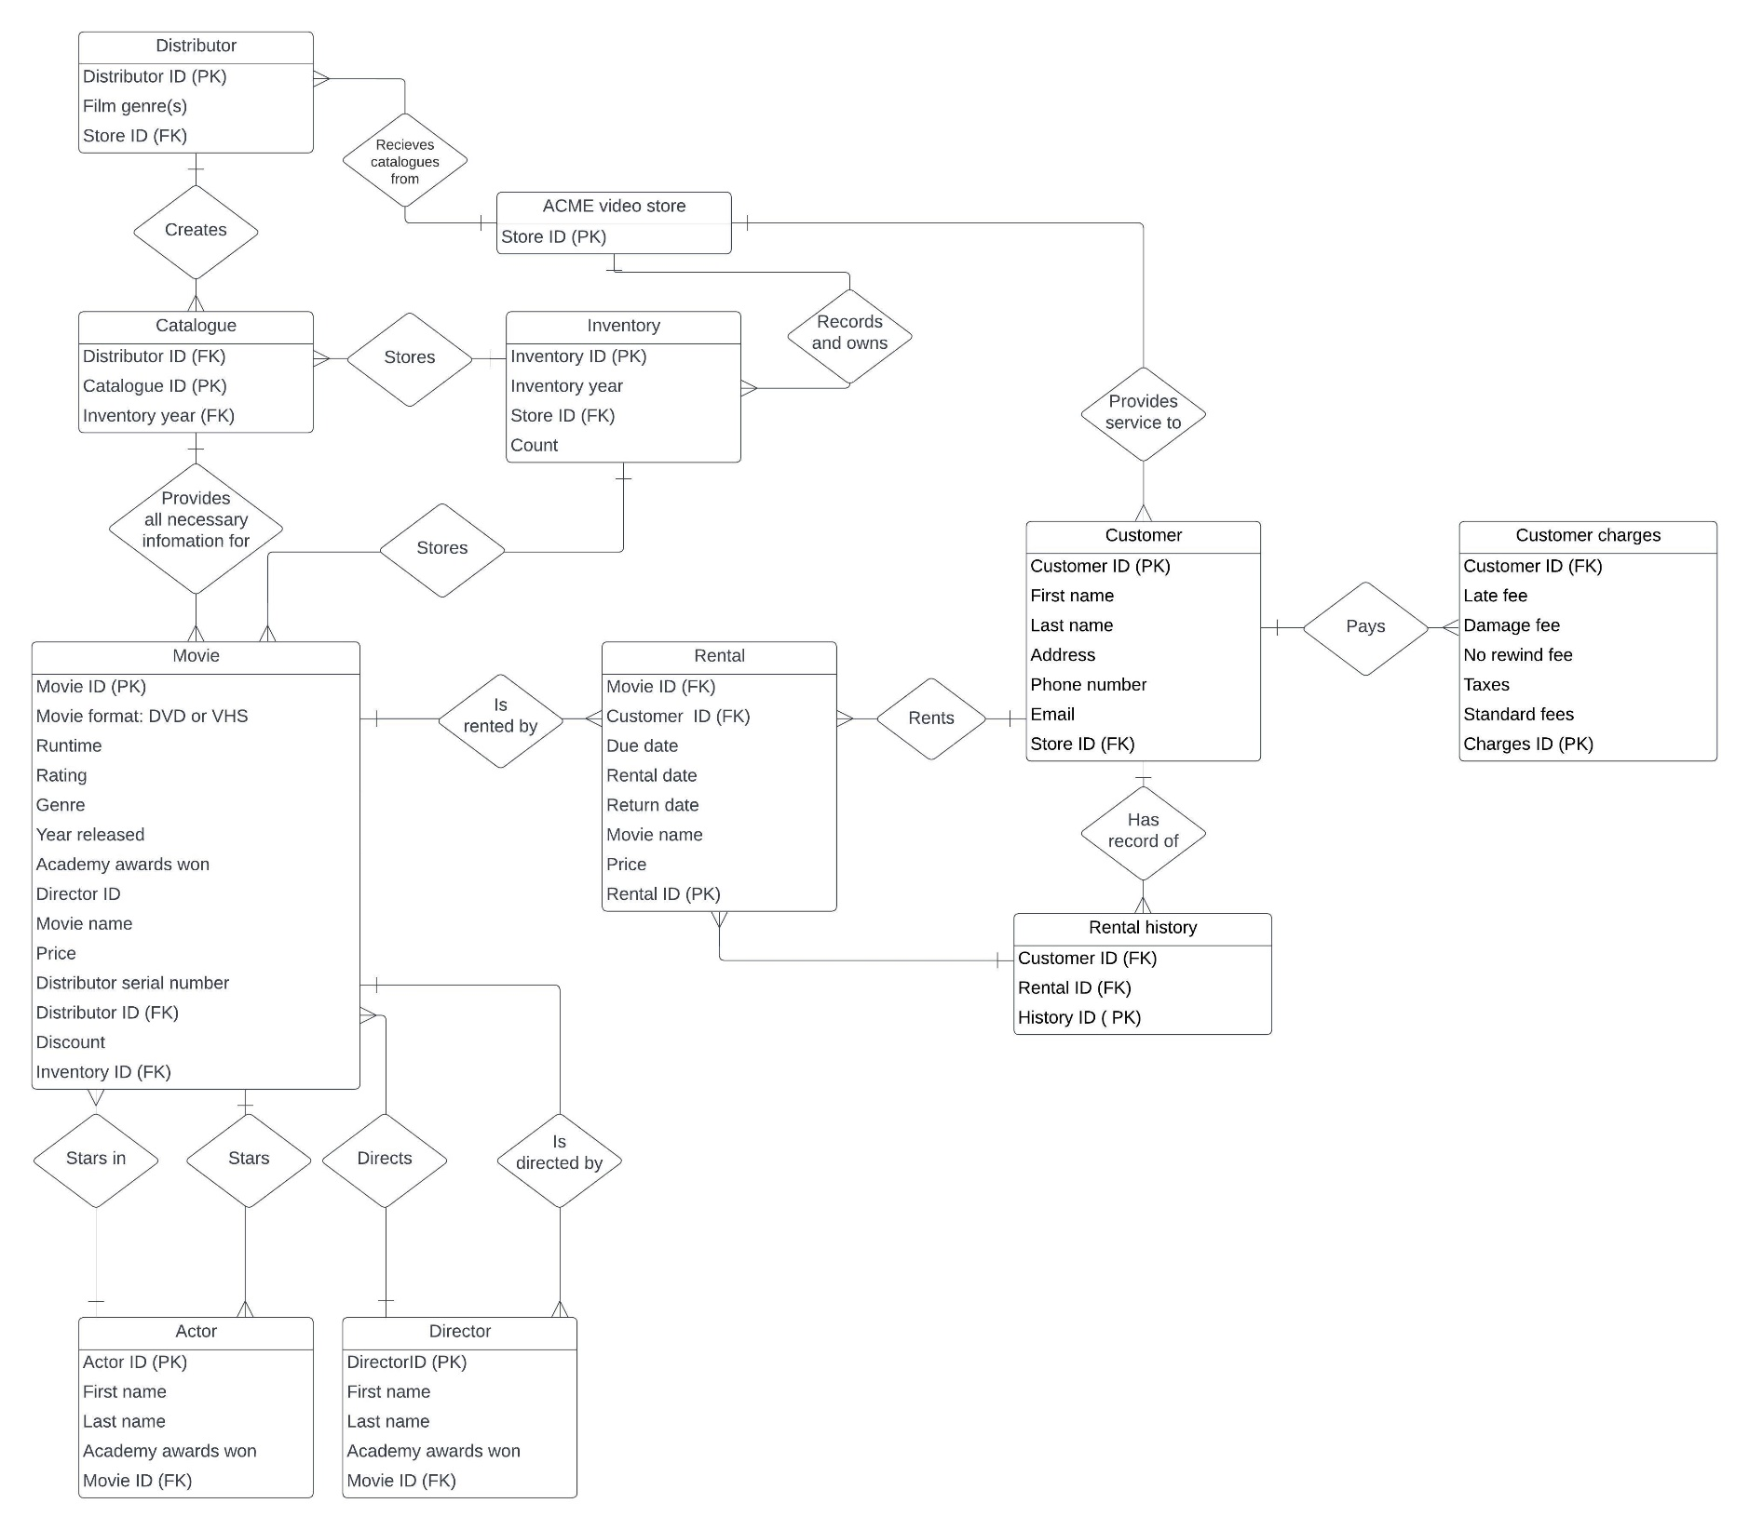

**ACME Video Rental**

|  |  |  |  |  |
| --- | --- | --- | --- | --- |
| **Entity Name** | **Attributes** | **PK/FK?** | **Data Types** | **Description** |
| ACME Video Store | Store ID | PK | NUMBER | Primary Key for ACME store |
|  |  |  |  |  |
| Distributor | Distributor ID | PK | NUMBER | PK for entity |
|  | Film genre(s) |  |  |  |
|  | Store ID | FK | NUMBER | FK for ACME store |
|  |  |  |  |  |
| Catalogue | Distributor ID | PK | NUMBER | PK for entity |
|  | Catalogue ID | FK | NUMBER | FK for Catalogue |
|  | Inventory ID | FK | NUMBER | FK for Inventory |
|  |  |  |  |  |
| Movie | Movie ID | PK | NUMBER | PK for entity |
|  | Movie Format |  | CHAR(3) | Movie format(DVD or VHS) |
|  | Runtime |  | NUMBER | Movie Length |
|  | Rating |  | CHAR(1) | Movie Rating |
|  | Genre |  | VARCHAR2(50) | Movie Genre |
|  | Year Released |  | CHAR(4) | Movie Release Year |
|  | Academy Awards Won |  | NUMBER | Number of awards won by the movie exclusively |
|  | Director ID |  | NUMBER | ID of Director |
|  | Movie Name |  | VARCHAR2(250) | Name of Movie |
|  | Price |  | NUMBER | Price of Movie before discounts |
|  | Distributor Serial Number |  | NUMBER | Serial Number given by the Distributor |
|  | Distributor ID | FK | NUMBER | FK for Distributor |
|  | Discount |  | NUMBER |  |
|  | Inventory ID | FK | NUMBER | FK for Inventory |
|  |  |  |  |  |
| Actor | Actor ID | PK | NUMBER | PK for entity |
|  | First Name |  | VARCHAR2(50) | First Name of Actor |
|  | Last Name |  | VARCHAR2(50) | Last Name of Actor |
|  | Academy Awards Won |  | NUMBER | Number of Awards Won by Actor |
|  | Movie ID | FK | NUMBER | FK for Movie |
|  |  |  |  |  |
| Director | Director ID | PK | NUMBER | PK for entity |
|  | First Name |  | VARCHAR2(50) | First Name of Director |
|  | Last Name |  | VARCHAR2(50) | Last Name of Director |
|  | Academy Awards Won |  | NUMBER | Number of Awards Won by Director |
|  | Movie ID | FK | NUMBER | FK for Movie |
|  |  |  |  |  |
| Inventory | Inventory ID | PK | NUMBER | PK for entity |
|  | Inventory Year |  |  | Year Inventory Began |
|  | Store ID | FK | NUMBER | FK for Store |
|  | Count |  | NUMBER | Number of Movies in Inventory |
|  |  |  |  |  |
| Customer | Customer ID | PK | NUMBER | PK for entity |
|  | First Name |  | VARCHAR2(50) | Customer First Name |
|  | Last Name |  | VARCHAR2(50) | Customer Last Name |
|  | Address |  | VARCHAR2(250) | Customer Address |
|  | Phone Number |  | NUMBER | Customer Phone Number |
|  | Email |  | VARCHAR2(250) | Customer Email |
|  | Store ID | FK | NUMBER | FK for Store |
|  |  |  |  |  |
| Rental | Rental ID | PK | NUMBER | PK for entity |
|  | Movie ID | FK | NUMBER | FK for Movie |
|  | Customer ID | FK | NUMBER | FK for Movie |
|  | Due Date |  | CHAR(10) | Rental Due Date |
|  | Rental Date |  | CHAR(10) | Day Movie was rented |
|  | Movie Name |  | VARCHAR2(250) | Name of Movie |
|  | Price |  | NUMBER | Price of Movie rental |
|  |  |  |  |  |
| Rental History | History ID | PK | NUMBER | PK for entity |
|  | Customer ID | FK | NUMBER | FK for Customer |
|  | Rental ID | FK | NUMBER | FK for Rental |
|  |  |  |  |  |
| Customer Charges | Charges ID | PK | NUMBER | PK for entity |
|  | Customer ID | FK | NUMBER | FK for Customer |
|  | Late Fee |  | NUMBER | Late Fee Amount |
|  | Damage Fee |  | NUMBER | Damage Fee Amount |
|  | No Rewind Fee |  | NUMBER | No Rewind Fee Amount |
|  | Taxes |  | NUMBER | Taxes Amount |
|  | Standard Fees |  | NUMBER | Standard Fees Amount |