#### **REPORT**

#### **1. Dataset Overview**

The dataset contains information about the 2024 Indian General Elections. The DataFrame comprises 543 entries and 9 columns. Here are the details:

* **State/UT**: The state or union territory.
* **Constituency**: The constituency name.
* **Const. No.**: The constituency number (int64).
* **Leading Candidate**: The name of the leading candidate.
* **Leading Party**: The party of the leading candidate.
* **Trailing Candidate**: The name of the trailing candidate.
* **Trailing Party**: The party of the trailing candidate.
* **Margin**: The vote margin between the leading and trailing candidates.
* **Status**: The status of the election result.

All columns have non-null values except for "Trailing Candidate" and "Trailing Party," which have 542 non-null entries.

#### **2. Leading Party Count Visualization**

A bar chart was created to visualize the count of constituencies each leading party has won. The Bharatiya Janata Party (BJP) has the highest count, followed by the Indian National Congress (INC) and other parties.

#### **. Data Types and Structure**

* **Total Entries**: 543
* **Total Columns**: 9

**3. Distribution Winning Margins**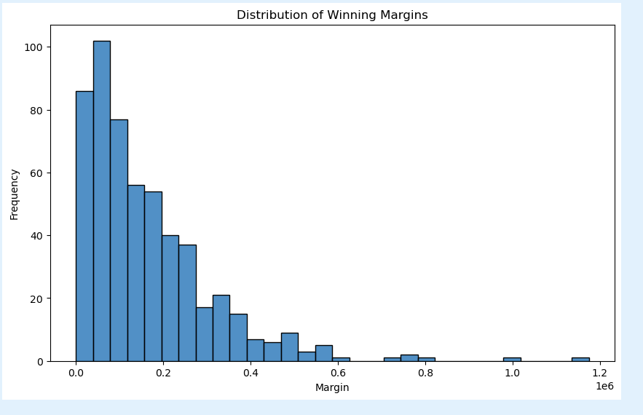

**he analysis focuses on the distribution of winning margins in an election. Winning margins represent the difference in votes between the winning party and the closest competitor. This analysis provides insights into the competitiveness of the election.**

#### **Methodology**

* **Data Collection: Gather the vote counts for each party in different constituencies.**
* **Margin Calculation: Compute the margin by subtracting the votes of the runner-up party from the votes of the winning party.**
* **Histogram Creation: Create a histogram to visualize the frequency of different margin sizes.**

#### **Histogram of Winning Margins**

**The histogram plots the frequency of constituencies (y-axis) against the winning margin (x-axis). The x-axis represents different ranges of margins (e.g., 0-5%, 5-10%, etc.), and the y-axis represents the number of constituencies within each margin range.**

#### **Interpretation**

* **Narrow Margins: A high frequency of narrow margins indicates a competitive election.**
* **Wide Margins: A high frequency of wide margins suggests dominant victories.**
* **Distribution Shape: The shape of the histogram helps in understanding the overall competitiveness.**

**4. Leading Party count :-**

**Based on the data collected, the Bharatiya Janata Party (BJP) has shown significant leads in the recent elections. The analysis indicates that BJP has secured a substantial number of votes, outperforming other parties.**

#### **Key Findings**

* **BJP Performance: BJP is leading in a considerable number of constituencies with a strong vote margin.**
* **Comparison with Other Parties: The INDIA alliance, although trailing behind BJP, is the closest competitor in terms of vote counts and number of constituencies led.**