ES 192: Mini-Project Brief
The Multi-Material Skateboard Deck Challenge

____________________________________________________________

Materials Selection in Mechanical Design
Harvard SEAS - Fall 2026

Prepared by: Seymur Hasanov
For discussion with: Nora Cullen, Director for Active Learning

Draft - April 2026

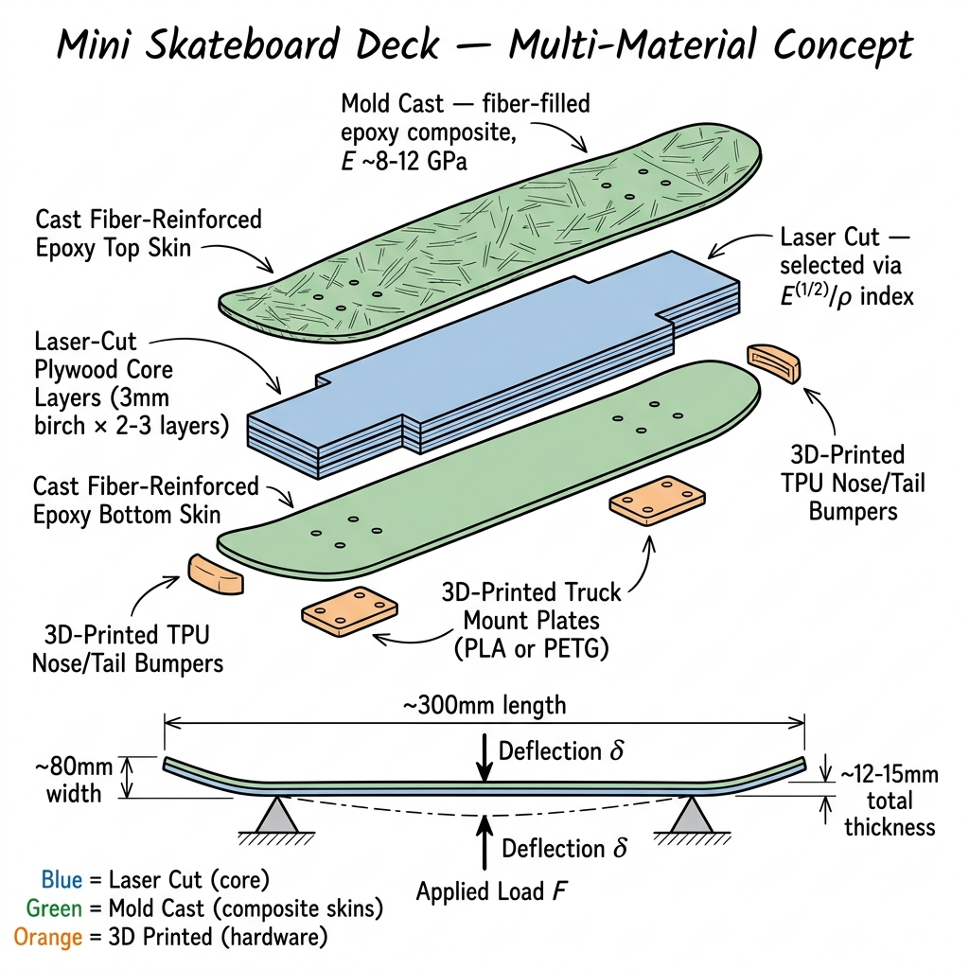

1. Concept Overview
Each team of 3 students designs, fabricates, and tests a multi-material mini skateboard deck that must maximize load-carrying capacity while minimizing weight. The deck is a sandwich panel: laser-cut core layers bonded to cast composite skins, with 3D-printed mounting hardware.
What makes this a materials selection project (not just a build project): every component's material is chosen using the Ashby methodology - students derive materials indices, screen candidates on property charts, and justify their choices with measured data. They then validate predictions against physical test results.

Why a Skateboard Deck?
- It is fundamentally a beam/panel under bending - same mechanics as a cantilever, but far more engaging
- The sandwich structure (skins + core) directly teaches composite and hybrid material concepts
- 3-point bend testing is standard and requires a simpler fixture than a cantilever clamp
- Students can hold it, flex it, and keep it - tangible and rewarding
- Directly leads into the "Composite longboard deck" group project option already in the syllabus

Performance Metric
P = F_max / m
- F_max = maximum load supported without exceeding 5 mm center deflection
- m = total mass of the deck assembly
- Secondary metric: load at structural failure / mass

2. Specifications
Parameter | Value
Deck length | ~300 mm (mini/cruiser scale)
Deck width | ~80 mm
Total thickness | ~12-15 mm (core + skins)
Shape | Flat (no concave, no kick tails)
Test method | 3-point bend: supports at truck positions (~200 mm span), load at center
Max allowable deflection | 5 mm under service load
Performance metric | P = F_max / m
Manufacturing processes | >= 3 required: laser cutting, 3D printing, silicone mold casting
Materials | Standard ALL stock provided (see Section 5)

3. Structural Concept - Exploded View
The deck is a sandwich panel - the same architecture used in real performance skateboard decks, aerospace panels, and composite structures. Each layer serves a specific structural function and is made by a different manufacturing process.

Figure 1: Exploded isometric view of the multi-material skateboard deck. Laser-cut plywood core (blue), cast fiber-reinforced epoxy skins (green), 3D-printed hardware (orange). Bottom: assembled profile with 3-point bend test.

Sandwich Panel Mechanics
- Top & bottom skins (cast composite): carry tension and compression from bending
- Core layers (laser-cut plywood): carry shear, provide bulk thickness to separate skins
- Hardware (3D-printed): truck mounts transfer load, bumpers absorb impact
This sandwich architecture is a direct application of the course's hybrid materials content (Chapters 13-14). Students learn that separating stiff skins with a lightweight core dramatically increases bending stiffness with minimal weight penalty - a concept they can feel by flexing their deck.

4. Materials Selection Logic
The Ashby methodology drives the material-to-process assignment for each component. Each component has a function, which translates to a materials index, which points to candidate materials, which constrain the manufacturing process.
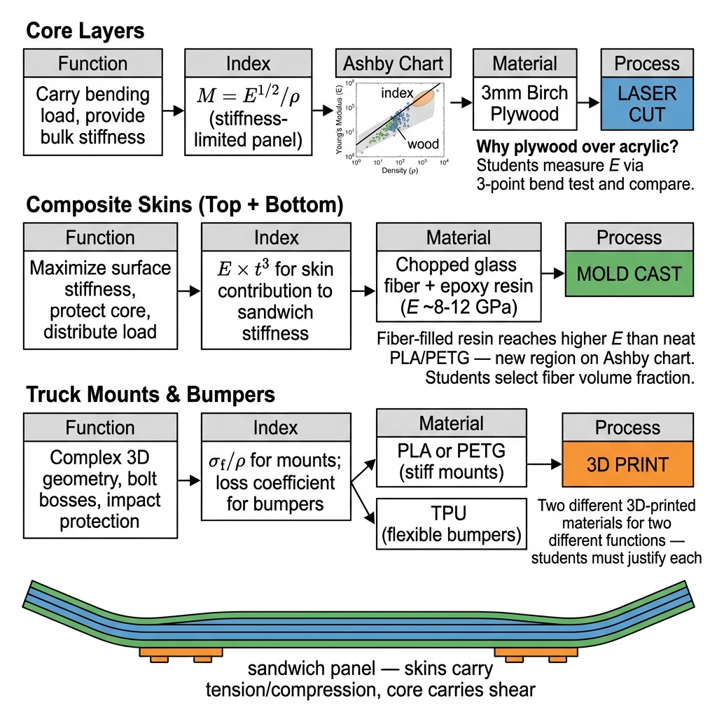
Figure 2: Materials selection logic - Function -> Index -> Ashby Chart -> Material -> Process. Bottom: cross-section showing sandwich panel mechanics.

5. Material Options - The Decision Space
The whole point of the Ashby exercise is that students have multiple real candidates to choose from and must justify their selection with data. Below is the full palette of materials available in the ALL, organized by manufacturing process.
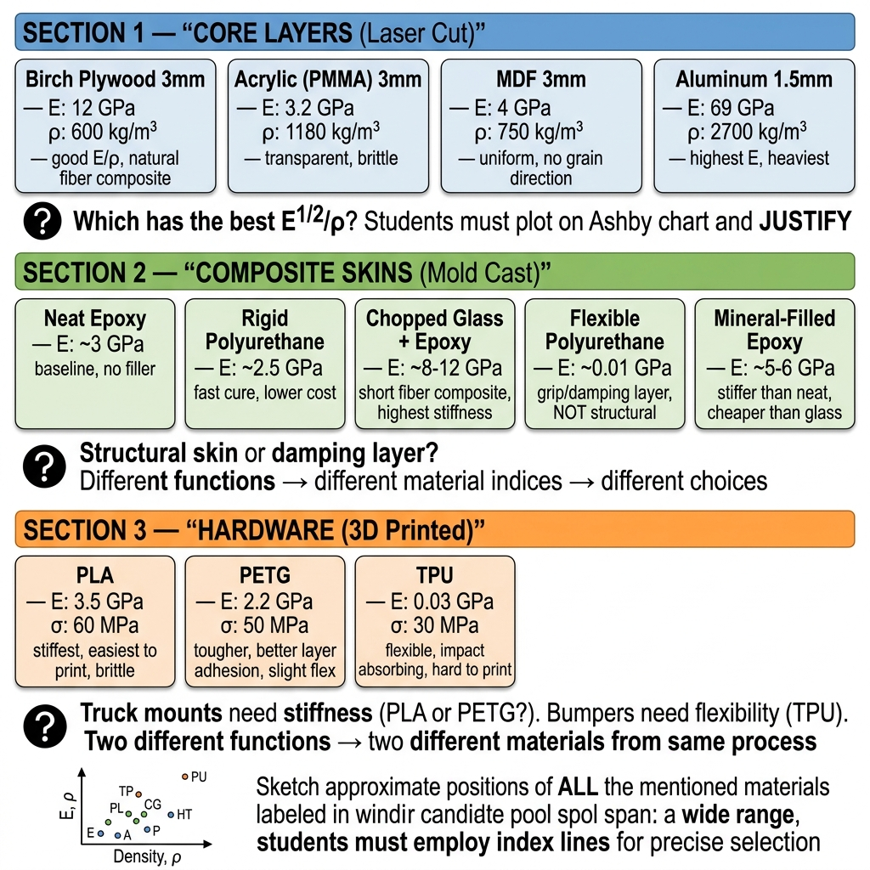
Figure 3: Complete material candidate pool organized by manufacturing process, with key properties and selection questions.

5.1 Core Layers - Laser Cut (students pick 1-2)
Material | E (GPa) | Density (kg/m3) | E^(1/2)/rho | Notes
Birch plywood (3mm) | 12 | 600 | 5.8 x 10^-3 | Natural fiber composite, best index
Acrylic / PMMA (3mm) | 3.2 | 1180 | 1.5 x 10^-3 | Transparent, brittle, poor index
MDF (3mm) | 4 | 750 | 2.7 x 10^-3 | Uniform (no grain), heavy
Aluminum (1.5mm) | 69 | 2700 | 3.1 x 10^-3 | Highest E, but heaviest

Selection question: Plywood wins on E^(1/2)/rho, but aluminum has 6x higher absolute E. When does raw stiffness matter more than specific stiffness? Students test coupons in Week 2 to decide.

5.2 Composite Skins - Mold Cast (students pick 1 per skin)
Material | E (GPa) | Density (kg/m3) | Notes
Neat epoxy | ~3 | ~1200 | Baseline, no filler, easy to pour
Rigid polyurethane | ~2.5 | ~1100 | Fast cure (~30 min), lower cost
Chopped glass + epoxy | ~8-12 | ~1600 | Short fiber composite, highest stiffness
Mineral-filled epoxy | ~5-6 | ~1500 | Stiffer than neat, cheaper than glass
Flexible polyurethane | ~0.01 | ~1050 | NOT structural - grip/damping layer

Selection question: Max stiffness (glass-filled bottom skin) or trade top-skin stiffness for a flexible grip layer? What if you use glass-filled on the bottom (tension side) and flexible PU on top (grip)?

5.3 Hardware - 3D Printed (students pick per component)
Material | E (GPa) | Strength (MPa) | Notes
PLA | 3.5 | 60 | Stiffest, easiest to print, brittle - cracks on impact
PETG | 2.2 | 50 | Tougher, better layer adhesion, slight flex
TPU | 0.03 | 30 | Flexible, impact absorbing - bumpers only?

Selection question: Truck mounts see bolt preload + vibration. PLA is stiffer but PETG won't crack. Students justify using sigma_f/rho AND consider failure mode (brittle vs. yielding).

6. Lecture-Lab Alignment
A key design principle of this mini-project is that each lab aligns with the lecture content being taught that same week. The table below shows how the weekly lab activities map to the textbook chapters covered in parallel lectures.
Week | Lecture Topic (Chapters) | Lab Activity | How They Align
1 | Ch 1-2: Intro, material properties, material families | Design + Ashby charts | Students apply Ch 2 property definitions and Ch 1 material families to their deck design
2 | Ch 3-4: Ashby charts, selection strategy, materials indices | Laser cutting + 3-point bend tests | Students generate Ashby charts and use indices to justify their core material - direct application of Ch 3-4
3 | Ch 5: Case studies applying the methodology | 3D printing + orientation experiment | Case studies show real selection decisions; lab shows how process affects properties
4 | Ch 6: Processes and their effect on properties | Silicone mold casting + resin selection | Ch 6 covers process-property relationships; students directly observe how casting and fiber addition change E
5 | Ch 7-8: Process selection, AM, design for AM | Load testing + validation | Students reflect on all three process choices (Ch 7) and validate their AM decisions (Ch 8)
6 | Ch 9-10: Multiple constraints, trade-offs | COMSOL simulation | Simulation enables "what-if" exploration of trade-offs (Ch 9-10)

Note on Composites Content
The formal composites theory (rule of mixtures, bounds, sandwich panel analysis) is covered in Weeks 8-9 lectures (Chapters 13-14). However, in Week 4, students are casting fiber-reinforced resin skins. This is intentional and pedagogically sound for the following reasons:
- Week 4 lectures cover Chapter 6: "How processing changes microstructure and properties." Adding chopped fiber to resin is a direct example of a process-property relationship, which is exactly the Ch 6 content.
- Students do NOT need rule-of-mixtures theory to select a resin system. They need to: (a) observe that fiber-filled resin has higher E than neat resin, (b) place it on an Ashby chart, and (c) justify the choice. This is pure Ashby methodology (Ch 3-4), applied to a process outcome (Ch 6).
- The experiential introduction in Week 4 ("I cast this, it's stiffer") creates a foundation that the formal composite theory in Weeks 8-9 can build on. Students will already know what a fiber-reinforced material feels like before they learn the math. This is experience-first pedagogy.
- The group project (Weeks 7-13) is where students apply the full composite theory from Ch 13-14 - the "Composite longboard deck" project is explicitly designed for this.
Summary: Week 4 lab teaches composites as a process-property concept (Ch 6). Weeks 8-9 lectures formalize it as composite theory (Ch 13-14). The group project applies the full theory. This sequence: experience -> theory -> application.

7. Lab Schedule Overview (6 Labs)
The mini-project runs over 6 weekly labs (2 hours each, ~10 students / 3-4 teams per section). Each lab has two parallel tracks: a manufacturing skill and a materials selection activity. The selection thread builds cumulatively: Screen -> Measure -> Validate -> Select -> Compare -> Simulate.
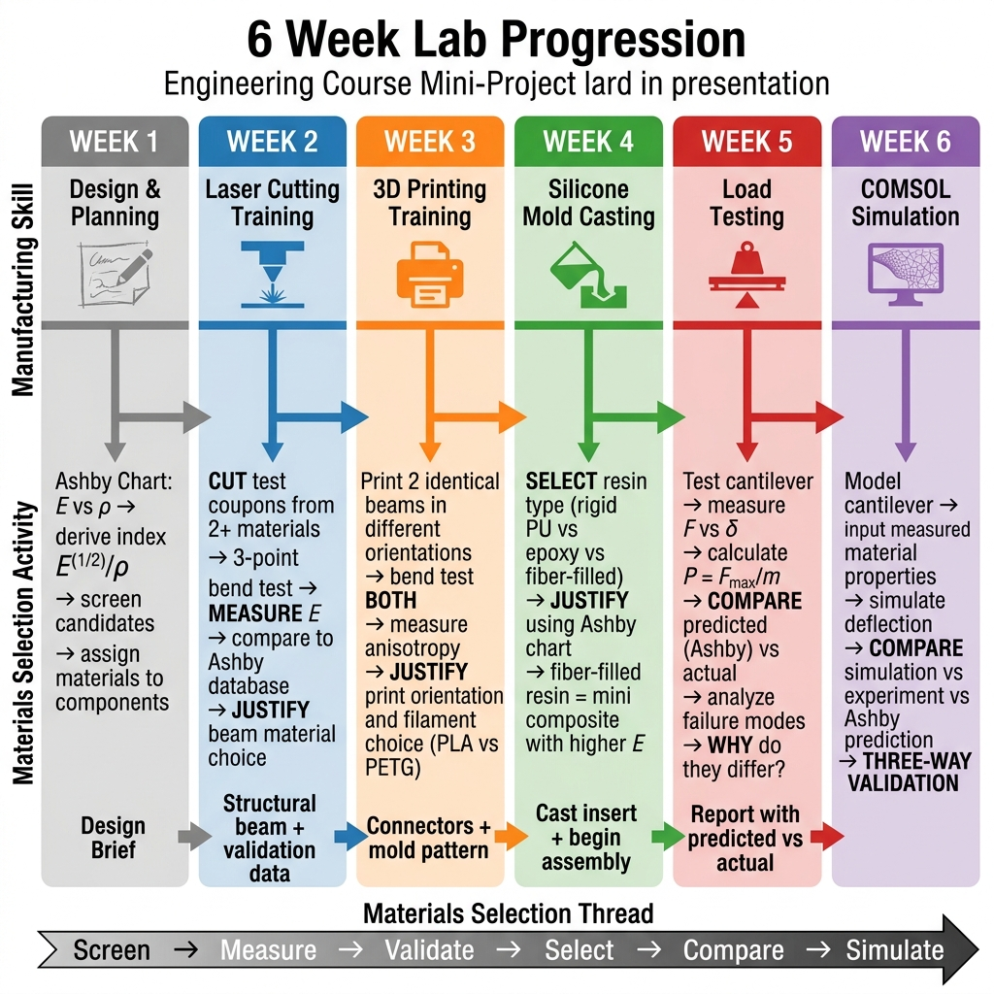
Figure 4: Six-week lab progression showing manufacturing skills (top) and materials selection activities (bottom).

8. Detailed Lab Plans

Lab 1 - Design & Planning (Week 1)
Selection Concept: SCREEN

Objectives
- Students are safe to work in the ALL and understand all equipment
- Teams of 3 form and understand the skateboard deck challenge
- Each team produces a design plan with Ashby-based material justification

Plan (2 hours)
Time | Activity | Details
0:00-0:30 | ALL Tour + Safety | Walk through laser bay, 3D print lab, casting station, workshop. Safety rules. Sign agreements.
0:30-0:45 | Project Briefing | Present the Skateboard Deck Challenge: specs, metric, test setup, timeline, grading rubric.
0:45-1:00 | Team Formation | Form teams of 3. Concept sketching: shape, layers, where do skins go?
1:00-1:30 | Design + Selection | Design Requirements Tables per component. Ashby E vs rho chart. Derive index. Screen candidates.
1:30-1:50 | Design Decisions | Assign material + process per component. Begin rough dimensioning. CAs challenge choices.
1:50-2:00 | Wrap-up | Deliverable explained: Design Brief (1-2 pages) due before next lab.

Materials & Equipment
- Whiteboards or large paper, markers
- Printed material property data sheets (E, rho, sigma_f for all stock)
- Rulers, example deck photos, materials selection software access
Deliverable: Design Brief (1-2 pages): annotated sketch, Design Requirements Table per component, Ashby chart with index line and candidates highlighted, material/process justification.

Lab 2 - Laser Cutting: Core Layers (Week 2)
Selection Concept: MEASURE

Objectives
- Students can safely operate the laser cutter
- Core layers are cut and test coupons prepared from 2+ materials
- Students have measured flexural modulus to validate Ashby chart data

Plan (2 hours)
Time | Activity | Details
0:00-0:20 | Laser Cutter Training | Demo: operation, material loading, focus, DXF/SVG import, kerf compensation, speed/power settings. Safety.
0:20-0:40 | File Preparation | Teams prep cut files: core layer profiles + test coupons (100x20mm from 2+ materials).
0:40-1:10 | Cutting | Teams take turns. Stock: 3mm plywood, 3mm acrylic, 3mm MDF, 1.5mm aluminum.
1:10-1:40 | Baseline Testing | 3-point bend test: 80mm span, load at center, measure deflection at 3+ loads. Calculate E = FL^3/(48*delta*I).
1:40-1:55 | Discussion | Which material had best specific stiffness? Did measurements match database? Process constraints?
1:55-2:00 | Wrap-up | Verify cut core layers + test data. Remind: bring CAD files for 3D printing next week.

Materials & Equipment
- Sheet stock: 3mm birch plywood, 3mm acrylic, 3mm MDF, 1.5mm aluminum
- 3-point bend test blocks (2 support + loading nose), calibrated weights (100g-1kg)
- Dial indicator or rulers, digital scales, calipers
Deliverable: Laser-cut core layers + measured flexural modulus data for 2+ materials with comparison to Ashby database.

Lab 3 - 3D Printing: Hardware & Mold Pattern (Week 3)
Selection Concept: VALIDATE PROCESS-PROPERTY EFFECTS

Objectives
- Students can use FDM printers and slicer software
- Truck mounts, bumpers, and mold pattern are printing
- Students understand print orientation anisotropy through hands-on experiment

Plan (2 hours)
Time | Activity | Details
0:00-0:20 | 3D Printing Training | Demo: slicer (STL, layer height, infill, orientation, supports). Filaments: PLA, PETG, TPU.
0:20-0:35 | Design Review + Slicing | CAs review printability. Prep: (A) truck mounts/bumpers, (B) mold pattern with draft angles.
0:35-0:55 | Orientation Experiment | Print 2 test beams (60x10x5mm) in PLA: flat vs. on-edge (~10 min each).
0:55-1:15 | Test Orientation Beams | 3-point bend both. Calculate stiffness ratio. Flat beam is stiffer - demonstrates anisotropy.
1:15-1:45 | Start Functional Prints | Queue truck mounts, bumpers, mold pattern. Small parts finish in session.
1:45-2:00 | Wrap-up | Confirm mold patterns ready for Week 4. Preview casting. Bring ALL components next week.

Materials & Equipment
- PLA, PETG, TPU filament spools; FDM printers (2-3 per section)
- Slicer software on lab computers; pre-made test beam STL (via Canvas)
- 3-point bend test setup from Week 2
Deliverable: 3D-printed truck mounts + bumpers + mold pattern + print orientation anisotropy data.

Lab 4 - Silicone Mold Casting & Assembly (Week 4)
Selection Concept: CREATE NEW MATERIALS

Objectives
- Students can make silicone molds and cast resin parts
- Composite skin layers are cast with justified resin selection
- Deck assembly begins - bonding skins to core

Plan (2 hours)
Time | Activity | Details
0:00-0:15 | Casting Training | Demo: mold release, containment box (foam core + hot glue), mix silicone by weight, pour, degas. Cure: 4-6 hrs.
0:15-0:40 | Mold-Making | Pour silicone molds for flat skin panels. Already-cured teams proceed to resin casting. Backup molds available.
0:40-1:10 | Resin Casting | Select resin (must justify): neat epoxy, rigid PU, fiber-filled epoxy, mineral-filled, or flexible PU. Mix, add fibers if chosen, pour.
1:10-1:40 | Begin Assembly | Dry-fit core layers + truck mounts. Plan bonding (epoxy, bolts, press-fit). Begin laminating core layers.
1:40-1:55 | Discussion | What shapes does casting enable? Defects observed? How does resin choice affect performance?
1:55-2:00 | Wrap-up | CAs demold after session. Teams finalize assembly before Week 5.

Materials & Equipment
- Silicone rubber (two-part, e.g., Smooth-On Mold Star), mold release spray
- Foam core sheets + hot glue guns (containment boxes)
- Casting resins: rigid PU, flexible PU, epoxy, chopped glass fiber, mineral filler
- Mixing cups, stir sticks, digital scale, gloves, eye protection
- Vacuum degassing chamber (if available); pre-made backup molds (2-3 per section)
Deliverable: Cast composite skin layers + resin selection justification + partially assembled deck.

Lab 5 - Load Testing & Validation (Week 5)
Selection Concept: COMPARE PREDICTED vs. ACTUAL

Objectives
- Every team has a fully assembled, tested deck with load-deflection data
- Students compare Ashby predictions to actual performance
- Students analyze failure modes and reflect on methodology gaps

Plan (2 hours)
Time | Activity | Details
0:00-0:15 | Final Assembly | Attach skins to core. Mount truck plates. Trim flash. Weigh. Measure dimensions.
0:15-0:20 | Test Procedure | Support at truck positions (~200mm span). Load center incrementally. Record F vs delta. Find F_max at 5mm.
0:20-1:00 | Testing | ~10 min per team. Others: calculate P, review Week 1 predictions. Load to failure if safe.
1:00-1:20 | Leaderboard | Calculate P = F_max/m. Post results. Rank by performance. Celebrate top design.
1:20-1:50 | Validation Discussion | Ashby prediction vs actual. Why different? Which choices mattered? What would you change?
1:50-2:00 | Report Assignment | Report (3-5 pages): design, Ashby plots, test data, predicted vs actual, failure modes, lessons.

Materials & Equipment
- 3-point bend fixture (2 supports at ~200mm span), calibrated weights (100g-5kg)
- Dial indicator + magnetic stand, digital scale, calipers
- Whiteboard for leaderboard, camera for failure photos
Deliverable: Report (3-5 pages, due in 1 week): design rationale, Ashby plots, load-deflection curve, predicted vs actual, failure mode analysis, lessons learned.

Lab 6 - COMSOL Simulation (Week 6)
Selection Concept: SIMULATE & THREE-WAY VALIDATION

Objectives
- Students can set up a basic structural simulation in COMSOL
- Three-way comparison: Ashby prediction vs. COMSOL vs. experiment
- Students understand when simulation adds value vs. when testing is necessary

Plan (2 hours) - Run by COMSOL Instruction Team
Time | Activity | Details
0:00-0:20 | COMSOL Intro | Interface overview. Pre-built sandwich panel template. Geometry, materials, BCs, load.
0:20-0:50 | Guided Exercise | Modify template: deck dimensions, assign measured material properties, apply test loads. Run.
0:50-1:10 | Comparison Exercise | Compare COMSOL deflection to Week 5 data. Fill comparison table for each load level.
1:10-1:40 | Parametric Study | Vary one parameter (core material, skin thickness). Plot results. "What if aluminum core?"
1:40-2:00 | Wrap-up | When is simulation useful vs testing? Preview COMSOL features for group projects.

Three-Way Comparison (students fill in)
Method | Source | Deflection at Load X
Ashby index (Week 1) | Analytical, from materials index | delta_predicted
COMSOL simulation (Week 6) | Computational, idealized geometry | delta_simulated
Experiment (Week 5) | Physical test, real structure | delta_measured

Materials & Equipment
- COMSOL via HUIT VDI (access set up in advance)
- Pre-built sandwich panel template (.mph file)
- Material property table, step-by-step worksheet

9. Materials Selection Thread Summary
The materials selection methodology is reinforced every week. Each lab has a "selection verb" that builds on the previous week:
Week | Lab | Selection Verb | What Students Learn
1 | Design | SCREEN | Use Ashby charts + indices to narrow candidates
2 | Laser Cut | MEASURE | Real properties != database; validate assumptions
3 | 3D Print | VALIDATE | Process changes properties (anisotropy)
4 | Casting | CREATE | Design new materials (fiber composites) for new chart regions
5 | Testing | COMPARE | Prediction vs reality; where methodology works/breaks
6 | COMSOL | SIMULATE | Computational "what-if" exploration

10. Grading Rubric (10% of Course Grade)
Criterion | Weight | Description
Materials Selection Rationale | 30% | Ashby charts, indices, Design Requirements Tables, justification quality
Design Quality & Manufacturing | 25% | Creativity, execution quality, appropriate use of each process
Test Results & Performance | 20% | Data quality, P = F_max/m, testing rigor
Report & Analysis | 25% | Clarity, predicted-vs-actual, failure modes, reflection

11. Pre-Semester Action Items
Task | Owner | Target
Finalize deck specs and 3-point bend fixture design | Seymur | End of April 2026
Test-run full 6-week sequence; write lab handouts + CA instructions | Nora | End of May 2026
Build/procure 3-point bend test fixture (2 supports + weights) | Nora + ALL staff | End of May 2026
Prepare 2-3 backup silicone molds (flat skin panel shape) | Nora | End of May 2026
Coordinate with COMSOL team: sandwich panel template specs | Seymur | End of April 2026
COMSOL team: build sandwich panel template .mph file | COMSOL team | End of May 2026
Recruit and train lab CAs from ES 51 | Seymur + Nora | August 2026
Procure silicone, resins, chopped fiber, casting supplies | Nora + ALL staff | August 2026
Prepare material data sheets for students (E, sigma_f, rho) | Seymur | Before Week 1
Set up materials selection software + COMSOL VDI access | Seymur | Before Week 1

