Name:

ID:

Date:

ITU, Computer Engineering Dept.

BLG527E, Machine Learning HW2

Due: May 5, 2024, 23:00 through Ninova.

**NO LATE SUBMISSION WILL BE ACCEPTED. DO NOT SUBMIT THROUGH E-MAIL.**

# Instructors: Yusuf Yaslan (yyaslan@itu.edu.tr)

**Grading: You must complete the table below according to what you expect to get out of each question. At the beginning of your report you should give the following table.**

|  |  |  |  |  |  |
| --- | --- | --- | --- | --- | --- |
|  |  | **Q1** | **Q2** | **Q3** | **Total** |
| **Grade** | **Max** | **4** | **3** | **3** | **0 pts** |
| **Expected** |  |  |  |  |

# Policy:

# Please do your homeworks on your own. You are encouraged to discuss the questions with your class mates, but the code and the hw you submitted must be your own work. Cheating is highly discouraged for it could mean a zero or negative grade from the homework.

# If a question is not clear, please let me know (via email or in class). Unless we indicate otherwise, do not use libraries for machine learning methods. When in doubt, email me.

There will be 3 homeworks this term. Each hw is worth 10 points and each question will be evaluated on a 0/1 basis.

Q1) Generate a 2 dimensional 2 class dataset with 1000 examples for each class where

$μ_{1}=\left[1 2\right], μ_{2}=\left[3 5\right]$ and

$Σ_{1}=\left[\begin{matrix}2 & 1 \\ 1 & 3\end{matrix}\right],Σ_{2}=\left[\begin{matrix}1 & -0.8 \\ -0.8 & 3\end{matrix}\right]$

plot the dataset.

(You can use built in functions to generate data)

1. Plot the generated datasets.
2. Partition the dataset into training (80%) and test set (20%) randomly. Compute the mean vectors and covariance matrices of the classes for training set. (In order to compute the covariance matrix and mean vectors use the formulas that are given in the book. You are not allowed to use built in functions.
3. Design a quadratic discriminant classifier using different covariance matrices. Obtain the training and test errors. Draw the decision boundary.
4. Design a linear discriminant classifier using a shared covariance matrix. Obtain the training and test errors. Draw the decision boundary

Q2) You will use the attached opdigits dataset for this hw. The last column of the file shows the label (class 0,1…9) [You need to write down the PCA code yourself, do not use a library pca() function. Do not use cov() and mean() function, but you may use eig() function to compute eingevalues]

Project the instances into two dimensional space and plot the projections in your report.

Implement a PCA projection on given the data.txt. The last attribute of the data.txt is the class label, range from 0..9 Therefore you should exclude the class labels during PCA operations.

• Use the covariance matrix Σ to calculate the PCA components

• Plot the transformed data points in 2D as shown in the Figure below. Only label randomly selected 200 instances in your report. You need to use annotate() like function to write text(class label) at each randomly selected 200 data points.

• Give all your plots in your report.

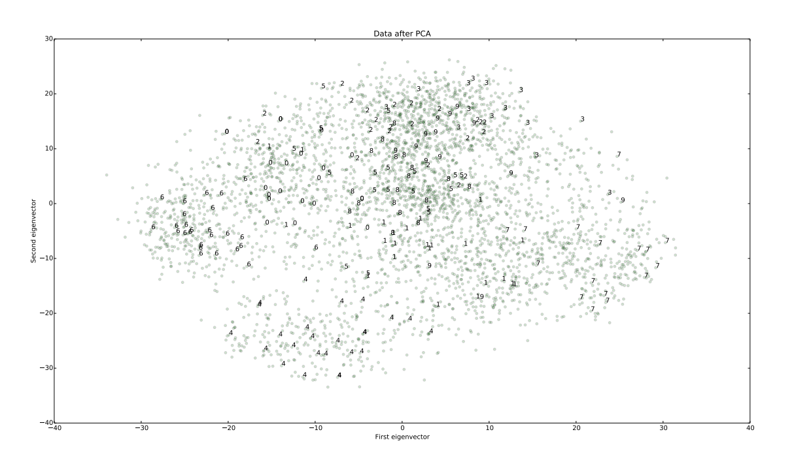

Q3) We are given two coins A and B where the probabilities for heads are QA and QB respectively. Each coin is selected randomly with a probability p(zk = 1) = πk , (k=1,2 and $\sum_{k=1}^{2}{π_{k}}=1$). After a coin is selected we take 10 observations from that coin. Suppose that you are given the following observations:

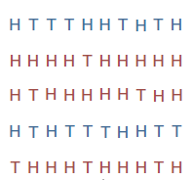

1. Write down the expectation maximization steps to find the parameters. **Show the derivation of the formulas that find the parameters (E and M steps).**
2. Write a program that computes the parameters of the given experiment. **Give the parameters in your report**.

**Hint:** Use Binomial distribution.

(See <http://ai.stanford.edu/~chuongdo/papers/em_tutorial.pdf> for detailed descriptions of the sample experiment)