Sezgin@DESKTOP-F8VRO1C MINGW64 ~/Desktop

$ cd HackYourFuture/

Sezgin@DESKTOP-F8VRO1C MINGW64 ~/Desktop/HackYourFuture

$ git clone git@github.com:SezginYurdakul/animals.git

Cloning into 'animals'...

The authenticity of host 'github.com (140.82.121.3)' can't be established.

ED25519 key fingerprint is SHA256:+DiY3wvvV6TuJJhbpZisF/zLDA0zPMSvHdkr4UvCOqU.

This key is not known by any other names

Are you sure you want to continue connecting (yes/no/[fingerprint])? y

Please type 'yes', 'no' or the fingerprint: yes

Warning: Permanently added 'github.com' (ED25519) to the list of known hosts.

remote: Enumerating objects: 3, done.

remote: Counting objects: 100% (3/3), done.

remote: Total 3 (delta 0), reused 0 (delta 0), pack-reused 0

Receiving objects: 100% (3/3), done.

Sezgin@DESKTOP-F8VRO1C MINGW64 ~/Desktop/HackYourFuture

$ cd animals/

Sezgin@DESKTOP-F8VRO1C MINGW64 ~/Desktop/HackYourFuture/animals (main)

$ touch zoo.txt

Sezgin@DESKTOP-F8VRO1C MINGW64 ~/Desktop/HackYourFuture/animals (main)

$ git add zoo.txt

Sezgin@DESKTOP-F8VRO1C MINGW64 ~/Desktop/HackYourFuture/animals (main)

$ git commit -m "A txt file created with 3 wild animals"

[main 52d81a4] A txt file created with 3 wild animals

1 file changed, 3 insertions(+)

create mode 100644 zoo.txt

Sezgin@DESKTOP-F8VRO1C MINGW64 ~/Desktop/HackYourFuture/animals (main)

$ git push

Enumerating objects: 4, done.

Counting objects: 100% (4/4), done.

Delta compression using up to 8 threads

Compressing objects: 100% (2/2), done.

Writing objects: 100% (3/3), 328 bytes | 328.00 KiB/s, done.

Total 3 (delta 0), reused 0 (delta 0), pack-reused 0

To github.com:SezginYurdakul/animals.git

c0305a1..52d81a4 main -> main

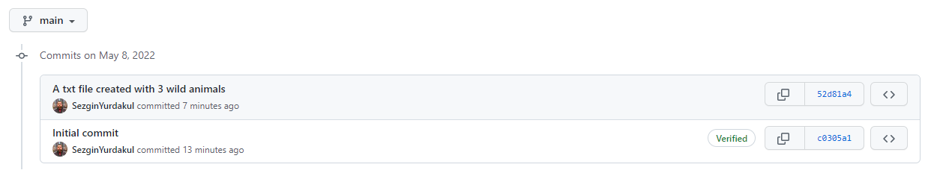

Sezgin@DESKTOP-F8VRO1C MINGW64 ~/Desktop/HackYourFuture/animals (main)

$ git branch new-feature

Sezgin@DESKTOP-F8VRO1C MINGW64 ~/Desktop/HackYourFuture/animals (main)

$ git branch

\* main

new-feature

Sezgin@DESKTOP-F8VRO1C MINGW64 ~/Desktop/HackYourFuture/animals (main)

$ git switch new-feature

Switched to branch 'new-feature'

Sezgin@DESKTOP-F8VRO1C MINGW64 ~/Desktop/HackYourFuture/animals (new-feature)

$ git push

fatal: The current branch new-feature has no upstream branch.

To push the current branch and set the remote as upstream, use

git push --set-upstream origin new-feature

Sezgin@DESKTOP-F8VRO1C MINGW64 ~/Desktop/HackYourFuture/animals (new-feature)

$ git push

fatal: The current branch new-feature has no upstream branch.

To push the current branch and set the remote as upstream, use

git push --set-upstream origin new-feature

Sezgin@DESKTOP-F8VRO1C MINGW64 ~/Desktop/HackYourFuture/animals (new-feature)

$ git push --set-upstream origin new-feature

Enumerating objects: 4, done.

Counting objects: 100% (4/4), done.

Delta compression using up to 8 threads

Compressing objects: 100% (2/2), done.

Writing objects: 100% (3/3), 355 bytes | 355.00 KiB/s, done.

Total 3 (delta 0), reused 0 (delta 0), pack-reused 0

remote:

remote: Create a pull request for 'new-feature' on GitHub by visiting:

remote: https://github.com/SezginYurdakul/animals/pull/new/new-feature

remote:

To github.com:SezginYurdakul/animals.git

\* [new branch] new-feature -> new-feature

branch 'new-feature' set up to track 'origin/new-feature'.

