PQC Secure Boot Verification Framework for QNX

Project Proposal
COMP 4900E – Real Time Operating Systems

Group 4:
Sebastian Ezman – sebastianezman@cmail.carleton.ca
Renee Hogarth – reneehogarthrosmus@cmail.carleton.ca
Evan Hall – evanhall3@cmail.carleton.ca
Roopvir Kang – roopkang@cmail.carleton.ca
Hamza Rizwan – hamzarizwan4@cmail.carleton.ca

Domain Description:
Secure Boot is a critical security mechanism in modern embedded systems, ensuring that only authenticated and trusted software is executed during system startup. This is especially important for safety and security critical platforms such as automotive systems, industrial controllers, and networking devices, where the execution of unauthorized code can lead to system compromise or dangerous operation. Traditional secure boot solutions rely on classical cryptographic algorithms, which are increasingly vulnerable to future quantum computing attacks. Post-quantum cryptography (PQC) has emerged as a solution to this emerging challenge by providing cryptographic algorithms resistant to both classical and quantum threats. However, this new integration of PQC into a secure boot process introduces new challenges related to increased computational cost, and resource usage in constrained embedded environments. This project focuses on the design and evaluation of a post-quantum secure boot verification framework on the QNX real-time operating system, assessing the feasibility and performance trade-offs of post quantum and hybrid codesigning for embedded platforms.

Research Question:
In this project, we are trying to achieve the implementation and evaluation of PQC signatures in a secure boot system for embedded devices. Currently, secure boot systems use classical cryptology schemes that are secure today but could be vulnerable to quantum computers in the future. We are trying to solve the issue of securely booting embedded systems in a post-quantum environment without breaking their compatibility with existing systems. We will investigate if PQC signatures can be integrated into low level firmware and evaluate the outcomes such as the speed to boot with PQC verification, the additional memory needed, and the security benefits of deploying this kind of cryptography.

Development Technology:
Category | Technologies | Purpose / Role
Hardware Target | Raspberry Pi | Physical embedded platform for realistic deployment, testing, and benchmarking of the secure boot system.
Operating System | QNX SDP | Target real-time operating system platform and virtual environment for development.
Development Environment | Momentics IDE | Code editing, compiling, debugging, and deploying applications in virtual environments.
Programming Languages | C, C++ | Implementing the chosen algorithms and developing system-level boot components.
Build Tools & Compilers | Makefiles, GCC | Compiling and linking system-level code.
Cryptographic Libraries | qcrypto , liboqs | Implementing and registering the chosen post-quantum cryptographic algorithms.
Version Control | Git, GitHub | Source code management, version control, and team collaboration.

We will be using the QNX SDP and the Momentics IDE as the platform for developing the project. We have gained introductory experience with the QNX SDP and the Momentics IDE through course assignments, becoming familiar with code editing, compiling, debugging, and deploying applications in the QNX virtual environments. While our experience has primarily been at the application level, this project will require extending our knowledge to system level boot components and startup processes. We will be relying on QNX documentation and system architecture references to correctly modify and rebuild boot-layer components.
We will be using qcrypto to implement and register our chosen cryptographic algorithm for the project. No one in our group has used this library before, having no familiarity with the library or how it functions. We intend to fill this knowledge gap by using the QNX documentation along with various posts and guides found on the internet to figure out how to use the library to implement our cryptographic algorithm.
We will be using Makefiles to compile and link our code, combined with GCC as the compiler. We are comfortable with the basics of using Makefiles and GCC as several courses have required their use, mainly COMP 2401 and COMP 2404 which are required and taught in C and C++ respectively and use Makefiles and GCC for compilation. We do not expect that more complicated uses of Makefiles will be required for this project, only the basic uses of compiling and linking our code, such that we already have all the requisite knowledge. For GCC we expect more complex usages to compile for the system level rather than at the application level, that is currently beyond our knowledge. We will be leveraging various guides on the internet, along with GCC documentation to fill these gaps in our knowledge.
We will be implementing the algorithm using C/C++, depending on what the algorithm we choose reference implementation has been done in. We all have some familiarity with these languages, COMP 2401 is taught in C and COMP 2404 is taught in C++ with both being required courses we have all taken. Some of us have further knowledge of the languages through other courses we have taken, personal projects, and work experience. We intend to fill our knowledge gaps using the C/C++ documentation along with general information found on the internet.
We will be using Git and GitHub for version control and to share our work with the group. We have used Git and GitHub for numerous group projects and assignment submissions throughout our time at Carleton, with many of us having additional knowledge through personal endeavors and work experience. As such, we have plenty of knowledge on using Git and GitHub and don’t believe we will require further knowledge from the internet or Git/GitHub documentation.

Project Responsibilities, and Contributions:
Name | Responsibilities (subject to change)
Sebastian Ezman | PQC algorithm selection
Renee Hogarth | PQC implementation in qcrypto
Evan Hall | Secure Boot PQC modification
Roopvir Kang | Testing Of PQC Secure Boot
Hamza Rizwan | Testing and Comparison of Secure Boot

GitHub Repo: https://github.com/tankmonx/-COMP4900E_PQC_QNX_BOOT-

Deliverable Deadlines:
Deliverable | Deadline
Project Proposal | Feb 15
Presentation | March 17
Final Project Report | April 5

Timeline:
Task | Dates
Choose PQC algorithm | Feb 16-23
Implement pqc algorithm in qcrypto | Feb 23 – Mar 2
Set secure boot to use pqc algo | Mar 2 – Mar 17
Create presentation | Mar 9 - 17
Test secure boot, compare to default | Mar 17 – April 2
Write final report | April 5

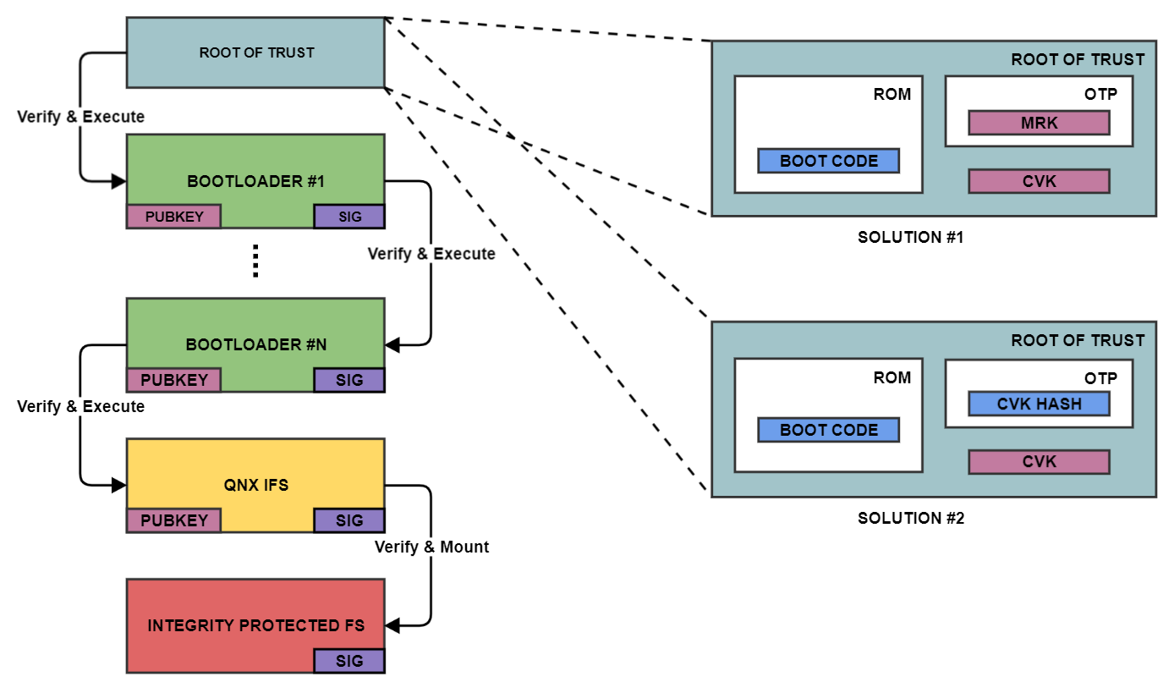
Secure Boot Diagram For QNX
Study Methodology:
Our study methodology begins with creating the system design, defining the implementation environment, comparing different secure boot schemes, measuring relevant metrics, and evaluating the results. When implementing our system design, we will need to decide on the architecture we will build, the algorithms we will select, and decide between using PQC-only or hybrid secure boot. Based on our implementation environment, we will select hardware platforms and software tools and modify the existing bootloader. We will then compare the possible secure boot systems. These are the classical, PQC-only secure boot, and hybrid boot. In our measurements, we will look at metrics such as boot time, signature verification time, code size increase, signature size, and key size. Lastly, we will evaluate these metrics to see if they are acceptable.
In our comparison of these systems, our first step is to figure out exactly how the standard, classical secure boot performs right now. By testing the current setup, we establish a clear baseline. This baseline is our measuring stick. Without it, we wouldn't be able to tell exactly how much extra time or memory the new post-quantum (PQC) methods require.
Next, we move into the design and algorithm selection phase. Rather than inventing new cryptography, we will examine existing, well-researched options, specifically focusing on candidate algorithms reviewed by standardization bodies such as NIST. By picking recognized algorithms, our project stays grounded in realistic security standards. We will look for algorithms that offer a good balance; some might have very fast verification times but require larger key sizes, while others might be slower but use less memory.
After the algorithms are chosen, the building phase begins. Since we are working with QNX, we will start our development using virtual environments. This allows us to safely modify the boot components and test our C/C++ code without needing physical hardware immediately. When we are confident the system boots successfully in a virtual environment, we plan to test it on a physical embedded board. Testing on actual hardware is important because embedded systems have strict limits on memory and processing power, and we need to see how they handle real-world constraints.
After the system is running, we will gather our measurements. We will look closely at our defined metrics: how long it takes to boot, how quickly signatures are verified, and how much additional space the new code takes up. To get accurate numbers, we will use built-in system timers to track exactly how long each step takes during startup.
Finally, we will compare the data from our PQC-only and hybrid models to our original classical baseline. To decide whether our new secure boot systems are "acceptable," we will check whether the systems still start up fast enough for practical use. If the new post-quantum security makes the boot process too slow, or uses too much memory for a small device, we will know it might not be a realistic solution yet. This evaluation helps us understand the real-world trade-offs of upgrading embedded systems against future quantum threats.

References and Resources
- QNX, (2025, August 25). Secure Boot. QNX. https://www.qnx.com/developers/docs/8.0/com.qnx.doc.security.system/topic/manual/secure_boot.html
- QNX, (2025, March 5). QNX Cryptography Library. QNX. https://www.qnx.com/developers/docs/8.0/com.qnx.doc.security.system/topic/manual/qcrypto.html
- NIST, (2025, December 11). Post-Quantum Cryptography. NIST. https://csrc.nist.gov/projects/post-quantum-cryptography
- OPEN QUANTUM SAFE, (2025, November 14). liboqs. OPS. https://openquantumsafe.org/liboqs

