Project Report

**Project Title:** **Online Retail Segmentation**

**Contact Information**

**Name: SAQLAIN FARAZ**

**Gmail:** saqlainfaraz568@gmail.com

**GitHub Profile:** <https://github.com/Sfaraz11/>

**Overview:**

Customer segmentation is a widely adopted strategic approach used by organizations to categorize clients based on various factors such as demographics, shopping patterns, and discernible traits. By effectively segmenting the customer base, businesses can tailor their offerings, communications, and marketing efforts with greater precision. This leads to improved customer satisfaction, targeted engagement, and overall enhanced business performance.

**MetaData:**

This project involves analyzing a dataset containing valuable information about customers, their purchasing history, and interactions. The dataset comprises the following variables:

**Invoic:eNo** A unique invoice number for each transaction.

**StockCode:** The unique code assigned to each product sold.

**Description:** A textual description of the product.

**Quantity:** The quantity of the product sold in each transaction.

**InvoiceDate:** The date and time of each transaction.

**UnitPrice:** The price of each product sold.

**CustomerID:** A unique identifier for each customer.

**Country:** The country where each transaction occurred.

**Digging into Online Retail Data: Using SQL to Explore the Dataset**

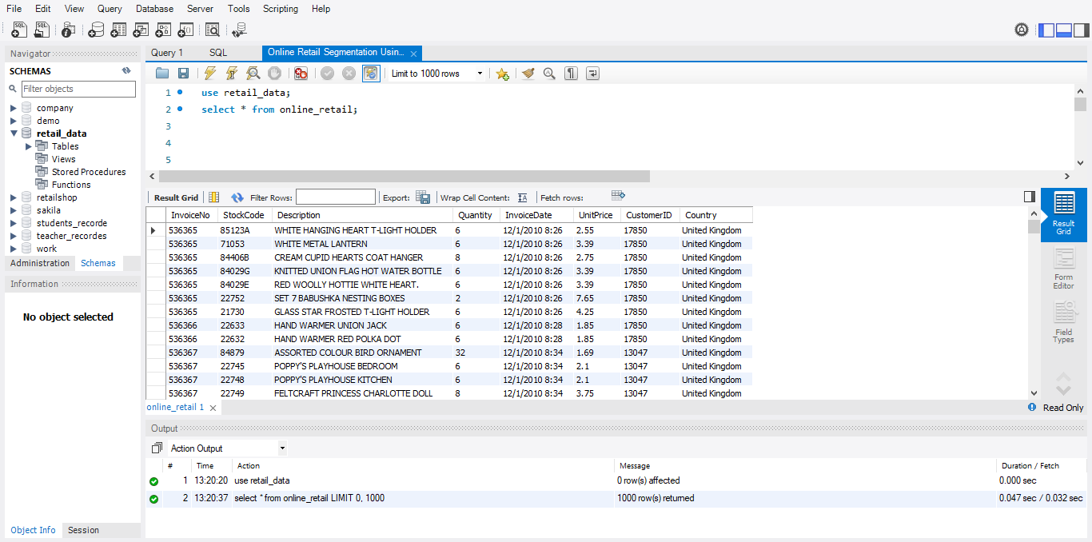

**Queries and Analysis:**

**Beginner Queries:**

**1.Distribution of Order Values Across All Customers:** This query calculates the total order value for each customer, providing insights into spending patterns.

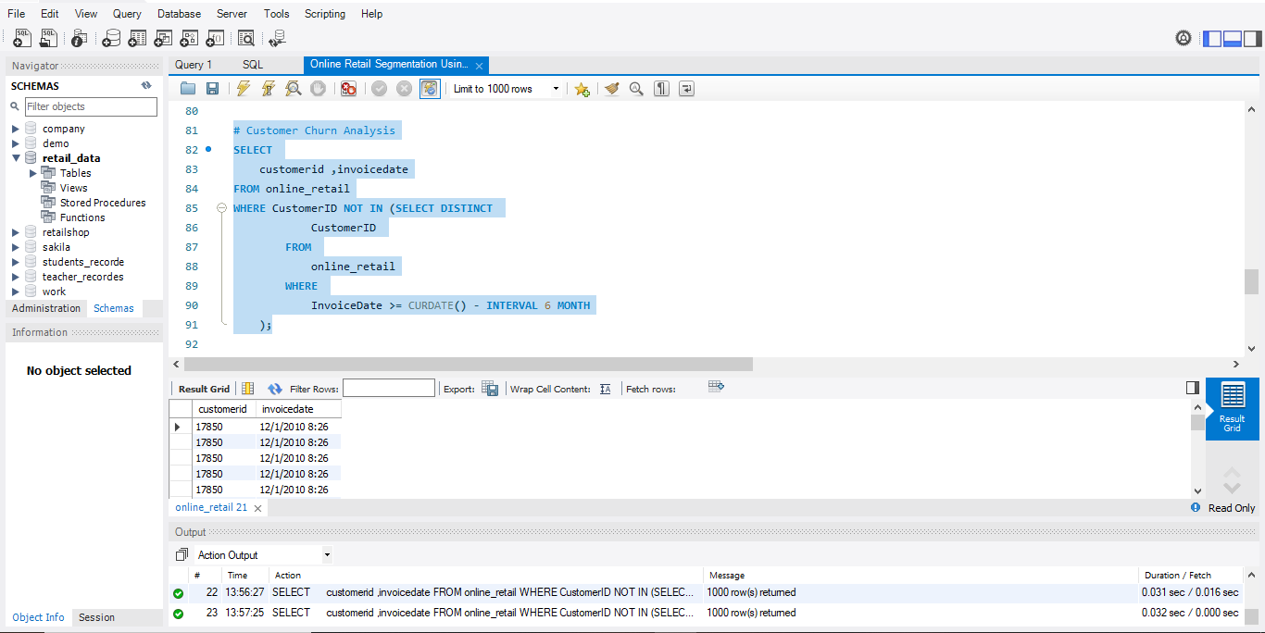

**2.Number of Unique Products Purchased by Each Customer:** This query calculates the number of unique products purchased by each customer, offering insights into product variety. 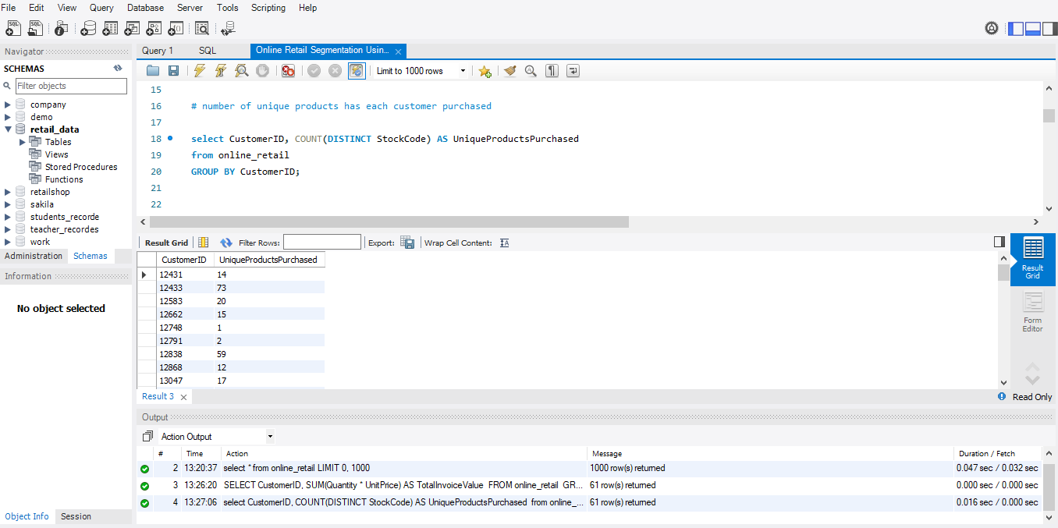

**3.Customers with Only a Single Purchase:** This query identifies customers who have made only one purchase from the

company, aiding in understanding retention. 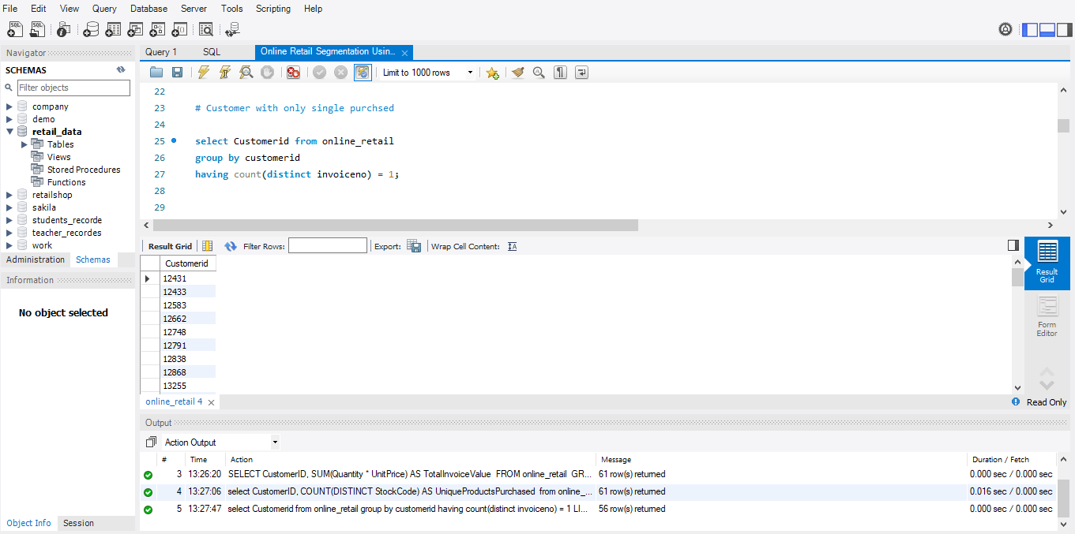

**4.Products Most Commonly Purchased Together:** This query identifies frequently purchased pairs of products, offering insights into product affinity.

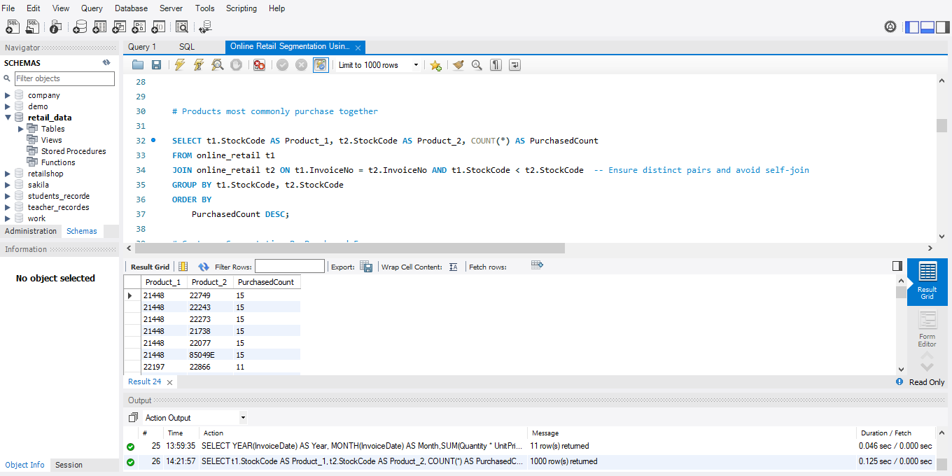

**Advanced Queries:**

**1.Customer Segmentation by Purchase Frequency:** This query segments customers into categories based on purchase frequency, identifying loyal and potentially at-risk customers. 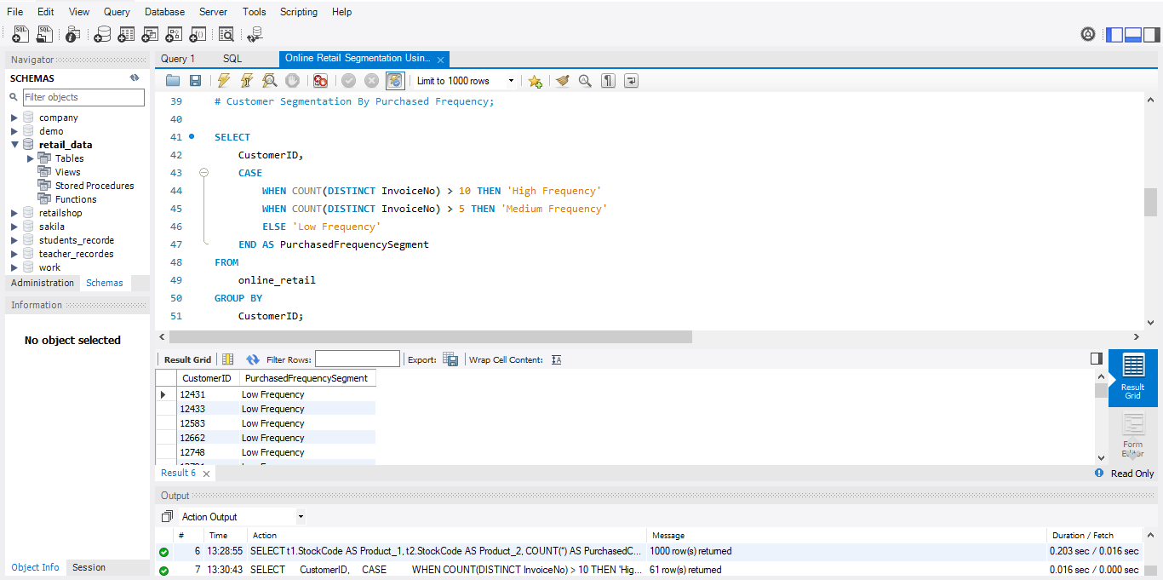

**2.Average Order Value by Country:** This query calculates the average order value for each country, highlighting valuable customer segments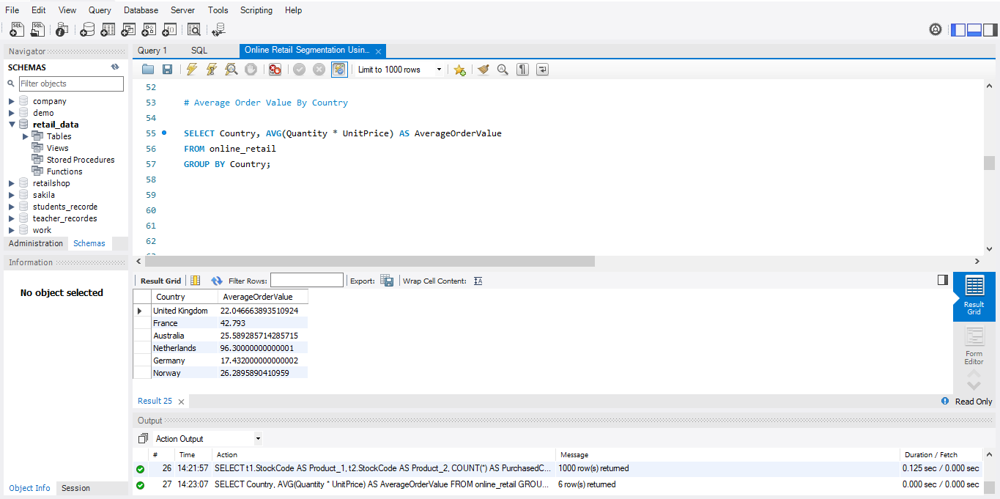.

**3.Customer Churn Analysis:** This query identifies customers who haven't made a purchase in the last 6 months, assisting in churn analysis.



**4.Product Affinity Analysis:** This query identifies pairs of products often purchased together, providing insights into product relationships. 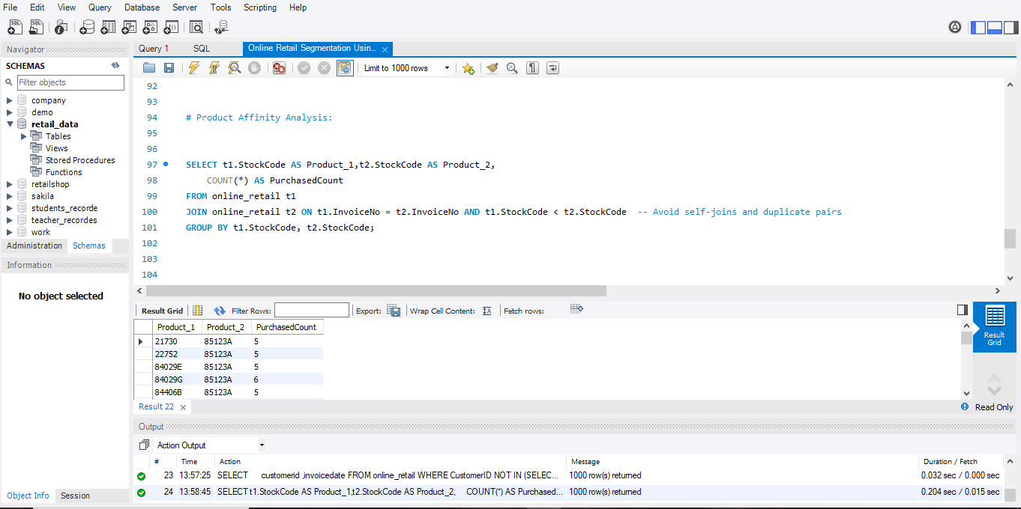

**5.Time-based Analysis:** This query explores trends in customer behavior over time by calculating monthly total sales. 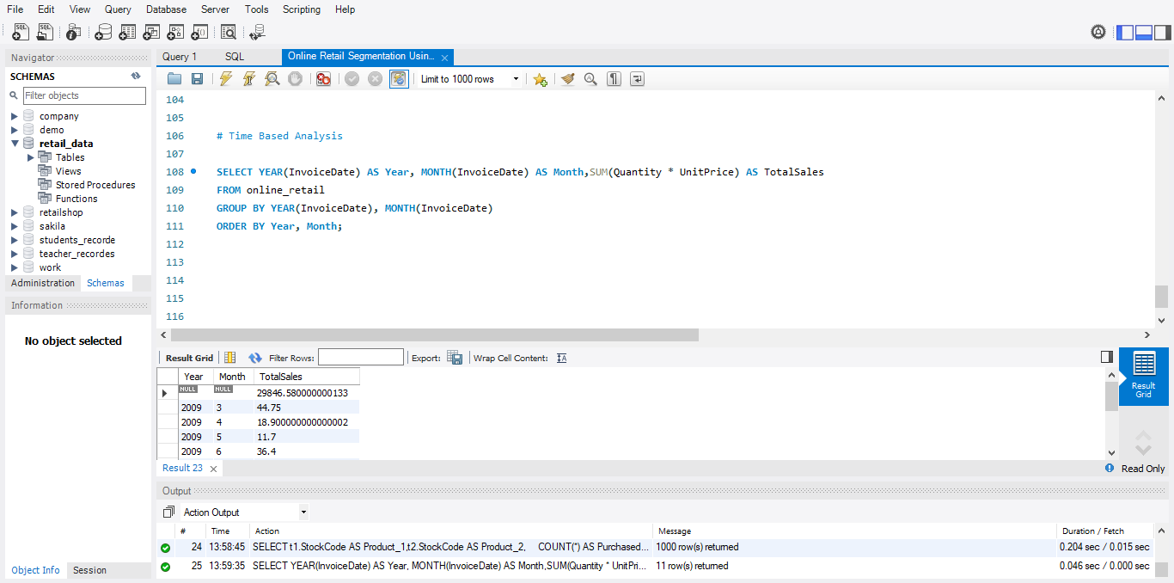

**Conclusion:**

The Online Retail Segmentation project demonstrates the power of customer segmentation for enhancing business strategies. By analyzing customer demographics, purchasing history, and interactions, organizations can tailor their approaches to engage customers more effectively. The presented queries offer a comprehensive understanding of customer behavior, product relationships, and sales patterns, all contributing to optimized marketing efforts, customer satisfaction, and overall business success.