Codebook for tidydata

Autogenerated data summary from dataMaid

2022-07-03 00:10:18

# Data report overview

The dataset examined has the following dimensions:

| Feature | Result |
| --- | --- |
| Number of observations | 180 |
| Number of variables | 81 |

# Codebook summary table

| Label | Variable | Class | # unique values | Missing | Description |
| --- | --- | --- | --- | --- | --- |
|  | **subjectID** | integer | 30 | 0.00 % |  |
|  | **activities** | character | 6 | 0.00 % |  |
|  | **Avg.of.tBodyAcc.mean.X** | numeric | 180 | 0.00 % |  |
|  | **Avg.of.tBodyAcc.mean.Y** | numeric | 180 | 0.00 % |  |
|  | **Avg.of.tBodyAcc.mean.Z** | numeric | 180 | 0.00 % |  |
|  | **Avg.of.tBodyAcc.std.deviation.X** | numeric | 180 | 0.00 % |  |
|  | **Avg.of.tBodyAcc.std.deviation.Y** | numeric | 180 | 0.00 % |  |
|  | **Avg.of.tBodyAcc.std.deviation.Z** | numeric | 180 | 0.00 % |  |
|  | **Avg.of.tGravityAcc.mean.X** | numeric | 180 | 0.00 % |  |
|  | **Avg.of.tGravityAcc.mean.Y** | numeric | 180 | 0.00 % |  |
|  | **Avg.of.tGravityAcc.mean.Z** | numeric | 180 | 0.00 % |  |
|  | **Avg.of.tGravityAcc.std.deviation.X** | numeric | 180 | 0.00 % |  |
|  | **Avg.of.tGravityAcc.std.deviation.Y** | numeric | 180 | 0.00 % |  |
|  | **Avg.of.tGravityAcc.std.deviation.Z** | numeric | 180 | 0.00 % |  |
|  | **Avg.of.tBodyAccJerk.mean.X** | numeric | 180 | 0.00 % |  |
|  | **Avg.of.tBodyAccJerk.mean.Y** | numeric | 180 | 0.00 % |  |
|  | **Avg.of.tBodyAccJerk.mean.Z** | numeric | 180 | 0.00 % |  |
|  | **Avg.of.tBodyAccJerk.std.deviation.X** | numeric | 180 | 0.00 % |  |
|  | **Avg.of.tBodyAccJerk.std.deviation.Y** | numeric | 180 | 0.00 % |  |
|  | **Avg.of.tBodyAccJerk.std.deviation.Z** | numeric | 180 | 0.00 % |  |
|  | **Avg.of.tBodyGyro.mean.X** | numeric | 180 | 0.00 % |  |
|  | **Avg.of.tBodyGyro.mean.Y** | numeric | 180 | 0.00 % |  |
|  | **Avg.of.tBodyGyro.mean.Z** | numeric | 180 | 0.00 % |  |
|  | **Avg.of.tBodyGyro.std.deviation.X** | numeric | 180 | 0.00 % |  |
|  | **Avg.of.tBodyGyro.std.deviation.Y** | numeric | 180 | 0.00 % |  |
|  | **Avg.of.tBodyGyro.std.deviation.Z** | numeric | 180 | 0.00 % |  |
|  | **Avg.of.tBodyGyroJerk.mean.X** | numeric | 180 | 0.00 % |  |
|  | **Avg.of.tBodyGyroJerk.mean.Y** | numeric | 180 | 0.00 % |  |
|  | **Avg.of.tBodyGyroJerk.mean.Z** | numeric | 180 | 0.00 % |  |
|  | **Avg.of.tBodyGyroJerk.std.deviation.X** | numeric | 180 | 0.00 % |  |
|  | **Avg.of.tBodyGyroJerk.std.deviation.Y** | numeric | 180 | 0.00 % |  |
|  | **Avg.of.tBodyGyroJerk.std.deviation.Z** | numeric | 180 | 0.00 % |  |
|  | **Avg.of.tBodyAccMag.mean** | numeric | 180 | 0.00 % |  |
|  | **Avg.of.tBodyAccMag.std.deviation** | numeric | 180 | 0.00 % |  |
|  | **Avg.of.tGravityAccMag.mean** | numeric | 180 | 0.00 % |  |
|  | **Avg.of.tGravityAccMag.std.deviation** | numeric | 180 | 0.00 % |  |
|  | **Avg.of.tBodyAccJerkMag.mean** | numeric | 180 | 0.00 % |  |
|  | **Avg.of.tBodyAccJerkMag.std.deviation** | numeric | 180 | 0.00 % |  |
|  | **Avg.of.tBodyGyroMag.mean** | numeric | 180 | 0.00 % |  |
|  | **Avg.of.tBodyGyroMag.std.deviation** | numeric | 180 | 0.00 % |  |
|  | **Avg.of.tBodyGyroJerkMag.mean** | numeric | 180 | 0.00 % |  |
|  | **Avg.of.tBodyGyroJerkMag.std.deviation** | numeric | 180 | 0.00 % |  |
|  | **Avg.of.fBodyAcc.mean.X** | numeric | 180 | 0.00 % |  |
|  | **Avg.of.fBodyAcc.mean.Y** | numeric | 180 | 0.00 % |  |
|  | **Avg.of.fBodyAcc.mean.Z** | numeric | 180 | 0.00 % |  |
|  | **Avg.of.fBodyAcc.std.deviation.X** | numeric | 180 | 0.00 % |  |
|  | **Avg.of.fBodyAcc.std.deviation.Y** | numeric | 180 | 0.00 % |  |
|  | **Avg.of.fBodyAcc.std.deviation.Z** | numeric | 180 | 0.00 % |  |
|  | **Avg.of.fBodyAcc.meanFreq…X** | numeric | 180 | 0.00 % |  |
|  | **Avg.of.fBodyAcc.meanFreq…Y** | numeric | 180 | 0.00 % |  |
|  | **Avg.of.fBodyAcc.meanFreq…Z** | numeric | 180 | 0.00 % |  |
|  | **Avg.of.fBodyAccJerk.mean.X** | numeric | 180 | 0.00 % |  |
|  | **Avg.of.fBodyAccJerk.mean.Y** | numeric | 180 | 0.00 % |  |
|  | **Avg.of.fBodyAccJerk.mean.Z** | numeric | 180 | 0.00 % |  |
|  | **Avg.of.fBodyAccJerk.std.deviation.X** | numeric | 180 | 0.00 % |  |
|  | **Avg.of.fBodyAccJerk.std.deviation.Y** | numeric | 180 | 0.00 % |  |
|  | **Avg.of.fBodyAccJerk.std.deviation.Z** | numeric | 180 | 0.00 % |  |
|  | **Avg.of.fBodyAccJerk.meanFreq…X** | numeric | 180 | 0.00 % |  |
|  | **Avg.of.fBodyAccJerk.meanFreq…Y** | numeric | 180 | 0.00 % |  |
|  | **Avg.of.fBodyAccJerk.meanFreq…Z** | numeric | 180 | 0.00 % |  |
|  | **Avg.of.fBodyGyro.mean.X** | numeric | 180 | 0.00 % |  |
|  | **Avg.of.fBodyGyro.mean.Y** | numeric | 180 | 0.00 % |  |
|  | **Avg.of.fBodyGyro.mean.Z** | numeric | 180 | 0.00 % |  |
|  | **Avg.of.fBodyGyro.std.deviation.X** | numeric | 180 | 0.00 % |  |
|  | **Avg.of.fBodyGyro.std.deviation.Y** | numeric | 180 | 0.00 % |  |
|  | **Avg.of.fBodyGyro.std.deviation.Z** | numeric | 180 | 0.00 % |  |
|  | **Avg.of.fBodyGyro.meanFreq…X** | numeric | 180 | 0.00 % |  |
|  | **Avg.of.fBodyGyro.meanFreq…Y** | numeric | 180 | 0.00 % |  |
|  | **Avg.of.fBodyGyro.meanFreq…Z** | numeric | 180 | 0.00 % |  |
|  | **Avg.of.fBodyAccMag.mean** | numeric | 180 | 0.00 % |  |
|  | **Avg.of.fBodyAccMag.std.deviation** | numeric | 180 | 0.00 % |  |
|  | **Avg.of.fBodyAccMag.meanFreq..** | numeric | 180 | 0.00 % |  |
|  | **Avg.of.fBodyBodyAccJerkMag.mean** | numeric | 180 | 0.00 % |  |
|  | **Avg.of.fBodyBodyAccJerkMag.std.deviation** | numeric | 180 | 0.00 % |  |
|  | **Avg.of.fBodyBodyAccJerkMag.meanFreq..** | numeric | 180 | 0.00 % |  |
|  | **Avg.of.fBodyBodyGyroMag.mean** | numeric | 180 | 0.00 % |  |
|  | **Avg.of.fBodyBodyGyroMag.std.deviation** | numeric | 180 | 0.00 % |  |
|  | **Avg.of.fBodyBodyGyroMag.meanFreq..** | numeric | 180 | 0.00 % |  |
|  | **Avg.of.fBodyBodyGyroJerkMag.mean** | numeric | 180 | 0.00 % |  |
|  | **Avg.of.fBodyBodyGyroJerkMag.std.deviation** | numeric | 180 | 0.00 % |  |
|  | **Avg.of.fBodyBodyGyroJerkMag.meanFreq..** | numeric | 180 | 0.00 % |  |

# Variable list

## subjectID

| Feature | Result |
| --- | --- |
| Variable type | integer |
| Number of missing obs. | 0 (0 %) |
| Number of unique values | 30 |
| Median | 15.5 |
| 1st and 3rd quartiles | 8; 23 |
| Min. and max. | 1; 30 |

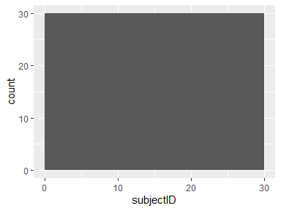

## activities

| Feature | Result |
| --- | --- |
| Variable type | character |
| Number of missing obs. | 0 (0 %) |
| Number of unique values | 6 |
| Mode | “laying” |

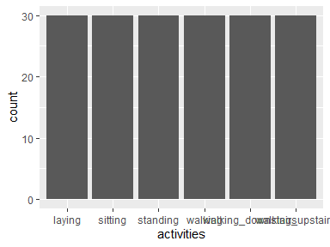

* Observed factor levels: "laying", "sitting", "standing", "walking", "walking_downstairs", "walking_upstairs".

## Avg.of.tBodyAcc.mean.X

| Feature | Result |
| --- | --- |
| Variable type | numeric |
| Number of missing obs. | 0 (0 %) |
| Number of unique values | 180 |
| Median | 0.28 |
| 1st and 3rd quartiles | 0.27; 0.28 |
| Min. and max. | 0.22; 0.3 |

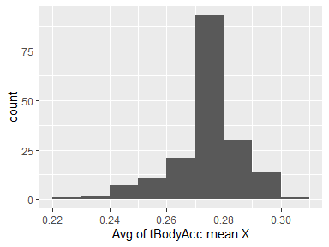

## Avg.of.tBodyAcc.mean.Y

| Feature | Result |
| --- | --- |
| Variable type | numeric |
| Number of missing obs. | 0 (0 %) |
| Number of unique values | 180 |
| Median | -0.02 |
| 1st and 3rd quartiles | -0.02; -0.01 |
| Min. and max. | -0.04; 0 |

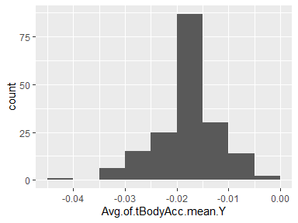

## Avg.of.tBodyAcc.mean.Z

| Feature | Result |
| --- | --- |
| Variable type | numeric |
| Number of missing obs. | 0 (0 %) |
| Number of unique values | 180 |
| Median | -0.11 |
| 1st and 3rd quartiles | -0.11; -0.1 |
| Min. and max. | -0.15; -0.08 |

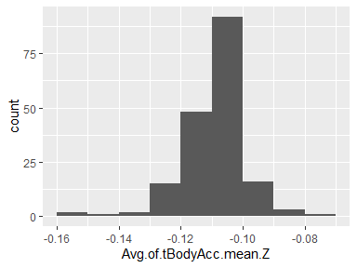

## Avg.of.tBodyAcc.std.deviation.X

| Feature | Result |
| --- | --- |
| Variable type | numeric |
| Number of missing obs. | 0 (0 %) |
| Number of unique values | 180 |
| Median | -0.75 |
| 1st and 3rd quartiles | -0.98; -0.2 |
| Min. and max. | -1; 0.63 |

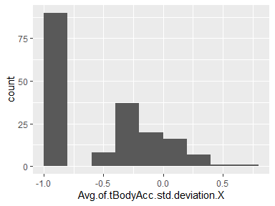

## Avg.of.tBodyAcc.std.deviation.Y

| Feature | Result |
| --- | --- |
| Variable type | numeric |
| Number of missing obs. | 0 (0 %) |
| Number of unique values | 180 |
| Median | -0.51 |
| 1st and 3rd quartiles | -0.94; -0.03 |
| Min. and max. | -0.99; 0.62 |

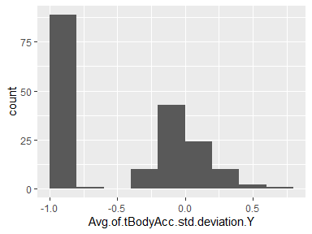

## Avg.of.tBodyAcc.std.deviation.Z

| Feature | Result |
| --- | --- |
| Variable type | numeric |
| Number of missing obs. | 0 (0 %) |
| Number of unique values | 180 |
| Median | -0.65 |
| 1st and 3rd quartiles | -0.95; -0.23 |
| Min. and max. | -0.99; 0.61 |

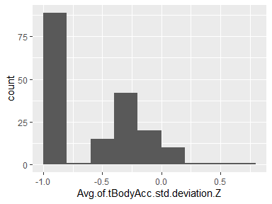

## Avg.of.tGravityAcc.mean.X

| Feature | Result |
| --- | --- |
| Variable type | numeric |
| Number of missing obs. | 0 (0 %) |
| Number of unique values | 180 |
| Median | 0.92 |
| 1st and 3rd quartiles | 0.84; 0.94 |
| Min. and max. | -0.68; 0.97 |

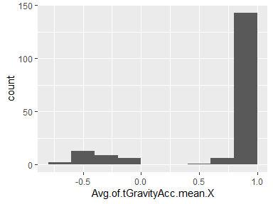

## Avg.of.tGravityAcc.mean.Y

| Feature | Result |
| --- | --- |
| Variable type | numeric |
| Number of missing obs. | 0 (0 %) |
| Number of unique values | 180 |
| Median | -0.13 |
| 1st and 3rd quartiles | -0.23; 0.09 |
| Min. and max. | -0.48; 0.96 |

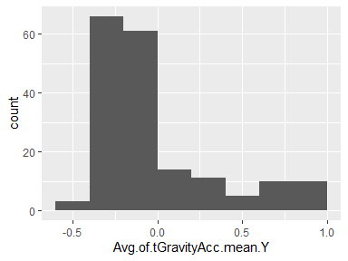

## Avg.of.tGravityAcc.mean.Z

| Feature | Result |
| --- | --- |
| Variable type | numeric |
| Number of missing obs. | 0 (0 %) |
| Number of unique values | 180 |
| Median | 0.02 |
| 1st and 3rd quartiles | -0.12; 0.15 |
| Min. and max. | -0.5; 0.96 |

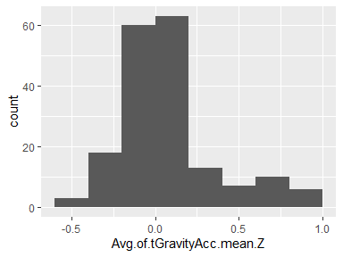

## Avg.of.tGravityAcc.std.deviation.X

| Feature | Result |
| --- | --- |
| Variable type | numeric |
| Number of missing obs. | 0 (0 %) |
| Number of unique values | 180 |
| Median | -0.97 |
| 1st and 3rd quartiles | -0.98; -0.95 |
| Min. and max. | -1; -0.83 |

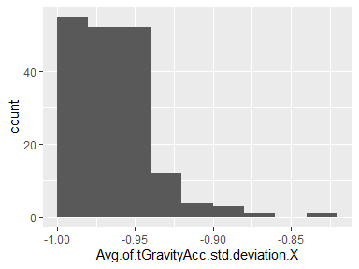

## Avg.of.tGravityAcc.std.deviation.Y

| Feature | Result |
| --- | --- |
| Variable type | numeric |
| Number of missing obs. | 0 (0 %) |
| Number of unique values | 180 |
| Median | -0.96 |
| 1st and 3rd quartiles | -0.97; -0.94 |
| Min. and max. | -0.99; -0.64 |

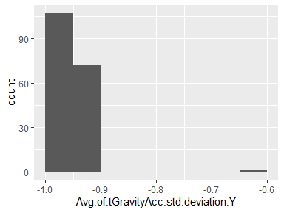

## Avg.of.tGravityAcc.std.deviation.Z

| Feature | Result |
| --- | --- |
| Variable type | numeric |
| Number of missing obs. | 0 (0 %) |
| Number of unique values | 180 |
| Median | -0.95 |
| 1st and 3rd quartiles | -0.96; -0.92 |
| Min. and max. | -0.99; -0.61 |

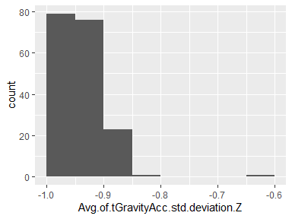

## Avg.of.tBodyAccJerk.mean.X

| Feature | Result |
| --- | --- |
| Variable type | numeric |
| Number of missing obs. | 0 (0 %) |
| Number of unique values | 180 |
| Median | 0.08 |
| 1st and 3rd quartiles | 0.07; 0.08 |
| Min. and max. | 0.04; 0.13 |

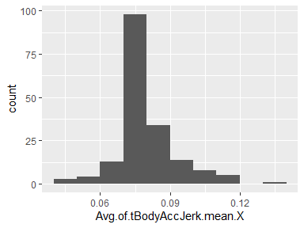

## Avg.of.tBodyAccJerk.mean.Y

| Feature | Result |
| --- | --- |
| Variable type | numeric |
| Number of missing obs. | 0 (0 %) |
| Number of unique values | 180 |
| Median | 0.01 |
| 1st and 3rd quartiles | 0; 0.01 |
| Min. and max. | -0.04; 0.06 |

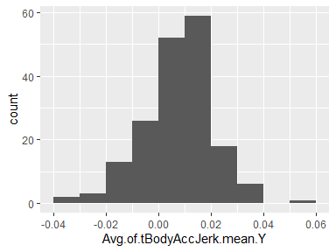

## Avg.of.tBodyAccJerk.mean.Z

| Feature | Result |
| --- | --- |
| Variable type | numeric |
| Number of missing obs. | 0 (0 %) |
| Number of unique values | 180 |
| Median | 0 |
| 1st and 3rd quartiles | -0.01; 0 |
| Min. and max. | -0.07; 0.04 |

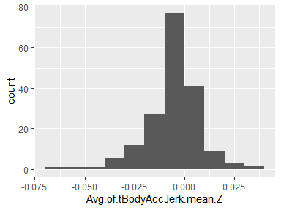

## Avg.of.tBodyAccJerk.std.deviation.X

| Feature | Result |
| --- | --- |
| Variable type | numeric |
| Number of missing obs. | 0 (0 %) |
| Number of unique values | 180 |
| Median | -0.81 |
| 1st and 3rd quartiles | -0.98; -0.22 |
| Min. and max. | -0.99; 0.54 |

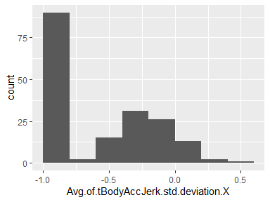

## Avg.of.tBodyAccJerk.std.deviation.Y

| Feature | Result |
| --- | --- |
| Variable type | numeric |
| Number of missing obs. | 0 (0 %) |
| Number of unique values | 180 |
| Median | -0.78 |
| 1st and 3rd quartiles | -0.97; -0.15 |
| Min. and max. | -0.99; 0.36 |

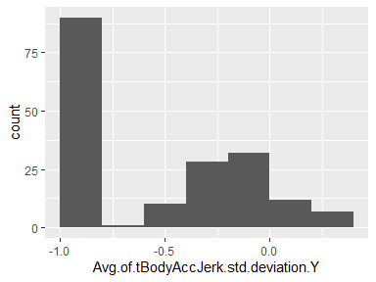

## Avg.of.tBodyAccJerk.std.deviation.Z

| Feature | Result |
| --- | --- |
| Variable type | numeric |
| Number of missing obs. | 0 (0 %) |
| Number of unique values | 180 |
| Median | -0.88 |
| 1st and 3rd quartiles | -0.98; -0.51 |
| Min. and max. | -0.99; 0.03 |

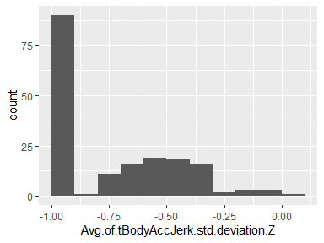

## Avg.of.tBodyGyro.mean.X

| Feature | Result |
| --- | --- |
| Variable type | numeric |
| Number of missing obs. | 0 (0 %) |
| Number of unique values | 180 |
| Median | -0.03 |
| 1st and 3rd quartiles | -0.05; -0.02 |
| Min. and max. | -0.21; 0.19 |

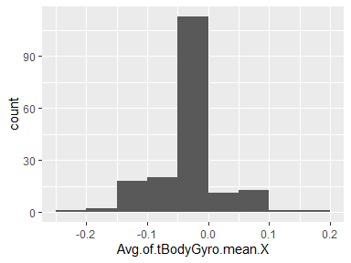

## Avg.of.tBodyGyro.mean.Y

| Feature | Result |
| --- | --- |
| Variable type | numeric |
| Number of missing obs. | 0 (0 %) |
| Number of unique values | 180 |
| Median | -0.07 |
| 1st and 3rd quartiles | -0.09; -0.06 |
| Min. and max. | -0.2; 0.03 |

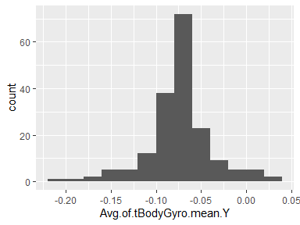

## Avg.of.tBodyGyro.mean.Z

| Feature | Result |
| --- | --- |
| Variable type | numeric |
| Number of missing obs. | 0 (0 %) |
| Number of unique values | 180 |
| Median | 0.09 |
| 1st and 3rd quartiles | 0.07; 0.1 |
| Min. and max. | -0.07; 0.18 |

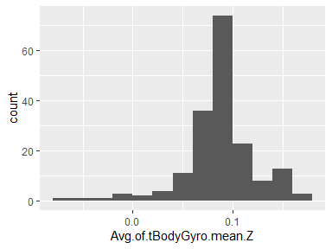

## Avg.of.tBodyGyro.std.deviation.X

| Feature | Result |
| --- | --- |
| Variable type | numeric |
| Number of missing obs. | 0 (0 %) |
| Number of unique values | 180 |
| Median | -0.79 |
| 1st and 3rd quartiles | -0.97; -0.44 |
| Min. and max. | -0.99; 0.27 |

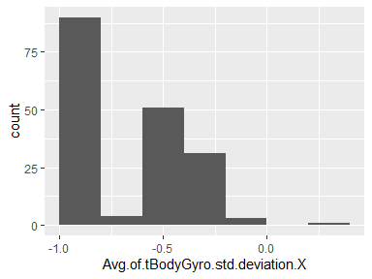

## Avg.of.tBodyGyro.std.deviation.Y

| Feature | Result |
| --- | --- |
| Variable type | numeric |
| Number of missing obs. | 0 (0 %) |
| Number of unique values | 180 |
| Median | -0.8 |
| 1st and 3rd quartiles | -0.96; -0.42 |
| Min. and max. | -0.99; 0.48 |

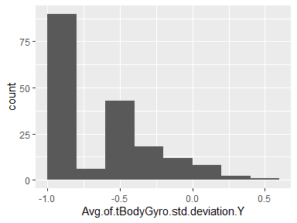

## Avg.of.tBodyGyro.std.deviation.Z

| Feature | Result |
| --- | --- |
| Variable type | numeric |
| Number of missing obs. | 0 (0 %) |
| Number of unique values | 180 |
| Median | -0.8 |
| 1st and 3rd quartiles | -0.96; -0.31 |
| Min. and max. | -0.99; 0.56 |

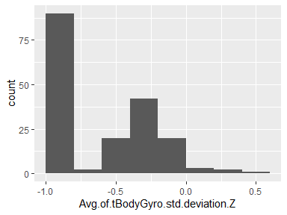

## Avg.of.tBodyGyroJerk.mean.X

| Feature | Result |
| --- | --- |
| Variable type | numeric |
| Number of missing obs. | 0 (0 %) |
| Number of unique values | 180 |
| Median | -0.1 |
| 1st and 3rd quartiles | -0.1; -0.09 |
| Min. and max. | -0.16; -0.02 |

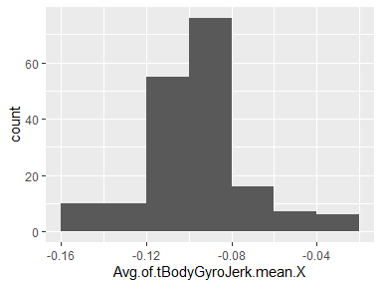

## Avg.of.tBodyGyroJerk.mean.Y

| Feature | Result |
| --- | --- |
| Variable type | numeric |
| Number of missing obs. | 0 (0 %) |
| Number of unique values | 180 |
| Median | -0.04 |
| 1st and 3rd quartiles | -0.05; -0.04 |
| Min. and max. | -0.08; -0.01 |

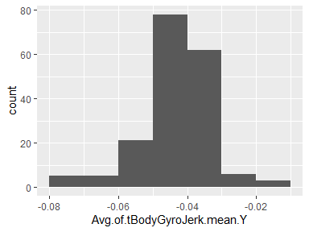

## Avg.of.tBodyGyroJerk.mean.Z

| Feature | Result |
| --- | --- |
| Variable type | numeric |
| Number of missing obs. | 0 (0 %) |
| Number of unique values | 180 |
| Median | -0.05 |
| 1st and 3rd quartiles | -0.06; -0.05 |
| Min. and max. | -0.09; -0.01 |

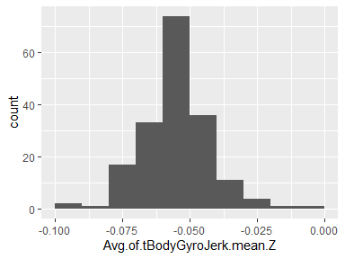

## Avg.of.tBodyGyroJerk.std.deviation.X

| Feature | Result |
| --- | --- |
| Variable type | numeric |
| Number of missing obs. | 0 (0 %) |
| Number of unique values | 180 |
| Median | -0.84 |
| 1st and 3rd quartiles | -0.98; -0.46 |
| Min. and max. | -1; 0.18 |

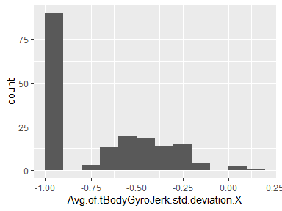

## Avg.of.tBodyGyroJerk.std.deviation.Y

| Feature | Result |
| --- | --- |
| Variable type | numeric |
| Number of missing obs. | 0 (0 %) |
| Number of unique values | 180 |
| Median | -0.89 |
| 1st and 3rd quartiles | -0.98; -0.59 |
| Min. and max. | -1; 0.3 |

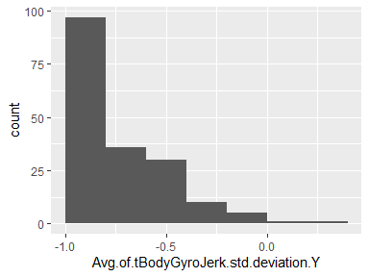

## Avg.of.tBodyGyroJerk.std.deviation.Z

| Feature | Result |
| --- | --- |
| Variable type | numeric |
| Number of missing obs. | 0 (0 %) |
| Number of unique values | 180 |
| Median | -0.86 |
| 1st and 3rd quartiles | -0.98; -0.47 |
| Min. and max. | -1; 0.19 |

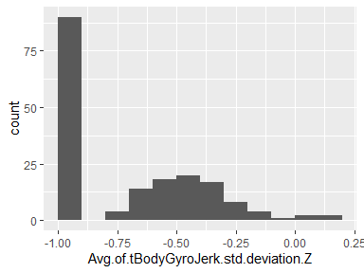

## Avg.of.tBodyAccMag.mean

| Feature | Result |
| --- | --- |
| Variable type | numeric |
| Number of missing obs. | 0 (0 %) |
| Number of unique values | 180 |
| Median | -0.48 |
| 1st and 3rd quartiles | -0.96; -0.09 |
| Min. and max. | -0.99; 0.64 |

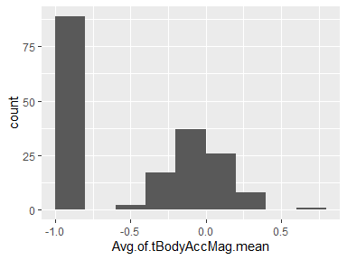

## Avg.of.tBodyAccMag.std.deviation

| Feature | Result |
| --- | --- |
| Variable type | numeric |
| Number of missing obs. | 0 (0 %) |
| Number of unique values | 180 |
| Median | -0.61 |
| 1st and 3rd quartiles | -0.94; -0.21 |
| Min. and max. | -0.99; 0.43 |

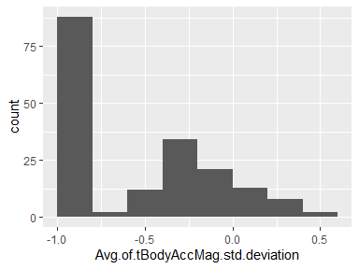

## Avg.of.tGravityAccMag.mean

| Feature | Result |
| --- | --- |
| Variable type | numeric |
| Number of missing obs. | 0 (0 %) |
| Number of unique values | 180 |
| Median | -0.48 |
| 1st and 3rd quartiles | -0.96; -0.09 |
| Min. and max. | -0.99; 0.64 |

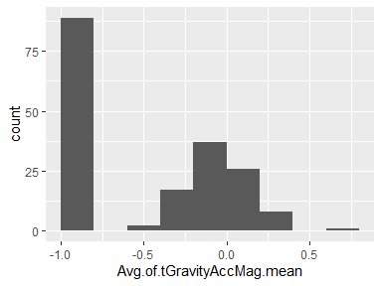

## Avg.of.tGravityAccMag.std.deviation

| Feature | Result |
| --- | --- |
| Variable type | numeric |
| Number of missing obs. | 0 (0 %) |
| Number of unique values | 180 |
| Median | -0.61 |
| 1st and 3rd quartiles | -0.94; -0.21 |
| Min. and max. | -0.99; 0.43 |

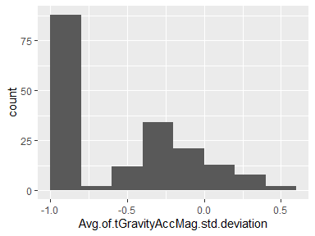

## Avg.of.tBodyAccJerkMag.mean

| Feature | Result |
| --- | --- |
| Variable type | numeric |
| Number of missing obs. | 0 (0 %) |
| Number of unique values | 180 |
| Median | -0.82 |
| 1st and 3rd quartiles | -0.98; -0.25 |
| Min. and max. | -0.99; 0.43 |

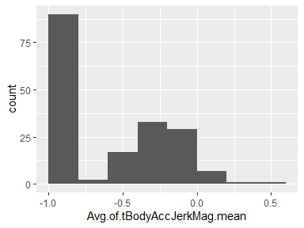

## Avg.of.tBodyAccJerkMag.std.deviation

| Feature | Result |
| --- | --- |
| Variable type | numeric |
| Number of missing obs. | 0 (0 %) |
| Number of unique values | 180 |
| Median | -0.8 |
| 1st and 3rd quartiles | -0.98; -0.22 |
| Min. and max. | -0.99; 0.45 |

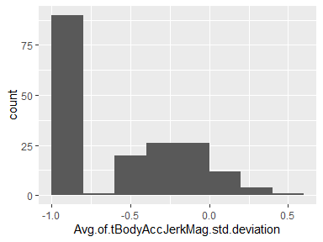

## Avg.of.tBodyGyroMag.mean

| Feature | Result |
| --- | --- |
| Variable type | numeric |
| Number of missing obs. | 0 (0 %) |
| Number of unique values | 180 |
| Median | -0.66 |
| 1st and 3rd quartiles | -0.95; -0.22 |
| Min. and max. | -0.98; 0.42 |

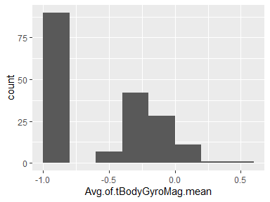

## Avg.of.tBodyGyroMag.std.deviation

| Feature | Result |
| --- | --- |
| Variable type | numeric |
| Number of missing obs. | 0 (0 %) |
| Number of unique values | 180 |
| Median | -0.74 |
| 1st and 3rd quartiles | -0.95; -0.36 |
| Min. and max. | -0.98; 0.3 |

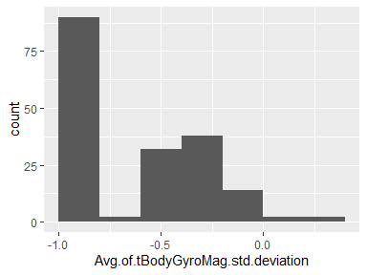

## Avg.of.tBodyGyroJerkMag.mean

| Feature | Result |
| --- | --- |
| Variable type | numeric |
| Number of missing obs. | 0 (0 %) |
| Number of unique values | 180 |
| Median | -0.86 |
| 1st and 3rd quartiles | -0.99; -0.51 |
| Min. and max. | -1; 0.09 |

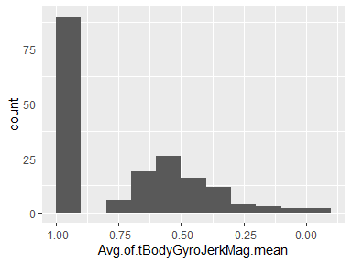

## Avg.of.tBodyGyroJerkMag.std.deviation

| Feature | Result |
| --- | --- |
| Variable type | numeric |
| Number of missing obs. | 0 (0 %) |
| Number of unique values | 180 |
| Median | -0.88 |
| 1st and 3rd quartiles | -0.98; -0.58 |
| Min. and max. | -1; 0.25 |

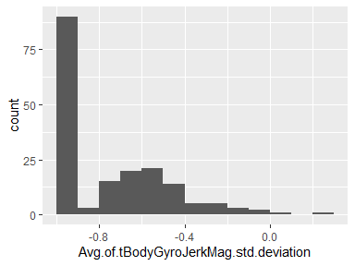

## Avg.of.fBodyAcc.mean.X

| Feature | Result |
| --- | --- |
| Variable type | numeric |
| Number of missing obs. | 0 (0 %) |
| Number of unique values | 180 |
| Median | -0.77 |
| 1st and 3rd quartiles | -0.98; -0.22 |
| Min. and max. | -1; 0.54 |

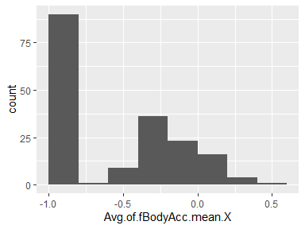

## Avg.of.fBodyAcc.mean.Y

| Feature | Result |
| --- | --- |
| Variable type | numeric |
| Number of missing obs. | 0 (0 %) |
| Number of unique values | 180 |
| Median | -0.59 |
| 1st and 3rd quartiles | -0.95; -0.06 |
| Min. and max. | -0.99; 0.52 |

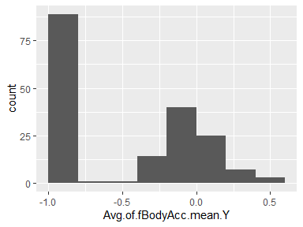

## Avg.of.fBodyAcc.mean.Z

| Feature | Result |
| --- | --- |
| Variable type | numeric |
| Number of missing obs. | 0 (0 %) |
| Number of unique values | 180 |
| Median | -0.72 |
| 1st and 3rd quartiles | -0.96; -0.32 |
| Min. and max. | -0.99; 0.28 |

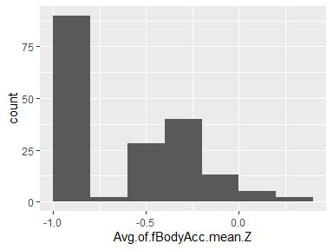

## Avg.of.fBodyAcc.std.deviation.X

| Feature | Result |
| --- | --- |
| Variable type | numeric |
| Number of missing obs. | 0 (0 %) |
| Number of unique values | 180 |
| Median | -0.75 |
| 1st and 3rd quartiles | -0.98; -0.2 |
| Min. and max. | -1; 0.66 |

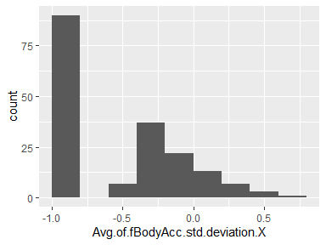

## Avg.of.fBodyAcc.std.deviation.Y

| Feature | Result |
| --- | --- |
| Variable type | numeric |
| Number of missing obs. | 0 (0 %) |
| Number of unique values | 180 |
| Median | -0.51 |
| 1st and 3rd quartiles | -0.94; -0.08 |
| Min. and max. | -0.99; 0.56 |

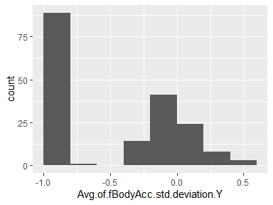

## Avg.of.fBodyAcc.std.deviation.Z

| Feature | Result |
| --- | --- |
| Variable type | numeric |
| Number of missing obs. | 0 (0 %) |
| Number of unique values | 180 |
| Median | -0.64 |
| 1st and 3rd quartiles | -0.95; -0.27 |
| Min. and max. | -0.99; 0.69 |

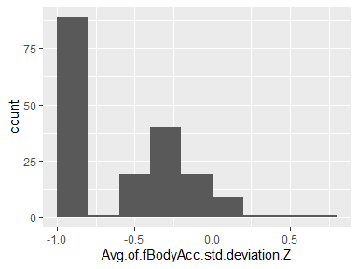

## Avg.of.fBodyAcc.meanFreq…X

| Feature | Result |
| --- | --- |
| Variable type | numeric |
| Number of missing obs. | 0 (0 %) |
| Number of unique values | 180 |
| Median | -0.26 |
| 1st and 3rd quartiles | -0.39; -0.06 |
| Min. and max. | -0.64; 0.16 |

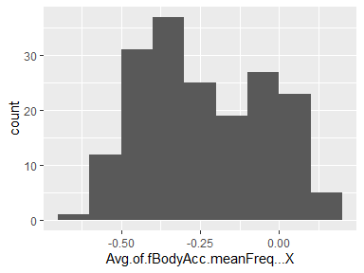

## Avg.of.fBodyAcc.meanFreq…Y

| Feature | Result |
| --- | --- |
| Variable type | numeric |
| Number of missing obs. | 0 (0 %) |
| Number of unique values | 180 |
| Median | 0.01 |
| 1st and 3rd quartiles | -0.08; 0.09 |
| Min. and max. | -0.38; 0.47 |

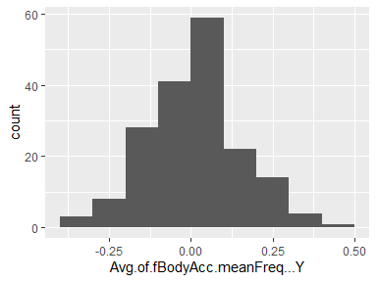

## Avg.of.fBodyAcc.meanFreq…Z

| Feature | Result |
| --- | --- |
| Variable type | numeric |
| Number of missing obs. | 0 (0 %) |
| Number of unique values | 180 |
| Median | 0.07 |
| 1st and 3rd quartiles | -0.04; 0.18 |
| Min. and max. | -0.52; 0.4 |

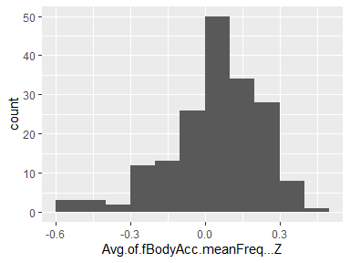

## Avg.of.fBodyAccJerk.mean.X

| Feature | Result |
| --- | --- |
| Variable type | numeric |
| Number of missing obs. | 0 (0 %) |
| Number of unique values | 180 |
| Median | -0.81 |
| 1st and 3rd quartiles | -0.98; -0.28 |
| Min. and max. | -0.99; 0.47 |

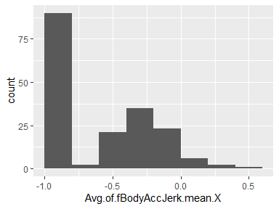

## Avg.of.fBodyAccJerk.mean.Y

| Feature | Result |
| --- | --- |
| Variable type | numeric |
| Number of missing obs. | 0 (0 %) |
| Number of unique values | 180 |
| Median | -0.78 |
| 1st and 3rd quartiles | -0.97; -0.2 |
| Min. and max. | -0.99; 0.28 |

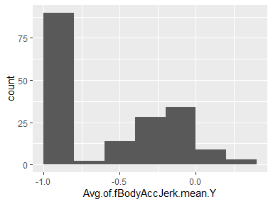

## Avg.of.fBodyAccJerk.mean.Z

| Feature | Result |
| --- | --- |
| Variable type | numeric |
| Number of missing obs. | 0 (0 %) |
| Number of unique values | 180 |
| Median | -0.87 |
| 1st and 3rd quartiles | -0.98; -0.47 |
| Min. and max. | -0.99; 0.16 |

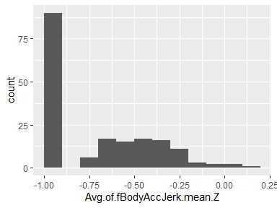

## Avg.of.fBodyAccJerk.std.deviation.X

| Feature | Result |
| --- | --- |
| Variable type | numeric |
| Number of missing obs. | 0 (0 %) |
| Number of unique values | 180 |
| Median | -0.83 |
| 1st and 3rd quartiles | -0.98; -0.25 |
| Min. and max. | -1; 0.48 |

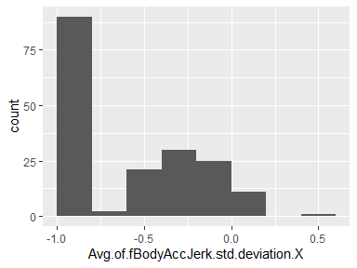

## Avg.of.fBodyAccJerk.std.deviation.Y

| Feature | Result |
| --- | --- |
| Variable type | numeric |
| Number of missing obs. | 0 (0 %) |
| Number of unique values | 180 |
| Median | -0.79 |
| 1st and 3rd quartiles | -0.97; -0.17 |
| Min. and max. | -0.99; 0.35 |

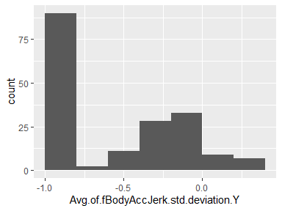

## Avg.of.fBodyAccJerk.std.deviation.Z

| Feature | Result |
| --- | --- |
| Variable type | numeric |
| Number of missing obs. | 0 (0 %) |
| Number of unique values | 180 |
| Median | -0.9 |
| 1st and 3rd quartiles | -0.98; -0.54 |
| Min. and max. | -0.99; -0.01 |

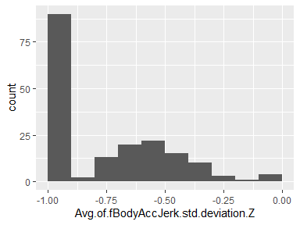

## Avg.of.fBodyAccJerk.meanFreq…X

| Feature | Result |
| --- | --- |
| Variable type | numeric |
| Number of missing obs. | 0 (0 %) |
| Number of unique values | 180 |
| Median | -0.06 |
| 1st and 3rd quartiles | -0.29; 0.18 |
| Min. and max. | -0.58; 0.33 |

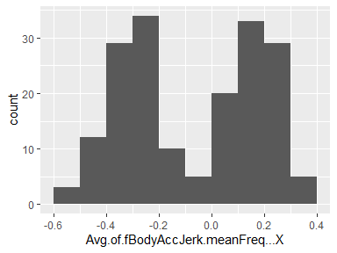

## Avg.of.fBodyAccJerk.meanFreq…Y

| Feature | Result |
| --- | --- |
| Variable type | numeric |
| Number of missing obs. | 0 (0 %) |
| Number of unique values | 180 |
| Median | -0.23 |
| 1st and 3rd quartiles | -0.4; -0.05 |
| Min. and max. | -0.6; 0.2 |

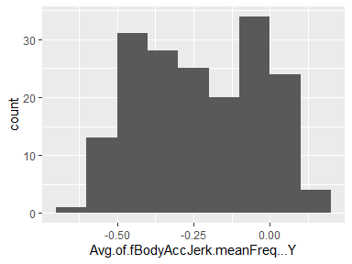

## Avg.of.fBodyAccJerk.meanFreq…Z

| Feature | Result |
| --- | --- |
| Variable type | numeric |
| Number of missing obs. | 0 (0 %) |
| Number of unique values | 180 |
| Median | -0.09 |
| 1st and 3rd quartiles | -0.31; 0.04 |
| Min. and max. | -0.63; 0.23 |

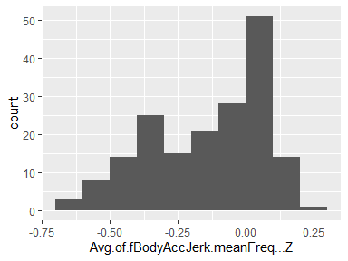

## Avg.of.fBodyGyro.mean.X

| Feature | Result |
| --- | --- |
| Variable type | numeric |
| Number of missing obs. | 0 (0 %) |
| Number of unique values | 180 |
| Median | -0.73 |
| 1st and 3rd quartiles | -0.97; -0.34 |
| Min. and max. | -0.99; 0.47 |

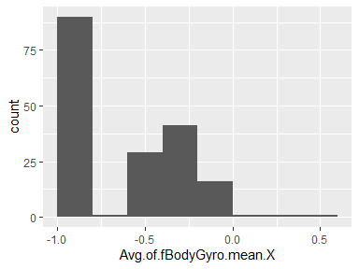

## Avg.of.fBodyGyro.mean.Y

| Feature | Result |
| --- | --- |
| Variable type | numeric |
| Number of missing obs. | 0 (0 %) |
| Number of unique values | 180 |
| Median | -0.81 |
| 1st and 3rd quartiles | -0.97; -0.45 |
| Min. and max. | -0.99; 0.33 |

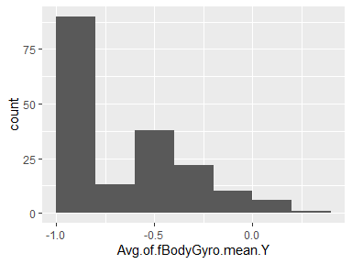

## Avg.of.fBodyGyro.mean.Z

| Feature | Result |
| --- | --- |
| Variable type | numeric |
| Number of missing obs. | 0 (0 %) |
| Number of unique values | 180 |
| Median | -0.79 |
| 1st and 3rd quartiles | -0.96; -0.26 |
| Min. and max. | -0.99; 0.49 |

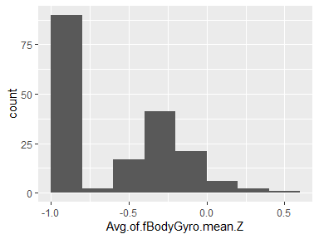

## Avg.of.fBodyGyro.std.deviation.X

| Feature | Result |
| --- | --- |
| Variable type | numeric |
| Number of missing obs. | 0 (0 %) |
| Number of unique values | 180 |
| Median | -0.81 |
| 1st and 3rd quartiles | -0.98; -0.48 |
| Min. and max. | -0.99; 0.2 |

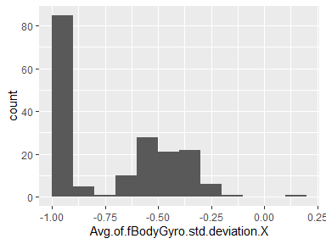

## Avg.of.fBodyGyro.std.deviation.Y

| Feature | Result |
| --- | --- |
| Variable type | numeric |
| Number of missing obs. | 0 (0 %) |
| Number of unique values | 180 |
| Median | -0.8 |
| 1st and 3rd quartiles | -0.96; -0.42 |
| Min. and max. | -0.99; 0.65 |

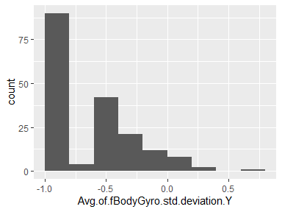

## Avg.of.fBodyGyro.std.deviation.Z

| Feature | Result |
| --- | --- |
| Variable type | numeric |
| Number of missing obs. | 0 (0 %) |
| Number of unique values | 180 |
| Median | -0.82 |
| 1st and 3rd quartiles | -0.96; -0.39 |
| Min. and max. | -0.99; 0.52 |

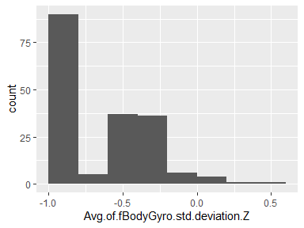

## Avg.of.fBodyGyro.meanFreq…X

| Feature | Result |
| --- | --- |
| Variable type | numeric |
| Number of missing obs. | 0 (0 %) |
| Number of unique values | 180 |
| Median | -0.12 |
| 1st and 3rd quartiles | -0.21; 0 |
| Min. and max. | -0.4; 0.25 |

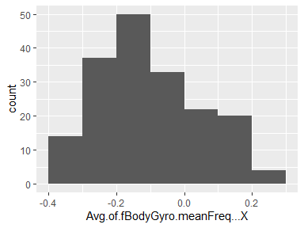

## Avg.of.fBodyGyro.meanFreq…Y

| Feature | Result |
| --- | --- |
| Variable type | numeric |
| Number of missing obs. | 0 (0 %) |
| Number of unique values | 180 |
| Median | -0.16 |
| 1st and 3rd quartiles | -0.29; -0.04 |
| Min. and max. | -0.67; 0.27 |

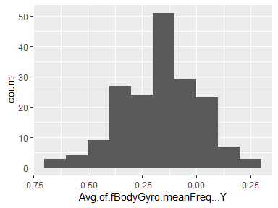

## Avg.of.fBodyGyro.meanFreq…Z

| Feature | Result |
| --- | --- |
| Variable type | numeric |
| Number of missing obs. | 0 (0 %) |
| Number of unique values | 180 |
| Median | -0.05 |
| 1st and 3rd quartiles | -0.15; 0.04 |
| Min. and max. | -0.51; 0.38 |

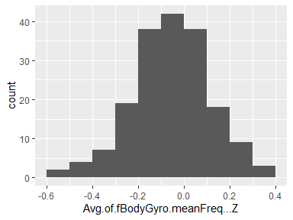

## Avg.of.fBodyAccMag.mean

| Feature | Result |
| --- | --- |
| Variable type | numeric |
| Number of missing obs. | 0 (0 %) |
| Number of unique values | 180 |
| Median | -0.67 |
| 1st and 3rd quartiles | -0.96; -0.16 |
| Min. and max. | -0.99; 0.59 |

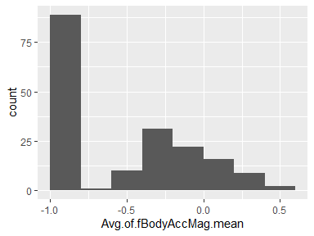

## Avg.of.fBodyAccMag.std.deviation

| Feature | Result |
| --- | --- |
| Variable type | numeric |
| Number of missing obs. | 0 (0 %) |
| Number of unique values | 180 |
| Median | -0.65 |
| 1st and 3rd quartiles | -0.95; -0.37 |
| Min. and max. | -0.99; 0.18 |

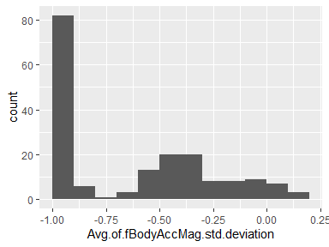

## Avg.of.fBodyAccMag.meanFreq..

| Feature | Result |
| --- | --- |
| Variable type | numeric |
| Number of missing obs. | 0 (0 %) |
| Number of unique values | 180 |
| Median | 0.08 |
| 1st and 3rd quartiles | -0.01; 0.17 |
| Min. and max. | -0.31; 0.44 |

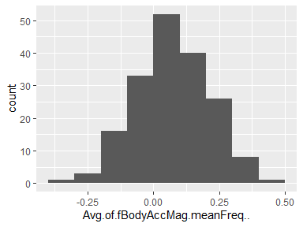

## Avg.of.fBodyBodyAccJerkMag.mean

| Feature | Result |
| --- | --- |
| Variable type | numeric |
| Number of missing obs. | 0 (0 %) |
| Number of unique values | 180 |
| Median | -0.79 |
| 1st and 3rd quartiles | -0.98; -0.19 |
| Min. and max. | -0.99; 0.54 |

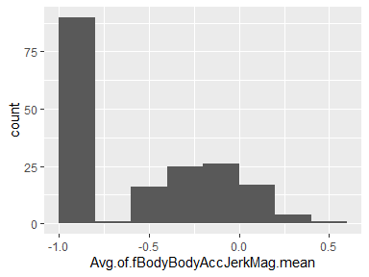

## Avg.of.fBodyBodyAccJerkMag.std.deviation

| Feature | Result |
| --- | --- |
| Variable type | numeric |
| Number of missing obs. | 0 (0 %) |
| Number of unique values | 180 |
| Median | -0.81 |
| 1st and 3rd quartiles | -0.98; -0.27 |
| Min. and max. | -0.99; 0.32 |

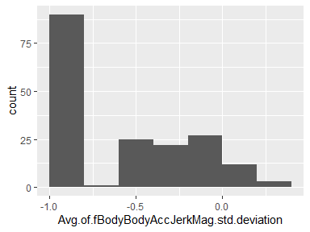

## Avg.of.fBodyBodyAccJerkMag.meanFreq..

| Feature | Result |
| --- | --- |
| Variable type | numeric |
| Number of missing obs. | 0 (0 %) |
| Number of unique values | 180 |
| Median | 0.17 |
| 1st and 3rd quartiles | 0.05; 0.28 |
| Min. and max. | -0.13; 0.49 |

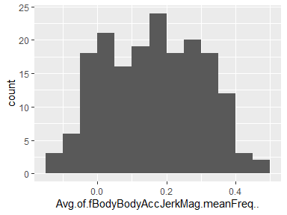

## Avg.of.fBodyBodyGyroMag.mean

| Feature | Result |
| --- | --- |
| Variable type | numeric |
| Number of missing obs. | 0 (0 %) |
| Number of unique values | 180 |
| Median | -0.77 |
| 1st and 3rd quartiles | -0.96; -0.41 |
| Min. and max. | -0.99; 0.2 |

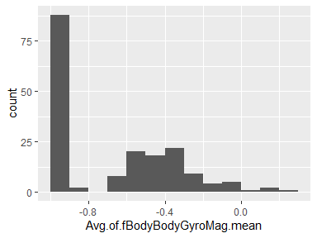

## Avg.of.fBodyBodyGyroMag.std.deviation

| Feature | Result |
| --- | --- |
| Variable type | numeric |
| Number of missing obs. | 0 (0 %) |
| Number of unique values | 180 |
| Median | -0.77 |
| 1st and 3rd quartiles | -0.95; -0.43 |
| Min. and max. | -0.98; 0.24 |

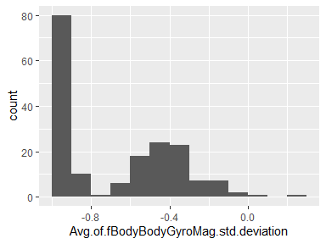

## Avg.of.fBodyBodyGyroMag.meanFreq..

| Feature | Result |
| --- | --- |
| Variable type | numeric |
| Number of missing obs. | 0 (0 %) |
| Number of unique values | 180 |
| Median | -0.05 |
| 1st and 3rd quartiles | -0.17; 0.08 |
| Min. and max. | -0.46; 0.41 |

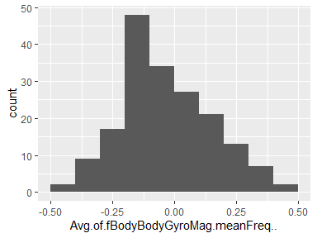

## Avg.of.fBodyBodyGyroJerkMag.mean

| Feature | Result |
| --- | --- |
| Variable type | numeric |
| Number of missing obs. | 0 (0 %) |
| Number of unique values | 180 |
| Median | -0.88 |
| 1st and 3rd quartiles | -0.98; -0.58 |
| Min. and max. | -1; 0.15 |

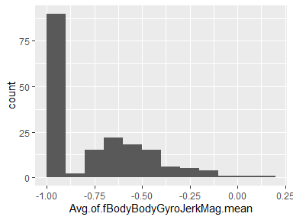

## Avg.of.fBodyBodyGyroJerkMag.std.deviation

| Feature | Result |
| --- | --- |
| Variable type | numeric |
| Number of missing obs. | 0 (0 %) |
| Number of unique values | 180 |
| Median | -0.89 |
| 1st and 3rd quartiles | -0.98; -0.61 |
| Min. and max. | -1; 0.29 |

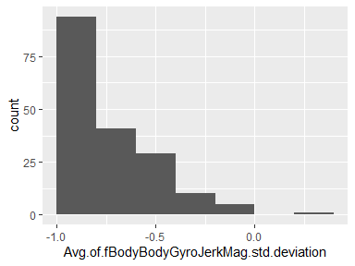

## Avg.of.fBodyBodyGyroJerkMag.meanFreq..

| Feature | Result |
| --- | --- |
| Variable type | numeric |
| Number of missing obs. | 0 (0 %) |
| Number of unique values | 180 |
| Median | 0.11 |
| 1st and 3rd quartiles | 0.05; 0.21 |
| Min. and max. | -0.18; 0.43 |

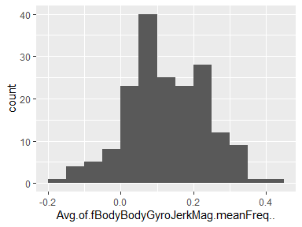

Report generation information:

* Created by: Sfarr70 (username: sfarr).
* Report creation time: Sun Jul 03 2022 00:10:22
* Report was run from directory: C:/Users/sfarr/OneDrive/Desktop/Coursera/Data Science/Getting and Cleaning Data/getdata_projectfiles_UCI HAR Dataset/UCI HAR Dataset
* dataMaid v1.4.1 [Pkg: 2021-10-08 from CRAN (R 4.2.1)]
* R version 4.2.0 (2022-04-22 ucrt).
* Platform: x86_64-w64-mingw32/x64 (64-bit)(Windows 10 x64 (build 22000)).
* Function call: dataMaid::makeDataReport(data = tidydata, mode = c("summarize", "visualize", "check"), smartNum = FALSE, file = "codebook_tidydata.Rmd", checks = list(character = "showAllFactorLevels", factor = "showAllFactorLevels", labelled = "showAllFactorLevels", haven_labelled = "showAllFactorLevels", numeric = NULL, integer = NULL, logical = NULL, Date = NULL), listChecks = FALSE, maxProbVals = Inf, codebook = TRUE, reportTitle = "Codebook for tidydata")