Employee Management System
Phase 2 Design Document: Interfaces & Polymorphism

Author: Sherika Fayson
Course: SDC 320
Date: May 24, 2026

1. Application Overview
The Employee Management System is a .NET web application that allows a company to view and manage employee records. The application organizes employee pay types, displays their personal information, and processes payroll.
Phase 2 builds on the Phase 1 foundation by introducing an interface, implementing it across all three employee types, and demonstrating polymorphism through a payroll processor service. The result is a system that is easy to read and extend, and that covers all the required object-oriented concepts for this project.

2. What Classes Will I Create?
The application is organized into the following classes and one interface. Each one has a clear, focused job — no class is doing more than it should.

Class / Interface | What It Does
Employee | The base class for all employee types. It holds the information every employee shares — ID, name, address, department, job title, email, and phone. It also defines two virtual methods that derived classes can override with their own behavior.
Address | Holds a physical mailing address (street, city, state, zip). It lives inside Employee as a property — an employee has an address. Keeping it separate makes the code cleaner and the address reusable if needed elsewhere.
HourlyEmployee | A derived class that extends Employee. It adds an hourly rate and knows how to calculate pay based on hours worked.
SalariedEmployee | A derived class that extends Employee. It adds an annual salary and calculates pay by dividing that salary into bi-weekly periods.
CommissionEmployee | A derived class that extends Employee. It adds a commission rate and a sales amount, and calculates pay as a percentage of sales.
IPayable | The interface that defines the payroll contract. Any class that implements it must provide a CalculatePay() method and a GetPaySummary() method. All three employee types implement this interface.
PayrollProcessor | Holds a list of IPayable employees and processes payroll for all of them. This is where polymorphism is demonstrated — it calls the same methods on every employee without knowing or caring which type it is dealing with.
PayrollResult | A simple model that carries one employee's payroll results to the view — name, employee type, pay summary, and pay amount.

3. What Logically Demonstrates Inheritance?

The Base Class
Employee is the base class because all employees share the same basic information categories and methods. Every employee has an ID, a name, a home address, a department, a job title, contact info, and a way to describe their pay type. It does not make sense to repeat all of that in three separate classes, so it lives in one place and the derived classes inherit it.

Shared Functionality
Every derived class gets the following from Employee automatically:
- All identity properties — EmployeeId, FirstName, LastName, Department, JobTitle, Email, Phone
- The EmployeeAddress property, which holds an Address object
- GetEmployeeType() — a virtual method each derived class overrides to return its own label
- GetPayInformation() — a virtual method each derived class overrides to describe its pay structure

The Derived Classes
There are three derived classes, one for each pay type. Each one inherits everything from Employee and adds only what is unique to that pay type:

Derived Class | What It Adds | How It Calculates Pay
HourlyEmployee | HourlyRate | Hours worked x hourly rate
SalariedEmployee | AnnualSalary | Annual salary / 26 bi-weekly periods
CommissionEmployee | CommissionRate, SalesAmount | Sales amount x (commission rate / 100)

The three derived classes receive all of the Employee properties and methods through inheritance. That is a significant amount of shared functionality that does not need to be rewritten in each class.

4. What Logically Demonstrates Composition?

Employee Has an Address
An employee has an address — they do not inherit from one. Address is embedded inside Employee as a property. This keeps the four address fields grouped together in one object and gives them a GetFullAddress() method without cluttering the Employee class with those details.

PayrollProcessor Has a List of Employees
PayrollProcessor holds a List<IPayable> as one of its properties. It does not inherit from Employee or IPayable — it just owns and operates on a collection of them. This is a has-a relationship, which is exactly what composition is.
This is also where composition and polymorphism work together. Because the list is typed as IPayable, PayrollProcessor can hold any mix of employee types and call the same methods on all of them. The processor does not need to know what type each employee is — it just calls CalculatePay() and GetPaySummary() and gets the right result for each one.

5. What Can Be Abstracted Out to an Interface?

IPayable
Pay calculation is something all three employee types can do, but they do it in completely different ways. There is no shared logic to put in a base class method — hourly, salaried, and commission pay are calculated differently from the ground up. That makes it a good candidate for an interface rather than a base class method.
IPayable defines two methods that any payroll-eligible class must implement:
- CalculatePay(decimal hoursWorked) — computes gross pay for a pay period
- GetPaySummary() — returns a readable description of how pay is calculated

It makes sense for this to be an interface because pay calculation is a capability, not an identity. It describes what an employee can do, not what an employee is. Using an interface also means that if a new pay type is added later — like a contractor or an intern — it can implement IPayable without being forced into the Employee hierarchy at all. The PayrollProcessor would pick it up automatically with no changes needed.

6. What Functionality Will Each Class Provide?
Each class has a focused responsibility:
- Employee — stores shared identity data and declares the virtual methods derived classes will override
- Address — stores address fields and formats them into a single string via GetFullAddress()
- HourlyEmployee, SalariedEmployee, CommissionEmployee — each overrides the virtual methods and implements IPayable with its own pay calculation logic
- IPayable — defines the contract: CalculatePay() and GetPaySummary()
- PayrollProcessor — processes payroll for all employees and returns the results as a list of PayrollResult objects
- PayrollResult — carries the computed data to the Razor view for display

Where Polymorphism Is Demonstrated
Polymorphism is demonstrated through the PayrollProcessor class using the IPayable interface. Different employee types are stored together in a List<IPayable>, and the same methods are called on each object. Even though the same method names are used, each employee type calculates pay differently depending on whether the employee is hourly, salaried, or commission-based.
The processor loops through the list and calls CalculatePay() and GetPaySummary() on each employee through the IPayable reference. It does not check what type each employee is. The runtime figures that out and calls the right implementation automatically. That is the core of what polymorphism is doing in this application.
The virtual methods on Employee also demonstrate polymorphism — GetEmployeeType() and GetPayInformation() are called on Employee references in the directory table, but the overridden versions in each derived class are what actually run.

7. How Do All the Classes Fit Together?
The application starts in the Razor Page model, which creates six employee objects — two of each type. Each one inherits from Employee, has an Address, and implements IPayable.
The employee list feeds the directory table in the view, where GetEmployeeType() and GetPayInformation() are called on each record. Those virtual method calls go to the correct derived class implementation without any type-checking code.
The same employee objects are also passed into a List<IPayable> and handed to PayrollProcessor. The processor calls CalculatePay() and GetPaySummary() on each one, builds a PayrollResult for each employee, and returns the full list to the view for the payroll table.
The design breaks down cleanly along three lines:
- Inheritance handles what employees are — a shared identity hierarchy under Employee
- Composition handles what employees have — an Address inside Employee, a list of employees inside PayrollProcessor
- The interface handles what employees can do — the payroll contract is separate from identity, which keeps the processor decoupled and the system easy to extend

Adding a new pay type later would only require creating a new class that extends Employee and implements IPayable. The PayrollProcessor, the view, and everything else would work without any changes.

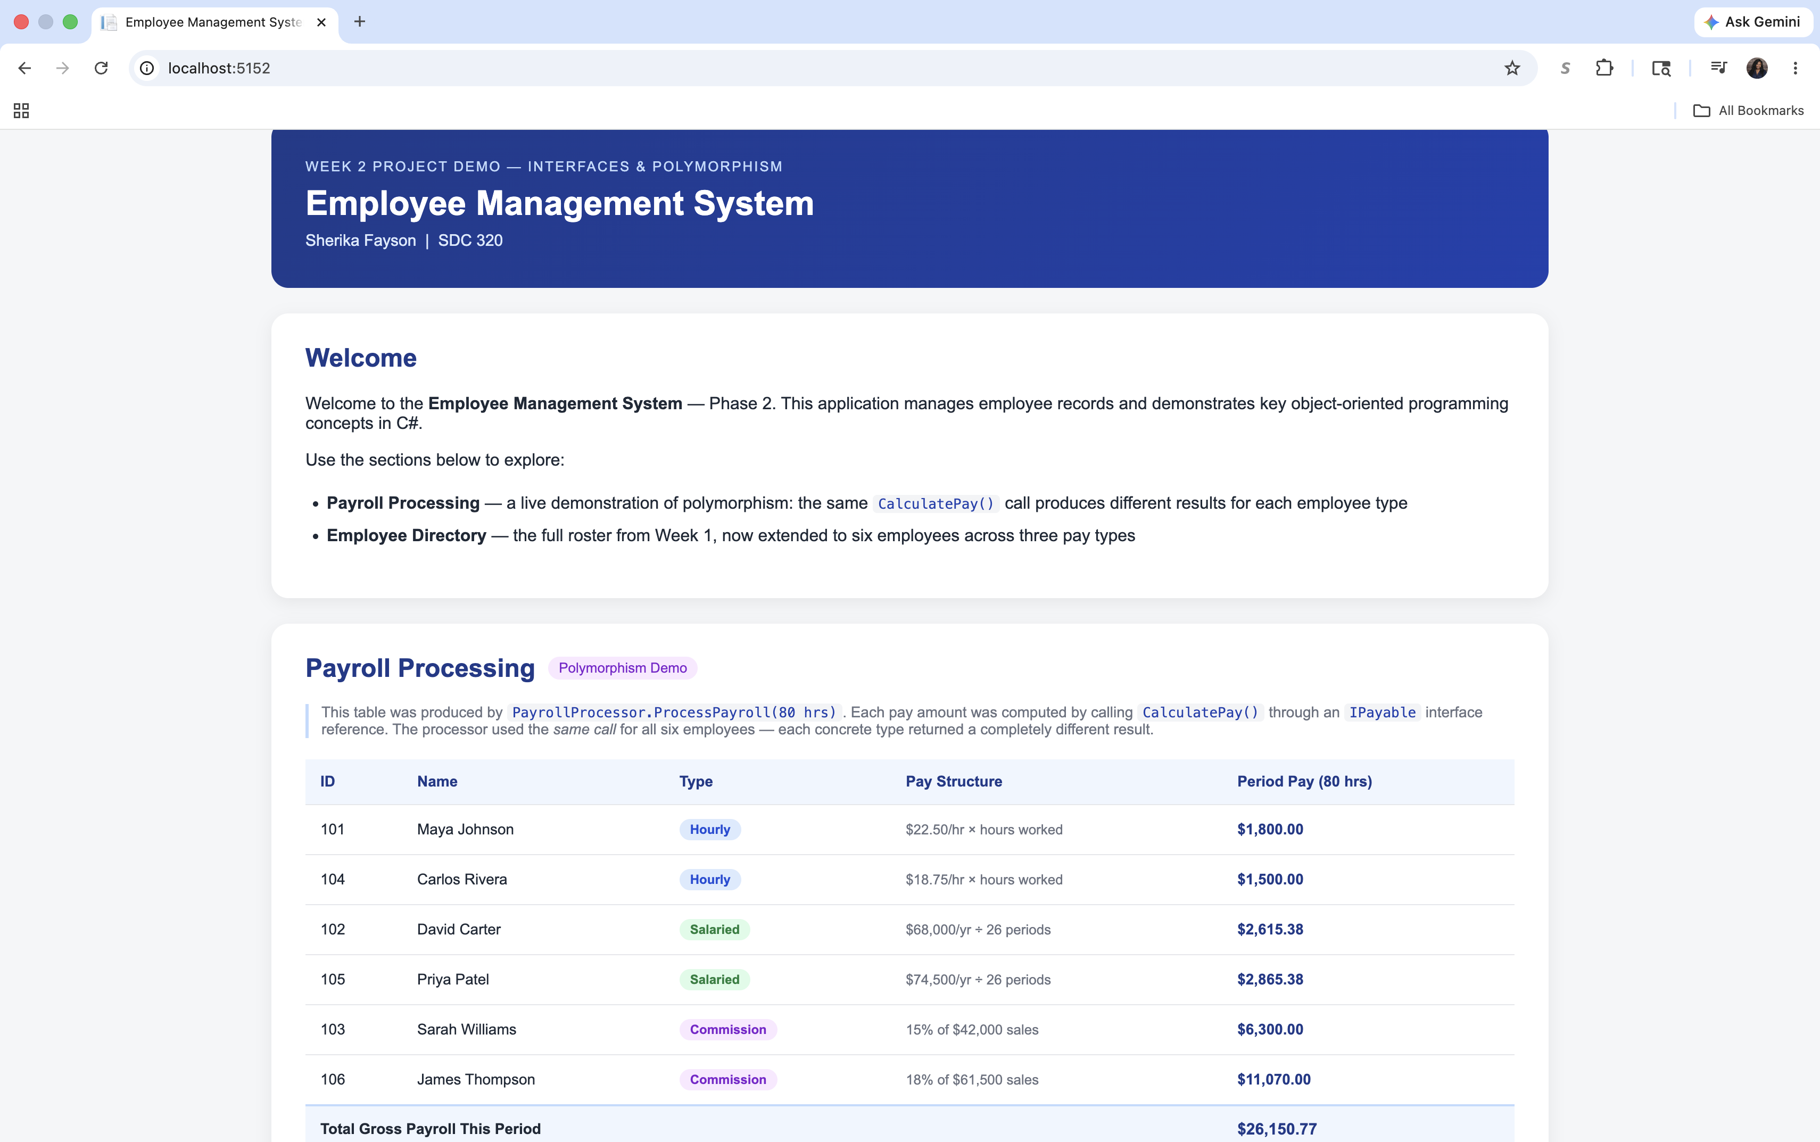
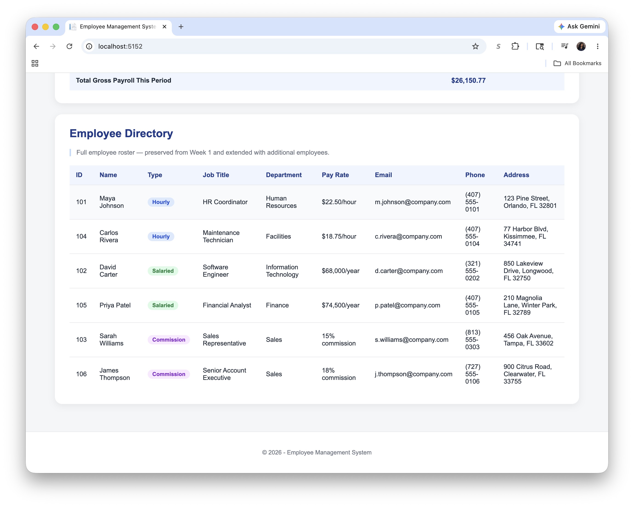
Employee Management System — Phase 2 Design Document | Sherika Fayson | SDC 320 | May 2026

