R3DMatch v4
Multi-Camera Exposure & Color Calibration
Technical Reference and User Guide

Platform | macOS · Apple Silicon · RED KOMODO-X
Camera | RED KOMODO-X 6K S35 · IPP2 / BT.709 / BT.1886
Measurement | Display-referred (IPP2) for white balance + scoring; scene-linear (REDWideGamutRGB) for exposure
Exposure accuracy | ±0.5 IRE across the array (repeatable); approaching ±0.1 IRE per camera under ideal lighting
Status | v4
This document is both a user's guide and a deep dive into the analysis and measurement methodology. It is written so a colorist or color scientist can verify, definitively, how the cameras are matched.

1. Overview

What R3DMatch v4 Does
R3DMatch v4 is an automated multi-camera exposure and color calibration system for RED KOMODO-X cinema cameras. It places a physical 18% gray sphere in frame during rehearsal, renders a reference frame per camera using REDLine, detects and measures the sphere automatically, then computes per-camera exposure and white-balance corrections. Those values are pushed live to the cameras via RCP2 WebSocket, so when principal photography begins every camera in the array is matched before a single frame of media is recorded.

What changed in v4
- Scene-linear exposure solve. Exposure is now solved in scene-linear (REDWideGamutRGB), not display IRE. A scene-linear stop maps exactly to exposureAdjust, so cameras converge onto the target instead of undershooting. This is the single largest accuracy improvement (Section 5.1).
- Shadow-side solver (shadow_specular gate). The gate stack now explicitly distinguishes a 3D convex sphere from a flat gray object using the shadow terminator, with a second pass (gating-2) that rescues evenly-lit spheres without admitting flats (Section 3.6).
- Robust 3-pass detection priority. Cold detection first, then gating-2, then a last-resort prior back-check. The solved prior is no longer a leading feature and is never blended into a real detection (Section 3.1).
- Exposure-only mode. Matches exposure alone and omits all white-balance metrics, charts and tint from the report — for when only luminance alignment is required.
- Array Coherence report page. A before/after contact sheet of the whole array, so coherence is read by eye, alongside the per-camera metrics.

Problem Solved
Multi-camera arrays of RED KOMODO-X bodies exhibit consistent inter-camera variance in exposure and white balance (up to ~200K color-temperature spread). Without calibration, matching footage in post requires manual per-clip grading. R3DMatch computes commit values (exposureAdjust, kelvin, tint) that bring all cameras to a common exposure target and white-balance model before recording.

Key Outputs
Output | Description
Exposure adjustment | Per-camera stop offset (scene-linear solve) applied before recording
Kelvin / tint | Per-camera white-balance commit pushed live via RCP2 (omitted in Exposure-only)
Corrected renders | Closed-loop verification TIFFs rendered with applied commits — match % is measured, not estimated
Sphere profile | Persistent record of sphere position across sessions (last-resort prior only)
HTML report | Overview, IRE-convergence chart, before/after Array Coherence contact sheet, per-camera pages

System Architecture
R3DMatch v4 is a native macOS desktop application built on PySide6. All camera interaction is via the REDLine command-line renderer and RCP2 WebSocket. The analysis pipeline is pure Python with NumPy, scikit-image, OpenCV and SciPy.
Layer | Technology
Desktop UI | PySide6 (Qt 6) — Ingest · Analyze · Assist · Match · Push, plus Cameras/Settings
Analysis pipeline | Python — workflow.py orchestrates render → detect → measure → solve → verify
Sphere detection | cv2 HOUGH_GRADIENT_ALT (primary) + scikit-image LoG/Hough fallback; gate pipeline + gating-2
BRDF scoring | Custom Lambertian radial-profile gate (brdf_gate.py)
Camera rendering | REDLine CLI — no RED SDK dependency
Camera communication | RCP2 WebSocket — push commits live before recording
Measurement math | BT.709 luma, log2-median IRE (display); 16-bit scene-linear center for exposure

2. User's Guide

Workflow Overview
A complete calibration session follows these steps:
- Place the 18% gray sphere in frame so it is visible to all cameras simultaneously, at talent face height in scene lighting.
- Capture a single-frame R3D per camera at the intended display transform (IPP2 Medium / Medium), cameras at their designated T-stops / ISO / shutter / Kelvin.
- Launch R3DMatch and select the footage folder on the Ingest screen; choose the matching strategy, delivery look, and white-balance mode (or Exposure only).
- Run Analyze — the pipeline renders (display + scene-linear), detects, measures, solves, and writes commits.
- Review on the Assist screen — a thumbnail grid of every camera; click any camera to open the large solver and confirm or place a sphere.
- Push commits live to the cameras on the Push screen before recording begins.

Screen Reference

Ingest
Select the input folder of R3D clips (scanned recursively). Choose the Matching Strategy (Median is the robust default), the Delivery Look the operator-facing match % is scored through, and the White Balance mode. A sphere profile from previous sessions is loaded automatically if one exists.

White Balance modes
Mode | Behavior
Match at scene temp (recommended) | Per-camera Kelvin trims match warm/cool to the group; per-camera tint matches green/magenta. Array stays at the as-shot scene Kelvin.
Match — shared Kelvin (v3 legacy) | One shared Kelvin for all cameras; only green/magenta corrected via tint. Kept for regression parity.
Match to neutral | Per-camera Kelvin + tint driven toward absolute neutral (WC=0, GM=0). Average shifts off scene temp. Special-case.
Exposure only | White balance untouched — no Kelvin/tint solved or pushed; report omits all WB. Only exposureAdjust commits.

Analyze
Displays real-time pipeline progress. Each camera cycles Render → Detect → Measure → Complete (or Failed). The solve step now reports the exposure space used — for example, “Target: 22.6 IRE — scene-linear” (or “DISPLAY fallback” if a scene-linear measurement is unavailable). Analysis runs on a background thread.

Assist
A full-width thumbnail grid of every camera, each frame shown with its sphere overlay and status edge (green = Auto OK, amber = Needs Assist, red = Failed). Click any thumbnail to open the large solver for that camera; drag to move the sphere, use the slider to resize, and Accept / Apply Adjustment / Exclude. Prev / Next cycle through the array without returning to the grid. The editor always presents a usable, on-image circle even if a detection returned a bad ROI.

Match
Per-camera corrections and the array-level charts: IRE convergence (raw vs corrected against the target, ±0.5 IRE acceptance band), exposure spread, and the before/after Array Coherence contact sheet.

Push
Connects to each camera's RCP2 WebSocket (port 9998) and writes kelvin → tint → exposureAdjust in that order. In Exposure-only runs, only exposureAdjust is written. Commits are written to camera metadata and affect all subsequent recording on that body until changed.

Sphere Placement Guidelines
Parameter | Recommendation
Distance from cameras | 12–15 ft (sphere r/w ≈ 0.019–0.058 at 6K 16:9)
Position in frame | Avoid frame edges — a partial sphere prevents circular detection
Background | Any background; dark backgrounds produce a stronger detection signal
Lighting | 5600K daylight or tungsten — the system is color-temperature agnostic
Sphere material | 18% neutral gray — non-metallic, matte, no specular coating
Sphere size | Minimum 8-inch diameter recommended at 15 ft on a 6K sensor

Manual Override
When automatic detection fails or is flagged NEEDS_ASSIST, the operator places the sphere manually in the Assist solver: drag to reposition the mask center, use the radius slider to resize, and Accept to confirm. The result is marked manual_operator, included in the re-solve, and written to the sphere profile. The re-solve recomputes the scene-linear measurement at the new ROI, so manual edits never drop the array out of the scene-linear exposure solve.

3. Sphere Detection — Algorithm

3.1 Detection Priority (3-pass)
Detection runs on a single rendered TIFF per camera, downscaled to 1080px on the long edge; coordinate math is done in detection-plane space and scaled back to full resolution for measurement. v4 applies a strict three-pass priority so the solved prior is only ever a last resort:
- Pass 1 — cold detection. Candidate generation (ALT, or skimage fallback) feeds the full gate stack at strict thresholds. No prior of any kind influences the result.
- Pass 2 — gating-2. If Pass 1 fails SOLELY at the shadow_specular gate and the candidate came from the clean ALT stream, the shadow gate is re-checked at a looser bound. This rescues evenly-lit spheres (Section 3.6).
- Pass 3 — prior back-check. Only if Pass 1+2 return FAILED or NEEDS_ASSIST is the stored sphere ROI validated. The prior is never blended into a real detection — a field user shooting a clip once gains nothing from it; it earns its keep only in repeat-calibration of the same setup.
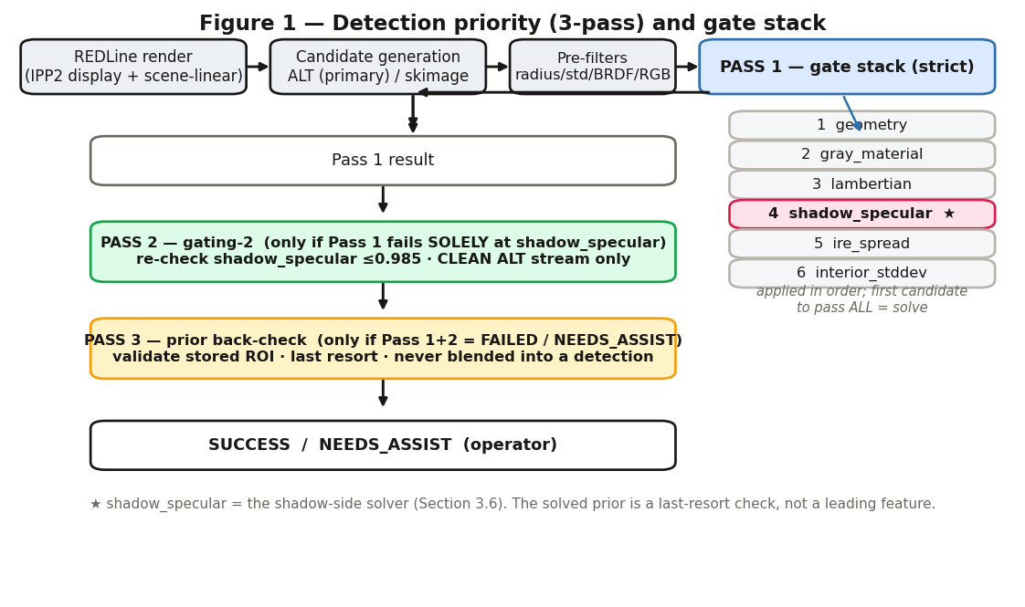
Figure 1 — Detection priority (3-pass) and the gate stack. shadow_specular (★) is the shadow-side solver detailed in Section 3.6.

3.2 Candidate Sources
Two algorithms produce candidates; the primary is gradient-constrained Hough, with a fallback for low-contrast scenes.

HOUGH_GRADIENT_ALT (primary)
cv2 HOUGH_GRADIENT_ALT only lets an edge pixel vote when its gradient direction agrees with the proposed center, so arc fragments from tape, markers and rig hardware are rejected at the source. In studio scenes it typically returns a single candidate — the ball. Because ALT proposes essentially no flat-object candidates, it is also what makes gating-2 (Section 3.6) safe.

scikit-image fallback (Hough + LoG)
When ALT returns nothing — low-contrast scenes such as gray sphere on gray backdrop — the standard scikit-image Hough transform runs; Laplacian-of-Gaussian blobs are added when Hough saturates (>200 peaks). LoG operates on intensity blobs rather than edge arcs, immune to tape-corner phantoms. The two methods are complementary, not competing.
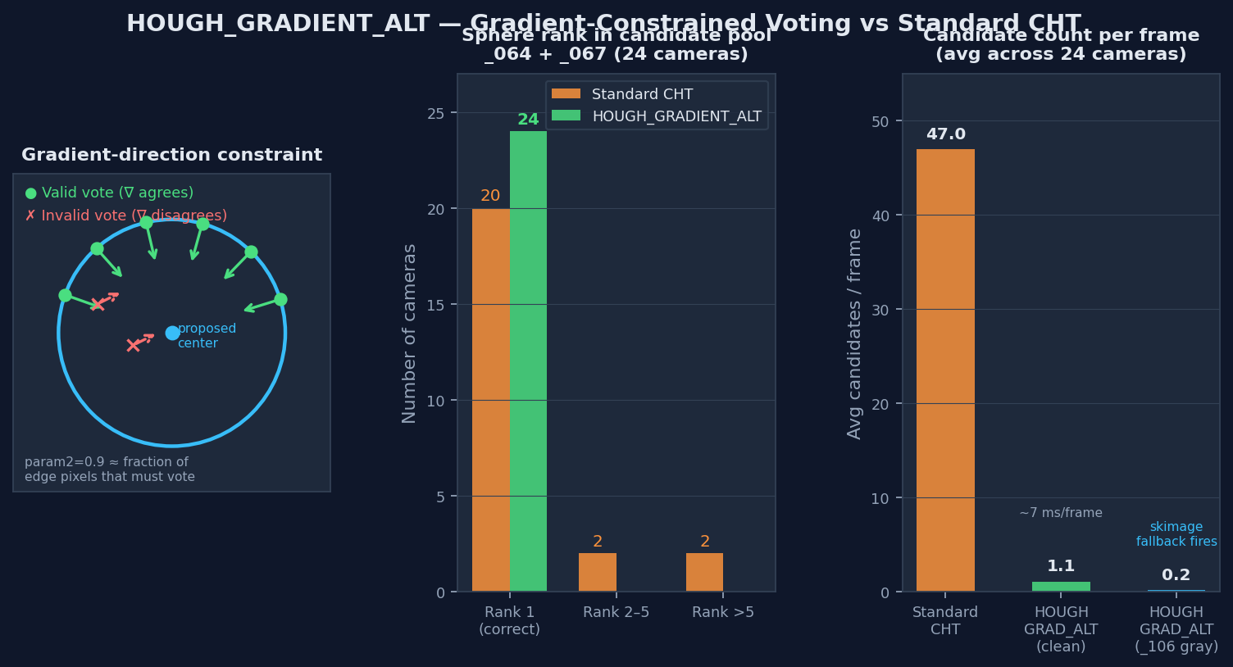
Figure 4 — HOUGH_GRADIENT_ALT vs standard CHT: gradient-direction constraint, sphere rank across 24 cameras, and average candidate count per frame by method.

3.3 Pre-Filter Gates
Fast numerical filters applied to every candidate before the gate pipeline: a radius floor (r/w ≥ 0.018, just below the smallest confirmed sphere), a scene-adaptive interior-std band with a BRDF fallback, an std floor, and an RGB-ratio neutrality check.
Condition | Action
std ≤ 0.020 | Pass (clean scene — gray backdrop, controlled lighting)
0.020 < std ≤ 0.130 | Require BRDF score ≥ 0.28 to pass (dramatic-lighting fallback)
std > 0.130 | Reject unconditionally (nothing legitimate exceeds this)

3.4 BRDF Confidence Score
The BRDF gate measures how well a candidate's luminance field matches the Lambertian reflectance model for a sphere under a single dominant light. It is the most physically specific pre-filter — only a convex Lambertian surface produces the center-bright radial falloff it measures. The display TIFF is inverted to scene-linear (display^2.4) first; the specular peak infers the light direction; 16 radial spokes are scored by Pearson correlation against the predicted Lambertian dot product, with a trimmed mean over spokes. BRDF is reliable only at larger radii (r/w ≥ ~0.030), which is exactly where the fallback path activates.
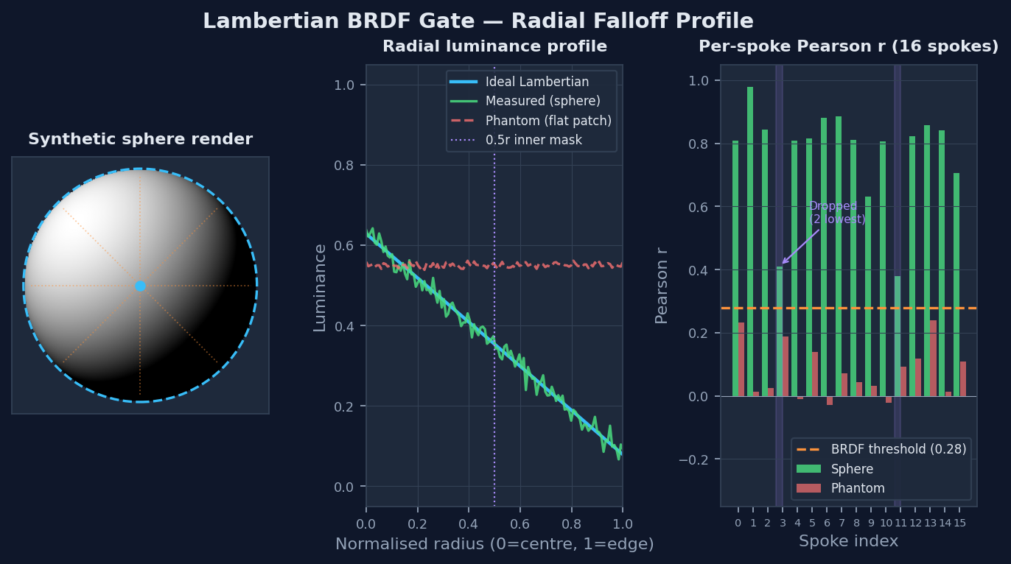
Figure 2 — Lambertian BRDF gate: synthetic sphere with radial spokes, ideal vs measured falloff, and per-spoke Pearson r for sphere vs flat phantom.

3.5 Gate Pipeline
Every candidate surviving the pre-filters runs the gate pipeline; all gates must pass for the candidate to be accepted. v4 inserts the shadow_specular gate (4) between Lambertian and IRE spread.
Gate | Test | Rationale
1 — Geometry | r/w 0.02–0.15 | Exclude objects too small (noise) or too large (walls, backdrops)
2 — Gray material | Chromaticity distance from achromatic within band | Gray sphere is near (1/3, 1/3) in normalized R/G
3 — Lambertian | Radial luminance decreases center→edge within tolerance | Flat objects have non-radial luminance profiles
4 — Shadow / Specular | shadow_ratio ≤ 0.96 (Section 3.6) | A 3D sphere under directional light has a shadow terminator; a flat card does not
5 — IRE spread | Bright/dark zone difference ≥ 0.8 IRE | Sphere has lit and shadow sides; flat patches do not
6 — Interior stddev | 0.003–0.170 | Too uniform = flat patch; too varied = textured object
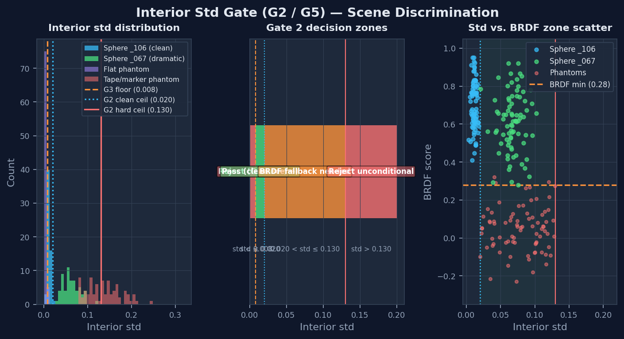
Figure 3 — Interior std gate: observed std distributions (clean, dramatic, flat, tape/marker), the three-zone decision, and the std×BRDF discrimination in the fallback band.

3.6 The Shadow-Side Solver (shadow_specular gate)
This is the gate that proves a candidate is a three-dimensional sphere rather than a flat gray object — a focus chart, a gray card, or a patch of neutral backdrop — that would otherwise pass the gray-material and Lambertian gates. It is the gate a color scientist should scrutinize most, because it is the physical discriminator of “this is the sphere.”

Principle
A real 18% gray sphere lit by a dominant key has a bright side and a dark side joined by a shadow terminator. A flat surface, however neutral, does not — its luminance is governed by the surface normal, which is constant. The gate quantifies this with the shadow ratio.

Metric
The brightest pixel inside the interior gives the bright direction. The interior is split into two halves along the axis from the center toward that peak, and:
shadow_ratio = dark_half_mean_luminance / bright_half_mean_luminance
A directionally-lit sphere reads shadow_ratio well below 1.0 (the dark half is meaningfully dimmer); a flat surface reads near 1.0 (both halves are nearly equal). A specular metric, peak_excess (peak luminance / interior mean), is also computed but is diagnostic only — its range overlaps between spheres and bright clutter, so it is not part of the pass/fail decision.

Threshold and calibration
Pass 1 accepts shadow_ratio ≤ 0.96. Calibrated across the footage sets:
- Sphere population (directional light): shadow_ratio 0.729–0.954.
- Flat chart / card population: shadow_ratio 0.862–1.018.
The 0.96 cutoff rejects flat charts while passing every directionally-lit sphere observed. peak_excess was demoted to diagnostic after live validation showed legitimate spheres below the old specular threshold.

The well-lit-sphere problem
An evenly or softly lit sphere loses its shadow terminator: both halves read nearly the same, so shadow_ratio climbs to ~0.97–0.98 — just above 0.96 — and Pass 1 rejects it. This is a true false-reject driven by good lighting, not a detection error. The corrected camera is otherwise a perfect sphere; it simply has no dark side to measure.

Gating-2 — the second pass
v4 resolves this with a guarded second pass. When a candidate fails Pass 1 SOLELY at shadow_specular, the gate is re-checked at a looser bound (shadow_ratio ≤ 0.985) — but only when the candidate came from the clean ALT stream. This is the key safety property: ALT's gradient-direction constraint does not propose flat charts as candidates in the first place, so loosening the shadow threshold on the ALT stream rescues well-lit spheres without admitting flats. If ALT had to fall back to the noisy skimage path (cluttered or low-contrast scene), gating-2 is skipped entirely.
This was validated on the F5.6 set before it was trusted: across all 12 cameras, ALT proposed exactly one candidate each — the ball — and zero flat objects; the only gate-failing candidates were the two genuinely well-lit spheres, which gating-2 correctly rescued. A flat 2D chart, lacking convexity, cannot pass even the loosened threshold because its shadow_ratio sits at the flat-population top of the range.
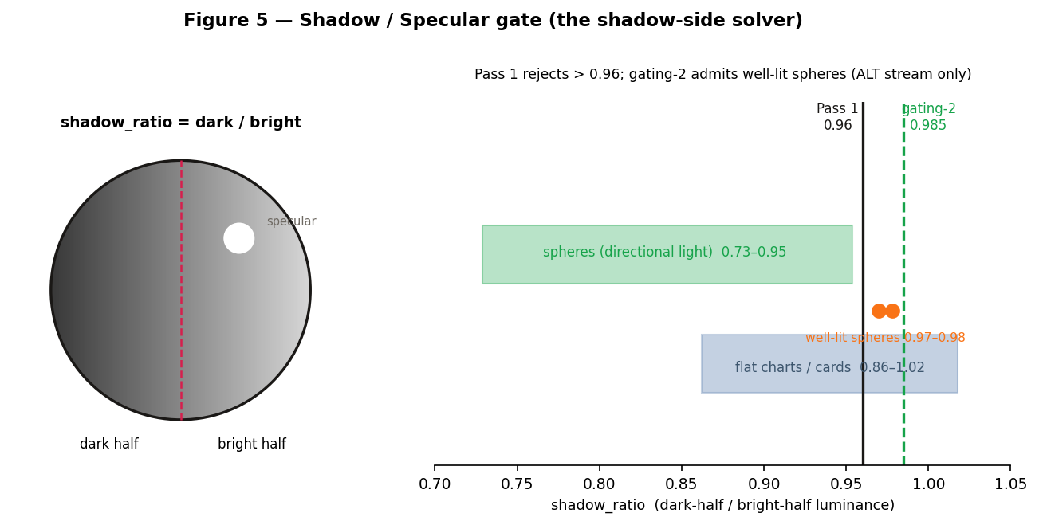
Figure 5 — Shadow / Specular gate. Left: a sphere's bright/dark halves and terminator. Right: shadow_ratio populations — directionally-lit spheres, flat charts, and the two well-lit spheres that Pass 1 rejects but gating-2 (≤0.985, ALT stream only) rescues.

3.7 IRE Context Check
A soft gate after the gate pipeline; it never rejects, only flags. With two or more measured peers, an acceptance window is derived from their range ([min−8, max+8] IRE, minimum width 12 IRE); a candidate outside it is flagged NEEDS_ASSIST for operator review. Without peers, the conservative window [18–65 IRE] prevents reporting a crushed or blown measurement as a valid solve.

4. Analysis Layer — Measurement Methodology

4.1 Two Render Domains
v4 measures in two domains, each chosen for what it is correct for:
- Display-referred (IPP2 / BT.709 / BT.1886 / Medium / Medium) — used for white balance, the operator-facing IRE numbers, and match scoring. This is the deliverable domain; it is the quantity that matters for on-set evaluation.
- Scene-linear (REDWideGamutRGB, linear gamma, tone-map and roll-off off) — a second render used solely to measure the sphere's scene-linear value for the exposure solve. exposureAdjust is a scene-linear stop, so the exposure correction must be derived in scene-linear (Section 5.1).

4.2 Luminance and Hero IRE (display domain)
Per-pixel BT.709 luma is computed on the float32 TIFF:
Y = 0.2126 × R + 0.7152 × G + 0.0722 × B
The hero IRE is computed from the inner 0.5r disk (tightened from 0.6r — this reduced WB spread on the _067 set 7×): trim to the 5th–95th percentile, take the median in log2 space, exponentiate, and scale to IRE.
IRE = (2 ** median(log2(clip(trimmed, 1e-6, None)))) * 100
The log2 median (rather than a linear median) is essential because display values are BT.1886 gamma-encoded; the log2 operation linearizes the distribution so the result corresponds to mid-tone luminance instead of being biased low by the gamma curve.
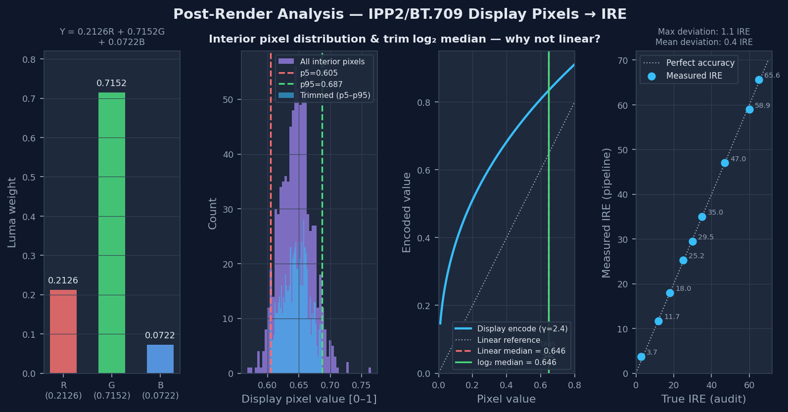
Figure 6 — Display pixel → IRE: BT.709 luma weights, the p5/p95 interior trim, the log2-vs-linear median gamma bias, and measured-vs-audit IRE across the validation set.
Validated against the gray-on-gray audit set (12 clips, 25.5–61.9 IRE incl. three overexposed stress clips): 12/12 within 3 IRE of audit at normal exposures, with the stress clips correctly measured high (the gates reject on physical sphere characteristics, never on IRE value). The method is accurate across the 18–65 IRE working range.

4.3 Scene-Linear Center Measurement (exposure)
For exposure, the sphere center (the same inner zone, same trim, same log2 median) is measured on the scene-linear render. This render is read at full 16-bit precision — the standard image loader down-converts to 8-bit, which is too coarse for a dark sphere near the bottom of the linear range (e.g. a 2.5-stop underexposed camera). The 16-bit read preserves ~3000 distinct levels in the shadow region versus ~13 at 8-bit, which is what lets a deeply underexposed camera be matched precisely.

4.4 Chromaticity & BT.1886 Inversion
Mean interior RGB is normalized to chromaticity; distance from the achromatic point discriminates neutral gray from colored objects and tinted light. For the BRDF gate, the display TIFF is inverted to scene-linear with the BT.1886 transfer function (rgb_display ** 2.4), recovering scene-linear values without a separate log render.

5. Camera Matching — Exposure and White Balance

5.1 Exposure Solve (scene-linear)
This is the core methodology change in v4 and the basis of the accuracy claim.
exposureAdjust scales scene-linear light by 2^offset. v2/v3 computed the offset from display IRE:
offset = log2(anchor_IRE / camera_IRE) # display-space (v2/v3)
Because display IRE is the non-linear IPP2 output, one scene-linear stop does not equal one “display stop” — so this formula systematically UNDER-shoots, and cameras far from the anchor land short of target. v4 solves in scene-linear instead:
offset = log2(target_linear / measured_linear) # scene-linear (v4)
This is the exact stop count: every camera is driven to the same scene-linear value, so all cameras are identical going into IPP2 and therefore matched at the display. Measured on the F5.6 set, the corrected cross-camera spread fell from 6.5 IRE (display-space solve) to ~0 IRE (scene-linear).
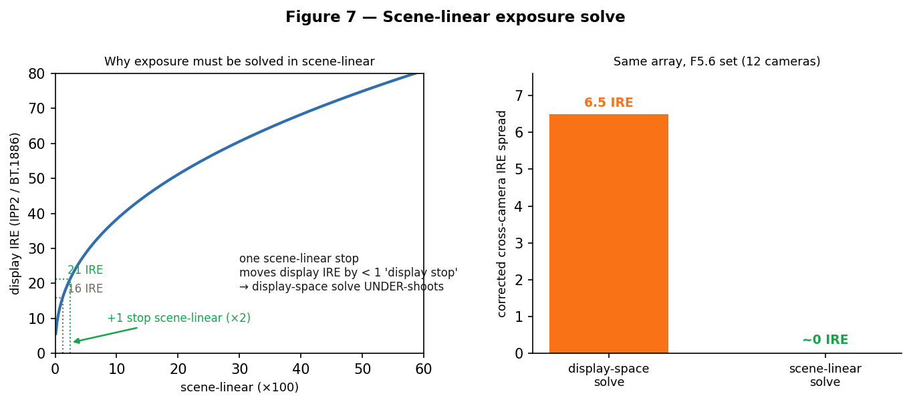
Figure 7 — Scene-linear exposure solve. Left: one scene-linear stop moves display IRE by less than a 'display stop', so a display-space solve undershoots. Right: corrected cross-camera spread, display-space vs scene-linear (F5.6, 12 cameras).

Anchor — robust median (3×MAD outlier rejection)
The exposure target is a robust median of hero values in log2 (stops): the median is taken, the median absolute deviation (MAD) is computed, and any camera more than 3×MAD from the median is excluded before the final median. The excluded camera is still corrected toward the anchor — it simply does not get to define it, so one badly-exposed body cannot drag the whole array. Worked example (12-camera under-exposed set): values span 38.8–50.9 IRE; the 38.8 IRE camera is the lone >3×MAD outlier, so the anchor is the median of the remaining 11 cameras = 47.3 IRE (not the range midpoint, ~44.9).

Accuracy
Exposure is matched to within ±0.5 IRE across the array — the repeatable benchmark, holding across targets and exposures. Per-camera precision approaches ±0.1 IRE under ideal lighting, the floor set by the camera's own exposureAdjust resolution (~0.01 stops ≈ 0.07 IRE near a mid-tone target). Every figure in the report is MEASURED from a closed-loop corrected re-render, not estimated.

5.2 White Balance Solve
White balance is matched per camera. Green/magenta is corrected with tint; warm/cool is corrected with per-camera Kelvin trims toward the working temperature (the recommended scene_match mode). The earlier shared-Kelvin model is retained as a legacy option, but tint alone cannot move warm/cool — that requires per-camera Kelvin. The solve outputs an integer kelvin and a fixed-point tint, pushed via RCP2. WB spread after the solve is reported and verified in the closed loop.

Scene-referred white balance via CDL — parked
A scene-referred per-camera color correction carried as ASC CDL over RCP2 was investigated with RED engineering. CDL is applied pre-output-transform in the Log3G10 working space, and RCP2 exposes CDL slope/offset/power (there is no RGB-gain handle). The blocker is that REDLine's --useMeta does not apply CDL on transcode (CDL defaults off); a REDLine change has been filed by RED. Until that lands, the scene-referred CDL color path cannot ship. Exposure matching (exposureAdjust via --useMeta) is unaffected and works today.

5.3 RCP2 Push
RCP2 Parameter | Notes
COLOR_TEMPERATURE | Integer Kelvin, divider = 1
TINT | Fixed-point; divider read live from camera (fallback 100)
EXPOSURE_ADJUST | Fixed-point stops; divider read live (fallback 100). ~0.01-stop resolution sets the matching floor
Write order is fixed: kelvin → tint → exposureAdjust (WB affects the pipeline before exposure gain). In Exposure-only runs only EXPOSURE_ADJUST is written.

5.4 Closed-Loop Verification
After solving, REDLine re-renders each clip with the committed values (--useMeta) and R3DMatch re-measures the corrected sphere. The corrected IRE is what appears in the report's IRE-convergence chart and the “After” coherence grid — so the match shown is verified at the sensor, not predicted.

5.5 Offline Fallback — Match Export
Every run writes the solved corrections to disk in the run's calibration folder, alongside summary.json, so the match survives even when RCP2 cannot be reached on set (network down, camera unreachable, or push deliberately skipped). These files are always written — they are the fallback receipt, never gated on a successful push:
File | Contents
match_export.json | Tool-agnostic, full fidelity. Per camera: exposureAdjust (plus Kelvin/tint on full white-balance runs), as-shot metadata, match %, and an rcp2_params block carrying the exact raw/divider integer form the camera uses — so post reproduces the on-set values without re-deriving them.
redcinex_develop.csv | REDCINE-X develop-panel values, one row per clip: Exposure (stops), Color Temp (K), Tint, with as-shot reference columns. A colorist enters or verifies these directly to reproduce the match in post.
Exposure-only runs omit the Kelvin/tint columns and note that white balance is left at as-shot. The same two files are produced by both the analysis pass and the post-QC verification pass.

6. Calibration — Parameters and Validation

Detection Parameter Reference
Parameter | Value and notes
_CANNY_SIGMA | 0.5 — tight edge detection
_CANNY_LOW / HIGH | 0.005 / 0.02 — narrow hysteresis band
_RADIUS_MIN/MAX_RATIO | 0.02 / 0.32 — Hough radius search range (ceiling raised from 0.15 to admit large 50mm spheres)
_PF_RADIUS_MIN | 0.018 — pre-filter radius floor
_PF_STD_CLEAN_MAX | 0.020 — clean-scene std ceiling
_PF_STD_HARD_MAX | 0.130 — absolute std rejection ceiling
_PF_BRDF_FALLBACK_MIN | 0.28 — BRDF threshold for the dramatic-lighting fallback
_HOUGH_SATURATION | 200 — peak count above which LoG is added
_GATE_SHADOW_RATIO_MAX | 0.96 — Pass-1 shadow_specular threshold
_GATE_SHADOW_RATIO_MAX_PASS2 | 0.985 — gating-2 looser threshold (ALT stream only)
_GATE_IRE_SPREAD_MIN | 0.8 IRE — Gate 5 minimum spread
_GATE_STDDEV_MIN / MAX | 0.003 / 0.170 — Gate 6 band
_OUTLIER_MAD_MULTIPLIER | 3.0 — exposure anchor: exclude cameras > 3×MAD from the median
_IRE_CONTEXT_FLOOR / CEIL | 18.0 / 65.0 IRE — soft-gate safety rails

Calibration Footage Sets
Set | Characteristics | Primary validation target
_106 | Gray sphere, gray backdrop, two circular focus charts | Gate calibration — cleanest conditions
_067 | Cluttered studio, dark background, colored tape, markers | LoG + BRDF fallback — worst-case complexity
_064 | Underexposed — one camera ~2 stops under | Robust-median solve + scene-linear exposure on dark spheres
F5.6 | Evenly-lit spheres, gray-on-gray | shadow_specular / gating-2 + scene-linear exposure

Gate Design Principles
- Calibrate on the hardest matching case, not the easiest. The std ceiling was set on gray-on-gray; the BRDF fallback was added for dramatic lighting that the clean-scene calibration could not handle.
- Never hard-gate on radius without measuring the sphere. The true sphere can sit at r/w 0.019–0.022; the floor was dropped to 0.018 accordingly. Radius depends on lens, distance, and sensor.
- Distinguish 3D from flat with the shadow side, not chroma. Chroma overlaps between sphere and clutter; the shadow_specular gate (Section 3.6) is the reliable convexity discriminator, with gating-2 covering the evenly-lit case the single threshold cannot.
- Solve exposure where the correction lives. exposureAdjust is a scene-linear stop, so it is solved in scene-linear — not in the non-linear display domain where it undershoots.
- The prior assists, it does not lead. The solved prior is a last-resort back-check (Pass 3) and is never blended into a real detection.

Sphere Plausibility Profile
Every confirmed detection (auto or manual) is written to a persistent sphere profile. On repeat calibration of the same setup it provides a last-resort prior ROI (Pass 3) and can narrow the radius search. It is not used to bias a cold first-look detection.

Reference: HTML report
The report is the chain-of-custody document: an overview with the matching strategy and array match %, the IRE-convergence chart (raw vs corrected against the target with the ±0.5 IRE acceptance band), the before/after Array Coherence contact sheet (the whole array read by eye), and a per-camera page showing the measured closed-loop result and the JSON commit. The exposure-accuracy statement is printed on the coherence page.

