DAY 1

* On January 26, Sunday in the morning to be exact, we set to our day to day tasks for our group members we already discussed about our plans for our ILS
* That day I and Aaron was assigned in our business plan and also deciding what products we will create for the upcoming EXPO

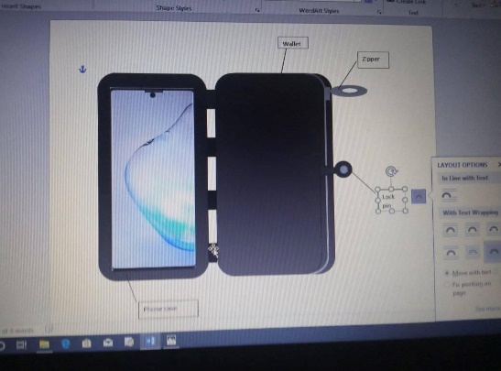Day 2

* I made a sketch of my first product that will propose to them
* A wallet phone case is a merge of wallet and smart phone case so that owner could carry their things more easily, but as time passed I learned that it’s already been in the market

;’

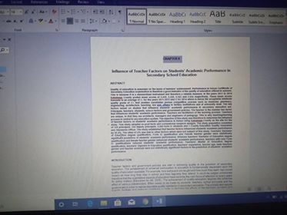 DAY 3

* My co group mates are assigned in making our research, to participate with them I researched some content for our CHAPTER 2

DAY 4

* I think about a new product.
* I decided that the next product I’ll make are connected in our environment I spend a whole day thinking about it

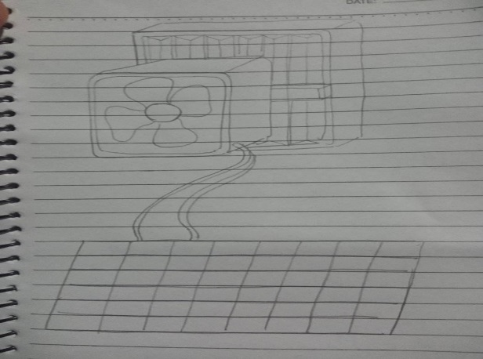 DAY 5

* I finally thought a new product and made a sketch of it
* This is an air filter powered by solar panel it also can be converted into a ventilator

DAY 6

* 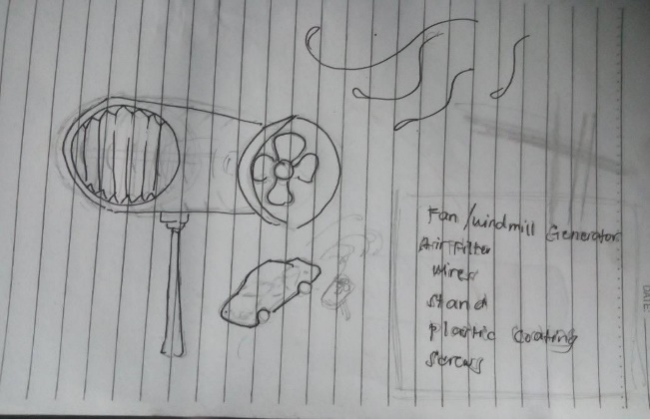 I made some change of it because I think it will not click in the market world
* I send it first to Aaron and he approved it.
* He also proposed a new product and that product is really helpful in the society

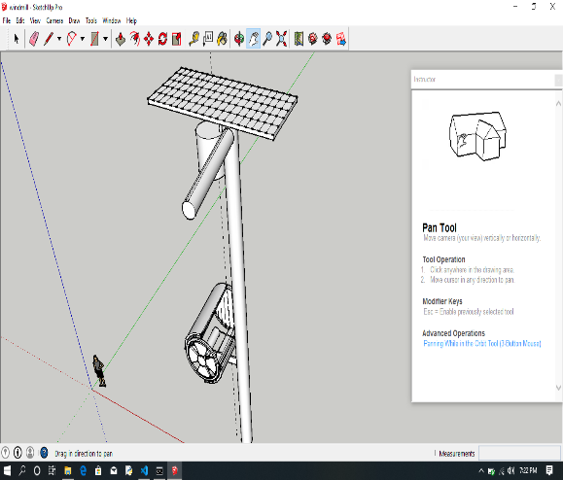DAY 7

* I started to draw it in sketch up, an application use for making structures
* I decided to draw it here so that I could easily explain to them what is this new product
* I spend a whole day in making it because it’s a bit challenging for me since I’m new in using this app

DAY 8

* 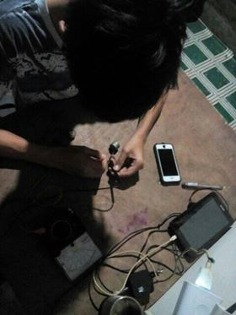I made some experiments how to make a mini windmill

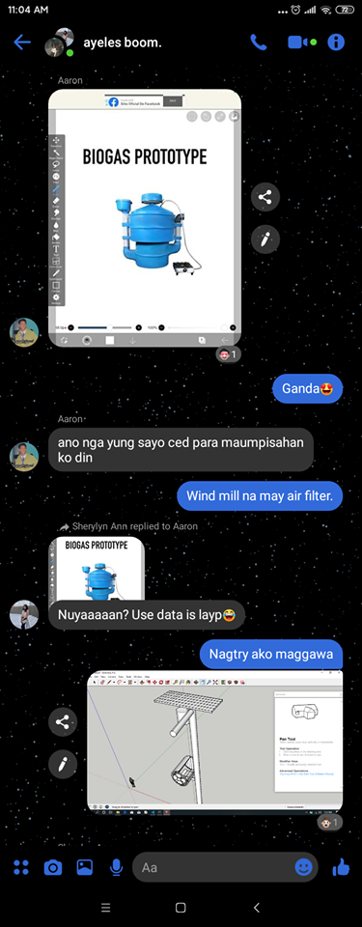

DAY 9

* Aaron and I send our products to our group mates and they agreed with it. We decided that we will proposed both of products to our teacher

DAY 10

* February 4, we have a first consultation for our EXPO
* Our proposed product has been approved by our entrepreneur teacher