TO WHOM IT MAY CONCERN:

I'm Gian Carlo L. Garcia, and I'd like to cancel my Toyota car loan application.

Given on this date of June 10, 2022

Sincerely,

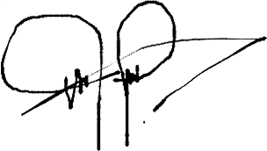

**GIAN CARLO L. GARCIA**