### Computer Skills

**Knowledgeable With:**  **Tools:**

* Java • Photoshop
* Java script • Microsoft Office
* HTML • Microsoft Excel
* CSS • Lucid Chart

• Figma

### Seminar and Training Attended

**IT Career Kickstart “How to Start Your Tech Career”**

CICT AVR, Pimentel Hall, Bulacan State University

Septermber 26, 2019

**Computer Ethics and Database Security**

CICT AVR, Pimentel Hall, Bulacan State University

Septermber 23, 2019

**Business Analytics & Data Mining**

Alvarado Hall, CIT, Bulacan State University

2019

**9-Hour Basic AutoCAD Hands-on Training**

Alvarado Hall, CIT, Bulacan State University

2019

**Tesda NCIII Passer**

Natividad Hall, COE, Bulacan State University

2015

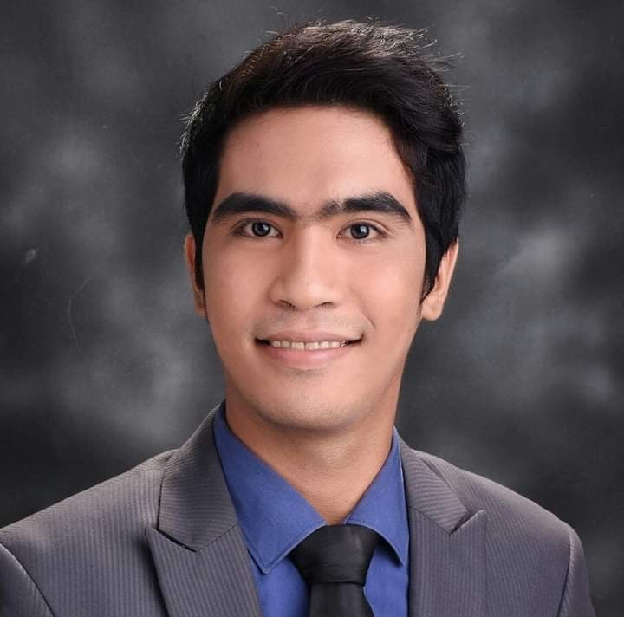

**About me** I'm a nice fun and friendly person, I'm honest and punctual, I work well in a team but also on my own as I like to set goals that I'm going to accomplish, I have good abilities to listen and communicate. I have a creative mind and I am always ready for new difficulties.

### Personal Data

**Date of Birth:** November 01,1996

**Age:** 24

**Height:** 5’6

**Weight:** 55kg

**Nationality:** Filipino

**Civil Status:** Single

**Religion:** Roman Catholic

### Education

**Bachelor of Science in Information Technology**

Bulacan State University

City of Malolos Bulacan

2019-Present

**Associate Computer Technology**

Bulacan State University

City of Malolos Bulacan

2017-2019

**Marcelo H. Del Pilar National Highschool**

City Of Malolos Bulacan

2009-2013

**Bulihan Elementary School**

City of Malolos Bulacan

2003-2009

Abala Ronnie C.

09951935061

Ronnieeeeeabala@gmail.com