GIAN CARLO

L. Garcia

# F U L L S T A C K

# S O F T W A R E

# E N G I N E E R

ABOUT ME

Seeking a position in life to

utilize my skills and abilities and

achieve professional growth

while being resourceful,

innovative and flexible. To add

valuable assets to your

esteemed organization as an

active member.

## PERSONAL DATA

**Date of birth:** July 14, 1998

**Age:** 23

**Height:** 5’9

**Weight:** 80kg

**Nationality:** Filipino

**Mother:** Nenita Corazon L. Garcia

**Mother's Occupation:** Sewer

## EDUCATIONAL BACKGROUND

## **Master of Science in Artificial Intelligence**

## BATANGAS STATE UNIVERSITY

## Alangilan, Batangas

## Present

## 

CONTACT

Mobile No: +639-2684-29590

Email: garcia.giancarlo714@gmail.com

GitHub: @SftwreDev

LinkedIn: Gian Carlo Garcia

Address: Marawouy Lipa City, Batangas

**BACHELOR OF INDUSTRIAL TECHNOLOGY**

MAJOR IN COMPUTER ENGINEERING TECHNOLOGY

BATANGAS STATE UNIVERSITY

Malvar, Batangas

2015-2021

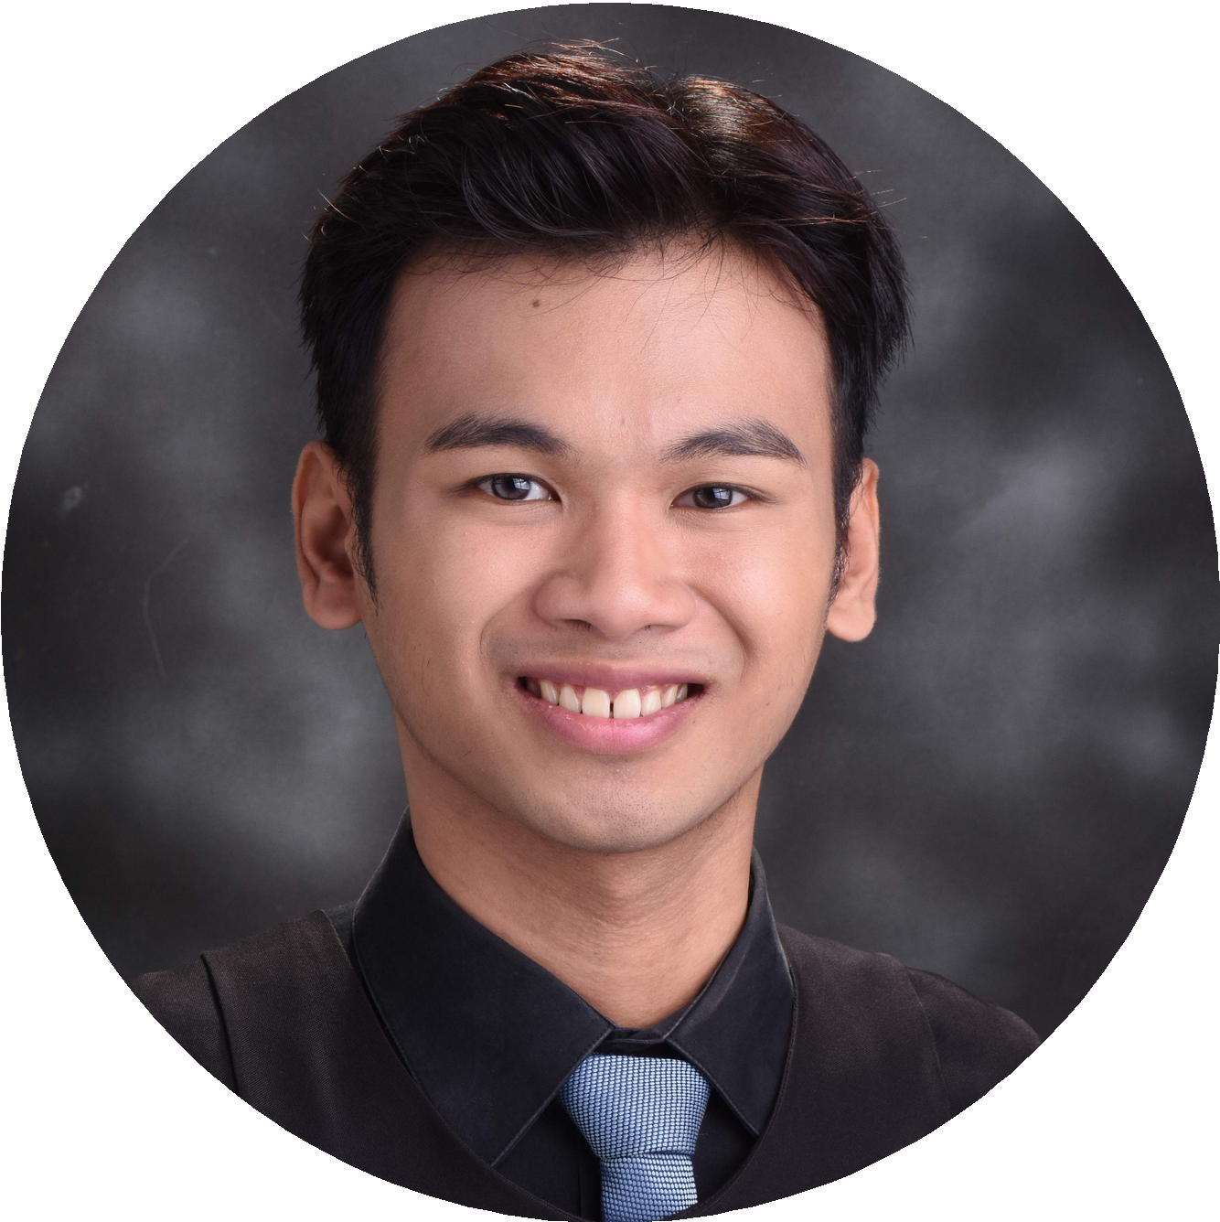

### Inosluban-Marawouy National High School

Lipa City, Batangas

2010 - 2014

## COMPUTER SKILLS

**Stacks/Languages:**

* 3 + years of experience in using Python Programming Language
* 3 + years of experience in Full Stack Web Development
* 3 + years of experience in using Django Web Framework
* Knowledgeable in using HTML, CSS, JavaScript
* Knowledgeable in using React.js and Next.js for developing frontend interface



* Knowledgeable in using Bootstrap , Materialize CSS, Ant Design, Material UI
* Knowledgeable in creating RESTful API using Django Rest Framework, FastAPI, Golang, and Next.js.
* Knowledgeable in using Flask Web Framework
* Knowledgeable in using Database Management System
* Knowledgeable in using Shopify.
* Knowledgeable in Scrum
* Knowledgeable in using AWS and Docker.
* Knowledgeable in implementing Robotic Processing Automation
* Knowledgeable in implementing Computer Vision using OpenCV
* Knowledgeable in using Golang.
* Knowledgeable in deploying to Digital Ocean.
* Knowledgeable in developing Object Detection using Artificial Intelligence
* Knowledgeable in developing software and hardware prototype using Arduino.
* Knowledgeable in developing mobile application using Flutter.

## WORKING EXPERIENCE

## **Freelance Projects**

## Full Stack Software Developer

## Developed LMS for Malvar School of Arts and Trade

## Developed Repository System for BatStateU Malvar

## Developed Testing Admission System for BSU TAO

## Developed Hotel Management System

## Set up and developed a Shopify Store for Aeghwasolutions

## Developed the Inventory Management System for DOST

## Developed the IAF Liberia Website for Liberia, West Africa

## T**ech Used:** Django | Bootstrap 4 | Heroku | Shopify | Digital Ocean

## 2019 - 2022

## **NXTLVL Farms, Inc.**

## Junior Software Engineer Intern

## Developed the Centralized Data Capturing System

## **Tech Used:** Django | Bootstrap 4 | Agile Methodology |Python | PostgreSQL

## August 2020 – October 2020

## **Data Kaizen Metrics**

## Full Time Software Developer

## Developed the Annual Online Reporting Dashboard

## Developed the Efficiency Metrics Dashboard

## Lead Dev for DKM-QA Application

## **Tech Used:** Django | Bootstrap | Python | Django Rest Framework| RESTful API | MSSQL | Flutter

## September 2020 - March 2021

## **Quadralogix**

## Part Time Software Developer

## Developed the E-Prescription Web Application

## One of the developers of EHR Web Application

## Developed LTO Registration App using Flutter.

## **Tech Used:** Django | Bootstrap | Python | React.js | Django Rest Framework| RESTful API | Flutter

## November 2020 - March 2021

## **Getaka Labs**

## Full Stack Software Engineer

## Developed the Backend API for AI Integration

## Developed and Maintained Odoo Modules.

## Developed Web Crawlers and Scraper API

## Handled the Full stack development for Insurance System

## Lead Developer for Video Tech System

## **Tech Used:** Python | FastAPI | Artificial Intelligence | Golang | Next.js | PostgreSQL | AWS

## March 2021 – February 2022