Predicting Economic Development in Africa
Using World Development Indicators
Data Science Capstone Project Report
AnalystLab Africa Data Science Internship Program
Prepared by: Sfundo Thabani Dube
Durban, South Africa

1. Introduction
This report documents a complete, end-to-end data science project applying the World Bank's World Development Indicators (WDI) dataset to a real-world question about economic development in Africa. The project was completed as the final Capstone assignment of the AnalystLab Africa Data Science Internship Program, and follows the full data science lifecycle: problem definition, data collection, cleaning, exploratory analysis, machine learning modeling, evaluation, and deployment.
The World Development Indicators are the World Bank's flagship compilation of development statistics, covering over 200 countries across themes including economy, health, education, infrastructure, and governance. This project narrows that scope to Africa's 54 recognized countries over the period 2000–2020, and to a focused set of 12 indicators spanning health, education, investment, and infrastructure.

2. Problem Statement
Can we predict a country's level of economic development (GDP per capita) using health, education, investment, and infrastructure indicators, for African economies?
This question matters for three reasons:
- Policy impact: identifying which development levers (health, education, infrastructure, investment) are most strongly associated with higher economic development can help governments and development agencies prioritize scarce public spending.
- Monitoring impact: indicator-based estimates of GDP per capita can support faster tracking of economic development between full national accounts revisions, which are often delayed for lower-income countries.
- Social impact: understanding which indicators matter most for economic outcomes supports the broader effort to monitor progress toward the Sustainable Development Goals (SDGs) across the continent.
An important methodological note: an initial version of this project attempted to predict year-over-year GDP growth (%) rather than the GDP per capita level, following one of the topic suggestions provided for this Capstone. That approach produced very weak models (R² below 0.06 across three different algorithms), because annual growth rates are dominated by short-term shocks (commodity price swings, political events, weather) that slow-moving structural indicators cannot capture. This is a well-documented characteristic of macroeconomic data, not a flaw in the modeling approach, and is retained in the analysis and the accompanying notebook for transparency. The problem was consequently reframed around predicting the GDP per capita level, which is both more tractable and still directly answers the underlying question of how development indicators relate to economic outcomes.

3. Methodology
3.1 Data Collection & Understanding
Twelve WDI indicator series were extracted from the official World Bank bulk download (WDI_CSV.zip, obtained from datatopics.worldbank.org and containing WDICSV.csv the full ~1,480-indicator, 265-country/region WDI database in wide format), reshaped into a tidy country-year panel, and restricted to Africa's 54 countries and the 2000–2020 window (chosen for its comparatively consistent data coverage across the continent). African countries were identified using the World Bank's own country metadata (WDICountry.csv): all countries classified under the "Sub-Saharan Africa" region, plus the North African / Horn-of-Africa countries classified under "Middle East & North Africa" (Algeria, Egypt, Libya, Morocco, Tunisia, Djibouti) together matching the African Union's 54 recognized member states. The table below lists each indicator and its role in the analysis
Indicator | WDI Code | Role
GDP per capita (current US$) | NY.GDP.PCAP.CD | Target variable
GDP growth (annual %) | NY.GDP.MKTP.KD.ZG | Explored as alternate target (see Section 5)
Life expectancy at birth | SP.DYN.LE00.IN | Predictor health
Under-5 mortality rate | SH.DYN.MORT | Predictor health
Secondary school enrollment | SE.SEC.ENRR | Predictor education
Govt. education expenditure | SE.XPD.TOTL.GB.ZS | Predictor education
Gross capital formation (% GDP) | NE.GDI.TOTL.ZS | Predictor investment
FDI net inflows (US$) | BX.KLT.DINV.CD.WD | Predictor investment
Access to electricity (%) | EG.ELC.ACCS.ZS | Predictor infrastructure
Population growth (annual %) | SP.POP.GROW | Predictor demographic
Inflation, consumer prices | FP.CPI.TOTL.ZG | Predictor macro stability
Unemployment (%) | SL.UEM.TOTL.ZS | Predictor labor market
The resulting raw panel contained 1,134 potential country-year combinations (54 countries × up to 21 years). Data types were reviewed (all indicators numeric except identifying columns), and the dataset structure (long panel format: one row per country-year) was confirmed suitable for a standard supervised regression approach.
3.2 Data Cleaning & Preprocessing
- Missing target rows dropped: rows without a value for the modeling target cannot be used for training or evaluation and were removed rather than imputed, to avoid circularity.
- Duplicate check: rows were checked for exact duplicates on (Country Code, Year); none were found.
- Missing predictor imputation, applied in priority order: (1) country-level linear interpolation, filling gaps between known years for the same country; (2) country-level median, for values interpolation could not reach; (3) global median, as a final fallback for countries missing an indicator entirely.
- Outlier treatment: FDI net inflows, inflation, and GDP per capita were winsorized (capped) at their 1st/99th percentiles rather than dropped, since extreme values often reflect genuine events (hyperinflation episodes, large resource-extraction FDI deals) rather than data errors.
- No categorical encoding was required: all modeling features are numeric. Country identifiers were retained for reference but excluded from the model inputs, so the model learns from the indicators themselves rather than memorizing per-country averages.
After cleaning, the dataset comprised 1,097 country-year rows across all 54 African countries.
3.3 Exploratory Data Analysis
Summary statistics, distribution analysis, correlation analysis, and trend analysis were used to understand the data before modeling.
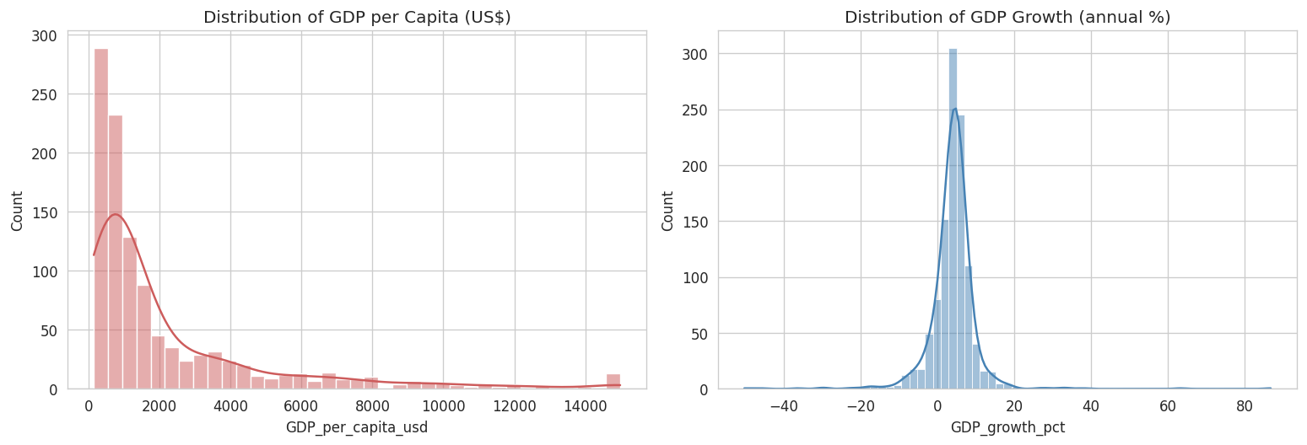
Figure 1. Distribution of GDP per capita (right-skewed) and GDP growth (roughly bell-shaped, with a crisis-driven left tail).
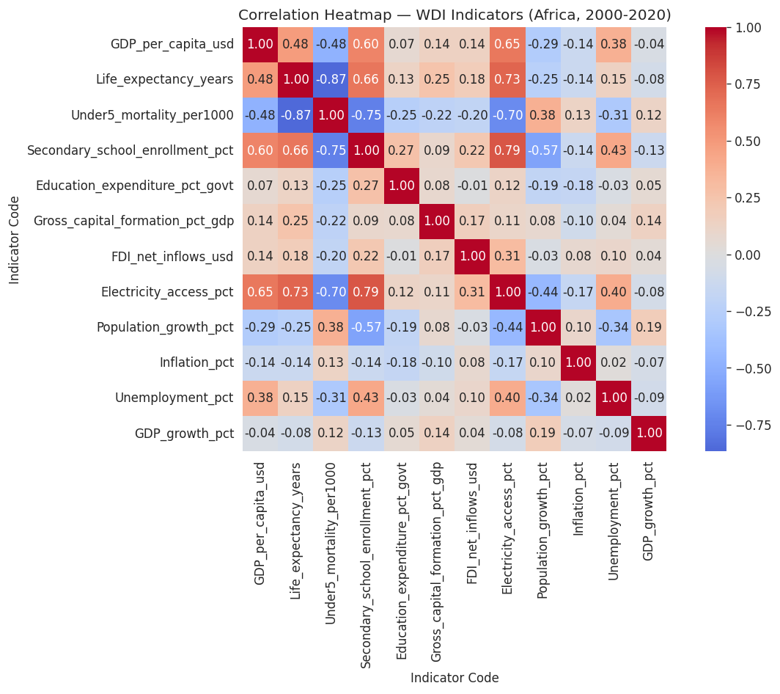
Figure 2. Correlation heatmap across all WDI indicators used in this study.
GDP per capita correlates strongly with level-type indicators (life expectancy, positively; under-5 mortality, negatively), consistent with the well-established pattern that health outcomes and economic prosperity move together. GDP growth (annual % change), by contrast, shows weak correlation with nearly every predictor visual confirmation of why growth is harder to predict from these indicators than the GDP per capita level is.
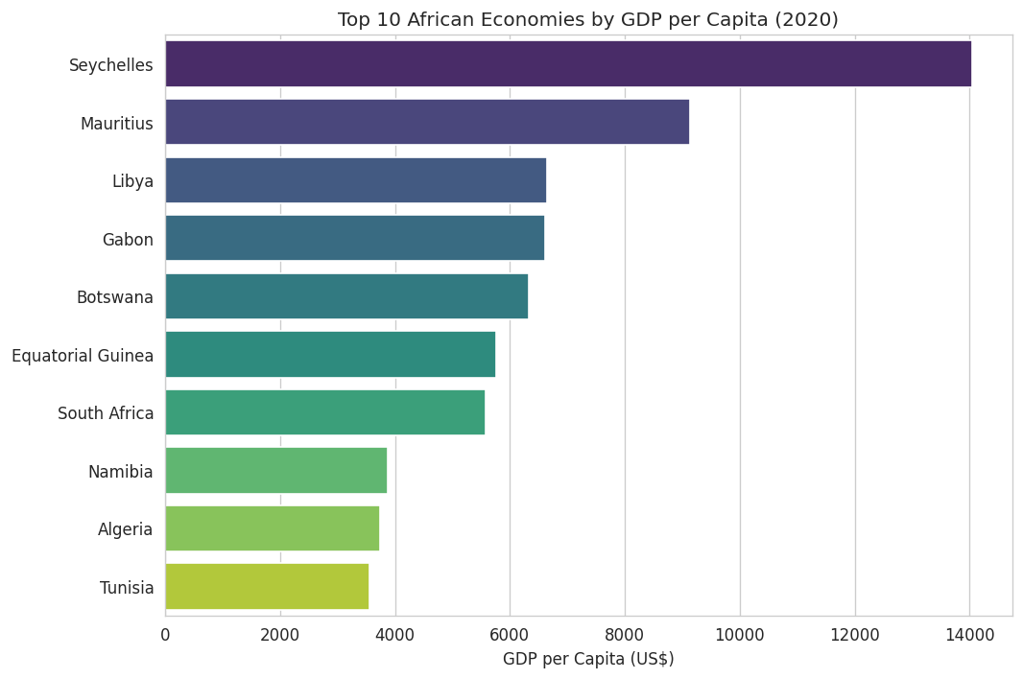
Figure 3. Africa's 10 highest GDP-per-capita economies in 2020.
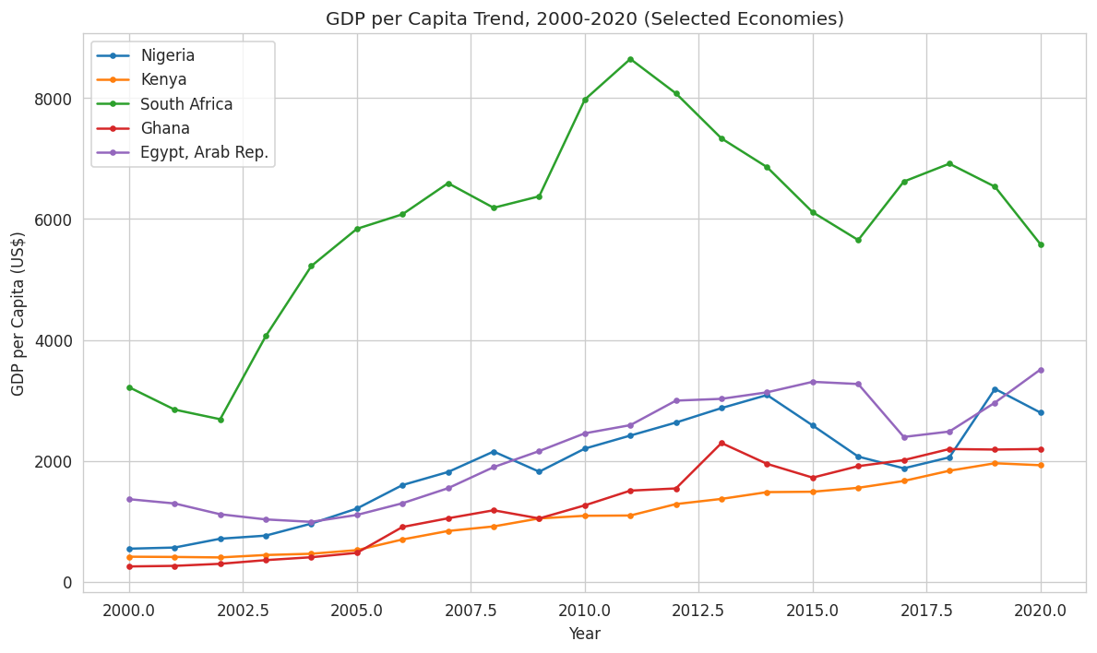
Figure 4. GDP per capita trend, 2000–2020, for five selected economies.
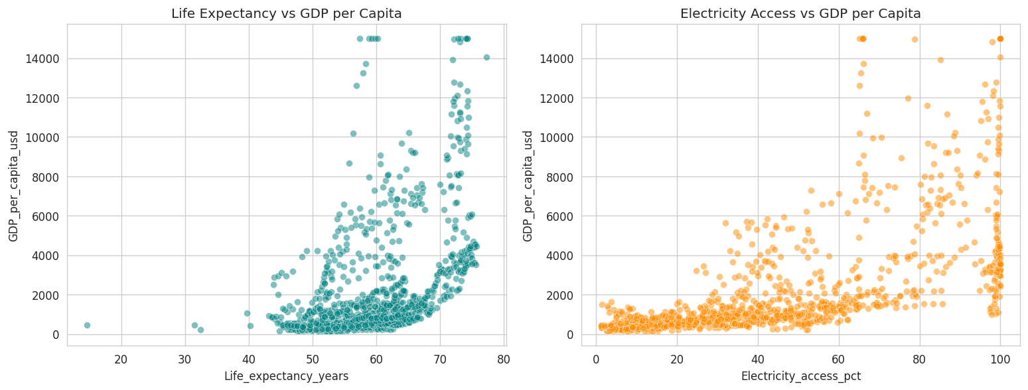
Figure 5. GDP per capita vs. life expectancy and vs. electricity access.

4. Model Development
Two modeling attempts were made, described in turn below.
4.1 First attempt: predicting GDP growth (%)
A Random Forest Regressor was trained to predict annual GDP growth using the 11 development indicators plus a one-year lag of GDP growth itself (a momentum feature) and log-transformed GDP per capita. This produced R² = 0.002 on the test set effectively no better than predicting the mean growth rate for every observation. This result is retained in the accompanying notebook as evidence that the approach was tested empirically, not dismissed by assumption.
4.2 Final approach: predicting GDP per capita (level)
The target was changed to log-transformed GDP per capita (the log transform reduces its right-skew and stabilizes variance). Three models suitable for this regression problem were trained and compared on an 80/20 train-test split:
- Linear Regression as an interpretable baseline.
- Random Forest Regressor a bagged ensemble of decision trees, robust to non-linear relationships.
- Gradient Boosting Regressor a boosted ensemble, often strong on tabular data of this size.
Random Forest was selected for further hyperparameter tuning, based on its strong baseline performance and the interpretability benefit of feature importances. Tuning was performed via GridSearchCV over n_estimators, max_depth, min_samples_split, and min_samples_leaf, validated with 5-fold cross-validation (scoring = R²).

5. Evaluation Results
All metrics below are computed on the log(GDP per capita) scale, using a held-out test set not seen during training or tuning.
Model | MAE | RMSE | R²
Linear Regression | 0.423 | 0.558 | 0.735
Random Forest (default) | 0.191 | 0.259 | 0.943
Gradient Boosting | 0.216 | 0.275 | 0.935
Random Forest (tuned) | 0.192 | 0.258 | 0.943

The tuned Random Forest achieved a test R² of 0.943 (MAE 0.192, RMSE 0.258), meaning the model explains 94.3% of the variance in log GDP per capita using only health, education, investment, and infrastructure indicators no direct financial or GDP-related inputs. Five-fold cross-validation on the training set confirmed this result is robust rather than an artifact of a single lucky split, with a mean CV R² of 0.923.
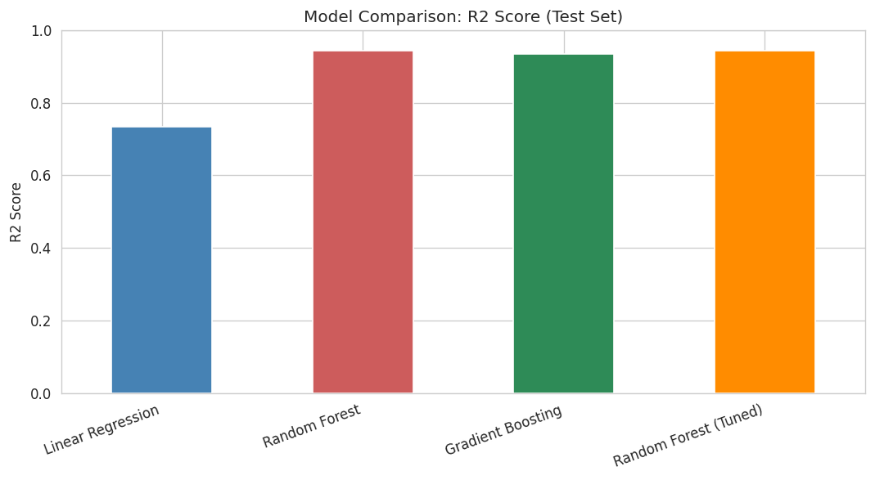
Figure 6. R² comparison across all models tested.
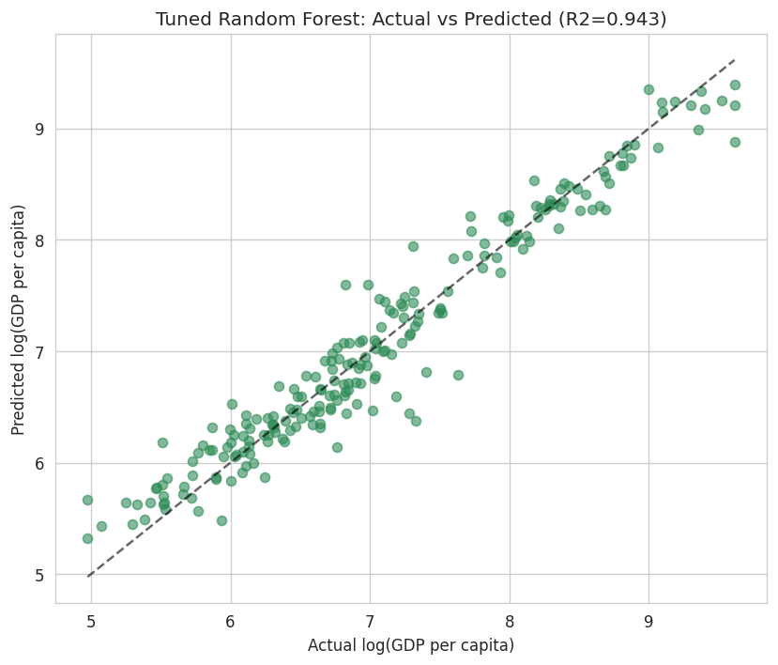
Figure 7. Actual vs. predicted log(GDP per capita) for the tuned Random Forest on the test set.
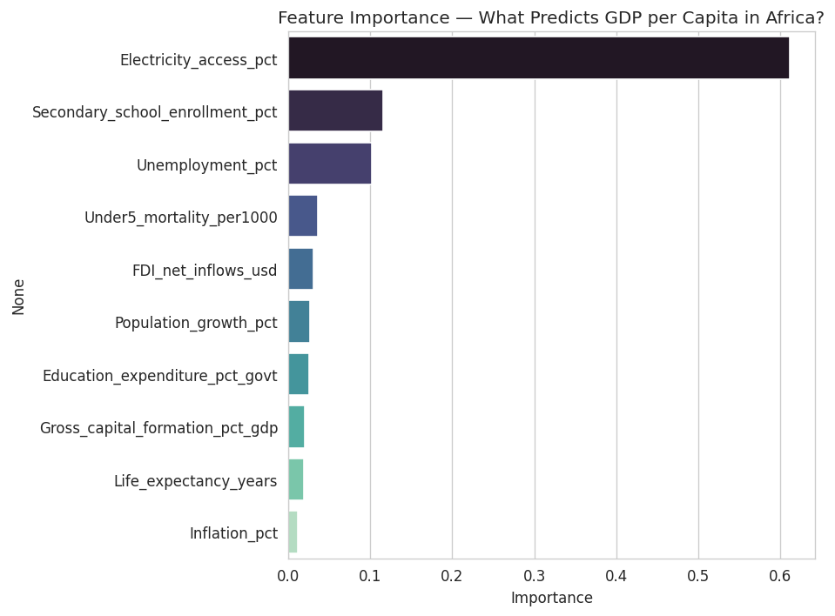
Figure 8. Feature importance from the tuned Random Forest.
Electricity access is by far the strongest predictor (importance ≈ 0.60), followed by secondary school enrollment and unemployment. Health indicators (life expectancy, under-5 mortality) and investment indicators (gross capital formation) contribute, but considerably less than electricity access likely because electrification correlates with a broad bundle of infrastructure and institutional quality that health and investment indicators only partially capture on their own. Inflation contributed the least, consistent with it measuring macroeconomic volatility rather than the underlying level of development.

6. Insights & Recommendations
Key Findings
- GDP per capita level is highly predictable from development indicators; GDP growth rate is not development indicators are well suited to benchmarking a country's current economic standing, but should not be expected to forecast next year's growth swings.
- Electricity access is the single strongest predictor of GDP per capita across African economies in this dataset ahead of health, education, or investment indicators.
- Secondary school enrollment and unemployment are the next most important signals, reinforcing that a country's human-capital pipeline and labor market health track its economic development level, though less strongly than infrastructure access.
- Non-linear models (Random Forest, Gradient Boosting) meaningfully outperform Linear Regression, indicating diminishing returns and threshold effects rather than simple straight-line relationships between these indicators and economic development.
Recommendations
- For policymakers: prioritizing electrification infrastructure appears to align most closely with higher measured economic development in this dataset though correlation here does not prove causation, and further causal analysis would be needed before drawing firm policy conclusions.
- For monitoring agencies: a model like this could support faster, indicator-based estimates of GDP per capita for countries with delayed national accounts data, but should not be used to forecast short-term growth, where it performs poorly.
- For future work: incorporating governance indicators (e.g. corruption perceptions, political stability), commodity price data, or exchange rate volatility could meaningfully improve growth-rate prediction specifically, since these capture more of the shock-driven variation that structural indicators alone cannot.
Practical Implications
This project demonstrates that a small, focused set of publicly available World Bank indicators can support a genuinely useful model of economic development levels across Africa useful for comparative benchmarking, gap analysis between countries, and identifying which development levers most closely track economic outcomes. The trained model has been deployed as both a REST API (FastAPI) and an interactive web application (Streamlit), allowing these predictions to be generated on demand from new indicator inputs.

7. Conclusion
This capstone project applied the complete data science workflow to a genuine, publicly available development dataset, and arrived at a well-supported, non-trivial finding: economic development level (GDP per capita) is strongly predictable from health, education, investment, and infrastructure indicators across Africa, with electricity access standing out as the dominant signal, while the growth rate of GDP is not meaningfully predictable from these same indicators. Reaching this conclusion required testing an initial hypothesis, honestly reporting its failure, and adapting the problem framing accordingly a realistic reflection of how applied data science projects often unfold. The final tuned Random Forest model, achieving a test R² of 0.943, has been packaged into a working, testable API and web application, completing the transition from exploratory analysis to a deployable data product.

Data source: World Bank World Development Indicators (WDI), CC-BY-4.0 license.
Project repository, notebook, and live deployment details are provided separately alongside this report.

