**Pre-Processing Results**

1. Loading the raw data



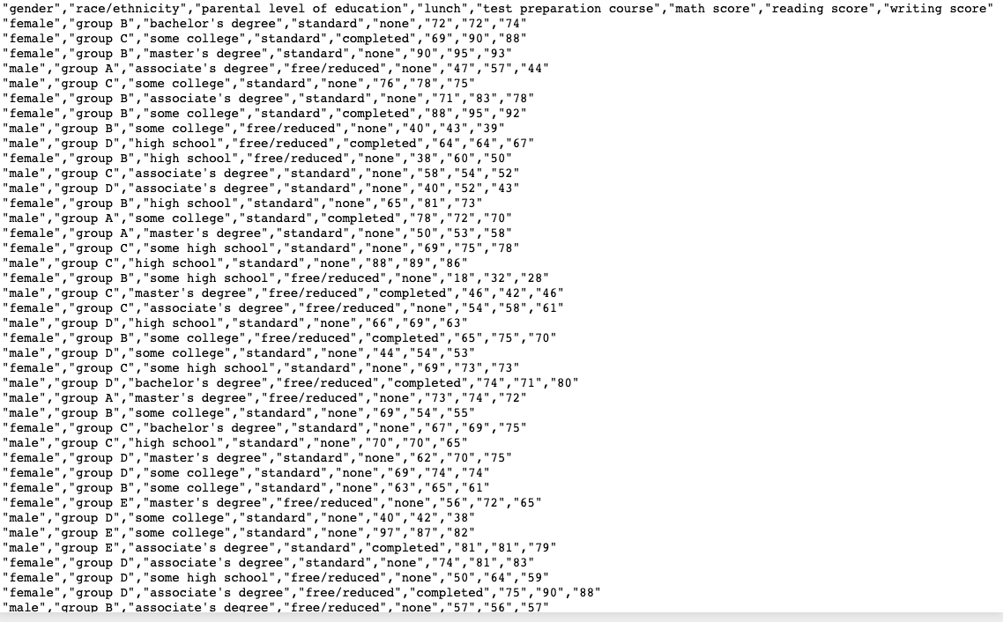

1. Understanding the data, its type and value and renaming the column names.

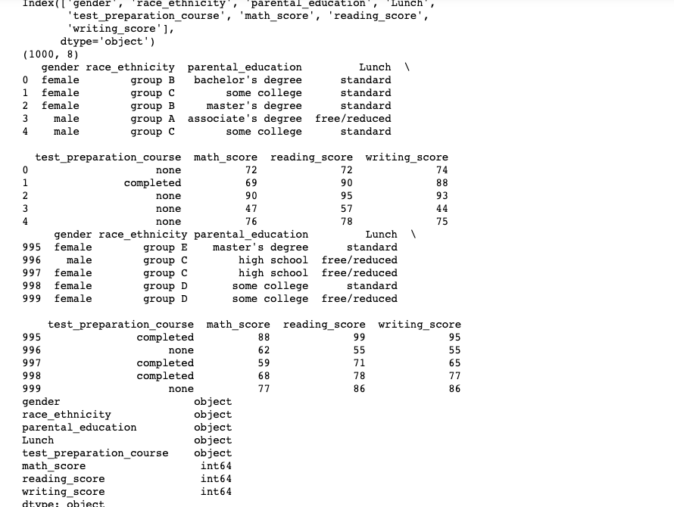

1. Dropping the irrelevant columns (Lunch) and summarizing the data frame. Checked for any missing values (False represents there are no missing values).

1. Cleaned and pre-processed data is stored in a new csv file.



