**Dr. Danielle Goolsby,** CEO & Founder

Website: [www.choyces.org](http://www.choyces.org/)

Phone: 347-916-6535

Email: info@choyces.org

April 15, 2021

To whom this may concern:

I recently had the opportunity to work with Sandra George in the Winter/Spring 2020-2021 Information Technology internship at CHOYCES where we aim to Creatively Help Our Youth Conquer Education & Success. It is my pleasure to now recommend her for further opportunities with your organization.

In all of her work throughout the internship, Sandra continually displayed commitment, dedication, enthusiasm, and professionalism. Her skills led to amazing contributions to her team and the organization as a whole. To enhance her skills while serving as an intern, she engaged in online webinars and articles related to her department to enhance her knowledge and skills related to Information Technology

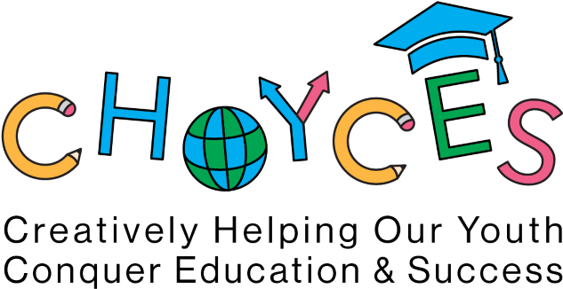Sandra’s skills in coding grew during the internship. During the winter/spring internship, Sandra participated in team meetings, supported using expertise during our virtual college tour and learned a lot about transferring to google suite. She also helped other departments, if needed, by participating in special projects, supported in fundraisers and anything else the company needed to Creatively Help Our Youth Conquer Education & Success. She understood the mission and vision of CHOYCES and made it her own. As you can see, Sandra is the ideal employee and was a pleasure to work with.

I believe Sandra would be a great addition to your team in both their skills and personality. She will not only be an asset for your own growth but will absolutely grow to achieve great things under your experience. If you have any further questions about this applicant, please feel free to reach out at dgoolsby@choyces.org, this letter can only capture so much of the work Sandra has completed as part of the CHOYCES team.

S

i

n

c

e

r

e

l

y

,

D

r

.

D

a

n

i

e

l

l

e

G

o

o

l

s

b

y

,

C

H

O

Y

C

E

S

F

o

u

n

d

e

r

a

n

d

C

E

O

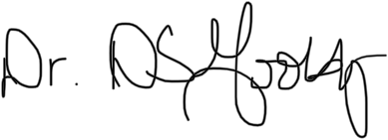

CHOCYES

Creatively Helping Our Youth Conquer Education and Success

*"Creativity is contagious, pass it on."* Albert Einstein