Name: Sandra George

Question 2

a.

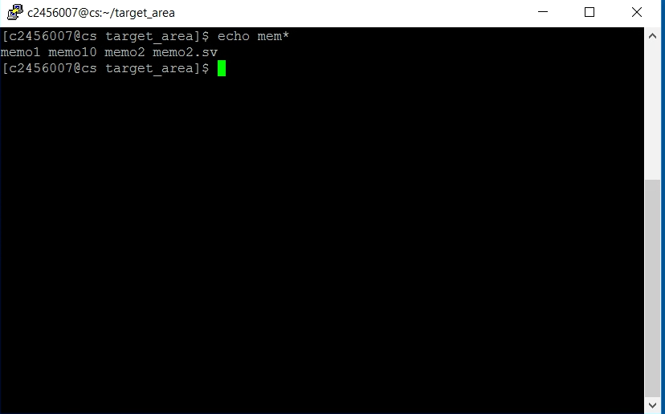

b.

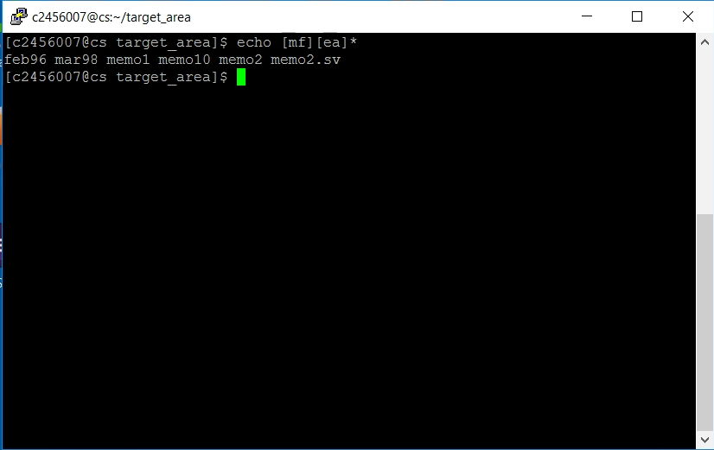

c.

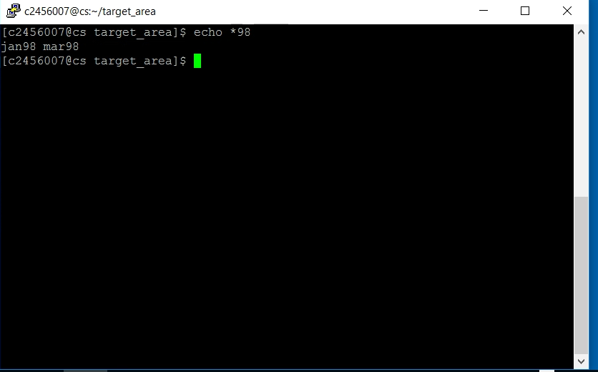

d.

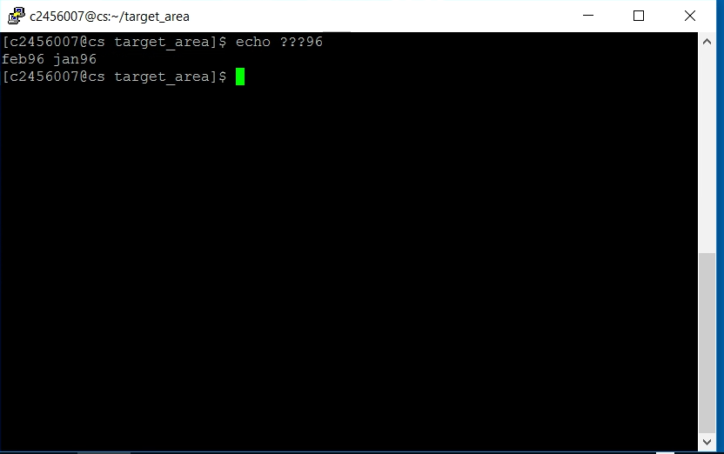

e. ls *![[:lower:]]

f. ls *2

g. rm -r *1

h. ls|wc -l

I have experience in all web design languages as HTML, CSS, Javascript, JQuery and PHP. I also have knowledge in SQL and data modeling. I am proficient in Object Oriented Programming like java and python. I have problem-solving skills and can troubleshoot software and fix problems. I also know a lot in cyber security, client-server model and networking topics. I am certified in cyber security as I have TestOut Security Pro certificate. I also have Azure administration and azure fundamentals certificate.

import { LightningElement } from 'lwc';

import { ShowToastEvent } from 'lightning/platformShowToastEvent';

import Contact_OBJECT from '@salesforce/schema/Contact';

import FIRSTNAME_FIELD from '@salesforce/schema/Contact.FirstName';

import LASTNAME_FIELD from '@salesforce/schema/Contact.LastName';

import EMAIL_FIELD from '@salesforce/schema/Contact.Email';

export default class AccountCreator extends LightningElement {

    objectApiName = ACCOUNT_OBJECT;

    fields = [FIRSTNAME_FIELD, LASTNAME_FIELD, EMAIL_FIELD];

    handleSuccess(event) {

        const toastEvent = new ShowToastEvent({

            title: "Contact created",

            message: "Record ID: " + event.detail.id,

            variant: "success"

        });

        this.dispatchEvent(toastEvent);

    }

}