Name: Sandra George

**Task 1 Create count-users script code:**

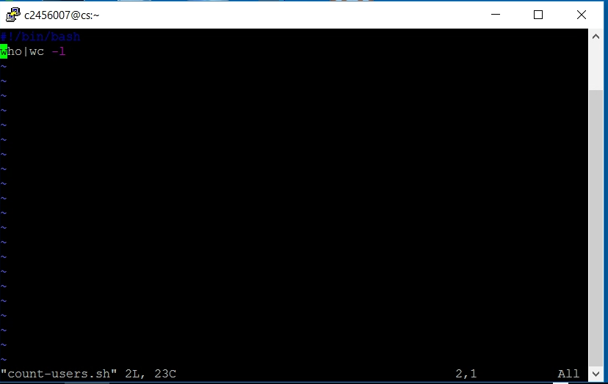

**Task 1 terminal results:**

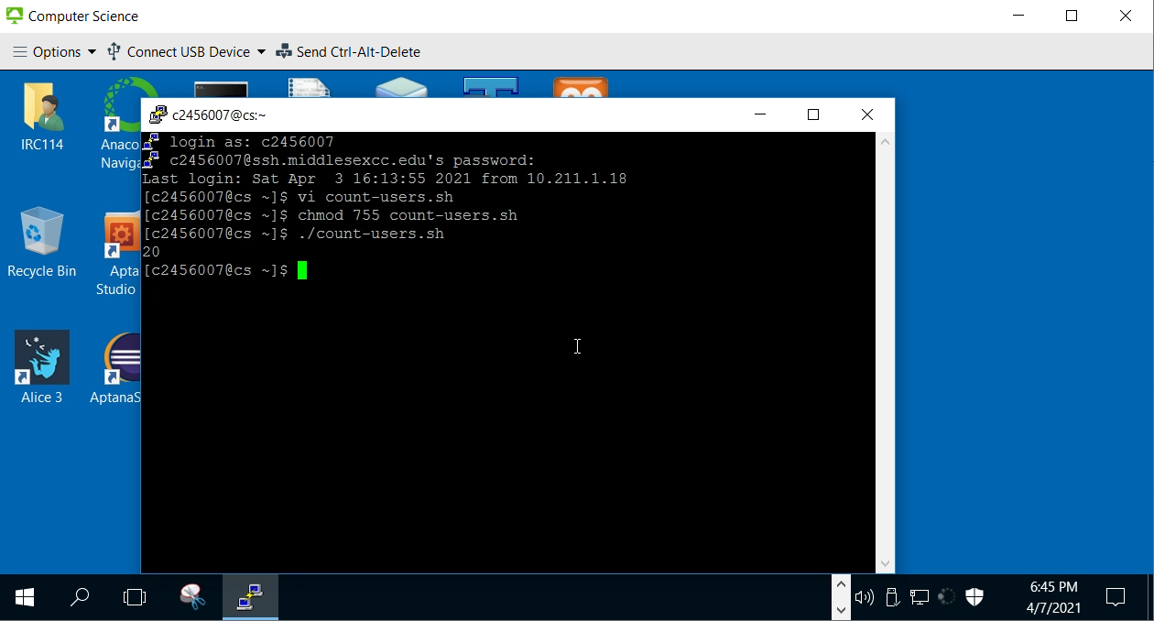

**Task 2 Modify count-users script:**

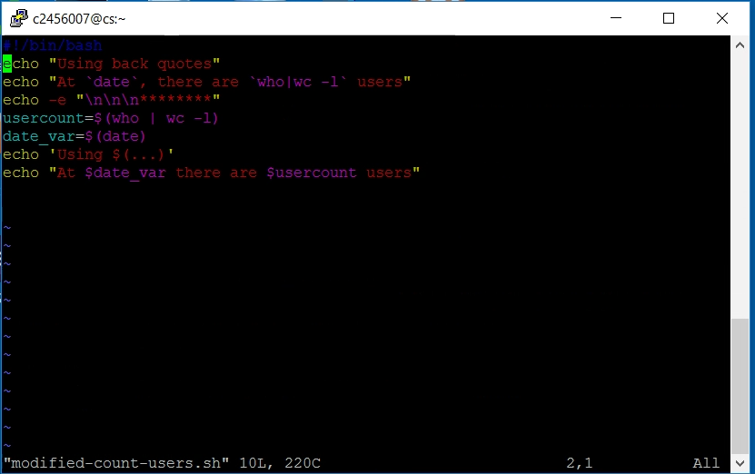

**Task 2 terminal results:**

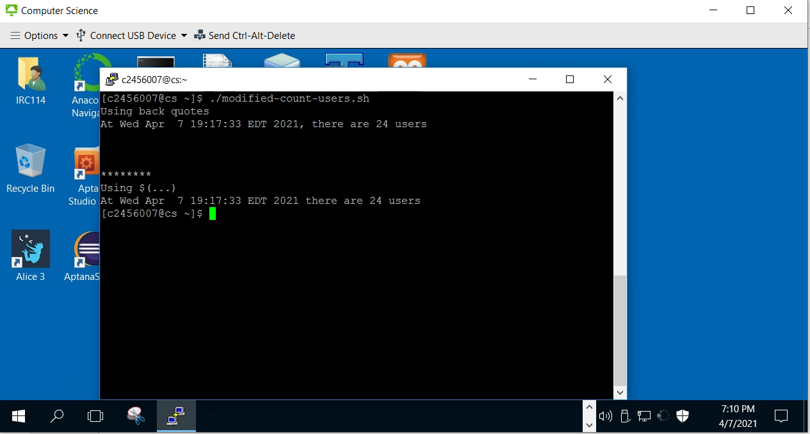

**Task 3** – Create a program called ison . This program accept a username and prints if that particular user is logged in or not.

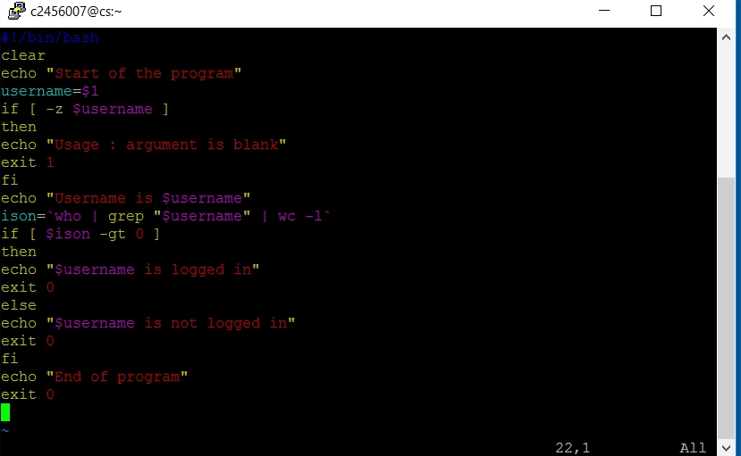

**Task 3 terminal:**

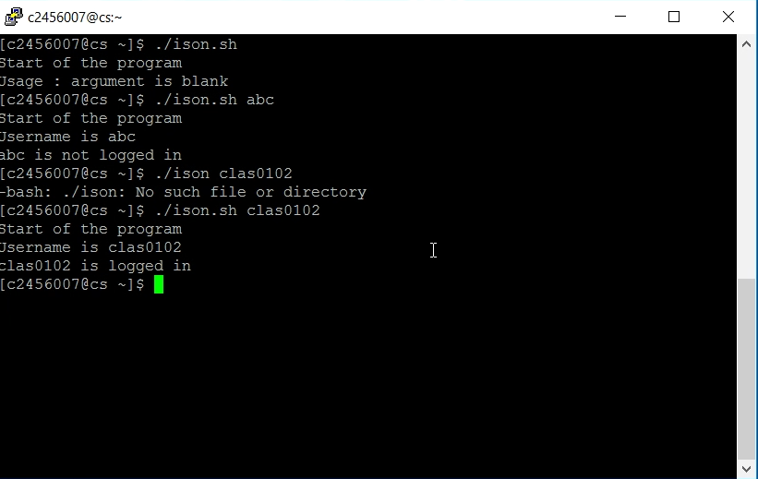

**Task 4** –Create grade script

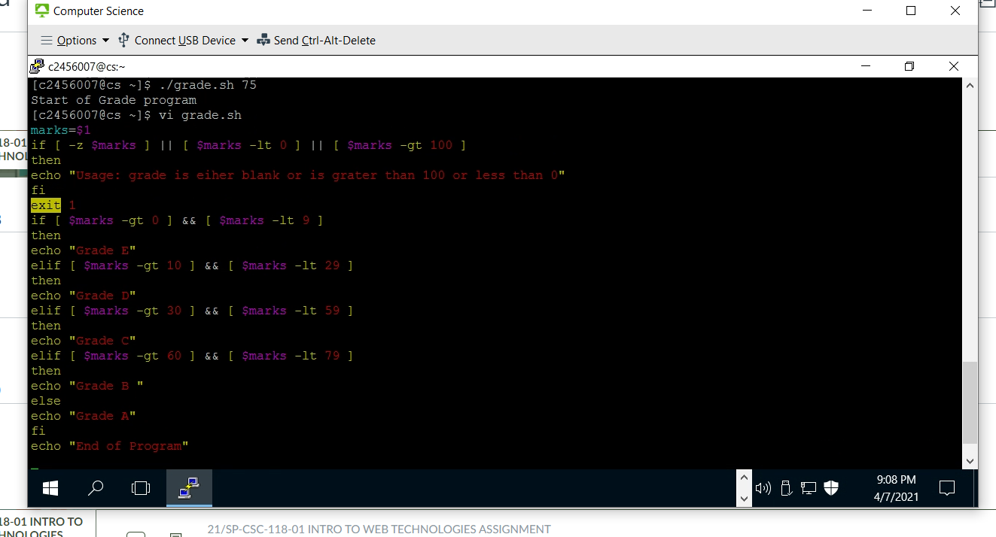

I t is not working for me, if I remove the exit and apply a grade as an argument, it prints only the first line “ Start of the grade program”, and that’s it