Development and evaluation of methods to visualise Airlines Delays using various visualization techniques.
__________________________________

Sapna Gupta
X14115824
13th Dec 2015.
Msc Data Analytics Year (2014-2016)
Abstract

Data is free but the information hidden inside this data is priceless. Various visualization techniques are applied on a massively huge Airlines dataset to answer various business queries concerning flight delays like cause of delay and forecasting future delays. Dataset used for this analysis consist of flight transactions, flight routes information with around 7 million records and 2 GB in size. A picture is worth thousand words and reading a picture can trigger a number of thoughts such as extracting, comparing or aggregating numerical values. Most of the charts that are presented in this report will trigger some of these thoughts. Results are represented in the form of dashboard and story. There is also a demonstration of comparative analysis using different types of technologies.

Contents
Introduction 3
Project Outline 3
Dataset Used 4
Tools used 5
Data Processing Steps 6
Related Work 7
Implementation of visual representations 9
Analysis done using R 20
Presentation of the final work 23
Conclusion 23
References 24
Appendix 24
Test Results 25

Introduction

The Federal Aviation Administration (FAA) considers a flight to be delayed when it is 15 minutes later than its scheduled time. A cancellation occurs when the airline does not operate the flight at all for a certain reason. When flights are cancelled or delayed, passengers may be entitled to compensation due to rules obeyed by every flight company, usually Rule 240, or Rule 218 in certain locations. This rule usually specifies that passengers may be entitled to certain reimbursements, including a free room if the next flight is the day after the cancelled one, a choice of reimbursement, rerouting, phone calls, and refreshments.
Flight delays are an inconvenience to passengers. A delayed flight can be costly to passengers by making them late to their personal scheduled events. A passenger who is delayed on a multi-plane trip could miss a connecting flight. Anger and frustration can occur in delayed passengers. In the United States, passengers are not entitled to compensation when a delay occurs, not even a cut of fees airlines must pay federal authorities for long delays. Airlines are required to pay for lodging costs of passengers if the delay or a cancellation is through their own fault, but not if the cause is beyond their control, such as weather. So every passenger is very careful while choosing the right Airlines, right time and right destination to fly. Aviation industry is always interested in finding the cause of delays and work very closely with airline industry in improving the services which causes flight delays.
This project is to create visual representation of historical flight data to help passenger to choose best airlines, good destinations and better time to fly. Second type of visualization is created for business users in the aviation industry who wants to know more than just top airlines and good destinations. Third type of visual representation is created for industry experts who have some or more statistical knowledge.

Project Outline

Keeping three types of audience in mind, 3 different types of dashboards are created.
- ✈ Passengers while booking their flights need to know best airlines to choose from, good time to fly and which are the busy airports can be avoided. Passengers usually don’t have much time and interest in any kind of interaction with the dashboards. They need all the information in less than 30 sec. So a static dash is required with all the information of the interest of a passenger.
- ✈ Business users have more time than passenger and more interested to find insights from the data present in the company. But not every business users have statistical knowledge, so interactive dashboard is required where users can drill down the problem and find trends etc.
- ✈ Third type of dashboard cater to industry experts who have statistical knowledge and are interested in finding the relationships between two or more parameters which are causing flight delays, for these type of people time is not an issue.

Dataset Used

In this project, we use publicly available data originally from the Bureau of Transportation Statistics to analyse and predict flight departure delays for a subset of commercial flights in the United States. The original dataset contains information for all commercial flights in the US from 1987 to 2008. Since the data set is extremely large (several million records) we selected only one years: 2008 of data. This dataset has 29 variables. Variable highlighted with colour are used for building dashboards.
Variable descriptions
 | Name | Description
1 | Year | 2008
2 | Month | 01-12
3 | DayofMonth | 01-31
4 | DayOfWeek | 1 (Monday) - 7 (Sunday)
5 | DepTime | actual departure time (local, hhmm)
6 | CRSDepTime | scheduled departure time (local, hhmm)
7 | ArrTime | actual arrival time (local, hhmm)
8 | CRSArrTime | scheduled arrival time (local, hhmm)
9 | UniqueCarrier | unique carrier code
10 | FlightNum | flight number
11 | TailNum | plane tail number
12 | ActualElapsedTime | in minutes
13 | CRSElapsedTime | in minutes
14 | AirTime | in minutes
15 | ArrDelay | arrival delay, in minutes
16 | DepDelay | departure delay, in minutes
17 | Origin | origin IATA airport code
18 | Dest | destination IATA airport code
19 | Distance | in miles
20 | TaxiIn | taxi in time, in minutes
21 | TaxiOut | taxi out time in minutes
22 | Cancelled | was the flight cancelled?
23 | CancellationCode | reason for cancellation (A = carrier, B = weather, C = NAS, D = security)
24 | Diverted | 1 = yes, 0 = no
25 | CarrierDelay | in minutes
26 | WeatherDelay | in minutes
27 | NASDelay | in minutes
28 | SecurityDelay | in minutes
29 | LateAircraftDelay | in minutes

This dataset is a good mix of categorical, discrete, date, continuous and range variables.
Catagorical Variables: UniqueCarrier , Origin , Dest , CancellationCode
Discreate Variables: DayofMonth , DayOfWeek , Year , Month , Cancelled , Diverted, FlightNum
DayofMonth are aliased with the month names.
DayOfWeek are aliased with the week names.
Continouse Variables: Distance . ArrDelay , DepDelay , LateAircraftDelay , SecurityDelay , NASDelay , WeatherDelay , AirTime
Date variable is calculated field is formed by concatenating DayofMonth, Month and Year field in the dataset.
CONCAT(CONCAT(CONCAT(CONCAT(DayofMonth,'-'), Month),'-'),Year) AS FLIGHT_DATE
Range Variables is also calculated field is created using Tableau bin functionality. Size of the bin can be entered dynamically using parameter.


Tools used

- HDFS is used to host the csv file from the web.
- HIVE is used to load the csv file into tables and segment this data into different tables. Hive was used to leverage Hadoop MapReduce parallel processing capability in order process fast queries on this massively large dataset.
- Tableau for visual representation.
- R was used for statistical analysis. RHIVE package used to lift data from HIVE data warehouse into R server. – Although R server crashed many times due to the size of the dataset loaded.
- Tableau with R is used to do predictive analysis.

Data Processing Steps

Date is downloaded as csv file from Bureau of Transportation Statistics(http://stat-computing.org/dataexpo/2009/the-data.html). This csv file if loaded into Hadoop distributed file system HDFS initially. Then the data was loaded into HIVE, where explorative analysis was done on the acquired dataset. This dataset has 7009728 records, analysing all these 7 million records in any dashboard can lead to saviour performance issue on the dashboard. It was decided to segment this data into small tables based on the insights found in this dataset. HIVE was chosen for explorative analysis. Results of explorative analysis are discussed below and code and detailed results can be found in the Appendix section.
17265 flights were diverted which were only 0.25 % of the whole dataset, so these were removed from the selected records.
137434 flights were cancelled, these were only 1.96 % of the whole dataset. A separate table called FLIGHTS_CANCELLED was created to analyse these records separately. Only relevant attributed were selected for this table creation.
CREATE TABLE FLIGHTS_CANCELLED AS SELECT CONCAT(CONCAT(CONCAT(CONCAT(DAY,'-'),MONTH),'-'),YEAR) AS FLIGHT_DATE , day, MONTH , DAY_OF_WEEK , unique_carrier , ORIGIN , DEST , cancellation_code FROM flight_data WHERE CANCELLED = 1;
5388838 Flights were on time, which were the largest portion (76.88 %) of the whole dataset, these were separated into a table called FLIGHTS_ON_TIME.
CREATE TABLE FLIGHTS_ON_TIME AS SELECT CONCAT(CONCAT(CONCAT(CONCAT(DAY,'-'),MONTH),'-'),YEAR) AS FLIGHT_DATE , day, MONTH , DAY_OF_WEEK , unique_carrier , ORIGIN , DEST , ARR_DELAY , DEP_DELAY FROM flight_data WHERE arr_delay <= 15 AND arr_delay IS NOT NULL;
1466191 Flights were actually delayed in the whole year these were 20.92 % of the whole dataset. These were separated into a table named FLIGHTS_DELAYED.
CREATE TABLE FLIGHTS_DELAYED AS SELECT CONCAT(CONCAT(CONCAT(CONCAT(DAY,'-'),MONTH),'-'),YEAR) AS FLIGHT_DATE ,day, MONTH , DAY_OF_WEEK , unique_carrier , ORIGIN , DEST , ARR_DELAY , DEP_DELAY, dep_time , arr_time ,air_time, carrier_delay ,weather_delay, nas_delay, security_delay, late_aircraft_delay FROM flight_data WHERE arr_delay > 15;
These tables were loaded into R using RHIVE package for further statistical analysis.
These tables were also loaded into Tableau using MapR ODBC connection for creating interactive visual representations. Fig. 1 shows a data flow pipelines created for this project.
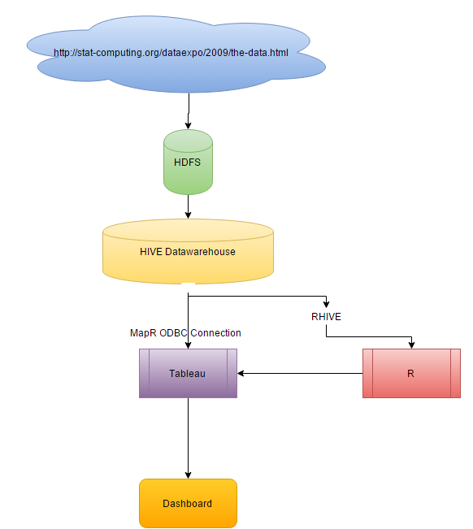
Figure: 1, Data flow diagram of ✈ dataset

Related Work

Before starting designing dashboards, an online survey was carried out to find best practices to build effective dashboards. During this survey we found some interesting golden rules to follow while designing dashboard [4], these are:
- Prioritize through positioning: A dashboard displays data through charts and gauges, but not all data is equally important. Certain data might be extremely important and it might be that the rest of the information that is displayed on the dashboard can only be comprehended if this data is analysed first. Under such circumstances a dashboard designer must position the important chart to the top-left corner of the dashboard, since this region receives the preliminary attention of a viewer (F-Shaped Pattern).
- Facilitate comparative analysis: In case you have two charts that are meant to be contrasted, then it is best to arrange them side by side. This arrangement signifies the need for comparison.
- Customize chart scale for optimal data presentation: Sometimes the data displayed on a chart has a very narrow range. This makes the task of analysing the data a lot difficult. Such situations call for manipulation of the chart scale. The chart scale should be adjusted so that, its lower limit and upper limit are close to the lower and upper limit of the data range. This adjustment will help in accentuating the ups and downs of the plotted data, thereby making analysis easier.
- Appropriate selection of charts: For maximum impact, it is essential that you choose the right chart for you data. The pie chart is often used inappropriately. A pie chart is actually meant for plotting percentages but, it is sometimes used for plotting non-percentage data such as sales, revenue, quantity etc.
- Proper formatting of numbers: It doesn't make sense to have a chart that displays numbers with unnecessary accuracy. If the chart is cluttered with very large numbers. So, it is best to restrict the number of decimal places to 1 or 2. And, scale large numbers by defining a proper scaling parameter. The K,M scale can be applied to financial charts to scale down numbers which are greater than thousand and million.
- Data-Ink ratio: The Data-Ink ratio is a concept introduced by Edward Tufte in 1983. The data-ink ratio is the proportion of Ink that is used to present actual data compared to the total amount of ink (or pixels) used in the entire display. Good graphics should include only data-Ink. Non-Data-Ink is to be deleted everywhere where possible. The reason for this is to avoid drawing the attention of viewers of the data presentation to irrelevant elements. The goal is to design a display with the highest possible data-ink ratio without eliminating something that is necessary for effective communication [2].
- Chartjunk: The term chartjunk was also coined by Edward Tufte in 1983. Chartjunk is a term for unnecessary or confusing visual elements in charts and graphs. Markings and visual elements can be called chartjunk if they are not part of the minimum set of visuals necessary to communicate the information understandably. Examples of unnecessary elements which might be called chartjunk include heavy or dark grid lines, ornamented chart axes and display frames, pictures or icons within data graphs, and ornamental shading [3].
- Overlay Types: Kong & Agrawal in 2012 introduce graphical overlays—visual elements that are layered onto charts to facilitate a larger set of chart reading tasks. These overlays directly support the lower-level perceptual and cognitive processes that viewers must perform to read a chart. Five main types of overlays are (1) reference structures such as gridlines, (2) highlights such as outlines around important marks, (3) redundant encodings such as numerical data labels, (4) summary statistics such as the mean or max and (5) annotations such as descriptive text for context [1].

Implementation of visual representations

Flight cancelation analysis

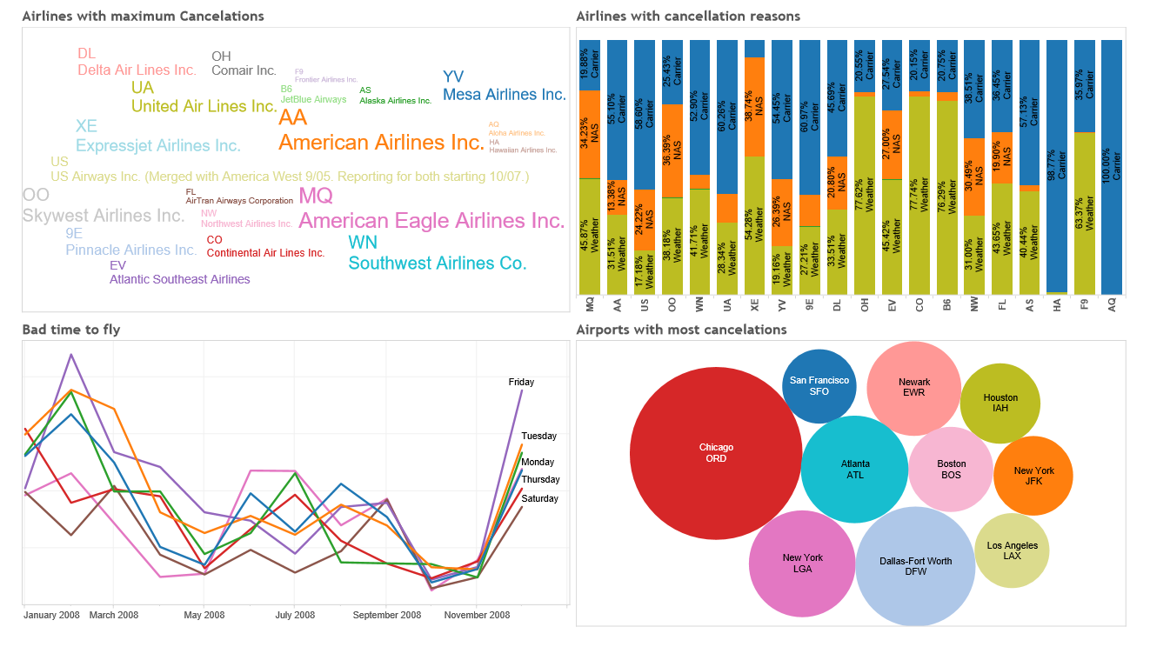
Fig: 1 Dashboard with flights cancelation analysis
- Purpose of the Dashboard: Flight cancelation is serious concern, which can lead to a big
lose in terms of money and time. If there is any cancelation then reason of cancellation is also
very important. Goal of these dashboards is to answer some of the common questions in less
than 30 sec. These questions are:
Which Airport had maximum cancelations in one year?
Which Airlines had maximum cancelations in one year?
When were the most flight cancelations in one year?
What were the common reasons of the cancellations?
Target Audience: Dashboards are designed for common public, who intend to book flight
for their next travel. These people don’t have much time to interact with the dashboards, so
no interactivity is provided.
Results: American eagle airlines had maximum cancelations and these cancelation were due
to bad weather and carrier delay. Avoid AQ completely which had all the delays due to bad
carrier performance. Friday is not a good day to fly. There was a peek in flights cancelation in
the month of Feb 2008 and in Dec 2008. Chicago (ORD) and NY (LGA) had maximum
cancelations.
Prioritize through positioning: Word cloud chart is placed on top left corner, representing
very important information like which airlines had maximum. Word cloud chart is used as it
is the modest way to represent any information, these charts are easy to read and understand.
Facilitate comparative analysis: These two dashboards are places next to each other in the
final story points, as they are built for same type of audience and represent contrast in the
dataset. Which airlines had maximum cancelation and which airlines had good performance
in terms of on time arrivals.
Customize chart scale for optimal data presentation: Chart scales are omitted as they are
not relevant to the information presented in the charts.
Appropriate selection of charts: Charts used in the two dashboards in fig 1 and fig2 were
selected to answer basic question asked by any traveller with no interactivity.
Proper formatting of numbers: Number formatting was used in Top Right chart in
dashboard 1 to show percentage of cancellation, this was used to represent clear
understanding of amount of cancelation and to avoid clutter caused by using the big real
numbers.
Data-Ink ratio: Data to ink ratio is very well kept in mind while designing all the charts
except for chart number 2 in dashboard 1. This was done to represent verity on the
dashboards.
Chartjunk: Chartjunks can be seen in 100% bar chart. This is to give some attractive looks
to the dashboards.
Overlay types used: Highlighting key information using bright colours is the only overlay
techniques used. Size of the bubble in bubble chart and size of the word in the word cloud is
used to represent number of flights under each category.
- There is no interactivity on this dashboards so these can be placed on the company web page
or newspaper articles.
- Purpose of the Dashboard: Flight cancelation is serious concern, which can lead to a big
lose in terms of money and time. If there is any cancelation then reason of cancellation is also
very important. Goal of these dashboards is to answer some of the common questions in less
than 30 sec. These questions are:
Which Airport had maximum cancelations in one year?
Which Airlines had maximum cancelations in one year?
When were the most flight cancelations in one year?
What were the common reasons of the cancellations?
Target Audience: Dashboards are designed for common public, who intend to book flight
for their next travel. These people don’t have much time to interact with the dashboards, so
no interactivity is provided.
Results: American eagle airlines had maximum cancelations and these cancelation were due
to bad weather and carrier delay. Avoid AQ completely which had all the delays due to bad
carrier performance. Friday is not a good day to fly. There was a peek in flights cancelation in
the month of Feb 2008 and in Dec 2008. Chicago (ORD) and NY (LGA) had maximum
cancelations.
Prioritize through positioning: Word cloud chart is placed on top left corner, representing
very important information like which airlines had maximum. Word cloud chart is used as it
is the modest way to represent any information, these charts are easy to read and understand.
Facilitate comparative analysis: These two dashboards are places next to each other in the
final story points, as they are built for same type of audience and represent contrast in the
dataset. Which airlines had maximum cancelation and which airlines had good performance
in terms of on time arrivals.
Customize chart scale for optimal data presentation: Chart scales are omitted as they are
not relevant to the information presented in the charts.
Appropriate selection of charts: Charts used in the two dashboards in fig 1 and fig2 were
selected to answer basic question asked by any traveller with no interactivity.
Proper formatting of numbers: Number formatting was used in Top Right chart in
dashboard 1 to show percentage of cancellation, this was used to represent clear
understanding of amount of cancelation and to avoid clutter caused by using the big real
numbers.
Data-Ink ratio: Data to ink ratio is very well kept in mind while designing all the charts
except for chart number 2 in dashboard 1. This was done to represent verity on the
dashboards.
Chartjunk: Chartjunks can be seen in 100% bar chart. This is to give some attractive looks
to the dashboards.
Overlay types used: Highlighting key information using bright colours is the only overlay
techniques used. Size of the bubble in bubble chart and size of the word in the word cloud is
used to represent number of flights under each category.
- There is no interactivity on this dashboards so these can be placed on the company web page
or newspaper articles.
Purpose of the Dashboard: Flight cancelation is serious concern, which can lead to a big lose in terms of money and time. If there is any cancelation then reason of cancellation is also very important. Goal of these dashboards is to answer some of the common questions in less than 30 sec. These questions are:

Which Airport had maximum cancelations in one year?
Which Airlines had maximum cancelations in one year?
When were the most flight cancelations in one year?
What were the common reasons of the cancellations?

Target Audience: Dashboards are designed for common public, who intend to book flight for their next travel. These people don’t have much time to interact with the dashboards, so no interactivity is provided.
 | Variables Used | Description | Type | Used As
1 | FlightDate | Date | Continuous | Axis in timeline Chart
2 | UniqueCarrier | unique carrier code | Categorical | Colour hue , Mark
3 | Origin | origin IATA airport code | Categorical | Colour hue
4 | Cancelled | was the flight cancelled? | Discrete | Filter
5 | CancellationCode | reason for cancellation (A = carrier, B = weather, C = NAS, D = security) | Categorical | Colour in the Bars
6 | Number of Flights | Number | Continuous | Size of Bouble , Size of Words
7 | DayOfWeek | 1 (Monday) - 7 (Sunday) | Discrete | Colour of Lines (hue)

Results: American eagle airlines had maximum cancelations and these cancelation were due to bad weather and carrier delay. Avoid AQ completely which had all the delays due to bad carrier performance. Friday is not a good day to fly. There was a peek in flights cancelation in the month of Feb 2008 and in Dec 2008. Chicago (ORD) and NY (LGA) had maximum cancelations.
Prioritize through positioning: Word cloud chart is placed on top left corner, representing very important information like which airlines had maximum. Word cloud chart is used as it is the modest way to represent any information, these charts are easy to read and understand.
Facilitate comparative analysis: These two dashboards are places next to each other in the
final story points, as they are built for same type of audience and represent contrast in the dataset. Which airlines had maximum cancelation and which airlines had good performance in terms of on time arrivals.
Customize chart scale for optimal data presentation: Chart scales are omitted as they are not relevant to the information presented in the charts.
Appropriate selection of charts: Charts used in the two dashboards in fig 1 and fig2 were selected to answer basic question asked by any traveller with no interactivity.
Proper formatting of numbers: Number formatting was used in Top Right chart in dashboard 1 to show percentage of cancellation, this was used to represent clear understanding of amount of cancelation and to avoid clutter caused by using the big real numbers.
Data-Ink ratio: Data to ink ratio is very well kept in mind while designing all the charts except for chart number 2 in dashboard 1. This was done to represent verity on the dashboards.
Chartjunk: Chartjunks can be seen in 100% bar chart. This is to give some attractive looks to the dashboards.
Overlay types used: Highlighting key information using bright colours is the only overlay techniques used. Size of the bubble in bubble chart and size of the word in the word cloud is used to represent number of flights under each category.
There is no interactivity on this dashboards so these can be placed on the company web page or newspaper articles.

On time Flights analysis

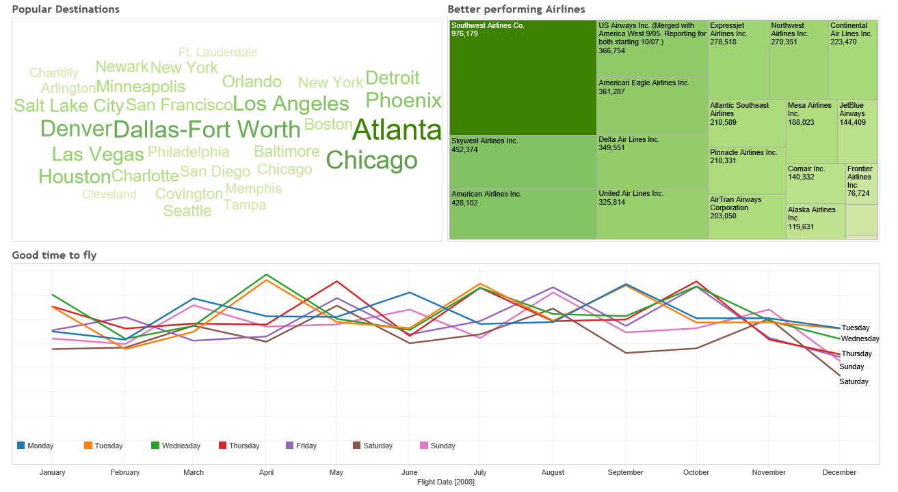
Fig: 2 Dashboard with flights on-time analysis

Purpose: While booking your flight, we are always concerned of few factors in case to make our travel peaceful. These are choice of good airlines, better airport, and good time to fly. Goal of these dashboards was to answer some of the common questions in less than 30 sec. These questions are,

Which airline is the biggest and had flight arrivals on time?
Which airport performed better in terms on-time arrivals?
What is the good time to fly in the whole year?

Target Audience: Dashboards are designed for common public, who intend to book flight for their next travel. These people don’t have much time to interact with the dashboards, so interactivity is provided.
 | Variables Used | Description | Type | Used As
1 | FlightDate | Date | Continuous | Axis in time Series Chart
2 | UniqueCarrier | unique carrier code | Categorical | Colour , Mark
3 | Origin | origin IATA airport code | Categorical | Colour
4 | Number of Flights | Number | Continuous | Size of Words , Size of Box , Colour of the Words from light to Dark ( hue , saturation)
5 | DayOfWeek | 1 (Monday) - 7 (Sunday) | Discrete | Colour of Lines

Results: Prefer Southwest airlines with 18% of market share of on line flights. Atlanta airport has most number of on-time flights. Fly in April, May, and September for uninterrupted travel.
Prioritize through positioning: Word cloud chart is placed on top left corner, representing very important information like which airport had maximum on time flight arrivals. These charts are easy to read and understand. Line chart need long space so it is placed at the bottom.
Facilitate comparative analysis: These two dashboards are places next to each other in the final story points, as they are built for same type of audience and represent contrast in the dataset. Which airlines had maximum cancelation and which airlines had good performance in terms of on time arrivals.
Customize chart scale for optimal data presentation: Chart scales are omitted as they are not relevant to the information presented in the charts.
Appropriate selection of charts: Charts used in Fig. 2 were selected to answer basic question asked by any traveller while booking next flight.
Proper formatting of numbers: Number formatting was used in Top Right corner in dashboard 2 to show percentage of market share of each airlines.
Data-Ink ratio: Data to ink ratio is very well kept in mind while designing all the charts except for the tree map chart on top right corner of the dashboard 2. This was done to represent verity on the dashboards.
Chartjunk: Chartjunks can be seen Tree Map in dashboard 2. This is due to give some attractive looks to the dashboards.
Overlay types used: Highlighting key information using bright colours is the only overlay techniques used. Size of the box in tree map chart and size of the word in the word cloud is used to represent number of flights under each category.
There is no interactivity on this dashboards so these can be placed on the company web page or newspaper articles.

Flight delay analysis

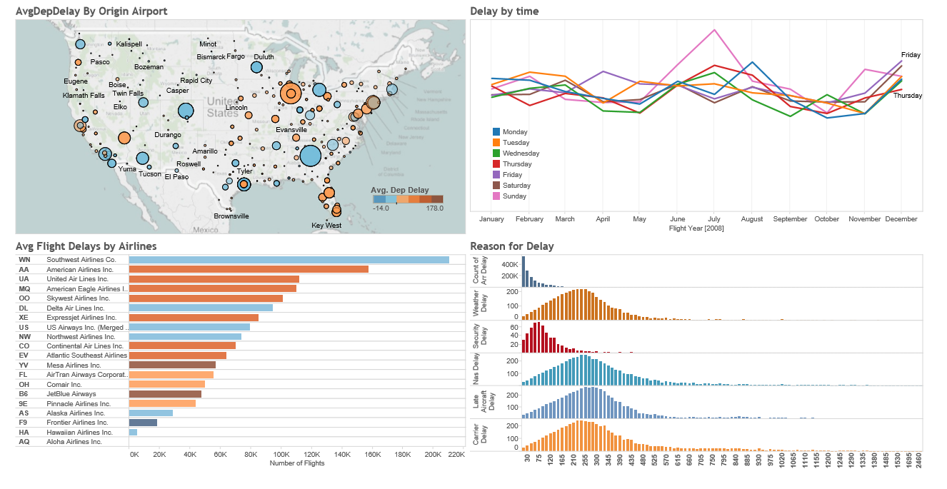
Fig: 3 Dashboard with flights delay analysis
Purpose of the Dashboard: These dashboards were created to answer questions which airport had maximum delays, what time of the year there were maximum delays, what were the various reasons of the delay, which airlines had maximum delays.
Target Audience: Dash boards in Fig. 3 is build keeping business users in mind who wants to know more than just 4 basic questions. These people wants to interact with the dashboard using filters and actions.
 | Variables Used | Description | Type | Used As
1 | FlightDate | Date | Continuous | Axis in time Series Chart , Position
2 | UniqueCarrier | unique carrier code | Categorical | Colour in the Bars , Mark
3 | Origin | origin IATA airport code | Categorical | Position on Map , Glut Due to number of Circles
4 | Number of Flights | Number | Continuous | Size of Circle on Map , Size of Bars , ( hue , saturation)
5 | DayOfWeek | 1 (Monday) - 7 (Sunday) | Discrete | Colour of Lines
6 | ArrDelay | arrival delay, in minutes | Continuous | Colour of Bar and Colour of Circles on Map
7 | CarrierDelay | in minutes | Continuous | Distribution in Histogram , Colour
8 | WeatherDelay | in minutes | Continuous | Distribution in Histogram , Colour
9 | NASDelay | in minutes | Continuous | Distribution in Histogram , Colour
10 | SecurityDelay | in minutes | Continuous | Distribution in Histogram , Colour
11 | LateAircraftDelay | in minutes | Continuous | Distribution in Histogram , Colour

Results Southwest airline having most number of flights. Mesa airlines and JetBlue airlines with most delays. Chicago airport and New York (JFK), Las Vegas, Sen Francisco, Orlando with most delays, it is obvious as these are most favourite tourist places. There is a peak on 1st july 2008, that could be due to first day of summer holidays in schools. Friday has largest probability of delayed flights. December, June and July have largest percentage of delayed flights. Security delay is the main cause of most of the delays.
Prioritize through positioning: US map is used in the first chart in the dashboard 1, as it is easy to relate with human perception and is placed on the top left corner. This makes the whole dashboard very interesting. After looking at this chart first user can easily understand the problem discussed on high level. It creates interest in user to read other charts to know more about the main problem.
Appropriate selection of charts: Careful selection of chart was made keeping business users as audience and also show verity at the same time. Map is selected to show relative position of the airports. Histogram is used to show distribution of various delays.
Proper formatting of numbers: Number are not used to save space on the charts.
Data-Ink ratio: Data to ink ratio is maintained.
Chartjunk: Chartjunks are kept under control.
Overlay types used: Dim grid lines are used where ever require, colour is used to differentiate between different airlines and airports. Size is used to sow different number of flights.
Interactivity: Filter other charts based on the airline selected.
These dashboards are designed for company internal websites, where employees would want to interact with the dashboard to find more information.

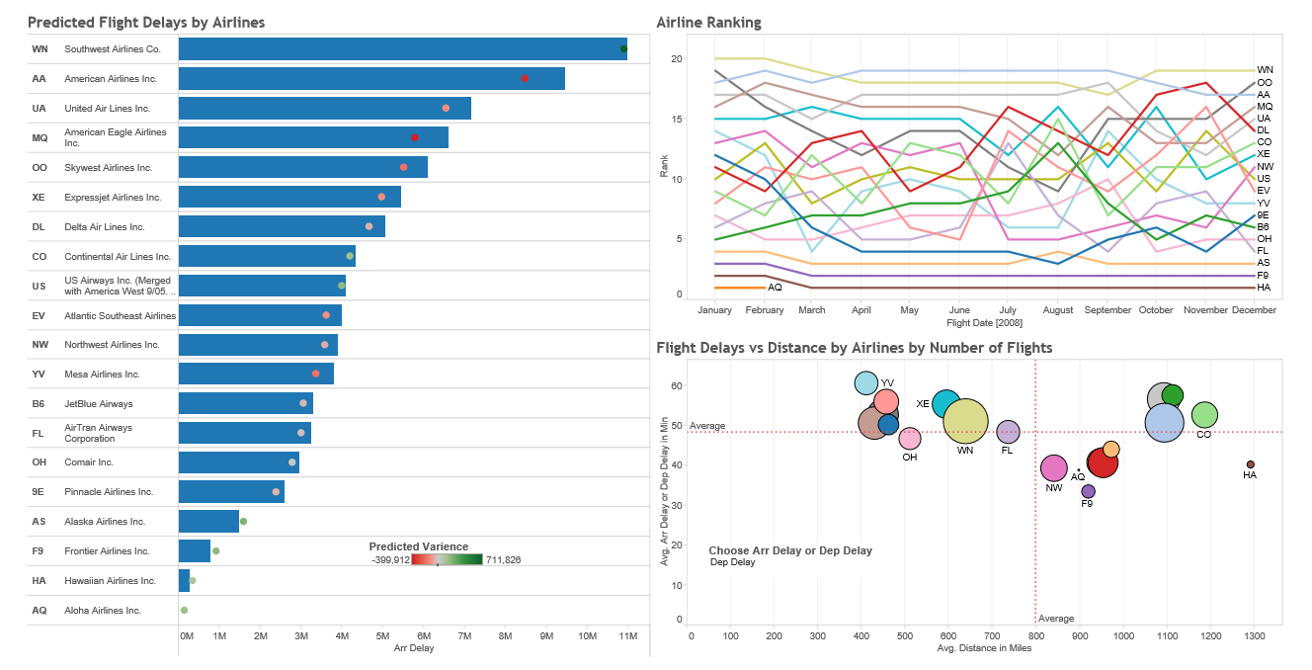

Fig: 4 Dashboard with Airlines performance and predicted flight delays.
Purpose of the Dashboard: These dashboards were created to answer questions like what is the ranking of each airlines in terms of average departure delays. To see predicted delay for each airlines and find dependency of delay based on the distance of the flight.
Target Audience: Dashboard is build keeping business users in mind who wants to know more than just 4 basic questions. These people wants to interact with the dashboard using filters and actions.
 | Variables Used | Description | Type | Used As
1 | FlightDate | Date | Continuous | Axis in Rank Chart , Position
2 | UniqueCarrier | unique carrier code | Categorical | Colour of Circles , Colour of Rank Lines , Position on Bar Chart
3 | Number of Flights | Number | Continuous | Size of Circle in scatter plot , Size of Bars ,
4 | Rank | 1 - 20 | Order | Position in Rank Chart
5 | Predicted Delay | in Minutes | Continuous | Position and colour of circles on the bar chart ( hue , saturation)
6 | Distance | in miles | Continuous | Position on the Scatter Plot
7 | ArrDelay | arrival delay, in minutes | Continuous | Position on the Scatter Plot
8 | DepDelay | Departure delay, in minutes | Continuous | Position on the Scatter Plot

Predicted Delay was calculated using R script -- SCRIPT_REAL( "fit <- lm(.arg1 ~ .arg2 + .arg3 + .arg4) fit$fitted",
SUM([Arr Delay]),
SUM([Dep Delay]),
SUM([Distance]),
SUM([Air Time])
)
Results: Overall performance of Southwest Airlines is the best and in the most popular airlines. Predicted delay for these airlines is very close the actual delays. Hawaiian Airlines are the farthest distance airlines with avg delay of 40.05 mins. Mesa Airlines have maximum delays and are short distance flights. Aloha Airlines only operated till Feb 2008. Increasing delays for small carriers, except for Aloha. Delta and US Airways are improving. Prediction of delay is very close to the actual delay.
Prioritize through positioning: Chart with Predicted delay has airlines description which is very important to understand rest of the chart, so it placed on top left corner of the dashboard.
Facilitate comparative analysis: Rank function in tableau is used to show ranking of the airlines in terms of airlines delays.
Appropriate selection of charts: Careful selection of chart was made keeping business users as audience and also show verity at the same time. Bar chart is a very good representation for comparing actual and predicted values.
Proper formatting of numbers: Numbers are not used instead size of the circle is used to represent number of flights.
Data-Ink ratio: Data to ink ratio is maintained on each chart.
Chartjunk: Chartjunks are kept under control.
Overlay types used: Dim grid lines are used where ever require, colour is used to differentiate between different airlines. Size is used to sow different number of flights under each category (airlines).
Parameters and Filters are used to give interactivity. Parameter created to change the axis of the chart.
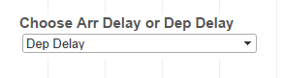
These dashboards are designed for company internal websites, where employees would want to interact with the dashboard to find more information.

Deep dive into flight delay cause analysis

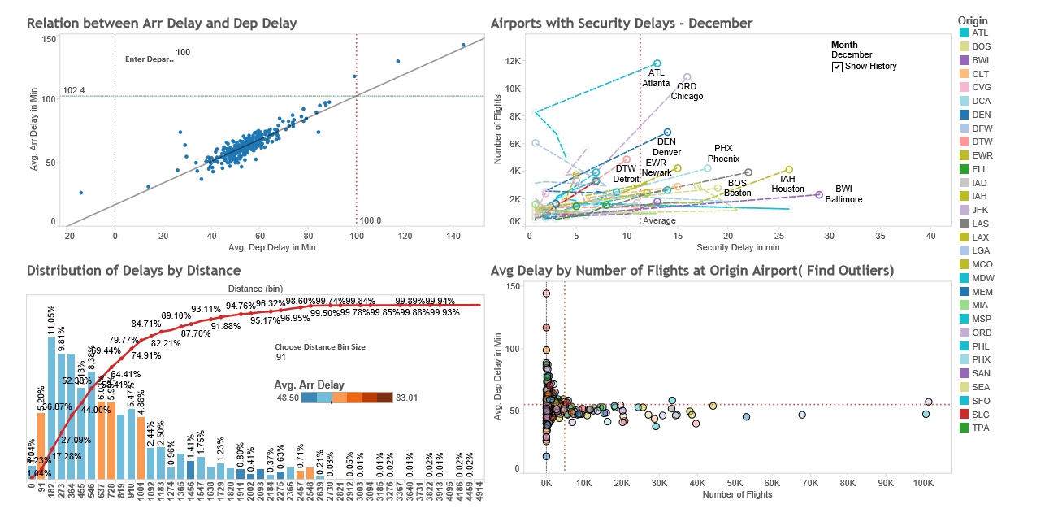
Fig: 5 Dashboard with deep dive into flights delays with a good example of chartjunk( Glut) , animation on 2 chart reduces the clarity of the data on the chart.
Purpose of the Dashboard: Dashboards in Figure 5 is designed to answer some advance questions like:
Predict future flight delays based on the past historical information. Which airports have more security delays? Does number of flights effect security delays? Is the airports facing problem in departure delays due to heavy traffic of flights on that airport?
Target Audience: Dashboards in figure 5 is build keeping industry experts in mind who are interested in finding hidden insights in the dataset. These people have statistical knowledge and understand statistical functions. These people have clear understanding of regression and scatter plots, outliers, and histograms distributions.

 | Variables Used | Description | Type | Used As
1 | Origin | origin IATA airport code | Categorical | Colour of Circles in 3 scatter plots
2 | Number of Flights | Number | Continuous | Size of Bar in Histogram , Position in the Scatter plots
4 | Predicted Delay | in Minutes | Continuous | Position on the Scatter Plot
5 | Distance | in miles | Continuous | Position on the histogram
6 | ArrDelay | arrival delay, in minutes | Continuous | Position on the Scatter Plot, Colour of Bars in Histogram ( hue , saturation)
7 | DepDelay | Departure delay, in minutes | Continuous | Position on the Scatter Plot
8 | SecurityDelay | in minutes | Continuous | Position on the Scatter Plot
9 | Running Total | in % | Continuous | Position on the histogram

Results: ATL (Newark) is the worst. ORD (Chicago O’Hare) is not good, but also has high volume. DFW (Dallas-Fort Worth) is relatively good - high traffic but relatively small delay. Weather plays a huge role in delays - any kind of precipitation, high winds, or reduced visibility increases delays (scatterplots above). Short distance flights are performing bad.
Regression analysis is performed using scatter plot. Arrival delay is closely related to departure delay with some outliers like TUP where arrival delay is negative. Delays at PUB, BJI, PIR Airport are more than expected delay, there are other factors effecting flight delays.
Trend Line on the chart is used to predict fure delays. P value < 0.0001 shows the model is good predictor. R Square is 0.809.
Used Calculated Field --
Predicted Arival Delay = (0.856761*[Enter Departure Delay]) + 16.75
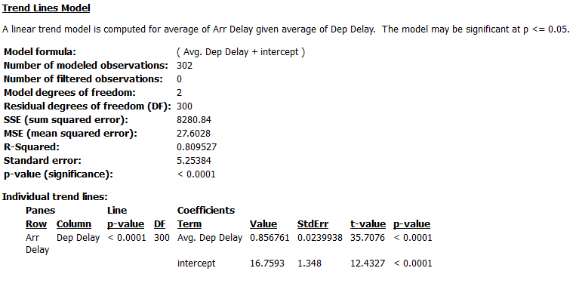
Most of the market share is for short distance flights, delays is more for very short distance flights.
Prioritize through positioning: Linear Regression analysis in very interesting chart catching attention of all statisticians. Next chart is animation chart showing trend of delays on various airport.
Facilitate comparative analysis: charts on dashboard 6 are placed on top of each other as both compares flight delays over the same time period.
Appropriate selection of charts: Regression analysis and scatter plot goes hand in hand. Distribution and histogram is very good representation.
Proper formatting of numbers: Number formatting is used to save space on the chart.
Data-Ink ratio: Data to ink ratio is maintained.
Chartjunk: Animation and colour in scatter plot is compromise to chart glut.
Overlay Types used: Highlights, gridlines, labels and average reference lines are extensively used. Annotation is used in the second chart in dashboard 5 to draw attention onto the outliers.
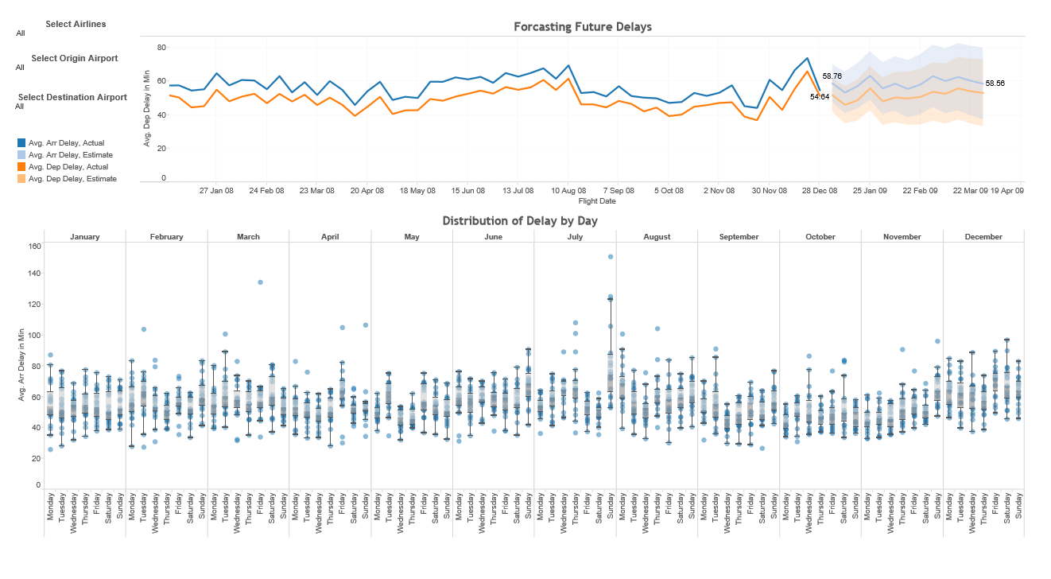
Fig: 6 Dashboard is showing trend, seasonality, forecasting and outliers in the flight dataset.

Purpose of the Dashboard: Dashboards in Figure 6 is designed to answer some advance questions like: Find daily outliers in terms of time. Find average delays during public holidays in US? What is the trend in delay from time to time? Find trends in arrival delay and departure delays and try to forecast future delays.
Target Audience: Dashboards in Figure 6 is build keeping industry experts in mind who are interested in finding hidden insights in the dataset. These people have statistical knowledge and understand statistical functions. These people have clear understanding of box plots and trend lines.
 | Variables Used | Description | Type | Used As
1 | FlightDate | Date | Continuous | Axis in timeline Chart , Position
2 | UniqueCarrier | unique carrier code | Categorical | Filter
3 | Origin | origin IATA airport code | Categorical | Filter
4 | Dest | Dest IATA airport code | Categorical | Filter
5 | DayOfWeek | 1 (Monday) - 7 (Sunday) | Discrete | Position in Box Plot
6 | Month | 1-12 | Discrete | Position in Box Plot
7 | Dep Delay | In Mins | Continuous | Position on time series, hue

Results:
In July on Sunday we see maximum delays and with outlier AirTran airlines with avg arrival delay of 151 mins. In march HA airlines with maximum delays of around 134 mins. 21st Dec with maximum delays. There is saviour delays expected on 25th Jan 2009.
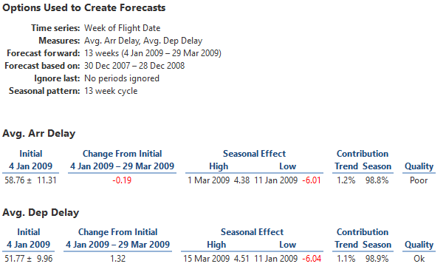

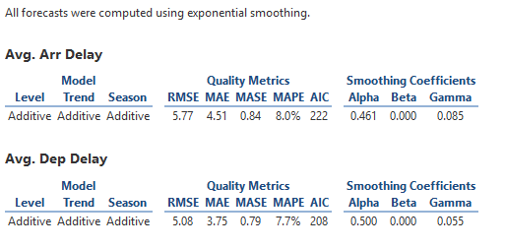
Prioritize through positioning: Forecasting is an interesting topic, therefor is placed on top left corner of the dashboard.
Facilitate comparative analysis: charts on dashboard 6 are placed on top of each other as both compares flight delays over the same time period.
Customize chart scale for optimal data presentation:
Appropriate selection of charts: For forecasting line chart is the best option. Box plot with time gives in depth analysis.
Proper formatting of numbers: Numbers are formatted to 2 decimal places.
Data-Ink ratio: Data to ink ratio is maintained.
Chartjunk: Due to using colours in the boxplot distribution of data points is not very clear.
Overlay Types used: Colours, gridlines, labels and average reference lines are used.
Level of difficulty of these dashboards is higher are only specific type of audience, so cannot be placed in any website, these for the experts.

Analysis done using R
# hist, plot, boxplot
# basic syntax of ggplot

# ggplot(dataframe, aesthetics = x coordinate, y coordinate, shape) + layer = geom_XYZ XYZ {bar, histogram}
ggplot(DF, aes(x = UniqueCarrier)) + geom_bar()

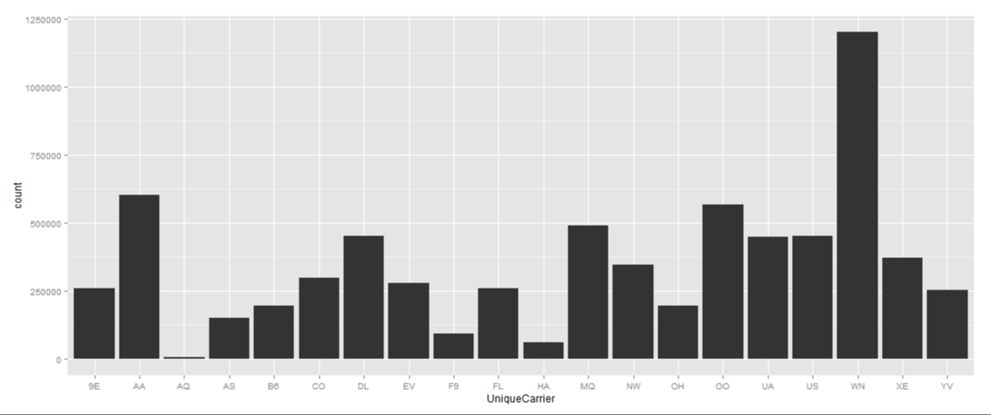

# stacked barchart - carrier & cancellationcode
ggplot(DF, aes(x = UniqueCarrier, fill = CancellationCode)) + geom_bar()
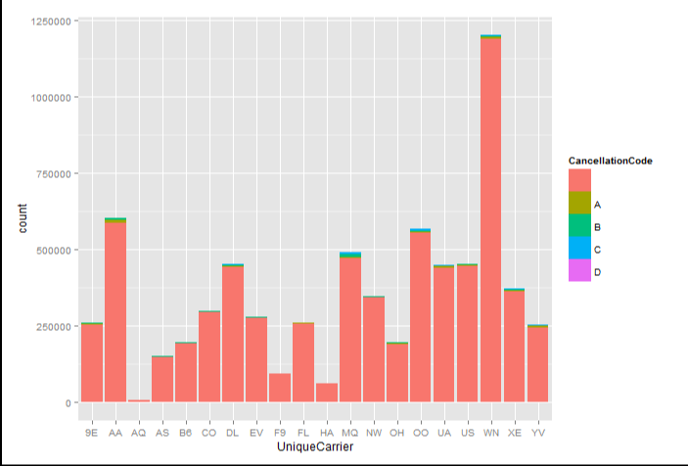
# stacked with proportion
ggplot(DF, aes(x = UniqueCarrier, fill = CancellationCode)) + geom_bar(position="fill")
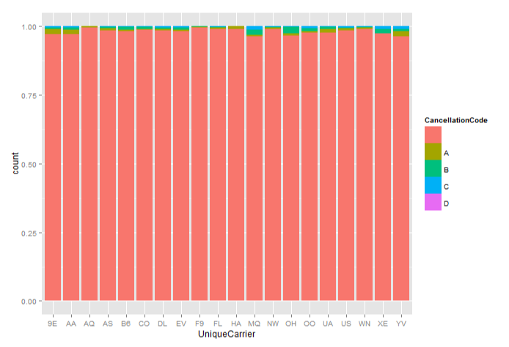
# histogram (1 quantative variable)
ggplot(DF, aes(x = Distance)) + geom_histogram()
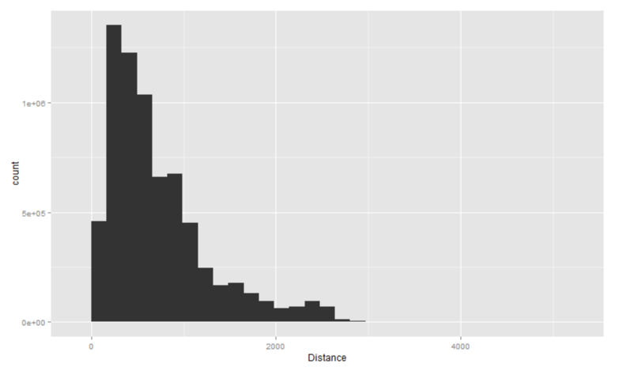
## stat_bin: binwidth defaulted to range/30. Use 'binwidth = x' to adjust this

ggplot(DF, aes(x = Distance)) + geom_histogram(binwidth = 100)
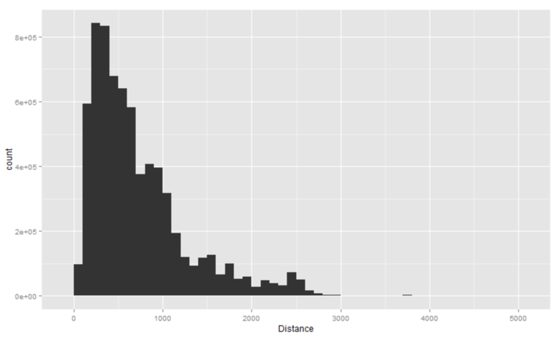

Presentation of the final work

Interactive version of the design highlighted in the above section is represented in form of a story using story feature in Tableau. A story in tableau is a sheet that contains a sequence of worksheets or dashboards that work together to convey information. It is a very good collaborative visualization representation of the work for the management in the company. Story is used to show how the level of difficulty in the dashboard increases from dashboard 1 to dashboard 6. All dashboards are designed based on same dataset, but are designed with different types of the audience. Level of difficulty to read the information increase from dashboard 1 to dashboard 6. There are a number of design elements in the story which can be viewed on this given link. Figure 7 is pictorial representation of these features.

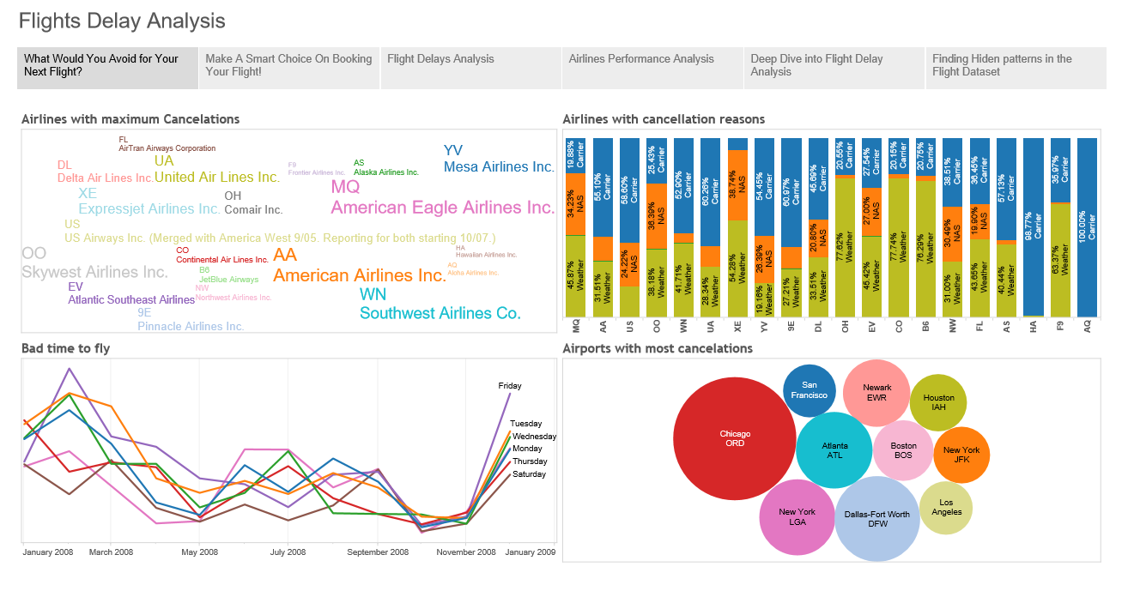
Fig: 7 Story with collaborative representation of all the dashboards created from Flights Delay Analysis.

Conclusion

Data is free but the information hiding in this data is priceless. In this project dataset which was free to download from internet was processed to find interesting insides of the ✈ delay. A picture is worth thousand words, so visual representations was created to share insights with different types of audience. There are some golden rules to keep in mind before designing any dashboard, these are know your audience , know what is the most important information for your target audience keep that information on top left corner of the dashboard. Use overlay techniques to draw attention of the viewer on the right place in the chart. Keep Data to ink ratio in mind while designing charts. Avoid Chartjunks. Dashboards are an important aspect of business management systems and they are referred to during planning and decision making process. Therefore, it is essential to make the dashboard uncluttered and user friendly.
Some more lessons were learned while working with large datasets. Hadoop worked well with this large dataset, queries were very slow in databases like Mysql. R server crashed many times. Charts drawn using R were not very interactive and not very informative. Many tools like Rapidminer failed to draw charts using this large dataset. Tableau worked very well for the dataset chosen and performance of the dashboards was phenomenal.

References
- Kong, N., & Agrawala, M. (2012). Graphical overlays: Using layered elements to aid chart reading. IEEE Transactions on Visualization and Computer Graphics, 18(12), 2631–2638. http://doi.org/10.1109/TVCG.2012.229
- Ward, Matthew, Georges Grinstein, and Daniel Keim. Interactive data visualization: foundations, techniques, and applications. AK Peters, Ltd., 2010
- Zoss, A. 2015, Introduction to Data Visualization: Visualization Types, Duke University Libraries
- DataLabs, 2015, 15 Most Common Types of Data Visualisation
- http://www.infovis-wiki.net/index.php/Data-Ink_Ratio
- https://en.wikipedia.org/wiki/Chartjunk
- http://www.dashboardinsight.com/articles/digital-dashboards/fundamentals/5-things-to-keep-in-mind-while-designing-a-digital-dashboard.aspx
- http://stat-computing.org/dataexpo/2009/posters/sun.pdf
- http://www.nngroup.com/articles/f-shaped-pattern-reading-web-content/
- http://stat-computing.org/dataexpo/2009/

Appendix

National federal holidays of USA in 2008
Day | Date | Holiday | Comments
Tuesday | January 01 | New Years Day
Monday | January 21 | Martin Luther King Day | Third Monday in January
Monday | February 18 | Presidents Day | Third Monday in February
Monday | May 26 | Memorial Day | Last Monday in May
Friday | July 04 | Independence Day
Monday | September 01 | Labor Day | First Monday in September
Monday | October 13 | Columbus Day | 2nd Monday in October
Tuesday | November 11 | Veterans Day
Thursday | November 27 | Thanksgiving | Fourth Thursday in November
Friday | November 28 | Day after Thanksgiving | Fourth Friday in November
Thursday | December 25 | Christmas Day

Test Results
drop table flight_data;
CREATE TABLE flight_data( year INT, month INT, day INT, day_of_week INT, dep_time INT, crs_dep_time INT, arr_time INT, crs_arr_time INT, unique_carrier VARCHAR(10), flight_num INT, tail_num VARCHAR(40), actual_elapsed_time INT, crs_elapsed_time INT, air_time INT, arr_delay INT, dep_delay INT, origin VARCHAR(10), dest VARCHAR(10), distance INT, taxi_in INT, taxi_out INT, cancelled INT, cancellation_code VARCHAR(10), diverted INT, carrier_delay VARCHAR(10), weather_delay VARCHAR(10), nas_delay VARCHAR(10), security_delay VARCHAR(10), late_aircraft_delay VARCHAR(10))
ROW FORMAT DELIMITED
FIELDS TERMINATED BY ','
LINES TERMINATED BY '\n'
STORED AS TEXTFILE;
LOAD DATA INPATH '/data/flight_data/2008.csv' into table flight_data;
SELECT CANCELLED, COUNT(*) AS TOTAL_FLIGHTS,ROUND(((COUNT(*)/7009728)*100),2) AS Perc_OF_TOTAL_FLIGHTS FROM flight_data GROUP BY CANCELLED;
0 6872294 98.04
1 137434 1.96
SELECT DIVERTED, COUNT(*) AS TOTAL_FLIGHTS ,ROUND(((COUNT(*)/7009728)*100),2) AS Perc_OF_TOTAL_FLIGHTS FROM flight_data GROUP BY DIVERTED;
0 6992463 99.75
1 17265 0.25
SELECT COUNT(*) AS TOTAL_FLIGHTS ,ROUND(((COUNT(*)/7009728)*100),2) AS Perc_OF_TOTAL_FLIGHTS FROM flight_data WHERE arr_delay > 15 ;
1466191 20.92
SELECT COUNT(*) AS TOTAL_FLIGHTS ,ROUND(((COUNT(*)/7009728)*100),2) AS Perc_OF_TOTAL_FLIGHTS FROM flight_data WHERE DEP_delay > 15 ;
1276396 18.21
SELECT COUNT(*) AS TOTAL_FLIGHTS ,ROUND(((COUNT(*)/7009728)*100),2) AS Perc_OF_TOTAL_FLIGHTS FROM flight_data WHERE arr_delay <= 15 AND arr_delay IS NOT NULL;
5388838 76.88
drop table FLIGHTS_CANCELLED;
CREATE TABLE FLIGHTS_CANCELLED AS SELECT CONCAT(CONCAT(CONCAT(CONCAT(DAY,'-'),MONTH),'-'),YEAR) AS FLIGHT_DATE , day, MONTH , DAY_OF_WEEK , unique_carrier , ORIGIN , DEST , cancellation_code FROM flight_data WHERE CANCELLED = 1;
SELECT UNIQUE_CARRIER, COUNT(*) AS TOTAL_FLIGHTS,ROUND(((COUNT(*)/137434)*100),2) AS Perc_OF_TOTAL_FLIGHTS FROM FLIGHTS_CANCELLED GROUP BY UNIQUE_CARRIER order by Perc_OF_TOTAL_FLIGHTS desc;
MQ 18331 13.34
AA 17440 12.69
OO 12436 9.05
WN 12389 9.01
UA 10541 7.67
XE 9992 7.27
YV 9219 6.71
9E 7100 5.17
DL 6813 4.96
US 6582 4.79
OH 6462 4.7
EV 5026 3.66
CO 3702 2.69
B6 3205 2.33
NW 2906 2.11
FL 2236 1.63
AS 2139 1.56
HA 570 0.41
F9 303 0.22
AQ 42 0.03
SELECT MONTH, COUNT(*) AS TOTAL_FLIGHTS,ROUND(((COUNT(*)/137434)*100),2) AS Perc_OF_TOTAL_FLIGHTS FROM FLIGHTS_CANCELLED GROUP BY MONTH order by Perc_OF_TOTAL_FLIGHTS desc;
2 20596 14.99
12 17779 12.94
1 17308 12.59
3 16183 11.78
6 10931 7.95
7 10598 7.71
4 10355 7.53
9 9913 7.21
8 9835 7.16
5 6229 4.53
11 4458 3.24
10 3249 2.36
SELECT DAY_OF_WEEK, COUNT(*) AS TOTAL_FLIGHTS,ROUND(((COUNT(*)/137434)*100),2) AS Perc_OF_TOTAL_FLIGHTS FROM FLIGHTS_CANCELLED GROUP BY DAY_OF_WEEK order by Perc_OF_TOTAL_FLIGHTS desc;
5 23962 17.44
2 23168 16.86
1 20513 14.93
3 20202 14.7
7 18138 13.2
4 17884 13.01
6 13567 9.87
SELECT ORIGIN, COUNT(*) AS TOTAL_FLIGHTS,ROUND(((COUNT(*)/137434)*100),2) AS Perc_OF_TOTAL_FLIGHTS FROM FLIGHTS_CANCELLED GROUP BY ORIGIN order by Perc_OF_TOTAL_FLIGHTS desc;
ORD 15050 10.95
DFW 7272 5.29
ATL 5830 4.24
LGA 5753 4.19
EWR 4511 3.28
BOS 3655 2.66
IAH 3261 2.37
JFK 3196 2.33
LAX 2838 2.06
SFO 2790 2.03
DCA 2735 1.99
DEN 2725 1.98
DTW 2583 1.88
IAD 2077 1.51
LAS 2057 1.5
CLT 1986 1.45
PHL 1969 1.43
PHX 1875 1.36
CVG 1853 1.35
MSP 1729 1.26
SELECT DEST, COUNT(*) AS TOTAL_FLIGHTS,ROUND(((COUNT(*)/137434)*100),2) AS Perc_OF_TOTAL_FLIGHTS FROM FLIGHTS_CANCELLED GROUP BY DEST order by Perc_OF_TOTAL_FLIGHTS desc limit 20;
ORD 16094 11.71
DFW 7716 5.61
ATL 6705 4.88
LGA 5721 4.16
EWR 4608 3.35
BOS 3601 2.62
IAH 3366 2.45
JFK 3200 2.33
LAX 3077 2.24
DTW 2995 2.18
DEN 2984 2.17
SFO 2984 2.17
DCA 2623 1.91
PHX 2554 1.86
CLT 2227 1.62
IAD 2210 1.61
CVG 2144 1.56
MSP 1988 1.45
PHL 1990 1.45
LAS 1805 1.31
SELECT cancellation_code, COUNT(*) AS TOTAL_FLIGHTS,ROUND(((COUNT(*)/137434)*100),2) AS Perc_OF_TOTAL_FLIGHTS FROM FLIGHTS_CANCELLED GROUP BY cancellation_code order by Perc_OF_TOTAL_FLIGHTS desc;
B 54904 39.95
A 54330 39.53
C 28188 20.51
D 12 0.01

drop table FLIGHTS_ON_TIME;
CREATE TABLE FLIGHTS_ON_TIME AS SELECT CONCAT(CONCAT(CONCAT(CONCAT(DAY,'-'),MONTH),'-'),YEAR) AS FLIGHT_DATE , day, MONTH , DAY_OF_WEEK , unique_carrier , ORIGIN , DEST , ARR_DELAY , DEP_DELAY FROM flight_data WHERE arr_delay <= 15 AND arr_delay IS NOT NULL;
SELECT UNIQUE_CARRIER, COUNT(*) AS TOTAL_FLIGHTS,ROUND(((COUNT(*)/5388838)*100),2) AS Perc_OF_TOTAL_FLIGHTS FROM FLIGHTS_ON_TIME GROUP BY UNIQUE_CARRIER order by Perc_OF_TOTAL_FLIGHTS desc;
WN 976179 18.11
OO 452374 8.39
AA 428102 7.94
US 366754 6.81
MQ 361287 6.7
DL 349551 6.49
UA 325814 6.05
XE 278518 5.17
NW 270351 5.02
CO 223470 4.15
EV 210589 3.91
9E 210331 3.9
FL 203050 3.77
YV 188023 3.49
B6 144409 2.68
OH 140332 2.6
AS 119631 2.22
F9 76724 1.42
HA 55967 1.04
AQ 7382 0.14
SELECT MONTH, COUNT(*) AS TOTAL_FLIGHTS,ROUND(((COUNT(*)/5388838)*100),2) AS Perc_OF_TOTAL_FLIGHTS FROM FLIGHTS_ON_TIME GROUP BY MONTH order by Perc_OF_TOTAL_FLIGHTS desc;
8 484800 9.0
5 484325 8.99
10 482378 8.95
7 480267 8.91
4 469710 8.72
9 462443 8.58
3 446837 8.29
1 443955 8.24
11 439743 8.16
6 436783 8.11
2 396241 7.35
12 361356 6.71
SELECT DAY_OF_WEEK, COUNT(*) AS TOTAL_FLIGHTS,ROUND(((COUNT(*)/5388838)*100),2) AS Perc_OF_TOTAL_FLIGHTS FROM FLIGHTS_ON_TIME GROUP BY DAY_OF_WEEK order by Perc_OF_TOTAL_FLIGHTS desc;
3 816393 15.15
2 800981 14.86
1 796946 14.79
4 790644 14.67
5 760134 14.11
7 743418 13.8
6 680322 12.62
SELECT ORIGIN, COUNT(*) AS TOTAL_FLIGHTS,ROUND(((COUNT(*)/5388838)*100),2) AS Perc_OF_TOTAL_FLIGHTS FROM FLIGHTS_ON_TIME GROUP BY ORIGIN order by Perc_OF_TOTAL_FLIGHTS desc;
ATL 306995 5.7
ORD 233115 4.33
DFW 205529 3.81
DEN 185065 3.43
LAX 174247 3.23
PHX 162509 3.02
IAH 142825 2.65
LAS 137240 2.55
DTW 119382 2.22
SLC 116760 2.17
SFO 104062 1.93
MCO 103711 1.92
MSP 99176 1.84
CLT 95184 1.77
EWR 89402 1.66
SEA 87366 1.62
BOS 86839 1.61
LGA 82183 1.53
BWI 82593 1.53
JFK 80966 1.5
SELECT DEST, COUNT(*) AS TOTAL_FLIGHTS,ROUND(((COUNT(*)/5388838)*100),2) AS Perc_OF_TOTAL_FLIGHTS FROM FLIGHTS_ON_TIME GROUP BY DEST order by Perc_OF_TOTAL_FLIGHTS desc limit 20;
ATL 316754 5.88
ORD 239876 4.45
DFW 216677 4.02
DEN 191420 3.55
LAX 167896 3.12
PHX 162889 3.02
IAH 146521 2.72
LAS 135961 2.52
DTW 130836 2.43
SLC 117289 2.18
MSP 104003 1.93
MCO 102918 1.91
CLT 99759 1.85
SFO 98292 1.82
EWR 87301 1.62
BOS 87433 1.62
BWI 84355 1.57
SEA 83609 1.55
JFK 82564 1.53
LGA 75949 1.41
drop table FLIGHTS_DELAYED;
CREATE TABLE FLIGHTS_DELAYED AS SELECT CONCAT(CONCAT(CONCAT(CONCAT(DAY,'-'),MONTH),'-'),YEAR) AS FLIGHT_DATE ,day, MONTH , DAY_OF_WEEK , unique_carrier ,Distance, ORIGIN , DEST , ARR_DELAY , DEP_DELAY, dep_time , arr_time ,air_time, carrier_delay ,weather_delay, nas_delay, security_delay, late_aircraft_delay FROM flight_data WHERE arr_delay > 15;
SELECT UNIQUE_CARRIER, COUNT(*) AS TOTAL_FLIGHTS,ROUND(((COUNT(*)/1466191)*100),2) AS Perc_OF_TOTAL_FLIGHTS FROM FLIGHTS_DELAYED GROUP BY UNIQUE_CARRIER order by Perc_OF_TOTAL_FLIGHTS desc;
WN 210732 14.37
AA 157383 10.73
UA 112165 7.65
MQ 109874 7.49
OO 101038 6.89
DL 94383 6.44
XE 84896 5.79
US 79332 5.41
NW 73759 5.03
CO 70385 4.8
EV 64278 4.38
YV 57108 3.89
FL 55663 3.8
OH 50363 3.43
B6 47705 3.25
9E 43991 3.0
AS 28861 1.97
F9 18660 1.27
HA 5245 0.36
AQ 370 0.03
SELECT MONTH, COUNT(*) AS TOTAL_FLIGHTS,ROUND(((COUNT(*)/1466191)*100),2) AS Perc_OF_TOTAL_FLIGHTS FROM FLIGHTS_DELAYED GROUP BY MONTH order by Perc_OF_TOTAL_FLIGHTS desc;
12 163391 11.14
6 158675 10.82
3 151506 10.33
2 150684 10.28
1 143175 9.77
7 135156 9.22
4 117013 7.98
8 115950 7.91
5 114885 7.84
11 78230 5.34
10 69693 4.75
9 67833 4.63
SELECT DAY_OF_WEEK, COUNT(*) AS TOTAL_FLIGHTS,ROUND(((COUNT(*)/1466191)*100),2) AS Perc_OF_TOTAL_FLIGHTS FROM FLIGHTS_DELAYED GROUP BY DAY_OF_WEEK order by Perc_OF_TOTAL_FLIGHTS desc;5 248738 16.96
4 221326 15.1
1 216464 14.76
7 212709 14.51
2 205011 13.98
3 200602 13.68
6 161341 11.0
SELECT ORIGIN, COUNT(*) AS TOTAL_FLIGHTS,ROUND(((COUNT(*)/1466191)*100),2) AS Perc_OF_TOTAL_FLIGHTS FROM FLIGHTS_DELAYED GROUP BY ORIGIN order by Perc_OF_TOTAL_FLIGHTS desc limit 20;
ORD 101414 6.92
ATL 100706 6.87
DFW 67845 4.63
DEN 53126 3.62
EWR 44269 3.02
DTW 39622 2.7
IAH 38578 2.63
LAX 38047 2.59
PHX 34582 2.36
JFK 34195 2.33
SFO 33393 2.28
LAS 33240 2.27
LGA 30929 2.11
MSP 29063 1.98
CLT 28598 1.95
BOS 27067 1.85
MCO 25681 1.75
PHL 24437 1.67
SLC 20824 1.42
SEA 20297 1.38

SELECT DEST, COUNT(*) AS TOTAL_FLIGHTS,ROUND(((COUNT(*)/1466191)*100),2) AS Perc_OF_TOTAL_FLIGHTS FROM FLIGHTS_DELAYED GROUP BY DEST order by Perc_OF_TOTAL_FLIGHTS desc limit 20;
ORD 93455 6.37
ATL 89990 6.14
DFW 55758 3.8
DEN 46682 3.18
EWR 46037 3.14
LAX 44475 3.03
SFO 39060 2.66
LGA 36746 2.51
LAS 34705 2.37
IAH 34504 2.35
PHX 33640 2.29
JFK 32508 2.22
DTW 27963 1.91
BOS 26727 1.82
MCO 26694 1.82
SEA 24128 1.65
MSP 24011 1.64
PHL 24021 1.64
CLT 23790 1.62
SLC 20281 1.38
/* Finding percentage of delays based on different factors */
SELECT MONTH, COUNT(*) AS TOTAL_FLIGHTS, round(avg(arr_delay),2) AS AVG_DELAYS FROM FLIGHTS_DELAYED GROUP BY MONTH order by AVG_DELAYS desc;
7 135156 64.31
12 163391 64.08
6 158675 61.69
8 115950 60.61
2 150684 59.32
1 143175 57.85
3 151506 57.83
11 78230 54.5
4 117013 54.41
5 114885 53.4
9 67833 52.84
10 69693 49.5
SELECT UNIQUE_CARRIER, COUNT(*) AS TOTAL_FLIGHTS, round(avg(arr_delay),2) AS AVG_DELAYS FROM FLIGHTS_DELAYED GROUP BY UNIQUE_CARRIER order by AVG_DELAYS desc;
B6 47705 69.49
YV 57108 66.43
XE 84896 64.45
UA 112165 63.82
EV 64278 62.3
CO 70385 61.66
OO 101038 60.57
AA 157383 60.26
MQ 109874 60.24
9E 43991 59.15
OH 50363 59.02
FL 55663 58.35
DL 94383 53.59
NW 73759 52.86
WN 210732 52.16
US 79332 51.84
AS 28861 51.53
HA 5245 51.09
F9 18660 42.88
AQ 370 41.67
SELECT ORIGIN, COUNT(*) AS TOTAL_FLIGHTS, round(avg(dep_delay),2) AS AVG_dep_DELAYS FROM FLIGHTS_DELAYED GROUP BY ORIGIN order by AVG_dep_DELAYS desc limit 30;
ACY 14 144.14
CMX 33 117.15
PIR 1 99.0
ALO 27 88.67
SPI 333 87.2
PLN 22 86.91
MOT 115 84.66
SLE 22 84.27
ABI 293 83.38
HHH 172 79.09
CIC 331 78.11
EGE 752 78.11
ACK 157 77.09
LNK 572 74.21
GUC 218 74.04
CEC 378 73.92
RDD 414 73.79
LMT 150 73.43
MQT 182 73.42
SBN 1186 72.22
SGF 2057 71.78
ACV 888 70.72
MBS 497 69.61
LCH 141 68.1
YAK 153 67.88
CWA 521 67.48
SBP 855 67.43
ROA 725 67.14
BGM 108 66.99
BPT 16 66.88
SELECT DEST, COUNT(*) AS TOTAL_FLIGHTS, round(avg(arr_delay),2) AS AVG_arr_DELAYS FROM FLIGHTS_DELAYED GROUP BY DEST order by AVG_arr_DELAYS desc;
MQT 352 94.3
SPI 357 80.5
ALO 50 76.24
EWR 46037 75.93
MCN 158 75.92
ORD 93455 73.94
MEI 118 72.95
TEX 28 72.5
CMX 49 72.08
CIC 430 71.79
LMT 136 71.7
ADQ 72 70.25
LNK 624 69.39
CEC 289 69.12
JFK 32508 68.62
ACY 24 68.46
AVP 584 67.14
BPT 45 66.58
CDV 191 66.28
BQN 410 65.87
HHH 234 65.87
CMI 799 65.74
CAE 2730 65.54
CRW 671 65.54
IAD 16782 65.54
GTR 185 65.35
YAK 201 65.27
MBS 678 64.84
FLO 119 64.81
EGE 846 64.79
ELM 212 64.68
LCH 212 64.58
PHL 24021 64.43
CHO 176 64.4
SFO 39060 63.83
INL 10 63.8
BTV 1675 63.72
ACK 174 63.71
CWA 638 63.44
BOS 26727 63.32
ROA 768 63.2
MOD 544 63.14
ABE 1048 63.1
RDD 466 63.03
SELECT DAY_OF_WEEK, COUNT(*) AS TOTAL_FLIGHTS, round(avg(arr_delay),2) AS AVG_DELAYS FROM FLIGHTS_DELAYED GROUP BY DAY_OF_WEEK order by AVG_DELAYS desc;
7 212709 62.42
2 205011 59.41
5 248738 58.98
1 216464 58.28
6 161341 57.41
4 221326 56.48
3 200602 56.09
--SELECT DISTANCE_GROUP, COUNT(*) AS TOTAL_FLIGHTS, round(avg(arr_delay),2) AS AVG_DELAYS FROM FLIGHTS_DELAYED GROUP BY DISTANCE_GROUP order by AVG_DELAYS desc;

library(ggplot2)
# loading the graphical library ggplot2
DF <- read.csv("//home//edureka//Downloads//new_2008.csv")
#colnames(DF) <- c("SNo", "Year"....)
dim(DF)

str(DF)

vec <- c("Year", "Month", "DayofMonth", "DayOfWeek", "DepTime", "CRSDepTime", "ArrTime", "CRSArrTime", "UniqueCarrier", "FlightNum", "TailNum", "ActualElapsedTime", "CRSElapsedTime", "AirTime", "ArrDelay", "DepDelay", "Origin", "Dest", "Distance", "TaxiIn", "TaxiOut", "Cancelled", "CancellationCode", "Diverted", "CarrierDelay", "WeatherDelay", "NASDelay", "SecurityDelay", "LateAircraftDelay")
colnames(DF) <- vec

str(DF)

X <- DF$ArrDelay + DF$DepDelay
summary(X)

Y <- with(DF, ArrDelay + DepDelay)
summary(Y)

#table
table(DF$UniqueCarrier)

with (DF, table(UniqueCarrier))

with (DF, table(UniqueCarrier, CancellationCode))

#proportions
X <- with (DF, table(UniqueCarrier))
X/sum(X)*100

# flights related to Christmas season # take a subset of flights on Dec 25
ChristmasFlights <- subset(DF, DayofMonth == 25)
summary(ChristmasFlights)
dim(ChristmasFlights)
ChristmasWeek <- subset(DF, DayofMonth %in% 21:27)
# between destinations - say origin is from JFK
JFKStuff <- subset(DF, Origin == "JFK")
JFKStuff <- subset(ChristmasFlights, Origin == "JFK" & Dest == "PIT")
Somestations <- subset(ChristmasFlights, Origin %in% c("JFK", "PIT", "LGA"))

# hist, plot, boxplot
# basic syntax of ggplot
# ggplot(dataframe, aesthetics = x coordinate, y coordinate, shape) + layer = geom_XYZ XYZ {bar, histogram}
ggplot(DF, aes(x = UniqueCarrier)) + geom_bar()
# stacked barchart - carrier & cancellationcode
ggplot(DF, aes(x = UniqueCarrier, fill = CancellationCode)) + geom_bar()
# stacked with proportion
ggplot(DF, aes(x = UniqueCarrier, fill = CancellationCode)) + geom_bar(position="fill")
# histogram (1 quantative variable)
ggplot(DF, aes(x = Distance)) + geom_histogram()
## stat_bin: binwidth defaulted to range/30. Use 'binwidth = x' to adjust this
ggplot(DF, aes(x = Distance)) + geom_histogram(binwidth = 100)
Note : Get data , Clean Data in HIVE , feed data into Tableau and show different techniques using different processing and charts.
# Uncomment line below if there's an issue getting mySQL to work
# HIVESERVER2 in unix prompt
# install.packages("/home/edureka/Downloads/RHive_2.0-0.2.tar.gz", repos = NULL, type = "source")
library(ggplot2)
library(RHive)
rhive.init()
rhive.env()
Sys.setenv(HADOOP_HOME="/usr/lib/hadoop-2.2.0")
Sys.setenv(HADOOP_STREAMING="/usr/lib/hadoop-2.2.0/share/hadoop/tools/lib/hadoop-streaming-2.2.0.jar")
Sys.setenv(HIVE_HOME="/usr/lib/hive-0.13.1-bin")
Sys.setenv(HADOOP_CMD="/usr/lib/hadoop-2.2.0/bin/hadoop")
Sys.setenv(RHIVE_FS_HOME="/home/edureka/Downloads/RHive")
rhive.init()
rhive.env()
rhive.connect(host="192.168.56.102",user="edureka", defaultFS="hdfs://localhost:8020")
rhive.query("show databases")
rhive.query("use airlines")
rhive.query("show tables")
# rhive.query("drop table airport1")
rhive.query("Select * from flights_delayed limit 10 ")
DF <- rhive.query("Select * from flights_delayed")
DF
colnames(DF)
length(rownames(DF))
# rhive.write.table(flight_delays, tableName = 'flight_delays', sep=',')
# rhive.query("Select * from flight_delays limit 10")
# flight_delays2 <- rhive.load.table(tableName = 'flight_delays')
# flight_delays2
dim(DF)
str(DF)
DF$flights_delayed.arr_delay
X <- DF$flights_delayed.arr_delay + DF$flights_delayed.dep_delay
summary(X)
Y <- with(DF, flights_delayed.arr_delay + flights_delayed.dep_delay)
summary(Y)
summary(DF$flights_delayed.day)
# flights related to Christmas season # take a subset of flights on Dec 25
ChristmasFlights <- subset(DF, DF$flights_delayed.day == 25)
summary(ChristmasFlights)
dim(ChristmasFlights)
ChristmasWeek <- subset(DF, flights_delayed.day %in% 21:27)
# between destinations - say origin is from JFK
# hist, plot, boxplot
# basic syntax of ggplot

# histogram (1 quantative variable)
ggplot(DF, aes(x = DF$flights_delayed.distance)) + geom_histogram()
## stat_bin: binwidth defaulted to range/30. Use 'binwidth = x' to adjust this
ggplot(DF, aes(x = DF$flights_delayed.distance)) + geom_histogram(binwidth = 100)

