Implementation of Strategic management information system for ABC PVT LTD

National College of Ireland
Msc in Data Analytics
CA 1 Paper
21th Dec 2014
Author(s)  Title | Sapna Gupta  STRATEGIC IT & E-COMMERCE
Degree | Msc in Data Analytics
Department | School of computing
Instructor | Ciaran Hayden

Introduction
ABC Computers PVT LTD is an international company based in Dublin Ireland. ABC Computers PVT LTD is a provider of Computers and other supplies in Ireland and outside Ireland. Their target market includes both business and individual consumers. Goal of ABC Computers PVT LTD is to be the nation's leading supply chain. Company’s main focus is on researching, sourcing and providing their customers the best available variety of low-cost, high-quality goods, and by exceeding customer service expectations in a way that will foster strong relationships with their customers.
It is a highly competitive market but the management have set ambitious growth targets as part of a 5 year strategic plan. Management is planning to consider the following:
- Determine what their strengths and weaknesses are. Develop a strategic plan that makes use of their strengths in order to minimize their weaknesses.
- Identify opportunities for growth.
- Pinpoint threats to the success of their strategic plans. Threats may be in the form of an economic recession, an industry competitor or a change in government regulations.
Company’s Vision of Growth in 5 years
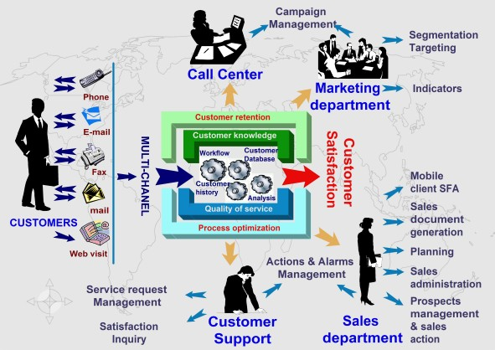
Company’s Objective and Challenges :
- Attracting new customers is objective but keeping costs down is the challenge.
- Newly acquired customers are unprofitable until they have purchased enough products or services to exceed the cost to acquire and service them.
- Retaining customers that generate profits (revenues in excess of the costs) is critical.
- Those companies who know their customers, understand their needs, and communicate intelligently with them will always have a competitive advantage over those that don’t.
- The company decided to cultivate brand loyalty.
- Collecting data at all customer contact points, the company turns those data into knowledge for understanding and anticipating customer behavior, meeting customer needs, and building more profitable customer relationships.
In addition to selling and campaign management, the ultimate goal is to make sure that when a customer wants to buy, he or she continues to buy from ABC computers PVT LTD and cannot be captured by a competitor’s marketing.
Objective of the company is to secure the company’s customer’s information and reach to the customers through their mobile devices within no time.
To achieve these future Goals, company is planning to implement cloud based CRM SAS.
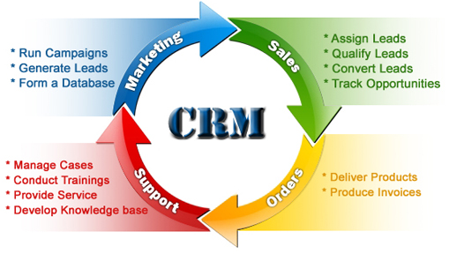
These CRM systems are customer relationship management platforms. The goal of the system is to track, record, store, and then data mine the information to improve customer relations. The CRM codifies the interactions between company and their customers so that it can maximize sales and profit using analytics and KPIs to give the marketing department as much information on where to focus their marketing and customer service to maximize revenue and decrease idle and unproductive contact with your customers.

As the company is growing very fast and all the company accounts and information is in messy excel sheets and into different databases, which are inefficiently integrated to generate reports and therefore, these reports are not able to show the true picture of the company. Different departments of the company are having difficult to communicate with each other for smooth business process. Therefore company is looking for implementation of strategic management information system to have up-to-date information regarding the company’s performance and to have 360–degree view of the company and define KPI's that will measure the company’s success.

Scope and Objectives
Projects are managed by managing the triple constraints, which are:
- Scope: what the project is supposed to accomplish—its outcomes or deliverables.
- Time: determined by task durations and task dependencies. Some tasks are dependent on other tasks being completed before they can begin. For example, in construction, a hole must be dug before the pouring of concrete can start. Task durations and task dependencies determine the time required to complete the project.
- Budget: resources allocated to the project.
Management wants quick implementation and running of information system. The solution which is scalable, low cost and can be deployed swiftly.With given timeframe and Buget ,Business processes in scope are Customer sales, Marketing and Analytics requirement for management. Once this information system is approved and reviewed by management will integrate with other parts of the Business process.
Business Process in scope

Marketing Process
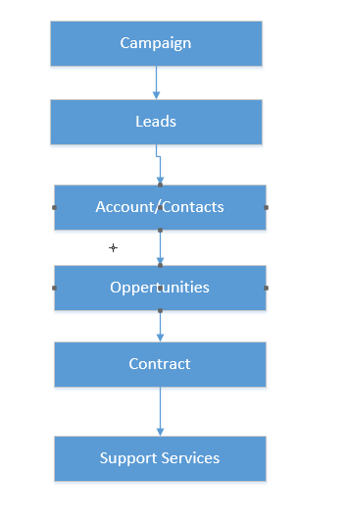
Campaign
- Create and Execute
- Track Response
- Analyze Campaign effectiveness
Leads
- Set up Web-to-Lead to automatically capture leads from your website.
- Import your organization’s existing leads.
- Create custom lead fields.
- Map custom lead fields to other custom fields for lead conversion.
- Edit the Lead Status picklist to choose the default status for new and converted leads.
Accounts/ Contact
- Create Business and Person Accounts and their contacts
- Maintain existing accounts and their contacts.
Opportunities (Opportunities are the sales and pending deals that you want to track. )
- Create new opportunities.
- Update status of the Opportunities.
Sales
- Invoices and billings
- Sales returns

Support Services
- New Case Creating
- Case is assigned and resolved
- Closed
- Leads – A lead is any person that may be interested in your products or services; for example, someone you met at a conference or who filled out a form on your website is a lead. If a rep qualifies a lead and decides to pursue it, the lead is “converted,” which automatically transforms it into three objects: an account, a contact, and an opportunity.

- Accounts – An account is an organization, individual, or company that you want to track in Salesforce CRM. An account can include customers, competitors, partners, or any other entities that make sense for your business. An account record contains—or connects to—all information about your interactions with the company, such as in-progress and completed opportunities, your points of contact, and records of past interactions.

- Contacts – The contact object stores information about people who work at the companies represented by the account object. A contact record contains all relevant information about the person, such as phone numbers, titles, and role in a deal, and much more. With contacts, you can capture all the personal information you need to develop the relationships that are so important in sales.

- Opportunities – The opportunity object contains the information for every deal you’re tracking, such as deal size and expected close date. The opportunity object is at the core of your sales process. By adding an opportunity, you build a “pipeline” you can use for forecasting.

- Chatter – The enterprise social network for your company that allows teams to take action & collaborate up like never before.

Analytics requirement for management
Dashboards / Report
- CEO of the company requires to view Dashboard with company’s key performance indicators. Sales by Division and category, number of orders CYTD and how this compared to LYTD, what the sales trend look like. Has the number of orders improved by the years. Opportunity report
- CMO of the company wants to see Product performance CYTD versus LYTD, Current trends, Number of orders per product category. Pending orders etc.
- Sales Manager is interested in CYTD sales person’s performance versus LYTD, Top and Bottom Salespersons based on their sales. Sales person’s performance over the years.
- Leads by Source – Find out the most and least effective lead sources
- Opportunity Pipeline – See upcoming opportunities, in current stage
- Stuck Opportunities – See which opportunities are not moving forward
- Closed Opportunities – Shows won opportunities

Infrastructure and Platform selection
IT infrastructure: collection of hardware, software, processes, networks, and users. A company’s IT infrastructure determines the workload that its ISs, apps, and mobile computing devices can handle and their speed. IT infrastructure allows (and limits) the ability to store, protect, and manage data so that it can be made accessible, searchable, shareable, and actionable. To improve performance at lower up-front costs, company has decided to implement Salesforce CRM cloud.
Cloud Computing services commonly referred to as Software as a Service (SaaS), Platform as a Service (PaaS) and Infrastructure as a Service (IaaS)
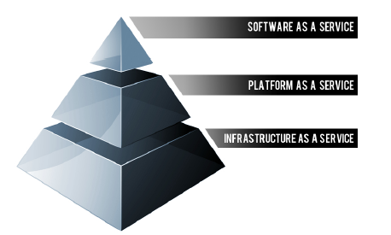
• SaaS applications are designed for end-users, delivered over the web
• PaaS is the set of tools and services designed to make coding and deploying those applications quick and efficient
• IaaS is the hardware and software that powers it all – servers, storage, networks, operating systems

Salesforce CRM is one such cloud based software solution , The system offers a broad suite of CRM applications for small, mid-market, and enterprise organizations, with a focus on sales and support.
Below are the salient features of Salesforce CRM.

1. Better visibility into customer information – Reps can see all their accounts, contacts, opportunities, tasks, and events in a single place. It means convenience, always being organized, and a 360-degree view of the customer.
2. Easy account planning – Reps can do their own account planning. Because reps can see their
customers’ history, they can develop an account strategy and an action plan, complete with to-do
tasks. Reps can also create reminders of follow-up activities on specific dates

3. Better time management – Reps can better prioritize their days and manage their activities. They
can see their calendars and upcoming tasks on their home pages. And by checking the
Opportunities view in Salesforce CRM, they can focus on and prioritize current opportunities.

4. Reports – Reps can run their own reports, including the following:
• Accounts they haven’t visited in a while
• Opportunities in the pipeline, including won opportunities and lost opportunities
• Products they’ve sold
• Activities and tasks they’ve completed

5. Dashboards – Reps can create their own dashboards to see how they’re doing—at a glance. With
dashboards, they can see the information that’s critical to them, in various graph formats. They can
also designate red, yellow, and green thresholds to show progress toward their goals.

6. Trending analyses – Reps can see selling trends and use this information to generate more sales.
With trending analysis, it’s possible to calculate the win/loss ratio on opportunities, see monthly
trends with opportunities in the pipeline, see the types of activities the rep does most, and see the
number of closed deals versus quota.

7. Opportunity forecasts – Because all opportunities are updated in Salesforce CRM, reps can see
where sales are coming in, what they forecast for previous periods, and where they can sell more.
They no longer have to update Excel spreadsheets and mail their forecasts to their managers. Their
managers will be happy as well—they can edit the forecasts without needing additional
spreadsheets.

8. Email templates – Reps can communicate more easily and consistently with their customers.
Salesforce CRM provides standard email templates—such as Introductory Sales Call, Welcome
Customer, and Thank You for Your Business—that can be easily edited and sent to multiple
contacts.

9. Easy data updates – With the click of a button, reps can request that their contacts update their
contact information. As with other email templates, it’s easy to customize this “stay-in-touch”
email. When the contact responds, reps can decide whether to accept the updated information.

10. Easy collaboration – Reps can share information with their team members easily through
Salesforce Chatter. That makes it easy to communicate about changes such as territory
realignment, information needs to be passed to the next account owner, or anything else. Reps can
add team members to either accounts or opportunities.

11. Built-in record search and create – Reps can quickly create or search for the records they need.
They can also add new leads, accounts, contacts, and opportunities with a single click.

13. No more micromanagement – Because managers can easily see histories, they can look in the
Application for pipeline information instead of constantly asking their reps. Also, accountability
Issues are easily resolved because reps always know what is assigned to them.
Mobile commerce (m-commerce, m-business): To meet company’s Objectives to reach customer anywhere and at any time , mobile m-commerce and m-business are key Infrastruture enablers and are an improtant feature of SalesForce CRM. Key features/concepts of m-commerce are location tracking, navigation and mapping of customer data and usage. General features of m-commerce are omni-presence , convenience of usage , interactive ,ability to customize , localization.

Information Systems Architectural Diagram
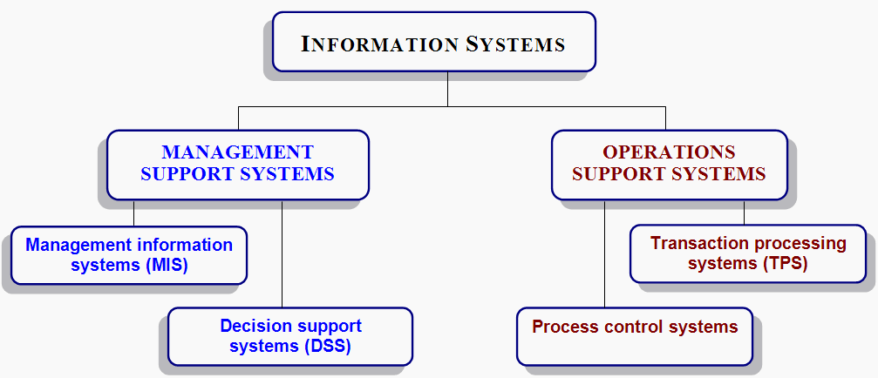

Operations support system
Processing of transactions is done in one of two modes:
- Batch processing: The TPS collects all transactions for a day or other time period; and later processes the “batch” of transactions at once.
- Online transaction processing (OLTP) or real-time processing: The TPS processes each transaction as it occurs, which is real-time processing.
  - OLTP requires that a network link the input device or Web site to the TPS.

Management Information Systems (MIS)
General purpose reporting systems are referred to as management information systems (MIS).3 types of reports
- Periodic: created or run according to a pre-set schedule.
- Exception: generated only when something is outside the norm.
- Ad hoc: generated on an as needed basis.

Decision Support Systems (DSS)
Support unstructured and semi-structured decisions, such as whether to make or buy products or what new products to develop & introduce into existing markets.2 characteristics of DSSs:
  - easy-to-use interactive interface
  - models that enable sensitivity analysis, what if analysis, goal seeking, and risk analysis
Organizations have different types of information systems that collect and process data, distribute reports, and support decision making and business processes.
- Starting with transactions that take place at an interface ( When a customer make a online purchases),a transaction processing system (TPS) processes the data as follows:
  - verifies available inventory.
  - subtracts withdrawn amount updating the data in the database

Data are extracted from the database and organized into reports using management information systems (MIS).
- Decision making is supported by decision support systems (DSS).

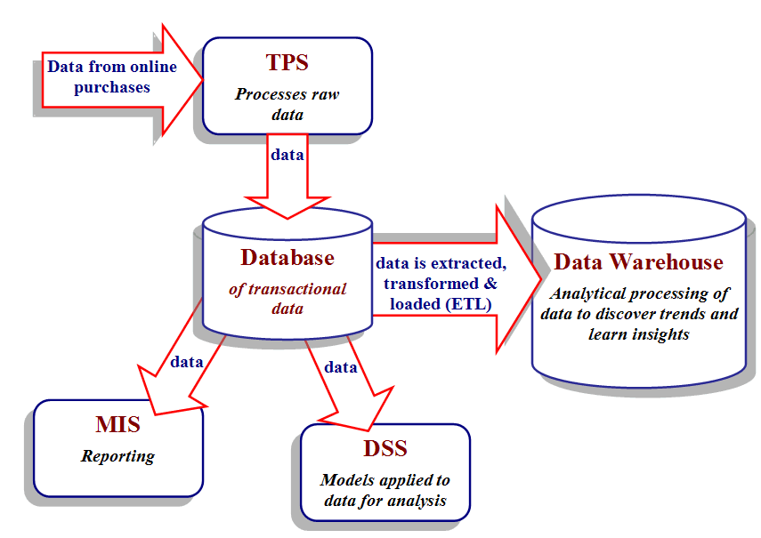
Figure 2.1 Diagram showing the relationships among information systems.
Various types of ISs and applications support managers, workers, work flows, business processes, and transactions with supply chain partners.
- Data: raw data
  - Database: stores data in such a way that it can be accessed, searched, retrieved, and/or updated
- Information: data that’s been processed, organized, or put into context.
- Knowledge: data or information that have been processed to convey understanding, experience, accumulated learning, and expertise as they apply to a current problem or activity.

Physical Design
- Database Schema
- 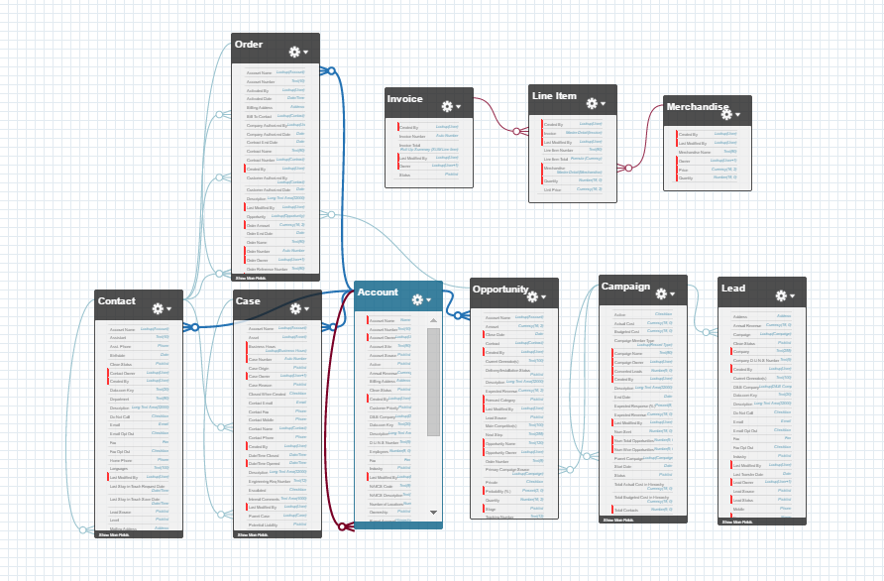
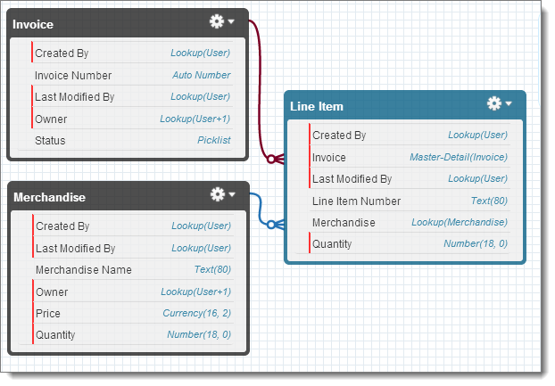
Use of Standard and Custom Objects

- Standard and Custom Objects and Fields required

Leeds
Standard Field Name (* = required) | Data Type | Pick list Values
Address | Address
Annual Revenue | Currency (18,0)
Campaign | Lookup (Campaign)
Company* | Text (80)
Created By* | Lookup (User)
Description | Long Text Area (32000)
Do Not Call | Checkbox
Email | Email
Email Opt Out | Checkbox
Fax | Fax
Fax Opt Out | Checkbox
Industry | Pick list | -Agriculture  -Apparel  -Banking  -Biotechnology  -Chemicals  -Communications  -Construction  -Consulting  -Education  -Electronics  -Energy  -Engineering  -Entertainment  -Environmental  -Finance  -Food & Beverage  -Government  -Healthcare  -Hospitality  -Insurance  -Machinery  -Manufacturing  -Media  -Not for Profit  -Recreation  -Retail  -Shipping  -Technology  -Telecommunications  -Transportation  -Utilities  -Other
Last Modified By* | Lookup (User)
Last Transfer Date | Date
Lead Owner | Lookup (User, Queue)
Lead Source | Pick list | -Advertisement
Lead Source | Pick list | -Employee Referral
Lead Source | Pick list | -External Referral
Lead Source | Pick list | -Partner
Lead Source | Pick list | -Public Relations
Lead Source | Pick list | -Seminar Internal
Lead Source | Pick list | -Seminar Partner
Lead Source | Pick list | -Trade Show
Lead Source | Pick list | -Web
Lead Source | Pick list | -Word of mouth
Lead Source | Pick list | -Other
Lead Status* | Pick list | -Open
Lead Status* | Pick list | -Contacted
Lead Status* | Pick list | -Qualified
Lead Status* | Pick list | -Unqualified
Mobile | Phone
Name | Name
Salutation | Pick list | -Mr.
Salutation | Pick list | -Ms.
Salutation | Pick list | -Mrs.
Salutation | Pick list | -Dr.
Salutation | Pick list | -Prof.
First Name | Text (40)
Last Name | Text (80)
No. of Employees | Number (8,0)
Phone | Phone
Rating | Pick list | -Hot
Rating | Pick list | -Warm
Rating | Pick list | -Cold
Title | Text (80)
Website | URL (255)

Custom Field Name | Data Type
Service/Product Interest | Pick list
Other Lead Source | Text
Key Considerations | Action
Manual Lead Creation | No set-up required – users directly create leads in Salesforce
Do you receive leads one at a time (i.e. referrals, business cards)?
Lead Import | Use Data Import Wizard to import your leads
Do you purchase lists, spreadsheets? If so
Web-to-Lead | Set up Web-to-Lead

Opportunities
Standard Field Name (* = required) | Data Type | Pick list Values
Account Name* | Lookup (Account)
Amount* | Currency (16,2)
Close Date* | Date
Created By* | Lookup (User)
Description | Long Text Area (32000)
Expected Revenue | Currency (16,2)
Forecast Category | Pick list | -Omitted  -Pipeline  -Best Case  -Commit  -Closed
Last Modified By* | Lookup (User)
Lead Source | Pick list | -Advertisement  -Employee Referral  -External Referral  -Partner  -Public Relations  -Seminar Internal  -Seminar Partner  -Trade Show  -Web  -Word of mouth  -Other
Next Step | Text (255)
Opportunity Name* | Text (80)
Opportunity Owner | Lookup (User)
Primary Campaign Source | Lookup (Campaign)
Private | Checkbox
Probability | Percent (3,0)
Quantity | Number (16,2)
Stage* | Pick list | -Prospecting  -Qualification  -Discovery/Scoping  -Proposal/Price Quote  -Negotiation/Review  -Closed Won  -Closed Lost
Type | Pick list | -Existing Business  -New Business

Custom Field Name | Data Type
Closed/Lost Reason | Pick list
Competitors | Lookup to Account (account type = Competitor)
Products/Services of interest (convert from lead) | Pick list

Stage | Probability | Forecast Category
Prospecting | 10% | Pipeline
Qualification | 20% | Pipeline
Discovery/Scoping | 50% | Pipeline
Proposal/Price Quote | 75% | Pipeline
Negotiation/Review | 90% | Pipeline
Closed Won | 100% | Closed
Closed Lost | 0% | Omitted

Accounts
Standard Field Name (* = required) | Data Type | Pick list Values
Account Name* | Text (80)
Account Number | Text (40)
Account Owner | Lookup (User)
Account Site | Text (80)
Account Source | Pick list
Annual Revenue | Currency (18,0)
Billing Address | Address
Created By* | Lookup (User)
Description | Long Text Area (32000)
Employees | Number (8,0)
Fax | Fax
Industry | Pick list | -Agriculture  -Apparel  -Banking  -Biotechnology  -Chemicals  -Communications  -Construction  -Consulting  -Education  -Electronics  -Energy  -Engineering  -Entertainment  -Environmental  -Finance  -Food & Beverage  -Government  -Healthcare  -Hospitality  -Insurance  -Machinery  -Manufacturing  -Media  -Not for Profit  -Recreation  -Retail  -Shipping  -Technology  -Telecommunications  -Utilities  -Other
Last Modified By* | Lookup (User)
Ownership | Pick list | -Public
Ownership | Pick list | -Private
Ownership | Pick list | -Subsidiary
Ownership | Pick list | -Other
Parent Account | Lookup (Account)
Phone | Phone
Rating | Pick list | -Hot
Rating | Pick list | -Warm
Rating | Pick list | -Cold
Shipping Address | Address
SIC Code | Text (20)
SIC Description | Text (80)
Ticker Symbol | Content (20)
Type | Pick list | -Analyst
Type | Pick list | -Press
Type | Pick list | -Competitor
Type | Pick list | -Prospect
Type | Pick list | -Customer
Type | Pick list | -Reseller
Type | Pick list | -Integrator
Type | Pick list | -Investor
Type | Pick list | -Partner
Type | Pick list | -Other
Website | URL (255)

Contacts
Standard Field Name (* = required) | Data Type | Pick list Values
Account Name | Lookup (Account)
Assistant | Text (40)
Asst. Phone | Phone
Birthdate | Date
Contact Owner | Lookup (User)
Created By* | Lookup (User)
Department | Text (80)
Description | Long Text Area (32000)
Do Not Call | Checkbox
Email | Email
Email Opt Out | Checkbox
Fax | Fax
Fax Opt Out | Checkbox
Home Phone | Phone
Last Modified By* | Lookup (User)
Last Stay-In-Touch Request Date | Date/Time
Last Stay-In-Touch Save Date* | Date/Time
Lead Source | Pick list | -Advertisement
Lead Source | Pick list | -Employee Referral
Lead Source | Pick list | -External Referral
Lead Source | Pick list | -Partner
Lead Source | Pick list | -Public Relations
Lead Source | Pick list | -Seminar Internal
Lead Source | Pick list | -Seminar Partner
Lead Source | Pick list | -Trade Show
Lead Source | Pick list | -Web
Lead Source | Pick list | -Word of mouth
Lead Source | Pick list | -Other
Mailing Address | Address
Mobile | Phone
Name* | Name
Salutation | Pick list | -Mr.
Salutation | Pick list | -Ms.
Salutation | Pick list | -Mrs.
Salutation | Pick list | -Dr.
Salutation | Pick list | -Prof.
First Name | Text (40)
Last Name | Text (80)
Other Address | Address
Other Phone | Phone
Phone | Phone
Reports To | Lookup (Contact)
Title | Text (80)
Custom Field Name | Data Type | Values
Active | Pick list | -Active (default)
Active | Pick list | -Not Active
Level/Role | Pick list | -CEO
Level/Role | Pick list | -VP
Level/Role | Pick list | -Director
Level/Role | Pick list | -Assistant
Level/Role | Pick list | -Other

Invoice
Line Item
Merchandise
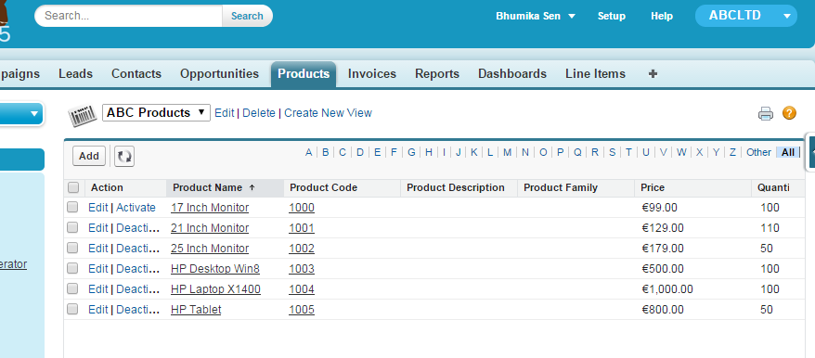
Chatter Box Settings
Key Considerations | Action
Opportunity Collaboration  How do your sales teams collaborate on deals? | - Enable Chatter  - Collaborate on opportunities (ask for information to  support an opportunity, follow an important opportunity  to receive updates)

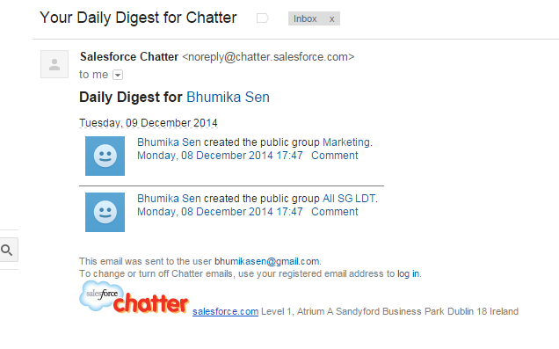
- Implementation of business rules
Database Trigger - By default, master-detail relationships automatically cascade the deletion of a master record to all related detail records. But here is needs to deviate from this default behaviour and employ a trigger that prevents the deletion of Invoices that have Line Items. Following Trigger code is added to the Invoice Object. After this you cannot delete invoice which has Line Item.
- 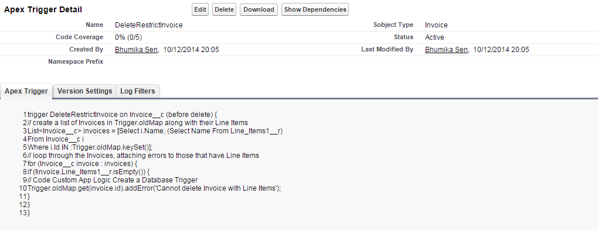
- 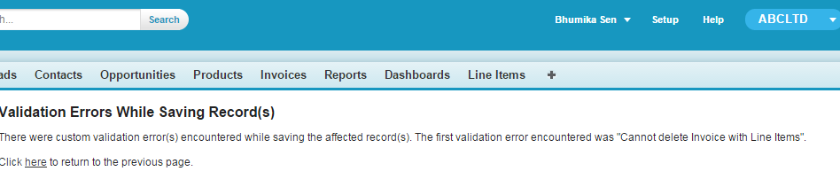

- Validation Rule –
  - Quantity cannot be –ve or more then the quantity in stock
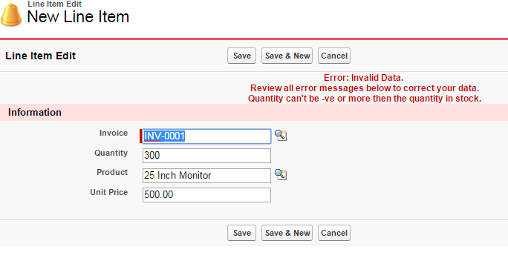

Invoice Total = Sum of all Line Items
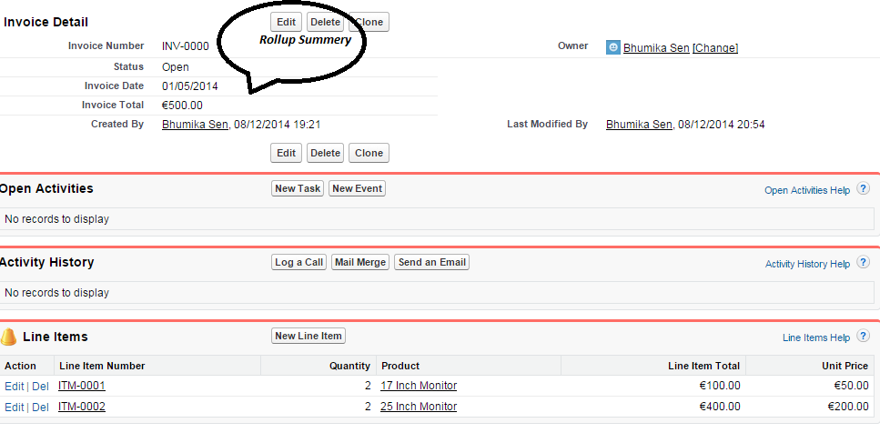

Custom User Interface
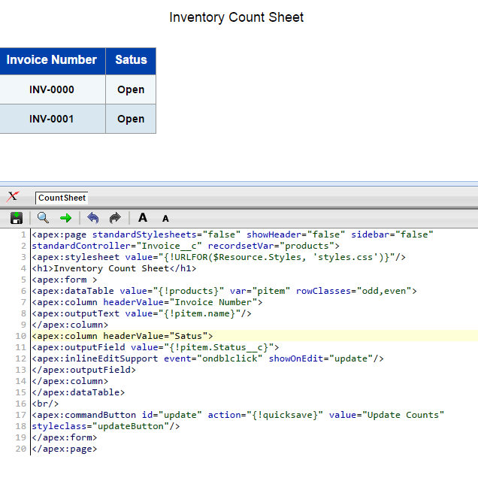
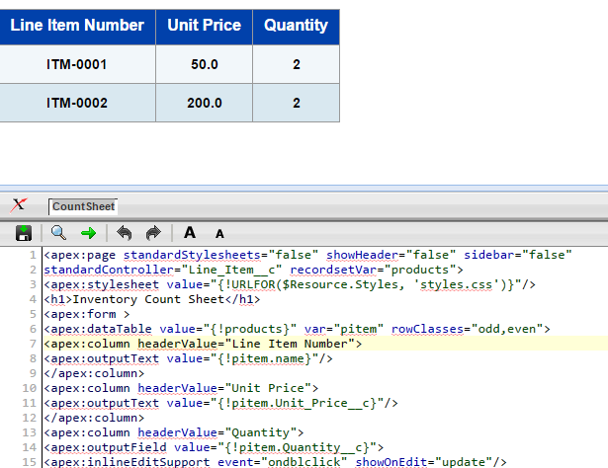

Process controls
Approval Process -An approval process also specifies the actions to take
when a record is first submitted for approval and that record is approved, rejected, or recalled. When the unit price is modified in the line item, a mail is sent to the user for the approval.
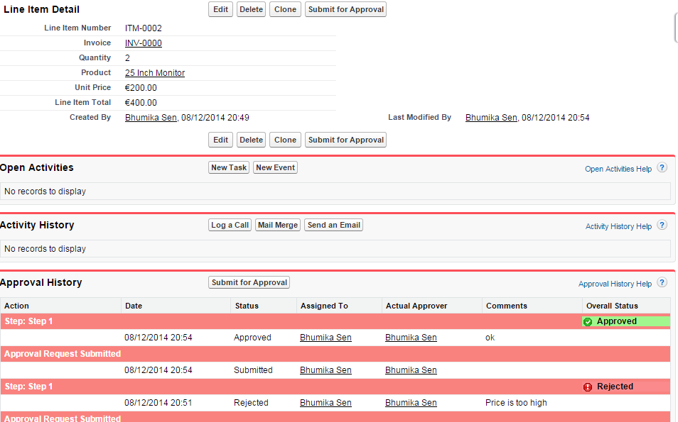
- 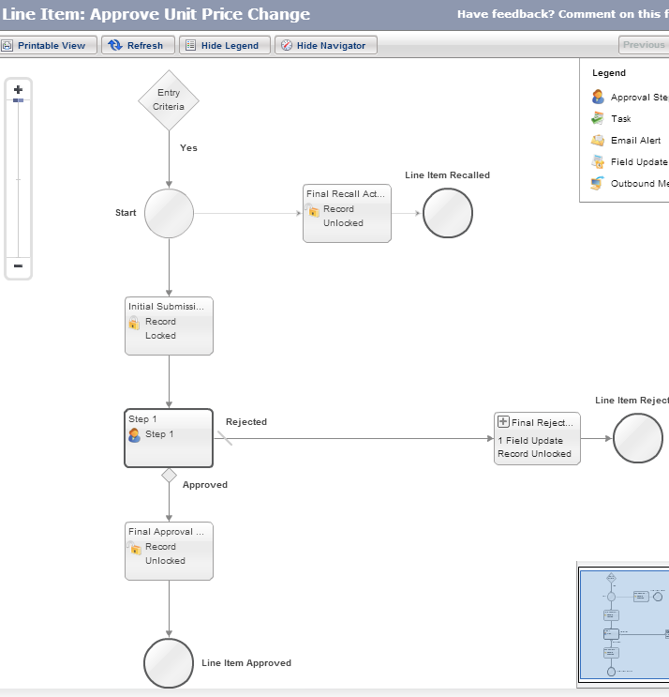

Implementation Approach
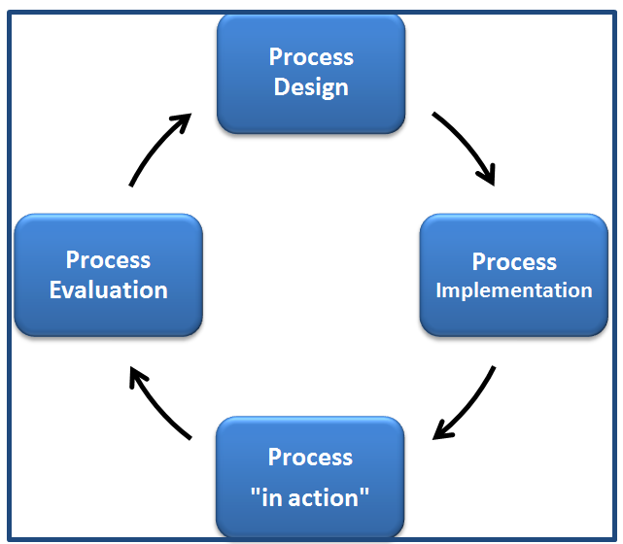

Step 1: Plan and Prepare
Your first step is to plan and prepare. In this step, you’ll identify your company’s vision, goals, and metrics as well as your resources, tools, and dependencies. Getting this step right is crucial, so you won’t waste time or have to back track.

Understand your data
Data always becomes a bottleneck if it’s not reviewed and cleaned early in a project. Plan steps to clean up, map, and load data into Salesforce. Data shouldn’t be loaded until your system is set up, including setting up your role hierarchy, sharing model, and sharing rules.
By taking the time to understand your data during the planning stage, you can help define critical questions such as “Are we tracking crucial data?” and “What else should we be tracking?”

- Understand the types of information systems and how they process data.
- Understand the types of information systems used to support business operations and decision makers.
- Describe how IT supports supply chains and business processes.
- Understand the attributes, benefits, and risks of service-based and cloud computing infrastructures.
- 85% of a company’s knowledge is not stored in databases.
- Knowledge is dispersed in social media, e-mail, texts, intranets, Word documents, spreadsheets, and presentations on individual computers and mobile devices.
- Knowledge typically is unstructured, and has strong experiential and reflective elements.
- Having knowledge implies that it can be used to solve a problem, whereas having information does not imply that ability.
- KM is a process that helps organizations identify, select, organize, disseminate, and transfer important information and expertise that are part of the organization’s memory.
- KM systems identify, capture, store, maintain, and deliver useful knowledge in a meaningful form to anyone who needs it, anyplace and anytime, within an organization.
- KM systems support sharing, decision making, and collaborating at the organization level regardless of location.
Implementation report
- Description of architecture
- 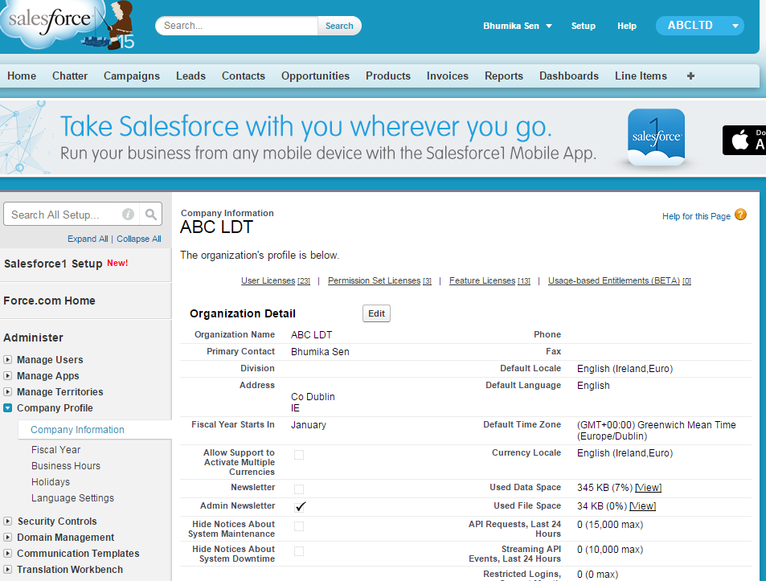
- 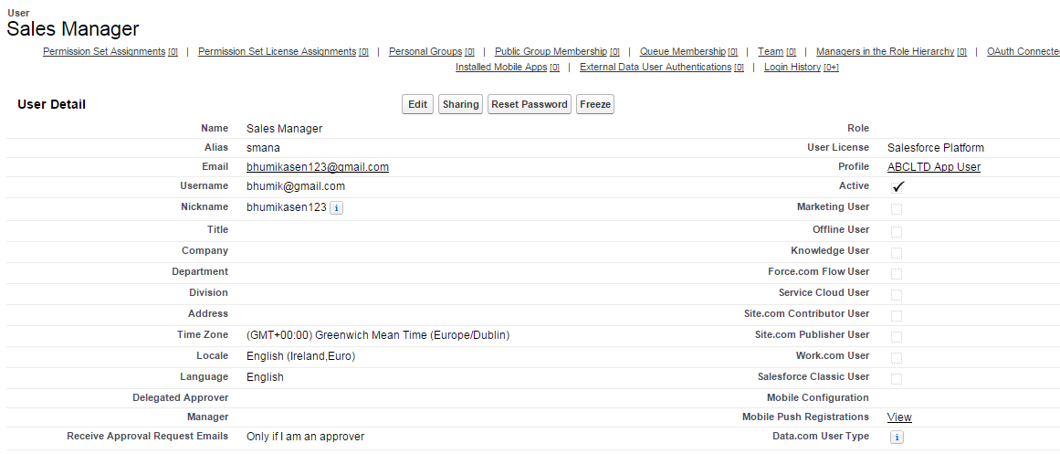

- 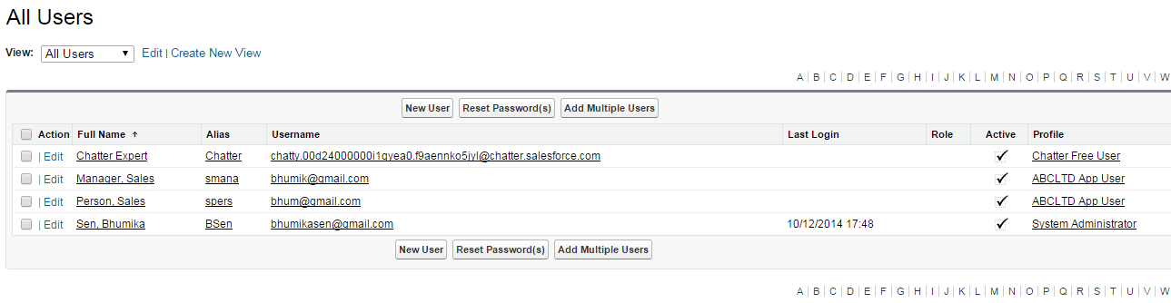
- 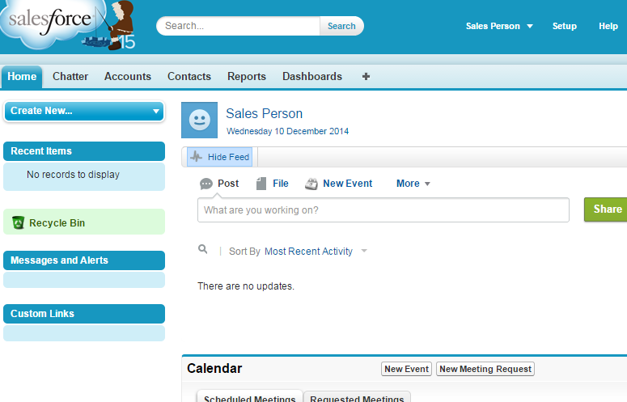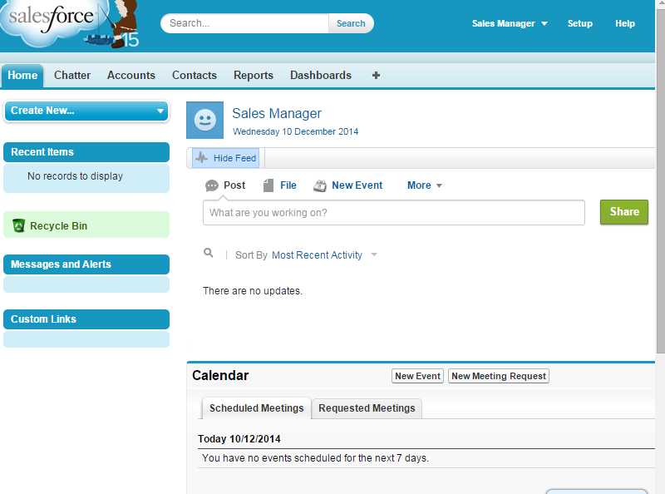

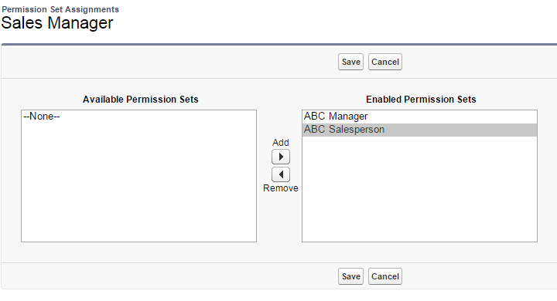
- 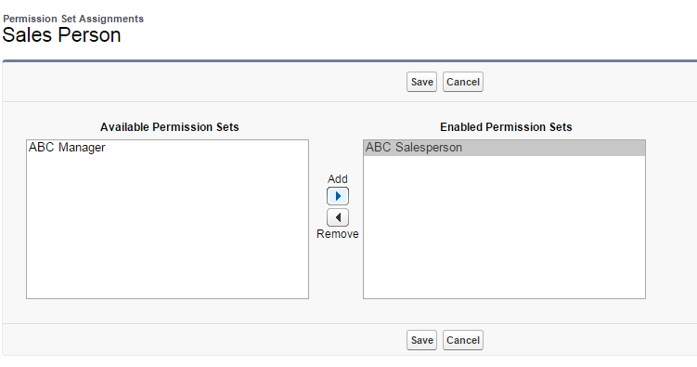
- Test Record Access
- 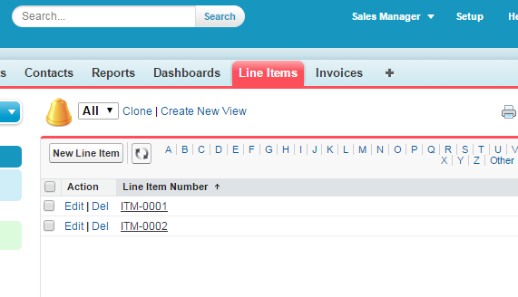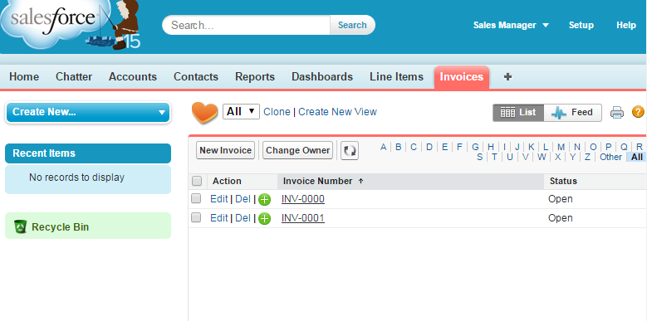
- 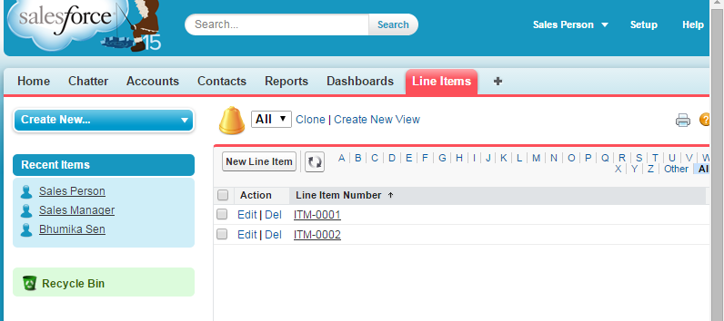
- 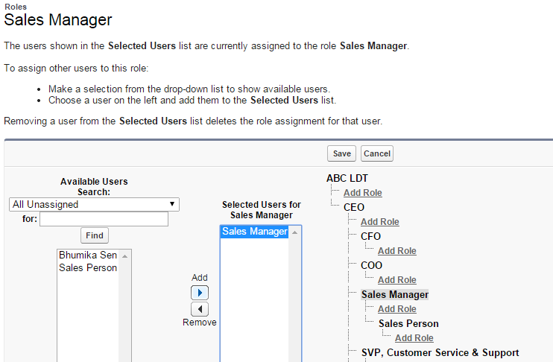
Notice that the Sales Manager user can now work with the invoice owned by the Sales Person user. That's because the role hierarchy shares private records up the role hierarchy.

- Business Benefits – New Email templates , which can be automated for every new customer joining or interested in products of ABC LTD.
- 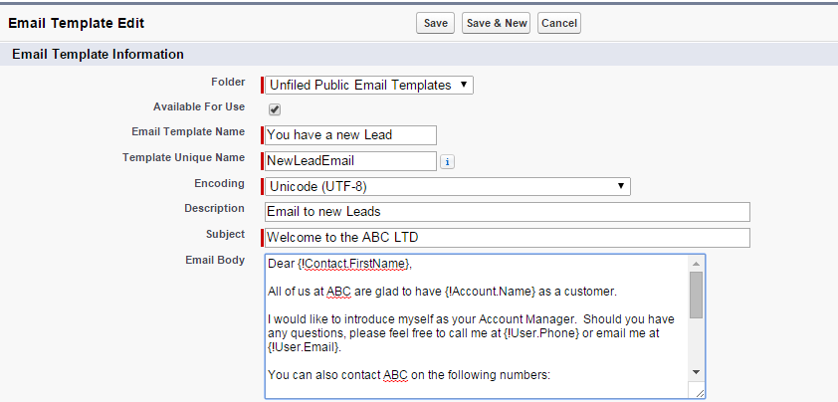
Metadata
- Screenshots of object definitions and field lists
Content
- Views showing your data from each object
- Screenshots of key processes (data entry, editing, etc)

- 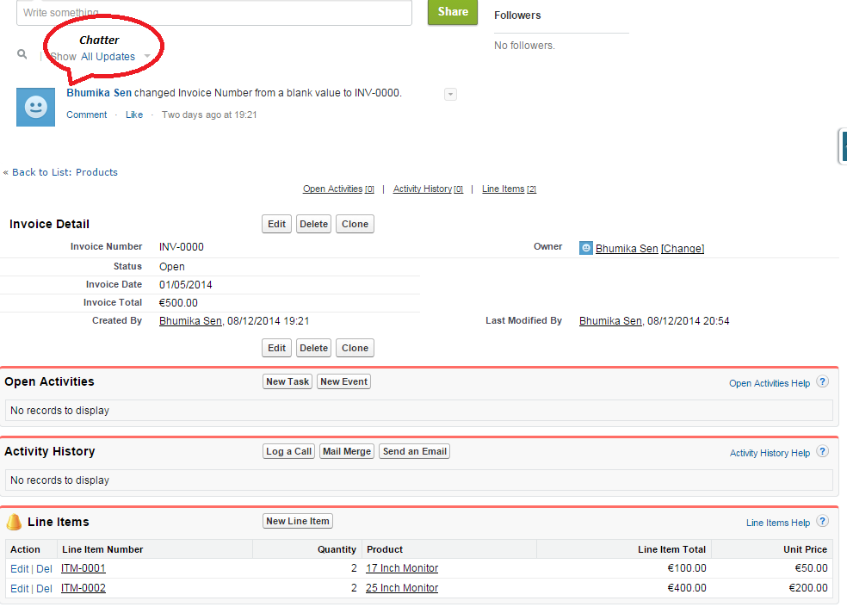
- 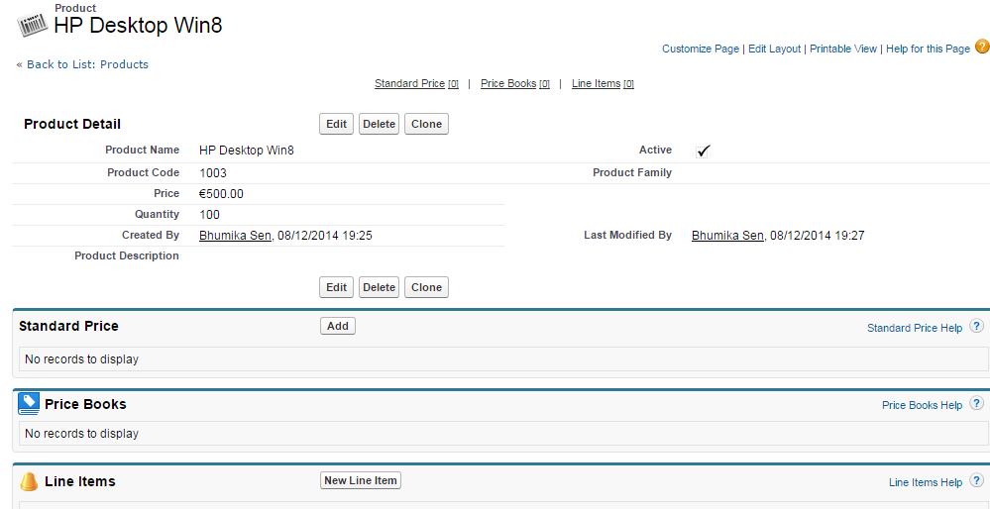
- HTML of integrated web pages
- 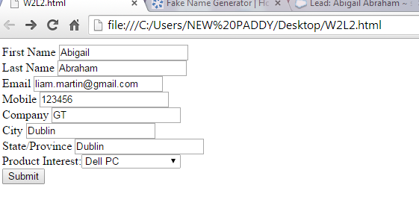
- <!-- ---------------------------------------------------------------------- -->
- <!-- NOTE: These fields are optional debugging elements. Please uncomment -->
- <!-- these lines if you wish to test in debug mode. -->
- <!-- <input type="hidden" name="debug" value=1> -->
- <!-- <input type="hidden" name="debugEmail" -->
- <!-- value="bhumikasen123@gmail.com"> -->
- <!-- ---------------------------------------------------------------------- -->

- <label for="first_name">First Name </label><input id="first_name" maxlength="40" name="first_name" size="20" type="text" /><br>

- <label for="last_name">Last Name </label><input id="last_name" maxlength="80" name="last_name" size="20" type="text" /><br>

- <label for="email">Email </label><input id="email" maxlength="80" name="email" size="20" type="text" /><br>

- <label for="mobile">Mobile </label><input id="mobile" maxlength="40" name="mobile" size="20" type="text" /><br>

- <label for="company">Company </label><input id="company" maxlength="40" name="company" size="20" type="text" /><br>

- <label for="city">City </label><input id="city" maxlength="40" name="city" size="20" type="text" /><br>

- <label for="state">State/Province </label><input id="state" maxlength="20" name="state" size="20" type="text" /><br>

- Product Interest:<select id="00N24000001xUEP" name="00N24000001xUEP" title="Product Interest "><option value="">--None--</option><option value="17 Inch Monitor">17 Inch Monitor</option>
- <option value="21 Inch Monitor">21 Inch Monitor</option>
- <option value="25 Inch Monitor">25 Inch Monitor</option>
- <option value="HP Desktop Win8">HP Desktop Win8</option>
- <option value="HP Laptop X1400">HP Laptop X1400</option>
- <option value="HP Tablet">HP Tablet</option>
- <option value="Dell PC">Dell PC</option>
- </select><br>

- <input type="submit" name="submit">

- </form>
- 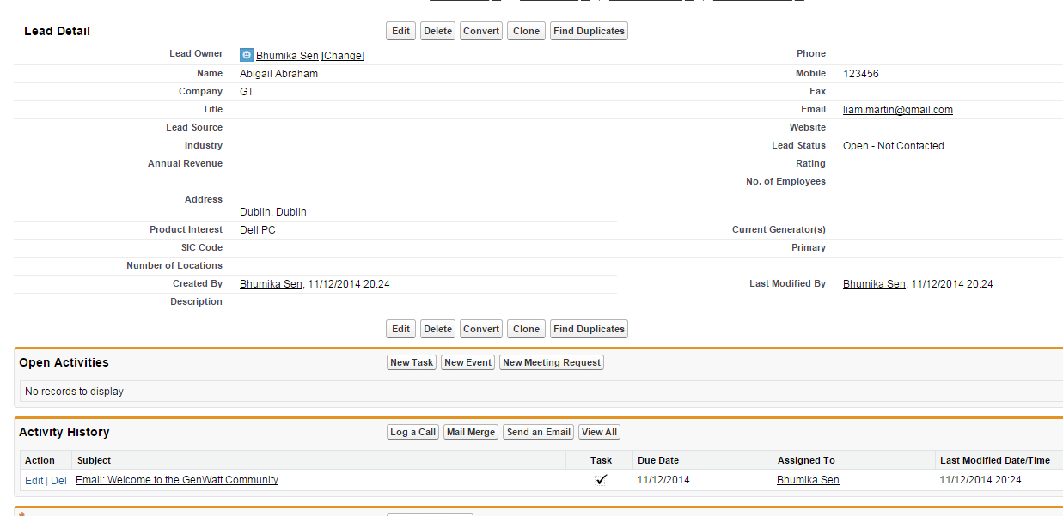
- Screenshots of coding behind formula fields, validation rules and workflow features
- 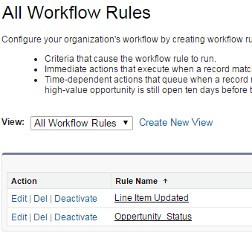
- 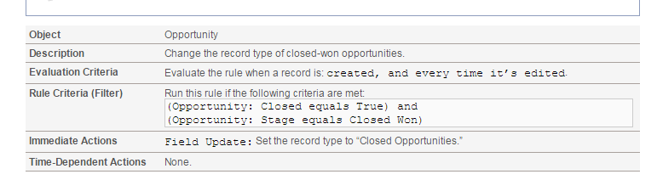
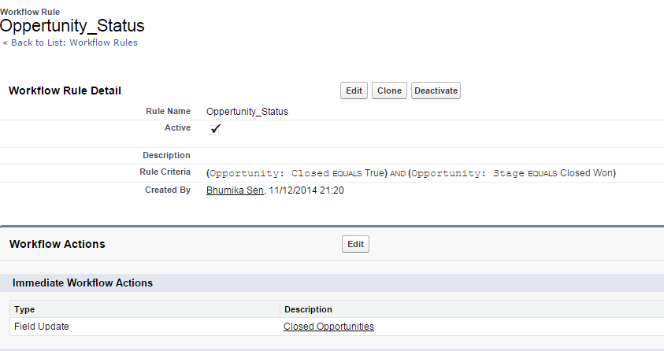
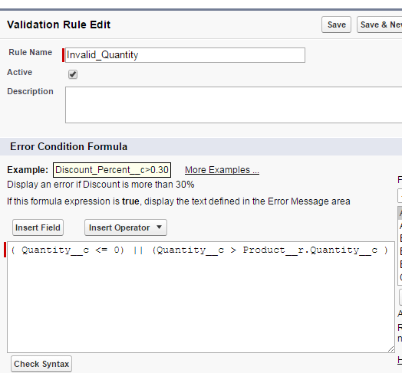
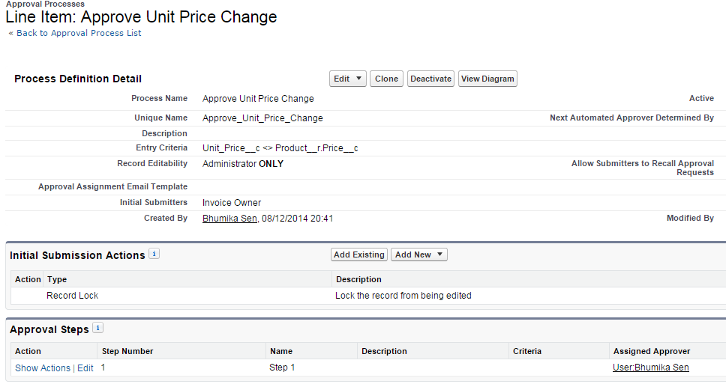
- Screenshots of reports and dashboards
