Creating chatbots with Google Dialogflow

1. **Chatbot Fundamentals**
   1. **What is a chatbot?**

**A chatbot is a software application that mimics conversation with a human in natural languages through various platforms like messaging, websites, mobiles etc. The chatbot responds by identifying the intent of the conversation and then responding accordingly.**

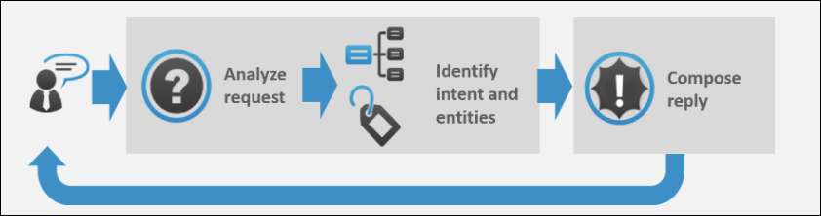

Image Courtesy: <https://expertsystem.com/chatbot/>

**Broadly, chatbots can be classified into two categories:**

1. **Rule-Based Chatbots: This is an extremely fundamental type of chatbot which generally works on simple ‘if-else’ constructs. It can respond to only simple predefined queries. The performance of this application highly depends on the programming skills of the developer.**
2. **Chatbots with Natural Language Understanding: At the core, it has a language processing and understanding model with pre-trained instances using Deep Learning. It can communicate through both text and speech.**
   1. **Uses of chatbots:**
3. **Can be used to answer FAQs.**
4. **Can be used for grievance handling.**
5. **Internal organizational automation.**
6. **To do the flight, hotel, appointment bookings etc.**
7. **Can guide customers to buy the correct product by answering their questions**
8. **Can be used for Customer Relationship Management.**
   1. **Advantages of Chatbots**
9. **24*7 customer support.**
10. **Uniform customer experience.**
11. **Cost-efficient.**
12. **Build once and deploy everywhere.**
13. **Integration with various channels and platforms**
14. **Better monitoring and insight generation.**
    1. **Frameworks Present in the Market:**
15. **Google Dialogflow: Dialogflow is a natural language understanding platform that makes it easy to design and integrate a conversational user interface into your mobile app, web application, device, bot, interactive voice response system, and so on.**
16. **Microsoft Bot Builder with LUIS: Azure Bot Service enables you to build intelligent, enterprise-grade bots with ownership and control of your data.**
17. **Amazon Lex: Amazon Lex is a service for building conversational interfaces into any application using voice and text. Amazon Lex provides the advanced deep learning functionalities of automatic speech recognition (ASR) for converting speech to text, and natural language understanding (NLU) to recognize the intent of the text, to enable you to build applications with highly engaging user experiences and lifelike conversational interactions.**
18. **RASA: Rasa provides infrastructure & tools necessary for high-performing, resilient, proprietary contextual assistants that work.**
19. **Wit.ai (Facebook):** **Wit.ai makes it easy for developers to build applications and devices that you can talk or text to.**
20. **Google Dialogflow**
    1. **Introduction:**

**Dialogflow is a natural language understanding platform that makes it easy to design and integrate a conversational user interface into your mobile app, web application, device, bot, interactive voice response system, and so on. Using Dialogflow, you can provide new and engaging ways for users to interact with your product.**

**Dialogflow can analyze multiple types of input from your customers, including text or audio inputs (like from a phone or voice recording). It can also respond to your customers in a couple of ways, either through text or with synthetic speech.**

* 1. **Signup For Dialogflow:**

**You need to have a google account to signup for Dialogflow.**

1. **Go to** <https://dialogflow.com/> **and click on ‘Sign Up for Free’ button.**

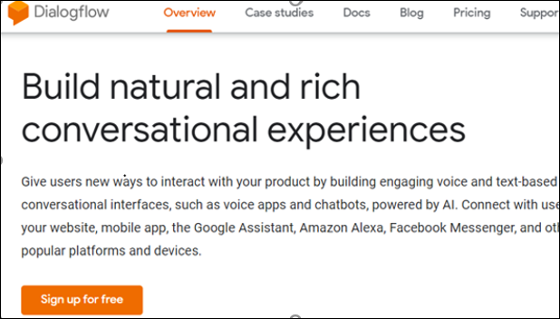

1. **Click ‘sign-in with Google’.**

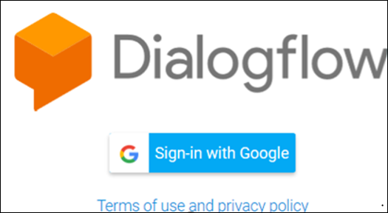

1. **Select your google account and once you are redirected, click on ‘Go To Console’ on the upper right corner of the screen.**
   1. **Dialogflow Console:**

**Dialogflow provides a web user interface called the *Dialogflow Console*** ([open console](https://dialogflow.cloud.google.com/)). **You use this console to create, build, and test agents. The uses are:**

* **Create Agents**
* **Create Intents**
* **Create entities**
* **Fulfillment to connect to other APIs.**
* **Integrate the bot with other platforms**
* **Analyze agent performance**
* **Test the agent in conversation simulator.**

## **Covid-19 Dialogflow chatbot:**

**Our Business problem in hand was to give back a reply through the bot to the user with the number of confirmed Covid-19 cases in his/her district based on the pincode provided by the user, also we will send one mail to the user of the same**.

**We completed the same business requirement using Google Dialogflow chatbot and integrated our bot with Telegram** **for end user experience**.

**My app is deployed on Heroku cloud platform, Link is given below**:

<https://intense-chamber-48356.herokuapp.com/>

Now below we will showcase one end to end convertation of our chatbot and an end-user.As I mentioned before we have integrated our bot in Telegram messenger application so here you will find screenshots from the telegram app, link of the bot in telegram will be given below, please do use it.

Start with Hi/Hello message:

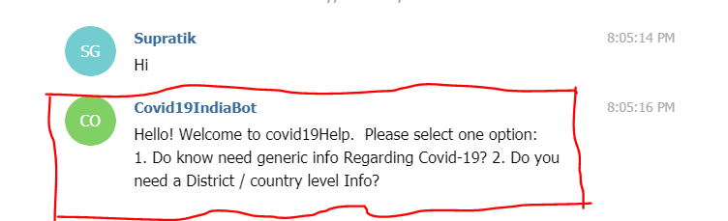

**Note: the red highlighted portion is the reply from the chatbot.

You can see the bot is giving two options so either we can choose No. 1 or No. 2, we will proceed one by one, first we will select option 1, and see what the bot replies.

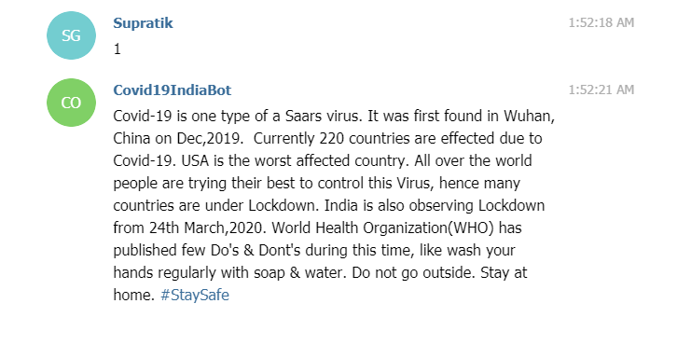

Now we will look for the 2nd option, and if you press 2 the bot will ask you for few details please provide genuine details so that you can validate the data yourself.let’s look an example.

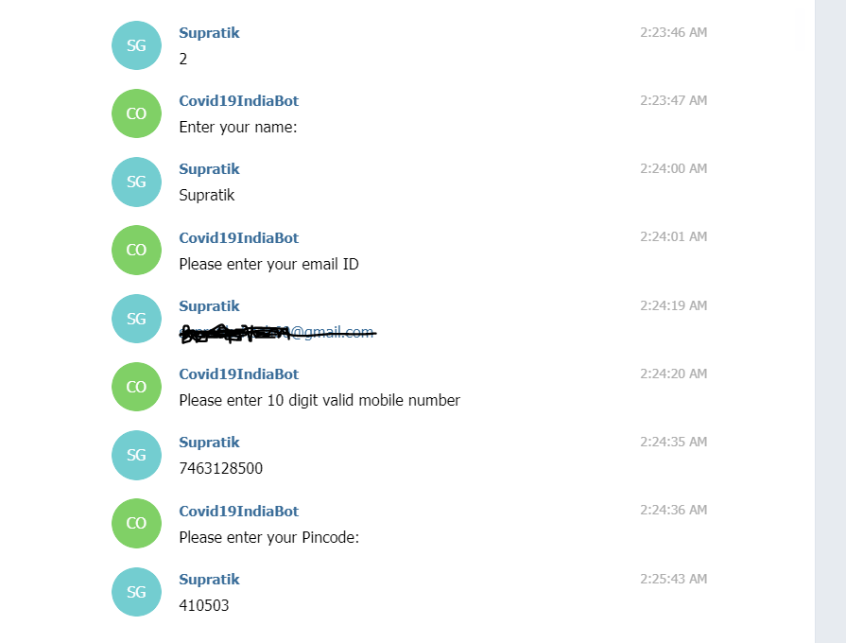

**Note: for privacy reasons the email ID portion is blacked out.

If all the above 4 informations are entered correctly then the bot will reply back with current number of confirmed covid-19 cases in the particular district of the given pincode like the below screenshot.

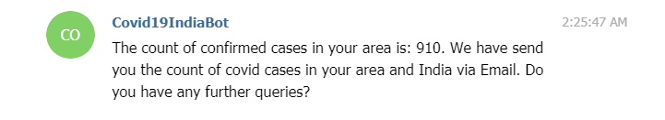

Apart from this reply the chatbot will also drop an email to the specified email address regarding count and other infos. An sample email is shown below:

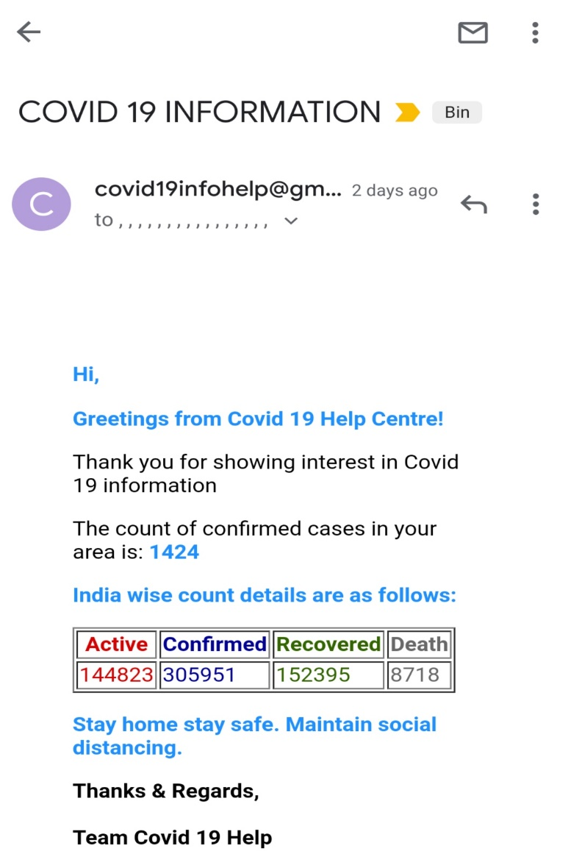

The link of the telegram bot is – [t.me/Mycovid19_India_bot](tg://resolve?domain=Mycovid19_India_bot). You can use this link to test the bot yourself.

Code & documentation link: <https://github.com/Sghosh023/Dialogflow_chatbot_Covid19>