**Machine Learning with Deployment to AWS Cloud Platform**

**The Problem statement**:

The goal here is to find the chance of admission of a candidate based on his/her GRE Score (out of 340), TOEFL Score (out of 120), rating of the University (out of 5) in which he/she is trying to get admission, Strength of the SOP (out of 5), strength of the Letter Of Recommendation (out of 5), CGPA (out of 10) and the research experience (0 or 1).

**Application Design**:

Our model training pipeline includes data pre-processing, selecting the right algorithm for creating the machine learning model, checking the accuracy of the model and finally saving the model file.

Below using the diagram, we can show the flow.



After completion of our model training we have exposed the trained model as an API for the end user to consume it and also we have deployed our API (web app) to AWS cloud platform, our cloud app link is below:

<http://linearregressiongreadmissionpredicti-env.eba-p2mmb8pc.us-east-1.elasticbeanstalk.com/>

**Application overview**:

1. Hit the above URL in any browser, it will open the below page:

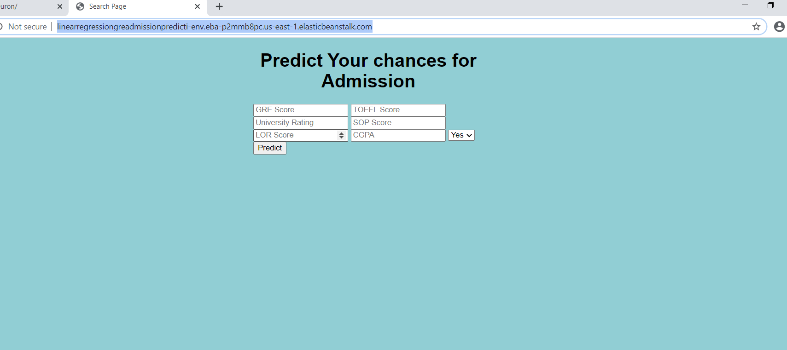

1. Now user can fill the textboxes as per their own choices, but they have to follow the norms of the values like GRE score should be 30 to 340, TOEFL score should be out of 120, University rating is integer value between 1 to 5, SOP score (out of 5, integer value), Letter Of Recommendation score (out of 5, integer value), CGPA (out of 10) and the research experience (0[No] or 1[Yes]). Once you have given all the values then press the ‘**Predict’** button**.** Look at the below screenshot as an example:



1. Once you press the predict button it will show the chance of that particular candidate to get an admission in his/her preferable University/Institute in the below format –

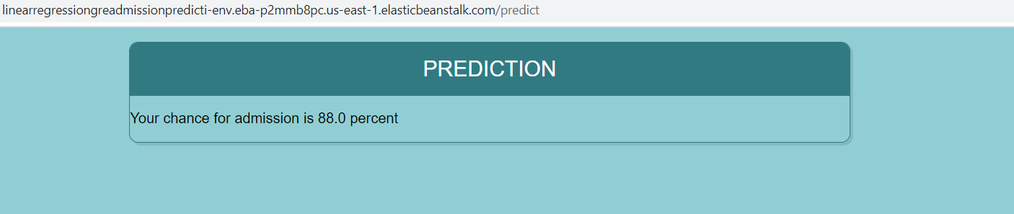

N.B: All the required code for this project is available at <https://github.com/Sghosh023/GREAdmission_AWS_model>