# FastAPI:

It is one of the very simple and lightest API available in python framework.

Steps to use FastAPI:

1. First install fastapi and Uvicorn packages in your environment.

pip install fastapi uvicorn

1. While creating app you have to do the necessary imports as like below –

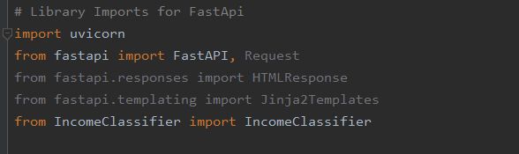

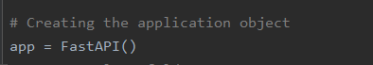

1. In order to run the app, you need to have the below requirement –

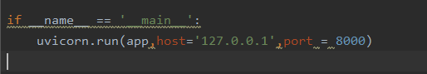

Then run from the command prompt using the below command –

uvicorn app:app --reload

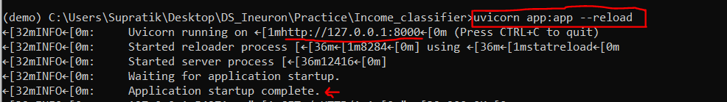

Then from any browser, you can run the app using the Host IP address.

The best part of fastapi is here you get an In-built UI based (swagger UI) application, in order to get that we have to use the /docs extension.

(http://127.0.0.1:8000/docs)

