PokeTower

I. Towers 2

1. Plant Tower 2

2. Fire Tower 2

3. Water Tower 3

4. Electrical Tower 3

5. Air Tower 4

6. Poison Tower 4

II. Enemies 5

1. Basic Enemies 5

7. Boss Enemies 6

III. Gameplay 7

# Towers

## Plant Tower

|  |  |  |
| --- | --- | --- |
|  | Name | Bulbasaur |
| Damage | 4 |
| Attack Speed | 6 |
| Cost | 200 |
| Range | 5 - Earth |
| Throws sharp leaves continuously as long as an enemy is in its range | | |

|  |  |  |
| --- | --- | --- |
|  | Name | Ivysaur |
| Damage | 5 |
| Attack Speed | 8 |
| Cost | 1 |
| Range | 6 - Earth |
| Throws sharp leaves continuously as long as an enemy is in its range | | |

|  |  |  |
| --- | --- | --- |
|  | Name | Venusaur |
| Damage | 6 |
| Attack Speed | 10 |
| Cost | 3 |
| Range | 7 - Earth |
| Throws sharp leaves continuously as long as an enemy is in its range | | |

## Fire Tower

|  |  |  |
| --- | --- | --- |
|  | Name | Charmander |
| Damage | 6 |
| Attack Speed | 1 |
| Cost | 200 |
| Range | 3 - Earth |
| Spit fire on a line of size 2 | | |

|  |  |  |
| --- | --- | --- |
|  | Name | Charmeleon |
| Damage | 8 |
| Attack Speed | 2 |
| Cost | 1 |
| Range | 4 - Earth |
| Spit fire on a line of size 3 | | |

|  |  |  |
| --- | --- | --- |
|  | Name | Charizard |
| Damage | 10 |
| Attack Speed | 3 |
| Cost | 3 |
| Range | 5 - Earth |
| Spit fire on a line of size 4 | | |

## Water Tower

|  |  |  |
| --- | --- | --- |
|  | Name | Squirtle |
| Damage | 1 |
| Attack Speed | 4 |
| Cost | 200 |
| Range | 4 - Earth |
| Spit bubbles that burst on an enemy and slow down all the enemies by 2 within the splash of size 2 | | |

|  |  |  |
| --- | --- | --- |
|  | Name | Wartortle |
| Damage | 1 |
| Attack Speed | 5 |
| Cost | 1 |
| Range | 5 - Earth |
| Spit bubbles that burst on an enemy and slow down all the enemies by 3 within the splash of size 2 | | |

|  |  |  |
| --- | --- | --- |
|  | Name | Blastoise |
| Damage | 1 |
| Attack Speed | 6 |
| Cost | 3 |
| Range | 6 - Earth |
| Spit bubbles that burst on an enemy and slow down all the enemies by 4 within the splash of size 2 | | |

## Electrical Tower

|  |  |  |
| --- | --- | --- |
|  | Name | Magnemite |
| Damage | 4 |
| Attack Speed | 6 |
| Cost | 300 |
| Range | 4 - Earth - Air |
| Throws a lightning that hurts the first enemy at 100% and the followings less and less | | |

|  |  |  |
| --- | --- | --- |
|  | Name | Magneton |
| Damage | 6 |
| Attack Speed | 7 |
| Cost | 3 |
| Range | 5 - Earth - Air |
| Throws a lightning that hurts the first enemy at 100% and the followings less and less | | |

## Air Tower

|  |  |  |
| --- | --- | --- |
|  | Name | Pidgey |
| Damage | 4 |
| Attack Speed | 5 |
| Cost | 200 |
| Range | 6 - Air |
| Attacks aerial units with wind blades | | |

|  |  |  |
| --- | --- | --- |
|  | Name | Pidgeotto |
| Damage | 5 |
| Attack Speed | 7 |
| Cost | 1 |
| Range | 7 - Air |
| Attacks aerial units with wind blades | | |

|  |  |  |
| --- | --- | --- |
|  | Name | Pidgeot |
| Damage | 6 |
| Attack Speed | 9 |
| Cost | 3 |
| Range | 8 - Air |
| Attacks aerial units with wind blades | | |

## Poison Tower

|  |  |  |
| --- | --- | --- |
|  | Name | Oddish |
| Damage | 2 (Poison) |
| Attack Speed | 4 |
| Cost | 200 |
| Range | 2 - Earth |
| Throws spores that inflicts poison, last 2 seconds | | |

|  |  |  |
| --- | --- | --- |
|  | Name | Gloom |
| Damage | 3 (Poison) |
| Attack Speed | 5 |
| Cost | 1 |
| Range | 3 - Earth |
| Throws spores that inflicts poison, last 3 seconds | | |

|  |  |  |
| --- | --- | --- |
|  | Name | Vileplume |
| Damage | 4 (Poison) |
| Attack Speed | 6 |
| Cost | 3 |
| Range | 4 - Earth |
| Throws spores that inflicts poison, last 4 seconds | | |

# Enemies

## Basic Enemies

|  |  |  |
| --- | --- | --- |
|  | Name | Grimer |
| Resistance | 5 |
| Move Speed | 3 |
| Type | Earth |

|  |  |  |
| --- | --- | --- |
|  | Name | Muk |
| Resistance | 7 |
| Move Speed | 4 |
| Type | Earth |

|  |  |  |
| --- | --- | --- |
|  | Name | Koffing |
| Resistance | 4 |
| Move Speed | 4 |
| Type | Earth |

|  |  |  |
| --- | --- | --- |
|  | Name | Weezing |
| Resistance | 6 |
| Move Speed | 6 |
| Type | Earth |

|  |  |  |
| --- | --- | --- |
|  | Name | Ekans |
| Resistance | 3 |
| Move Speed | 5 |
| Type | Earth |

|  |  |  |
| --- | --- | --- |
|  | Name | Arbok |
| Resistance | 4 |
| Move Speed | 7 |
| Type | Earth |

|  |  |  |
| --- | --- | --- |
|  | Name | Spearow |
| Resistance | 4 |
| Move Speed | 4 |
| Type | Aerian |

|  |  |  |
| --- | --- | --- |
|  | Name | Fearow |
| Resistance | 6 |
| Move Speed | 6 |
| Type | Aerian |

## Boss Enemies

|  |  |  |
| --- | --- | --- |
|  | Name | Meowth |
| Resistance | 6 |
| Move Speed | 6 |
| Type | Earth |

|  |  |  |
| --- | --- | --- |
|  | Name | Persian |
| Resistance | 8 |
| Move Speed | 8 |
| Type | Earth |

|  |  |  |
| --- | --- | --- |
|  | Name | Mewtwo |
| Resistance | 10 |
| Move Speed | 10 |
| Type | Earth |

# Maps & Waves

The maps and waves will be based on text files, to make it easier to create/modify.

Maps

Here are all the symbols used to create a game :

- 'S' : spawner of enemies

- '.' : path of the enemies

- 'X' : place where you can't put a tower

- ' ' : place where you can put a tower

- 'P' : Princess Pikachu

- 'B' : borders

Example of a map :

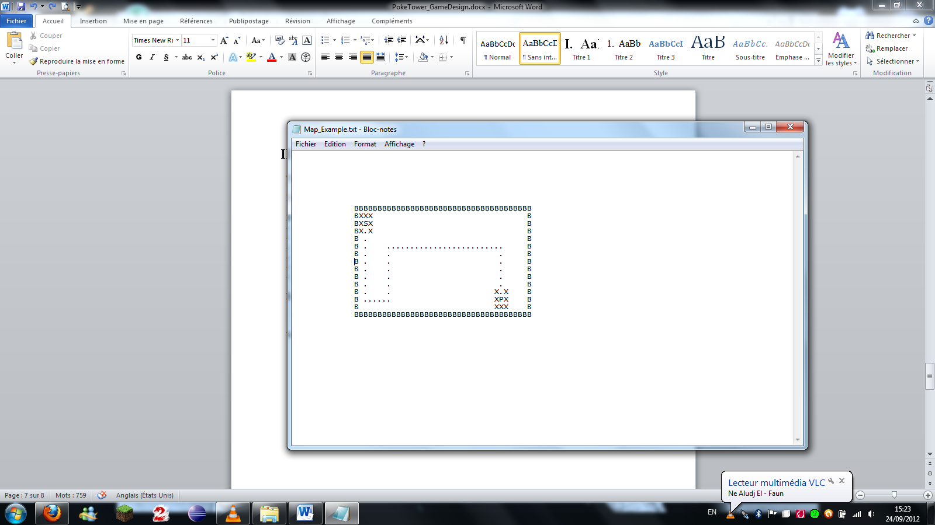

Waves

The file describing a map will provide the following informations :

- Start of a new wave, a new start ends the previous wave, the first one is Wave0

- Time of appearance after the start of the wave

- Enemy's type

- Number of enemies

The time of apparition will be calculated function of the speed and size of the enemy.

Time|Enemy|Number

Example of a wave :

WAVE

0|Grimer|10

2|Koffing|5

WAVE

0|Ekans|15

4|Grimer|5

6|Koffing|4

WAVE

0|Meowth|1

WAVE

0|Mewtwo|1

# Gameplay

The player starts with a defined amount of PokeDollars at the start of the map. He can launch a wave of enemies, pause, accelerate or slow the game.

He can buy and place a tower, by dragging and dropping it where he wants to put it, it will then deduct the cost of the tower from his PokeDollars. By vanquishing enemies, he will earn money and be able to buy new towers or stones to make his Pokémons evolve.