**AI-Driven Exploration and Prediction of Company Registration Trends with Registrar of Companies (RoC )**

**Abstract**

1. **Data Collection**: Start by obtaining historical data on company registrations from the RoC. This data might include details like company names, registration dates, locations, industries, and more.
2. **Data Cleaning and Preprocessing**: Clean and preprocess the data to handle missing values, outliers, and ensure consistency. This step is crucial to ensure the quality of your predictions.
3. \*\***Feature Engineering**\*\*: Create relevant features from the data that can help in trend analysis and prediction. For example, you might want to extract information on the number of registrations per month, industry-specific trends, or geographic patterns.
4. \*\***Time-Series Analysis**\*\*: Use time-series analysis techniques to identify patterns and trends over time. This can involve methods like moving averages, seasonal decomposition, and autocorrelation analysis.
5. \*\***Machine Learning Models**\*\*: Train machine learning models on the preprocessed data to predict future company registration trends. You can use regression models, time-series forecasting models (e.g., ARIMA or LSTM), or even more advanced AI models like XGBoost or neural networks.
6. \*\***Natural Language Processing (NLP)**\*\*: If you have textual data related to companies (e.g., descriptions or news articles), you can apply NLP techniques to extract sentiment or contextual information that might influence registration trends.
7. \*\***Visualization**\*\*: Create meaningful visualizations such as line charts, heatmaps, or geographical maps to present your findings and predictions effectively.

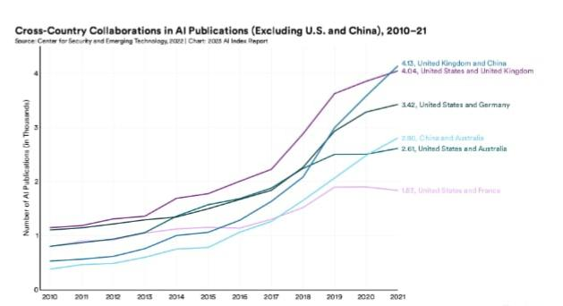

1. \*\***Evaluation and Validation**\*\*: Evaluate the performance of your AI models using appropriate metrics and validate the predictions against real-world data. This step helps in assessing the accuracy and reliability of your predictions.
2. \*\***Continuous Learning**\*\*: Set up a system for continuous learning and updating of your AI model. Registration trends can change over time due to various factors, so your model should adapt to new data.
3. \*\***Interpretability**\*\*: Ensure that your AI-driven insights are interpretable, so stakeholders can understand the reasons behind the trends and predictions.
4. \*\***Policy and Decision Making**\*\*: Use the insights gained from your AI analysis to inform business decisions, government policies, or investment strategies.
5. \*\***Ethical Considerations**\*\*: Be mindful of ethical considerations, including data privacy and bias in AI models, especially if your predictions impact individuals or businesses.

**Algorithm:**

1. **\*\*Time-Series Forecasting Models\*\***:

- **ARIMA (AutoRegressive Integrated Moving Average)**: ARIMA models are well-suited for univariate time series data. They can capture trends, seasonality, and autocorrelation in your registration data.

* **\*\*Prophet\*\***: Developed by Facebook, Prophet is designed for forecasting with daily observations that display patterns on different time scales. It handles missing data and outliers well and is particularly useful when dealing with time series with seasonal and holiday effects.
* **\*\*LSTM (Long Short-Term Memory)\*\***: If you have a large dataset and want to work with recurrent neural networks, LSTM can be a good choice. LSTMs are effective for capturing long-term dependencies in time series data.

**2. **Regression Models**:**

- **Linear Regression**: Simple linear regression can be used if you have a straightforward relationship between your features and the registration trends. It’s interpretable but assumes a linear relationship.

* **\*\*XGBoost or LightGBM\*\***: These gradient boosting algorithms are robust and can handle complex relationships between features and trends. They often perform well in predictive tasks.

**3. **Prophet-NLP Hybrid**:**

- Consider combining Prophet with natural language processing (NLP) techniques if you have textual data related to companies. You can use NLP to extract sentiment or context from news articles or descriptions and then incorporate this information into your predictions with Prophet.

**4. **Ensemble Methods**:**

- Ensemble methods like Random Forest or Gradient Boosting can be effective for combining the predictions of multiple models, potentially improving accuracy.

The “best” algorithm depends on factors such as the size of your dataset, the complexity of the registration trends, the availability of features, and your computational resources. It’s often a good practice to start with simple models like ARIMA or linear regression and then experiment with more complex algorithms like XGBoost or LSTM if needed.

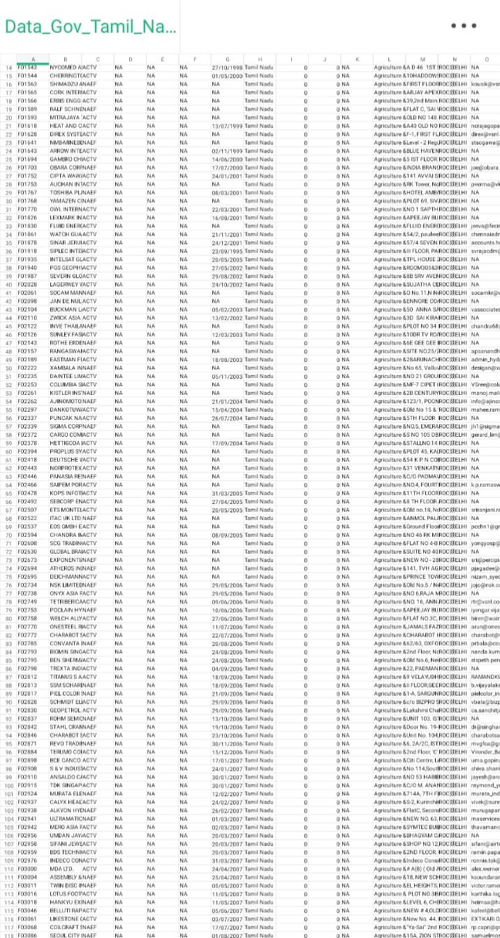**Dataset:**

5. Feature Engineering: Create relevant features from the data, such as time-series features, location-based features, or industry-specific features.

6. AI Model Development: Build machine learning or deep learning models to analyze the data. Time-series forecasting models, clustering algorithms, and natural language processing (NLP) can be useful, depending on the specific goals.

7. Trend Analysis: Use AI to identify historical trends in company registrations. You can detect patterns, seasonality, and anomalies in the data.

8. Predictive Modeling: Develop predictive models that can forecast future company registration trends. This can help businesses, investors, and policymakers make informed decisions.

9. Natural Language Processing (NLP): Apply NLP techniques to analyze text data related to company registrations, such as company descriptions or reasons for registration.

8. Visualization: Create visualizations and dashboards to communicate insights and trends effectively.

9. Continuous Learning: Keep the AI system updated with new data to improve its predictive accuracy.

10. Compliance and Security: Ensure that the AI-driven program complies with data protection regulations and maintains data security.

Creating a complete Python program for the AI-driven prediction of company registration trends with the Registrar of Companies (RoC) is a complex task that requires significant time and resources. Here’s a simplified example to get you started. This example demonstrates time-series analysis and prediction using a Python library called Prophet, which is useful for forecasting trends.

First, you would need to install the necessary libraries:

```bash

Pip install pandas numpy fbprophet

```

Here’s a simplified Python script to get you started:

```python

Import pandas as pd

From fbprophet import Prophet

# Load your company registration data (replace ‘data.csv’ with your dataset)

Data = pd.read_csv(‘data.csv’)

Data = data[[‘date’, ‘registrations’]]

Data.rename(columns={‘date’: ‘ds’, ‘registrations’: ‘y’}, inplace=True)

# Initialize and fit the Prophet model

Model = Prophet()

Model.fit(data)

# Create a dataframe for future predictions

Future = model.make_future_dataframe(periods=365) # You can adjust the prediction period

# Make predictions

Forecast = model.predict(future)

# Visualize the forecast

Fig = model.plot(forecast)

# Access forecasted values

Forecasted_values = forecast[[‘ds’, ‘yhat’]]

# You can save forecasted_values to a CSV file or use them for further analysis

# If you need more advanced features like NLP analysis or complex feature engineering, additional code is required.

```

This code is a basic starting point. You will need to adapt it to your specific dataset and requirements. Make sure to clean and preprocess your data as needed and consider more advanced techniques for feature engineering, trend analysis, and natural language processing if required.

Please note that this example only covers time-series forecasting and doesn’t encompass the full scope of a comprehensive AI-driven system for company registration trend analysis. Building a production-ready system would require much more extensive code and potentially collaboration with relevant data sources.

