**AC measurements**

Lab work done by _______________Sean Gordon_________________________

and ________________________________________

Lab work date: 9/12/2018

Report submission date:  
  
  
Graded by ________________________________________

Score __________________________________

**Note: Calculations for each part are attached as an appendix.**

**Introduction**

This lab was to introduce the oscilloscope and grant familiarity with AC voltage. The lab is designed to force students to play around with different circuits powered by an AC source, and to get a better understanding of how the tools and RMS voltage work.

**voltage divider**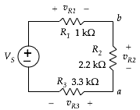

Voltage measurements:

*VS* = ___________5v___________

*vR1* = ___________.778v___________; *iR1* = _________.766mA _____________

*vR2* = ___________1.768v___________; *iR2* = ________.766mA ______________

*vR3* = ___________2.475v___________; *iR3*  = ________.766mA ______________

current (measured with ammeter) = ____________.766mA__________________

Attach a screen shots of the of the source voltage together *vR3* for sinusoidal and triangle-wave inputs.

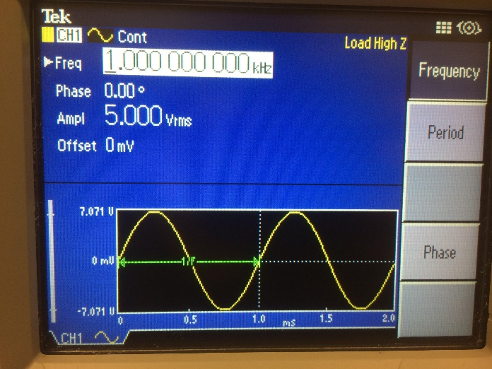

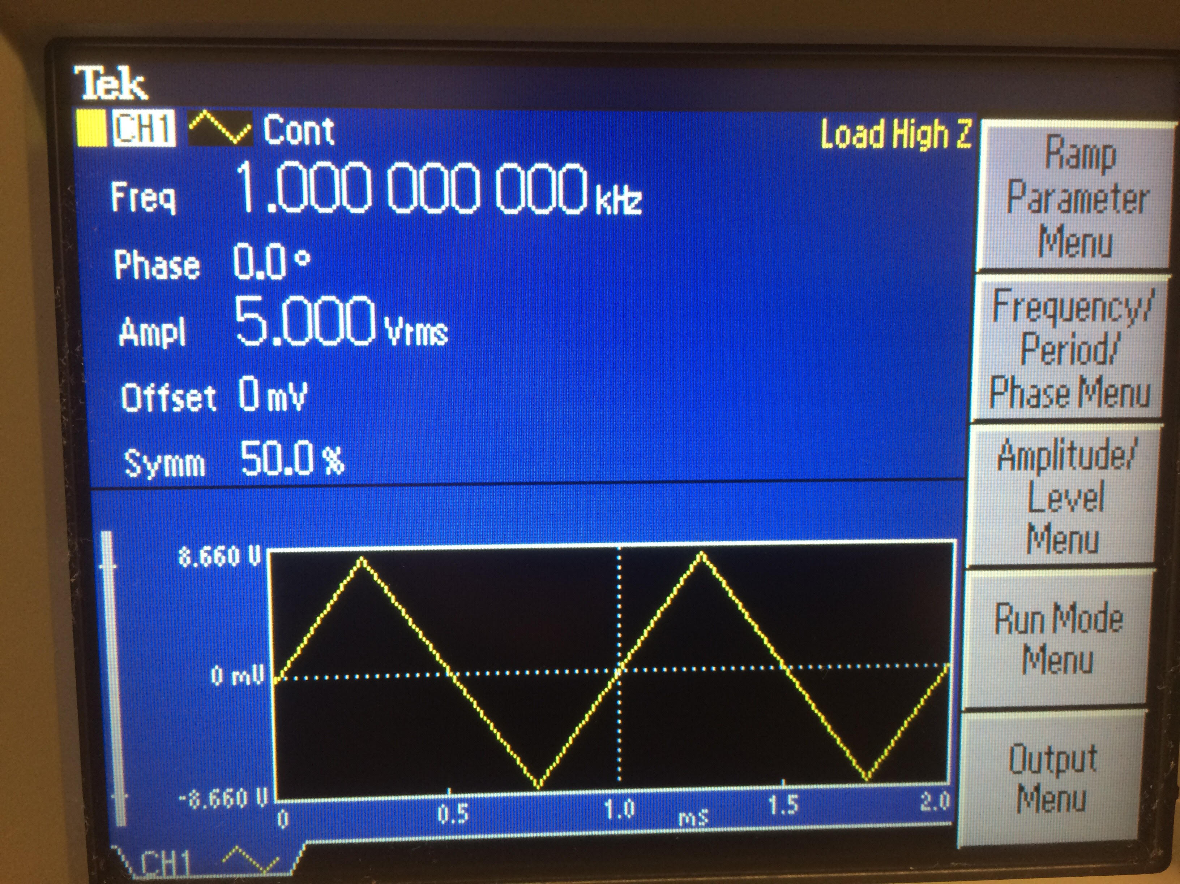

**current divider**

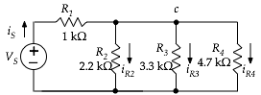

Voltage measurements:

*VS* = ___________5v___________

*vR1* = ___________2.44v___________; *iR1* = __________1.712mA____________

*vR2* = ___________2.52v___________; *iR2* = __________1.141mA____________

*vR3* = ___________2.49v___________; *iR3*  = __________.751mA____________

current (measured with ammeter) = ______________2.46mA________________

Attach a screen shots of the of the source voltage together *vR3* for sinusoidal and triangle-wave inputs.

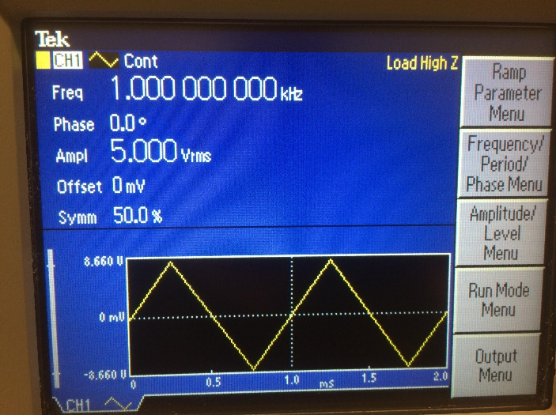

**circuit with capacitor**  
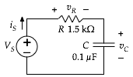

With *f* = 1000 Hz.

Voltage measurements:

*VS* = _________4.967v_____________

*vR* = ____3.864v, .6v, 4.87v ______; *vC* = __3.04v, 5.02v, .424v______

*iR* = ____2.6mA, .405mA, 3.29mA_____________;

current (measured with ammeter) = _______2.605 mA, .412 mA, 3.287mA___________

Attach a screen shot of the of the source voltage together *vR3*.

Repeat everything above with with *f* = 100 Hz and then with *f* = 10,000 Hz,

**Design it**

*Sketch your circuit. Include the design equation showing how you came up with your circuit. Describe the DC and AC measurements that you performed to confirm that your design matches the specification.*

**Conclusion**

This lab was an effective exercise to increase familiarity with the tools at our disposal. I