**Circuits analysis and measurements**

Lab work done by _______________Sean Gordon_________________________

and ________________________________________

Lab work date: 9/19/2018

Report submission date:  
  
  
Graded by ________________________________________

Score __________________________________

**Note: Calculations for each part are attached as an appendix.**

**Introduction**

In this lab students will practice node-voltage techniques with various circuits. This lab exposes the student to many different combinations of resistors and voltage sources in an attempt to familiarize them with the information. As classes and labs can never seem to line their schedules up, this lab attempts to completely teach the node-voltage technique without instruction.

1. **Node-voltage A.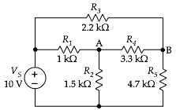  
     
     
     
     
   Figure 1**

Node grounded 🡪

|  | **calculated** | **measured** |
| --- | --- | --- |
| *vR2* (node A) |  | 6.188v |
| *vR5* (node B) |  | 6.665v |

*Comment on the results and discuss any discrepancies between any of the values.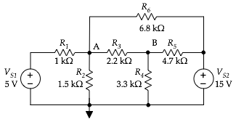*

1. **Node-voltage B.  
     
     
     
   Figure 2.**

Node grounded 🡪

|  | **calculated** | **measured** |
| --- | --- | --- |
| *vR2* (node A) |  | 4.222v |
| *vR4* (node B) |  | 5.261v |

*Comment on the results and discuss any discrepancies between any of the values.*

1. **Node-voltage C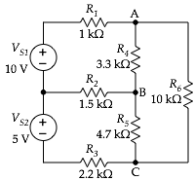  
     
     
     
      
   Figure 3.** Note that you must specify which node you are using as ground.  
     
     
     
    Node G2 grounded 🡪

|  | **calculated** | **measured** |
| --- | --- | --- |
| node A |  | 12.355v |
| node B |  | 6.608v |
| node C |  | 3.470v |

*Comment on the results and discuss any discrepancies between any of the values.*

1. **Mesh-current A.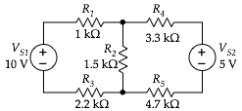  
     
     
     
    Figure 4.**

|  | **calculated** | **measured** |
| --- | --- | --- |
| *iR1* (mesh A) |  | 2.07 mA |
| *iR4* (mesh B) |  | .203mA |

*Comment on the results and discuss any discrepancies between any of the values.*

**Mesh-current B.***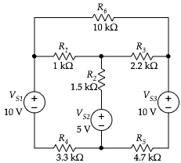*  
  
  
  
  
  
A  
 **Figure 5.**

B C

|  | **calculated** | **measured** |
| --- | --- | --- |
| *iR4* (mesh A) |  | .105mA |
| *iR5* (mesh B) |  | .733mA |
| *iR6* (mesh C) |  | .617mA |

*Comment on the results and discuss any discrepancies between any of the values.*

1. **Superposition A.  
   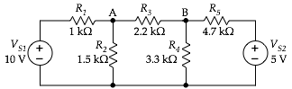  
     
     
     
     
   Figure 6.**

|  | **calculated** | **measured (total)** | **measured (*VS1* only)** | **measured (*VS2* only)** |
| --- | --- | --- | --- | --- |
| *vR2* |  | 5.5v | .259v | 5.241v |
| *vR4* |  | 3.662v | 1.225v | 2.431v |

*Comment on the results and discuss any discrepancies between any of the values.*

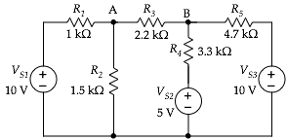

1. **Superposition B.  
     
     
     
     
     
    Figure 7.**

Node grounded 🡪

|  | **calculated** | **measured (total)** | **measured (*VS1* only)** | **measured (*VS2* only)** | **measured (*VS3* only)** |
| --- | --- | --- | --- | --- | --- |
| *vR2* |  | 6.137v | 5.255v | .368v | .517v |
| *vb* |  | 6.628v | 2.445v | 1.743v | 2.444v |

*Comment on the results and discuss any discrepancies between any of the values.*

**Design it.**

Sketch the circuit, including the values for the resistors. Describe the measurements the were done to confirm that the voltages and currents met the specifications. Describe how you designed the circuit – a few words of explanation plus the equations that show arrived at the resistors values you used.

**Conclusion**

*Write a concluding paragraph describing the basic results. If you encountered any problems with the circuit or your calculations, be sure to discuss those here.*