**Thevenin equivalent circuits**

Lab work done by ___________________Sean Gordon_____________________

and ________________________________________

Lab work date:

Report submission date: 10/10/2018  
  
  
Graded by ________________________________________

Score __________________________________

**Note: Calculations for each part are attached as an appendix.**

**Introduction**

This lab serves as an introduction to or a reinforcement of the concepts of Thevenin Equivalence. The lab centers around reinforcing the concept of equivalency between Thevenin and ‘normal’ circuits.

1. **Thevenin A.**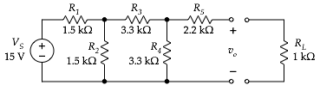

From original circuit: *vRL* = ______.664v ______; *PRL* = _______.441mW________

|  | **calculated** | **measured** |
| --- | --- | --- |
| *VTh* | 3.367 | 3.361 |
| *RTh* | 4.018k | 4.001k |

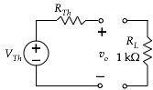

From equivalent circuit that you built: *vRL* = ____.670v_____; *PRL* = ____.449mW___

I used the Ohm-meter method to find R-Thevenin. The load voltages of both circuits as expected are nearly the same, save some margin of error.

1. **Thevenin B.**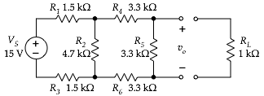

From original circuit: *vRL* = ______.764v_______; *PRL* = ________.584mW_______

|  | **calculated** | **measured** |
| --- | --- | --- |
| *VTh* | 2.57556 | 2.583 |
| *RTh* | 2.371703753k | 2.342k |



From equivalent circuit that you built: *vRL* = ____.758v___; *PRL* = _____.575mW_____

I used the Ohm-meter method to find R-Thevenin. The load voltages of both circuits as expected are nearly the same, save some margin of error.

1. **Thevenin C.**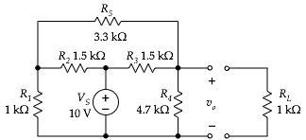   
     
     
     
     
     
     
     
     
   From original circuit: *vRL* = __________3.605v___________; *PRL* = ____12.996mW____y

|  | **calculated** | **measured** |
| --- | --- | --- |
| *VTh* | 6.77v | 6.778v |
| *RTh* | .8804k | 1.638k |



From equivalent circuit that you built: *vRL* = ______3.57v______; *PRL* = __12.745mW_

I used the Ohm-meter method to find R-Thevenin. The load voltages of both circuits are nearly the same, further supporting the Thevenin equivalence method.

1. **Thevenin D.**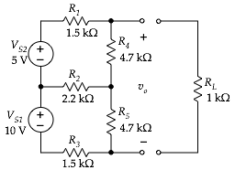   
     
     
     
     
     
     
     
     
     
     
     
     
     
     
     
     
     
     
     
     
   From original circuit: *vRL* = __________3.470v___________; *PRL* = ________12.041mW_______

|  | **calculated** | **measured** |
| --- | --- | --- |
| *VTh* | 11.37 | 11.356v |
| *RTh* | 2.274k | 2.245k, 2.241k, 2.252k |

Note: There should be three measured values for *RTH* for this circuit.

From equivalent circuit that you built: *vRL* = _______3.468v_______; *PRL* _12.027mW_

I had some trouble with the potentiometer part, but all the values I found for resistance were within an acceptable margin of error. There was almost no difference between the load voltage of the two respective circuits, showing Thevenin equivalency is an effective simplification method.

| ***RL*** | ***vRL*** | ***iRL*** | ***PRL*** |
| --- | --- | --- | --- |
| .250k | 1.14v | 4.56mA | 5.19mW |
| .570k | 2.27v | 3.98mA | 9.04mW |
| .970k | 3.40v | 3.51mA | 11.92mW |
| 1.51k | 4.54v | 3.01mA | 13.65mW |
| 2.27k | 5.68v | 2.50mA | 14.24mW |
| 3.41k | 6.82v | 2.00mA | 13.65mW |
| 5.30k | 7.96v | 1.50mA | 11.96mW |
| 9.08k | 9.09v | 1.00mA | 9.10mW |
| 20.33k | 10.23v | 0.50mA | 5.15mW |

1. **Maximum power transfer**  
      
     
   The required resistance to acheive the defined voltage increased in an exponential curve, opposite to the current through the load resistor. The power through the load resistor displayed a bell curve as a result.

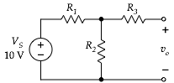

**Design it.**

List the values that were used for the resistors. Describe the measurements that were done to confirm that the voltages and resistances met the specifications. Describe how you designed the circuit – a few words of explanation plus the equations that show arrived at the resistors values you used.

**R1 = 1k R2 = 1k R3 = 1k**

To find these values, I knew R1 == R2, and that

(R1*R2) / (R1+R2) + R3 = 1.5k **∴** R1/2 + R3 = 1.5k

So I chose 1k resistors for all 3.

I used the ohm-meter method to confirm Rth, and simply measured the voltage across Vo to confirm Vth.

**Conclusion**

This lab was an exercise in Thevenin equivalency, reinforcing through repetition that the Thevenin equivalent circuit produces the same result on the load resistor as the original. I had a little trouble wherever potentiometers were involved because they’re so damn sensitive, but otherwise everything went as smoothly as expected.