Mohamed Gesalla EE 330

Lab: 12

Thyristor Device Characterization and Applications

# Introduction:

In this lab, I will be experimenting some thyristors’ operations, developing methods of measuring key parameters of thyristors as well as investigating some basic applications of these devices.

## Part One: Extract 𝑽𝒈𝒕 and 𝑰𝒈𝒕

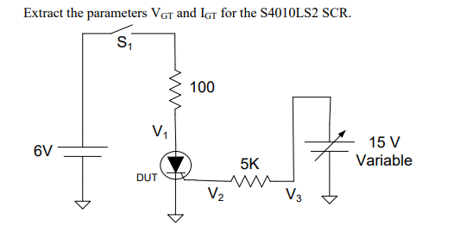

The circuit above was built and tested for V3 set to 0Vwhile the switch S1 was closed which led the SCR to be in the “OFF” state right after S1 is closed. The voltage obtained (V1) was monitored using the oscilloscope. The voltage V1 found to be 6V as expected when SCR is in the “OFF” state.

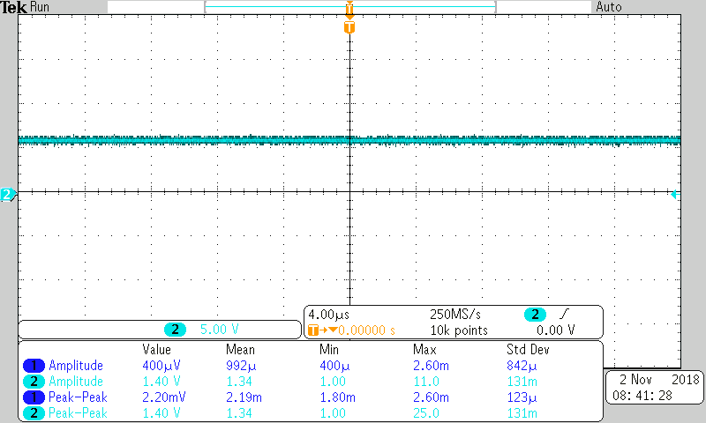

Next, we started increasing V3 until the voltage on V1 drops. As seen in the figure below, the voltage in V1 dropped from 6V. The drop in voltage occurred because the SCR was triggered.

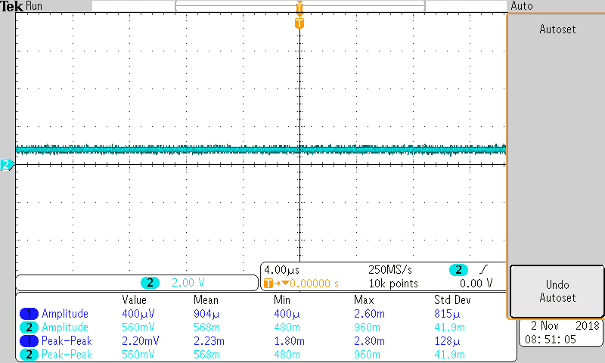

In this part, I measured V2 (VGT) with another port on the oscilloscope while measuring V3 with the same instrument.

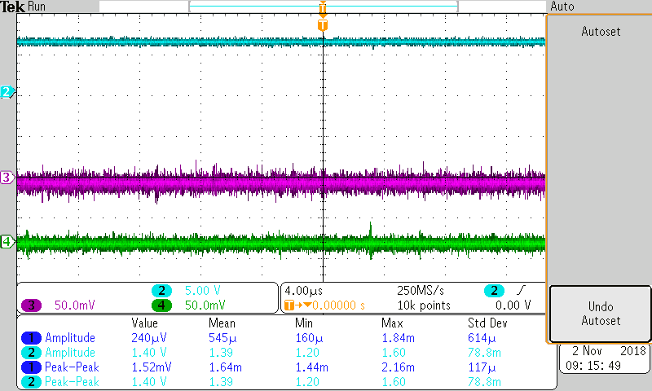

Using the trigger current IGT expression, I calculated IGT and compared it to the one from the datasheet



$$I_{GT}= \frac{2-0.7}{5KΩ}=260µA$$

$$V_{GT}= V_{2}=0.7V$$

|  |  |  |
| --- | --- | --- |
|  | **Calculated** | **Datasheet Value** |
| $$I_{GT}$$ | $$260µA$$ | $$200µA$$ |
| $$V_{GT}$$ | $$0.7$$ | $$0.7$$ |

## Part Two: Light Dimmer

In this part, we designed a light dimmer circuit for light driven by an AC voltage. The circuit drives a 24 V supplied for a transformer.

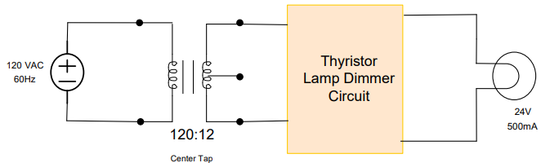

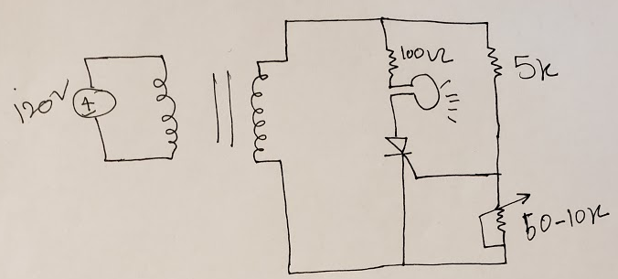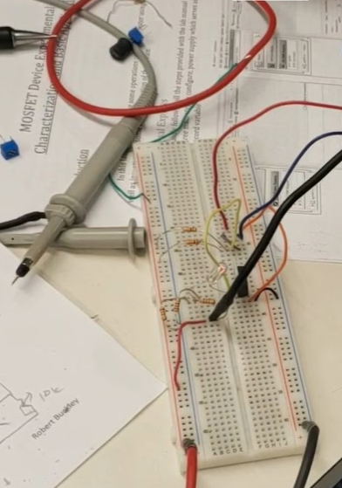

Using a 50K resistor pot, we were able to adjust the resistance which controlled the voltage across to the light.

## Part Three: Burglar Alarm

In this part, we deigned a circuit that is similar to the light dimmer circuit. Again in a similar design, we used the 10-50K ohms potentiometer to control the current through the buzzer.

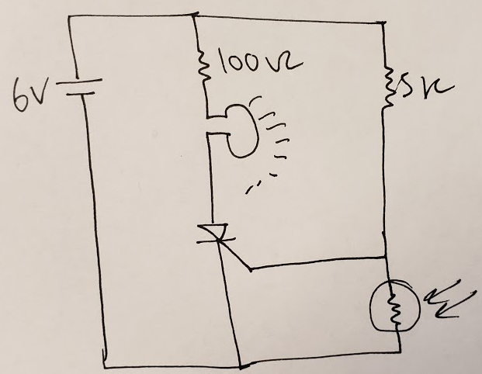

## Part Four (Extra Credit) : Light Controlled Light Dimmer

In this part, we intended to design, build, and test a circuit where the input to a separate photodetector (such as a photo resistor or photo diode) can be used to modulate the intensity of the incandescent lamp.

We were able to design the circuit but when we implemented it we could not get the light to dim using the photoresistor but when trying the same design using a potentiometer, the circuit seemed to operate just fine.

One of the approaches we tried is replacing the photoresistor with a photodiode but we still could not get the circuit to perform properly.

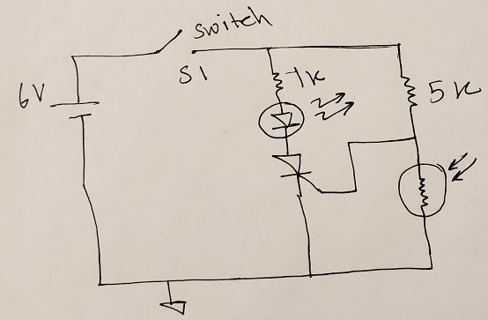

# Conclusion:

This was a beneficial lab as far as experimenting Thyristors and seeing some their functionality. Also on the measurement of the voltage in the first part of the lab, I saw how small gate current or gate voltage can trigger a large current flow.