**Olouwole Eteka**

**Lab report 11**

**Thyristor Device Characterization and Applications**

**INTRODUCTION**

We will familiarize ourselves with the Thyristors deice characteristics as well as how they operate in reality. In this lab several different circuits that are going to be implemented to understand the basic applications of these devices. We are also going to use the thyristor to build a dimer and alarm

Part 1: Extract 𝑽𝒈𝒕 and 𝑰𝒈𝒕

In this part one of the lab, we are required to extract the parameters 𝑽𝒈𝒕 and 𝑰𝒈𝒕 for the SCR in the picture bellow

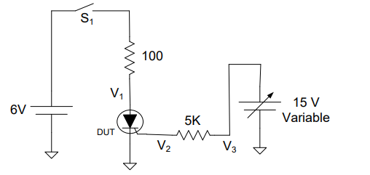

In this approach, the voltage V3 is set to zero and the switch S1 is closed. The SCR will be in the “OFF” position right after the switch S1 is closed. The oscilloscope is used to monitor the voltage V1 and turn out to be 6V when the SCR is in the “OFF” position still. We can observe the scope bellow

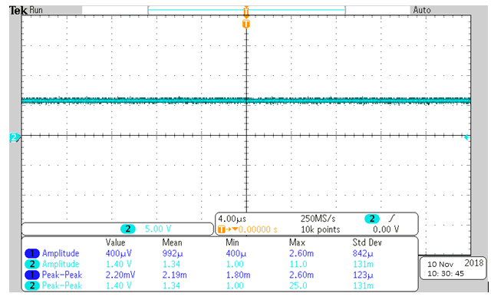

I started increasing the Voltage V3 until V1 voltage drops. The drop in V1 occurs when the SCR is triggered, and the drop in the voltage V1 should be both abrupt and rapid. After this event, I can then stabilize the voltage V3 and take measurements.

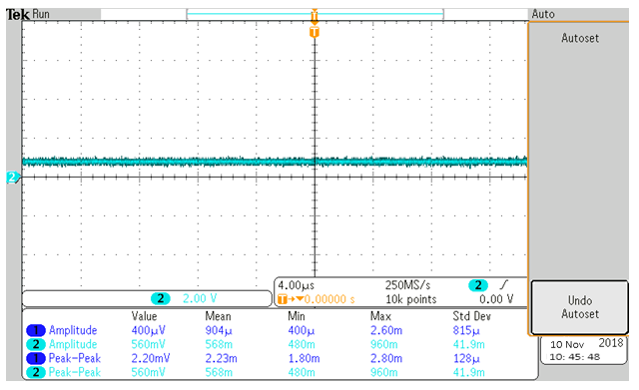

When I measure V2 with another port on the oscilloscope, I will find it to be equal to VGT. Then V3 will be measurement using the same method.

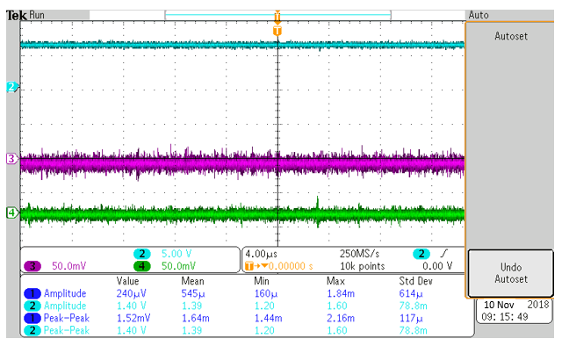

We can observe that v2 is equal to VGT

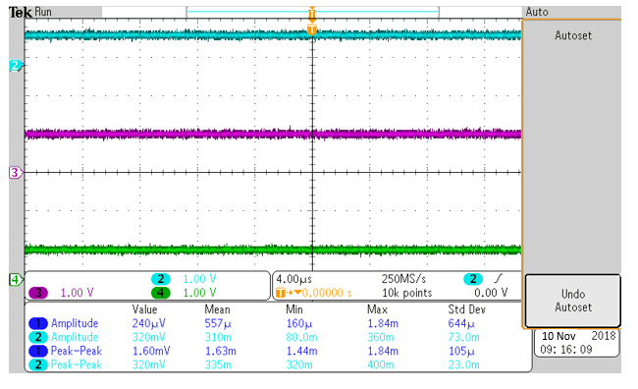



**= (2-0.8)/5k**

**IGT= 240 uA VGT=V2= 0.8V**

**Comparison**

|  |  |  |
| --- | --- | --- |
|  | **Calculated** | **Datasheet Value** |
| $$I_{GT}$$ | $$260µA$$ | $$200µA$$ |
| $$V_{GT}$$ | $$0.8$$ | $$0.7$$ |

**Part 2: Light Dimmer**

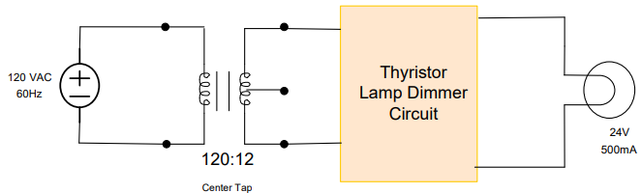

In this part, we designed a light dimmer circuit for light driven by an AC voltage. The circuit drives a 24 V supplied for a transformer. The circuit of the design provided above

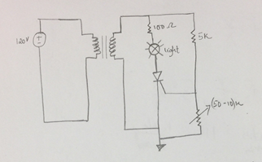**Circuit drawing and implementation**

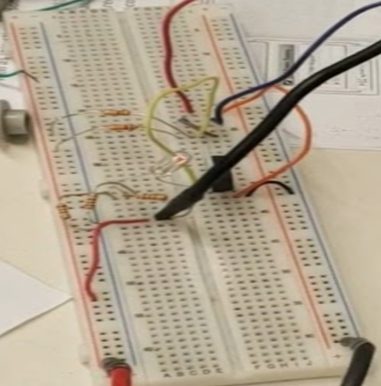

I used a 50K potentiometer and I was able to adjust the resistance, which controlled the voltage across to the light. The variance in the resistance across VG change the current IF which make the light brighter or dimmer.

**Part 3: Burglar Alarm**

Unlike other parts of the lab, the design is not provide in this part of the lab and we are required to build a light-sensitive burglar alarm. However, if we look closely, Part 3 is a buildup on the design in part 2. Similarly, I used 10-50K ohms potentiometer to control the current through the load.

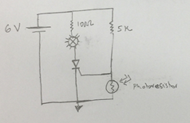

Instead of a photo resistor, a potentiometer was used to vary to the current through the load as it is showing bellow.

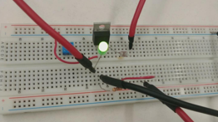

**Part 4 (Extra Credit): Light Controlled Light Dimmer**

Part four of the lab is the design part. We intended to design, build, and test a circuit where the input is a dc voltage controlled by the combination of a switch and a photodetector such as a photo resistor or photo diode. It can be used to modulate the intensity of the incandescent lamp.

I was able to design the circuit but when I was implementing it did not get the light to dim using the photo resistor (I also tried the photo diode). However, when trying the same design using a potentiometer, the circuit seemed to operate just fine. I was thinking that maybe it has something to do with the propagation time of the photo resistor not matching with the SCR one.

When I replaced the photo resistor with a photodiode it still not performing properly but the behavior was different so I can conclude the noise is coming from the photodetector incorporated in the circuit.

The diagram of design is provide bellow.

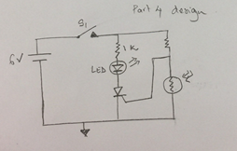

**CONCLUSION**

In this lab, I have learned quite some basic applications of thyristors, mainly SCRs on real life. Such as light dimmer and burglar alarms which are all very helpful to us. I think this lab is one of the most useful application in circuit design I have learned throughout this class.