**Olouwole Eteka**

**EE330 lab 6 report**

**Introduction**

In this lab, the objective is to learn the relationship between the square law model and the BSIM model of the MOS transistor. We will essentially compare two models with the same parameters and find out the percentage of difference.

**Part 1: Square-law Parameter Extraction**

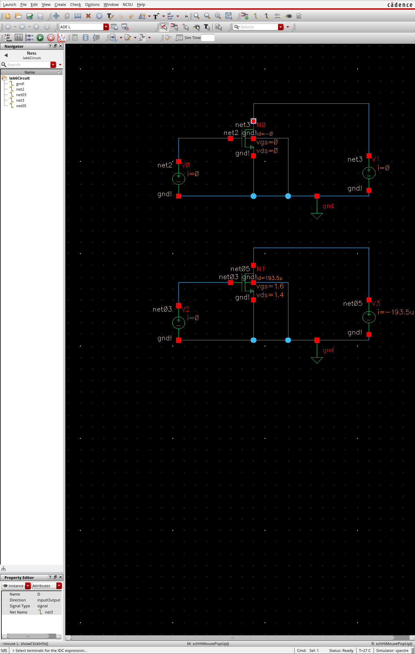

**MOS transistor with W=12µm, L=3µm**

Derive the process parameter VT0   
Keeping the VDS constant and used the different VGS to get the two current values.

From measurement:

VGS=2V, ID1=980.6µA; VGS=2.5V, ID2= 1.523mA

From the equation:

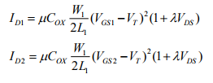

We get:

$\sqrt{\frac{980.6µ}{1.523m}}=\frac{2-V_{T}}{2.5-V_{T}}$

VT0 = -0.03048V

Derive the process parameter λ

VGS=2V,

When VDS=4V, ID1=980.6µ

When VDS=3V, ID2=974.6µ

$\frac{980.6µ}{974.6µ}=\frac{1+4λ}{1+3λ}$

λ = 0.00627

Derive the process parameter µCox

VGS=2V, VDs=4V, ID=980.6µ, λ=0.00627, VT=-0.03048V

µCox =

µCox = 174.02µA/V2

Derive the process parameter γ



VT0 = -0.03048V

When VBS = -2V, VT = 0.382369V

$0.382369=0.03048+γ(\sqrt{0.6-\left(-2\right)}-\sqrt{0.6})$

γ = 0.42

**Repeat step 1-4 with VGS=1.2V, VDS=0.8V, w=1.5µ, L=0.6µ**

I repeated the same steps of calculation as in the previous line with a result of:

ID=146.2µ, VT0=0.185V, λ=0.03607, µCox=110.34µA/V2, γ=0.6788

**Part 2: Comparison with BSIM Model**

With W=12µ, L=0.6µ, VGS=2V, VDS=3V, and VBS=0:

For this part I believe the amplitude of my graph was too high. I was expecting my value to be close to the operating point for the MOS transistor (about 980.601µA). I repeated the process with he values (W=60μ, L=3μ, VGS=2V, VDS=3V, and VBS=0) below.

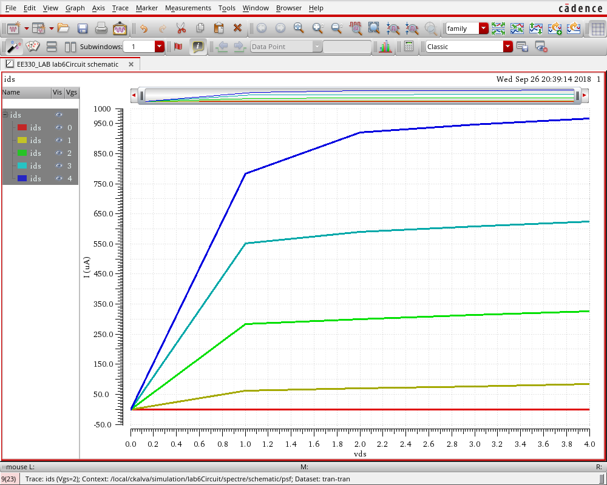

With W=60μ, L=3μ, VGS=2V, VDS=3V, and VBS=0:

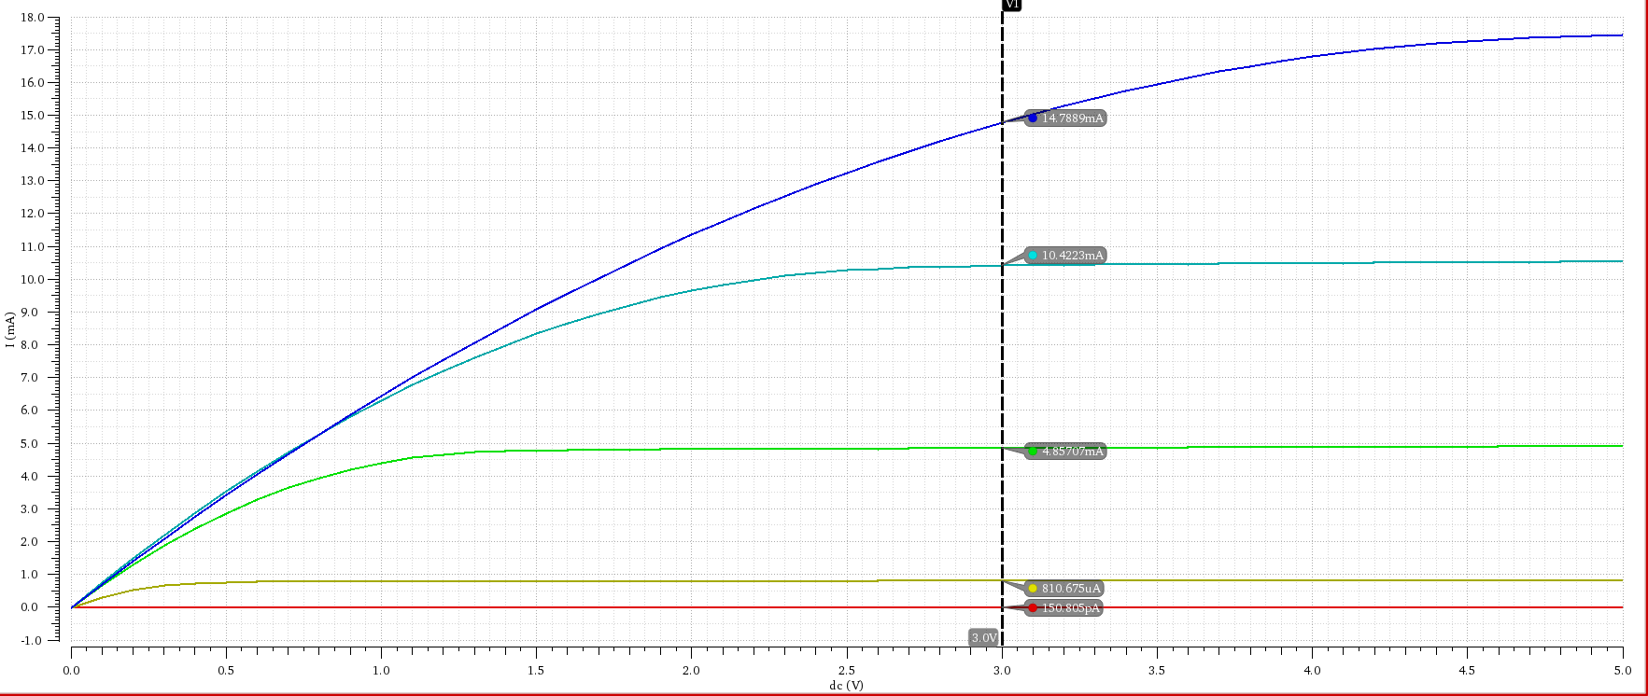

The graph above has the respective parameters:

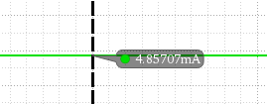VGS=0V, VGS=1V, VGS=2V, VGS=4V

As shown on the side, the operating

current for the MOS transistor (VDS= 3V, VGS=2V (Green) and VBS=0) is about ID = 4.85707mA.

In order to compare, we have to use back the model parameters extracted in the previous part to calculate the operating point:



$I_{D} = (174.02µA/V^{2})\frac{60µ}{2\left(3µ\right)}{\left(2-\left(-0.03048\right)\right)}^{2}(1+\left(0.00627\right) x 3)$

ID = 7.3095mA

$Error= \frac{7.3095mA-4.85707mA}{7.3095mA}$ x 100% = 33.55%

Therefore, we can observe that the operating current ID from the BSIM model is lower than the one calculated from square-law parameter extraction by 33.55%.

**Part 5: Output Conductance Extraction/Part 6: Early Voltage**

Small signal output conductance, from square-law model is given by the equation, 𝑔0 = 𝜆𝐼𝐷𝑄. In order to find out the differences between them, I first set it the Vgs to 2V, 3V, and 4V and with constant VDS = 3V.

In the above schematic design, I’ve set the length to variable ‘l’ so that I can sweep it using the parametric analysis of ADE L. Then, I’ve created an equation by clicking **Edit -> Open Calculator -> Check ‘op’ -> (Add the equation 𝑔0 = 𝜆𝐼𝐷𝑄)**.

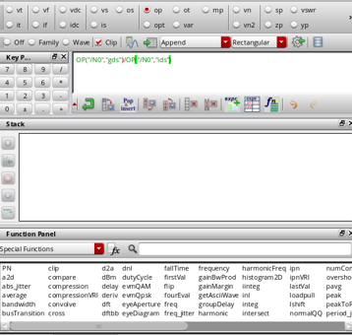

The figure above shown the calculator that I’ve used in this part to calculate my 𝜆 from the equation given above.

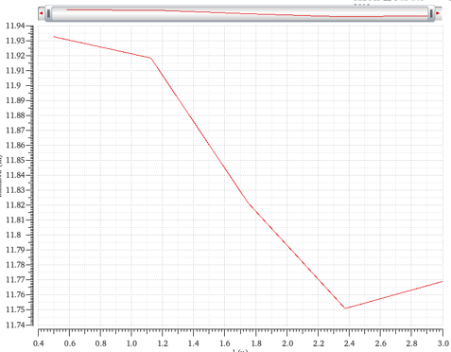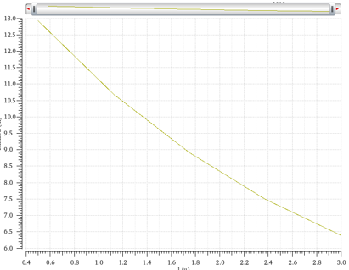

Figure 2(Vgs=3V)

Figure 1 (Vgs=2V)

Figure1

we know that VGS < VDS, and therefore we are expecting 𝜆 to reduce as the length ‘l’ reduces.

Figure2

VGS is set equal to VDS and from that the slope changes when length is at 1.2 and 2.3 whereas at point l=2.3u, the slope starts to go upwards.

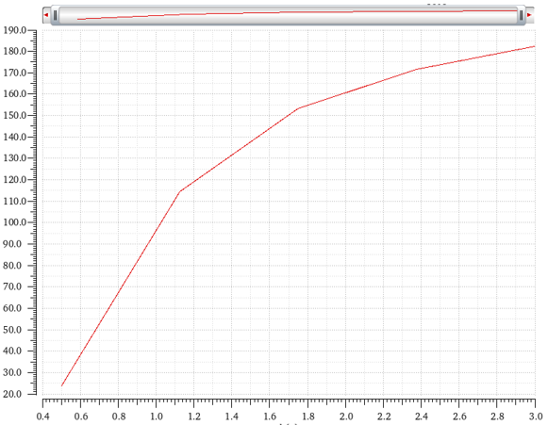

Figure 1(Vgs=4V)

Figure3

we know that VGS > VDS, therefore we can observe that the slope of the graph changes where it looked like an increasing exponential function where the 𝜆 increase as the length increases.

Conclusion

In this lab I have learned the difference in certain values like 𝜆 when we are comparing a square-law and a BSIM model but the current value that we are expecting from the saturation equation will be about the same. I can conclude that the BSIM is more accurate when getting the value of the current than the value of 𝜆.