**Olouwole Eteka**

**EE 330 lab 7**

**Introduction**

we are measuring the parameters from an actual hardware MOSFET transistor with the help of test equipment mentioned below and the software Signal Express. It is similar to the previous lab but in this one we are using an actual hardware to take our measurments . we will using the function generator and the oscilloscop to measure values and the parameter analyzer for the stimulation.

**Part 1. Set up Signal Express**

We will begin by setting up signal express as well as all our test equipment. Then we have to connect our devise to the computer and to signal express. After powering them on, we can go ahead and set up the Signal Express. Then we can follow the steps.

1. IVI Power Supply
2. IVI DMM Acquire
3. Sweep

We can see it on the pictures bellow.

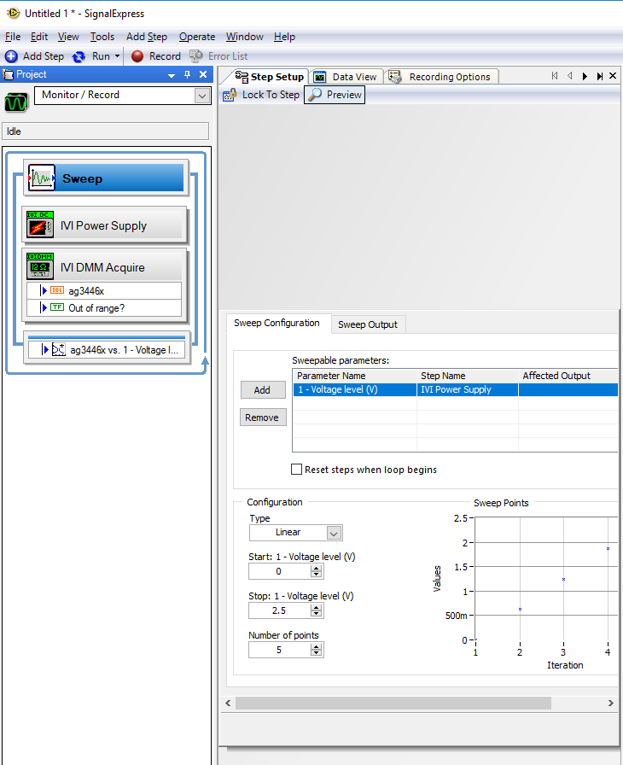

In order to set up the power supply, we have to first make sure that we connect to the right power supply device under the drop down box of configuration tab. Then, we have to make sure that all channels 1-3 are turned on. They each represent different voltage terminal of the DC power supply

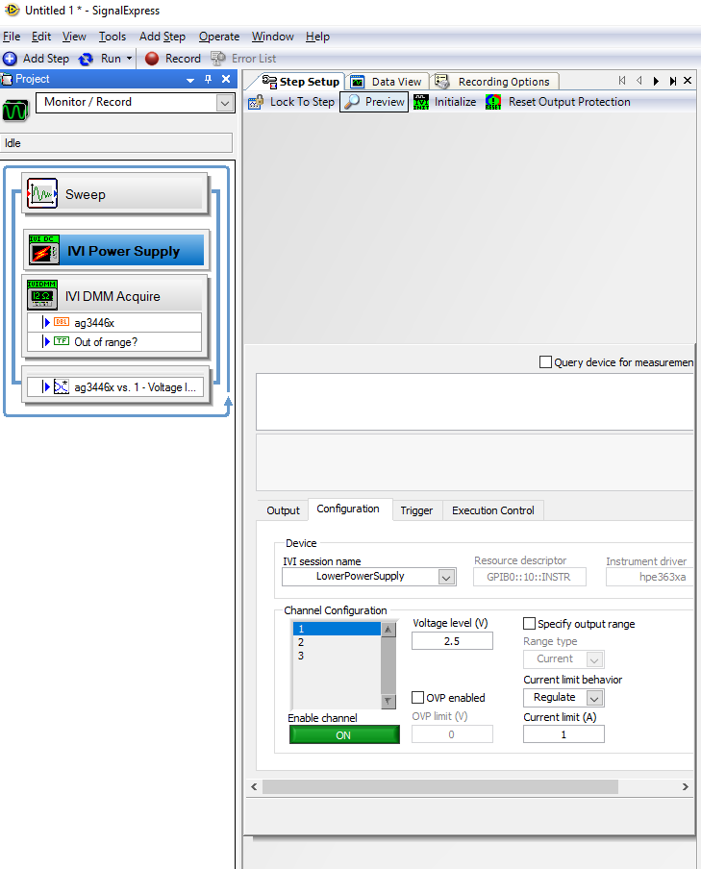

we can set up the Sweep in the Sweep Configuration tab and proceed to the sweep.

Try running it with a different setting and we can run it by using the shortcut key (Ctrl+Shift+R) or click on the Run Once button on toolbar above

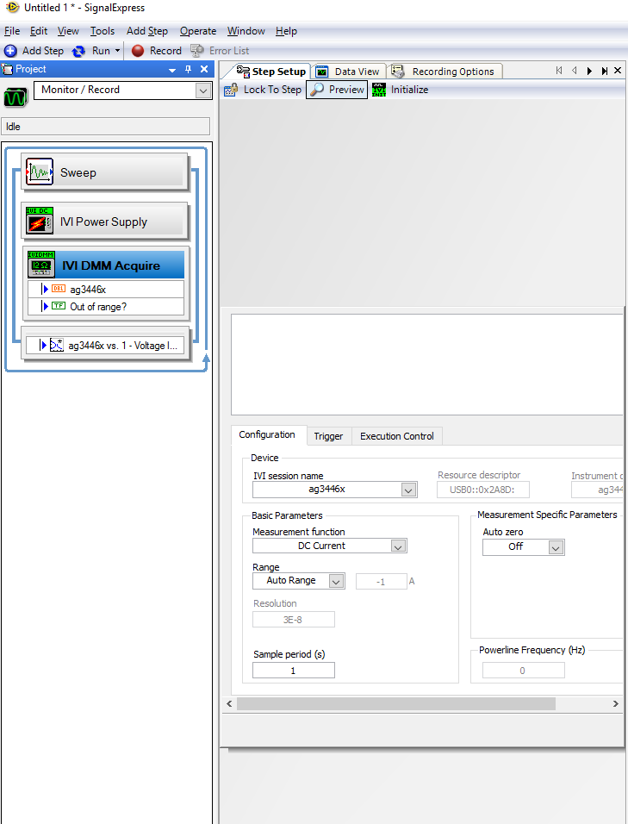

**Part 2. Measurement of MOSFET output characteristics Part 2. Measurement of MOSFET output characteristics**

We will be setting up the MOS devis in this part and look their caracteristics. We want to know the relationships between the current ID and the voltage variables VGS and VDS. Similar to what we did in previous lab, we can do that by sweeping VDS values and measuring the ID with VGS being constant, then repeat with different VGS values but in this case we are using MOSFET. we are allowed to choose any one of the transistors model inside, I’ve chosen to use NMOS short channel transistor.

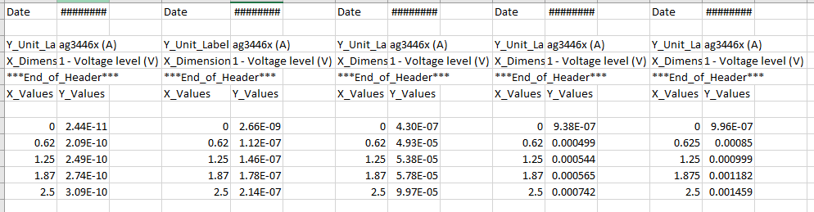

we are sweeping the VDS to create a graph with good accuracy

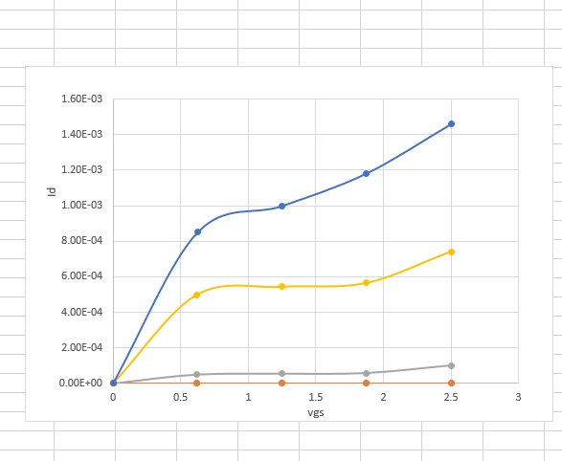

**Part 3. Measurement of MOSFET parameters**

We are required to find the parameters μCox , VT0, λ and γ.

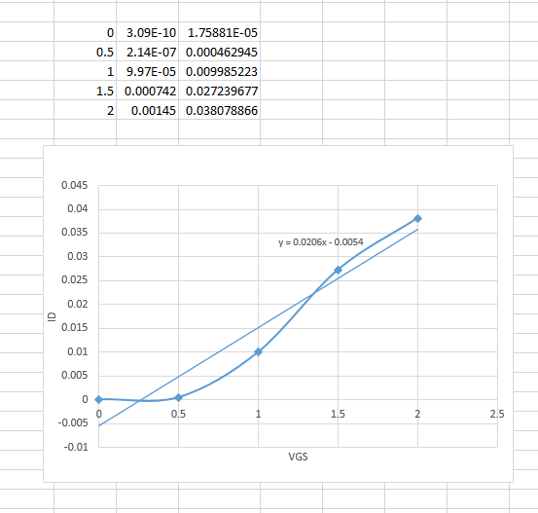

Slope = 0.0206

We can find the Ucox using the equation since we the slope : 

Ucox = 54.3μA/V2

For this part of the lab, we will be getting a plot from 0V to 2.5V for VDS but instead of using the whole graph, we are only using the graph at the part which it starts to form a linear-like plot and we draw a best fit out of it so that we can apply the equations that we got earlier. As shown above, the slope is 0.0206 and the V­GS axis intercept can be calculated from the linear equation which is about 0.48. From that, we get that VT0 = 0.479V, and μCox = 54.3μA/V2.

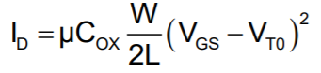To extract these parameters, we can do an approach like connecting substrate(bulb) to the source which makes VBS = 0 and we estimate 𝜆 = 0. From that, our saturation region equation can be simplified to:

When we are connecting the gate to drain (VGS = VDS), it’s going to force the device into the saturation region (if VGS > VT) and therefore we can use the same method as Part 2 to plot ID versus VGS

**b) Extraction of** γ

|  |  |
| --- | --- |
| Voltage (V) | Id (mA) |
| 0 | 0 |
| 0.5 | 0 |
| 1 | 16.79 |
| 1.5 | 0.40 |
| 2 | 0.979 |

$Vt = Vto + γ(sqr(ɸ-Vb)-sqr(ɸ))$

Vto = slope of X = 0.0206

From the figure above, we can calculate that the VGS axis intercept has the value of 0.54, so we know that VT = 0.54V. Then, we can use the equation above along with the slop to find the γ = 0.14.

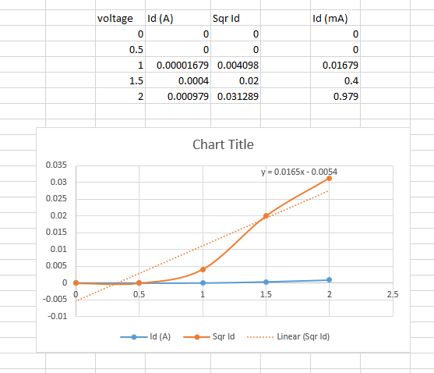

**c) extraction of λ $=\frac{Id2-Id1}{Id1*Vds2-Id2*Vds1}$**

|  |  |
| --- | --- |
| Vds(v) | Id(mA) |
| Vds1=2 | Id1=2.176 |
| Vds2=2.5 | Id2=2.695 |

λ= ((2.295*10^-3) - (2.176*10^-3)) / ((2.176*10^-3)(2.5) - (2.295*10^-3)(2))

**λ=0.14**

**Part 4. Measurement of parameters using B1500a Parameter Analyzer**

We will be finding μCox , VT0, λ and γ as before But instead of using Signal Express to get the graphs and analyze them like the previous part, we are using the B1500a Parameter Analyzer to do what we did before. The table of data extraction below.

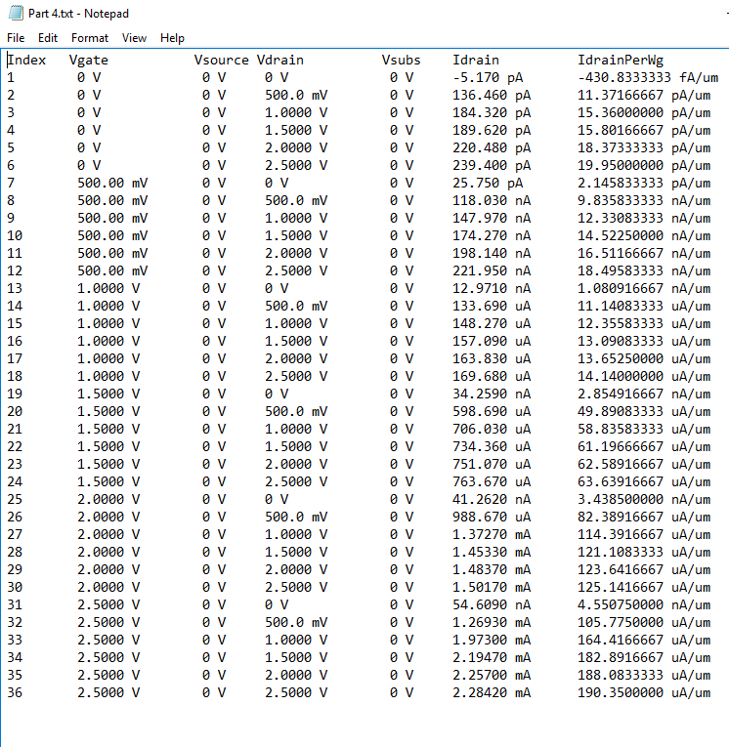

The amplitude from the function generator to the oscilloscope is off. It was supposed to be 2.5-volt peak to peak but it was given me 2.72v for the first case and 3.20v for the second case. But the transistors are working and inverting correctly.

**In Case 1, M1 will be an NMOS(Short Channel), and M2 will be a PMOS(Short Channel)**

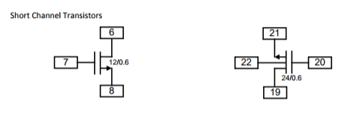

On the diagram above, the left is the schematic diagram of the short channel NMOS while the right is the schematic diagram of the short channel PMOS.

Vin = 0V, Vout = 0V and Vin = 2.5V, Vout = 2.5V

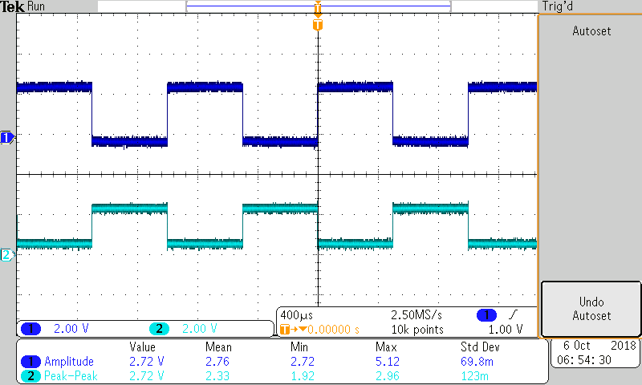

**In Case 2, M1 will be an NMOS(Long Channel) , and M2 will be a PMOS(Short Channel)**

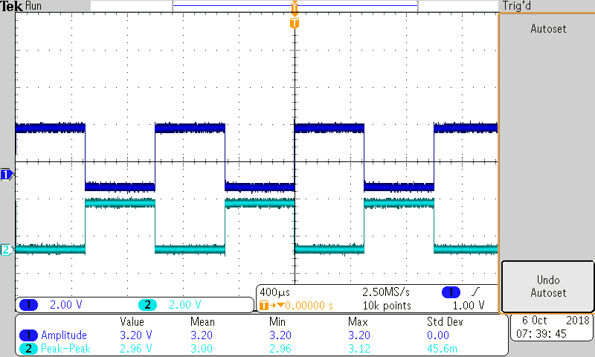

As we observe from both of the cases of short and long channels, we can see that they both give about the same graph but only with slight differences in amplitude.

From comparison we can tell that the results we got from method in Part 3 & 4 doesn’t have much different except the difference is a little high for λ and VT0. But regardless of using method in Part 3 or Part 4, we get values that are a lot more different than what it supposed to be except for VT0. The one in part 3 was close.

**Conclusion**

I learned that in reality, the parameters of the transistor might malfunction. we can assume that we get similar results for the parameters when we do different tests such as the method in Part 2 and the other method that was using the Parameter Analyzer but the result can be very different. We also have to check if the transistor is working properly.