**Olouwole Eteka**

**EE330**

**Lab 8**

**Discrete Semiconductor Amplifiers**

**Introduction**

In this lab we will be experiment with the small-signal amplifiers of MOS and Bipolar transistors. We will also view how to use BJTs and MOSFETS in both digital and analog applications. We will be measuring waveforms, operating points, and gains and all of these measurements should be made with the oscilloscope.

**Part 1**

we will be creating a voltage controlled amplifier using MOSFET transistor. Which means we can control the gain of the output voltage to input by changing the VCONT voltage.

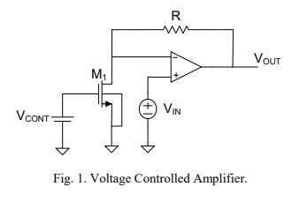

**Calculations**

determine R so that the voltage gain is 30 with VCONT = 2.5V then find VGS with gain 10

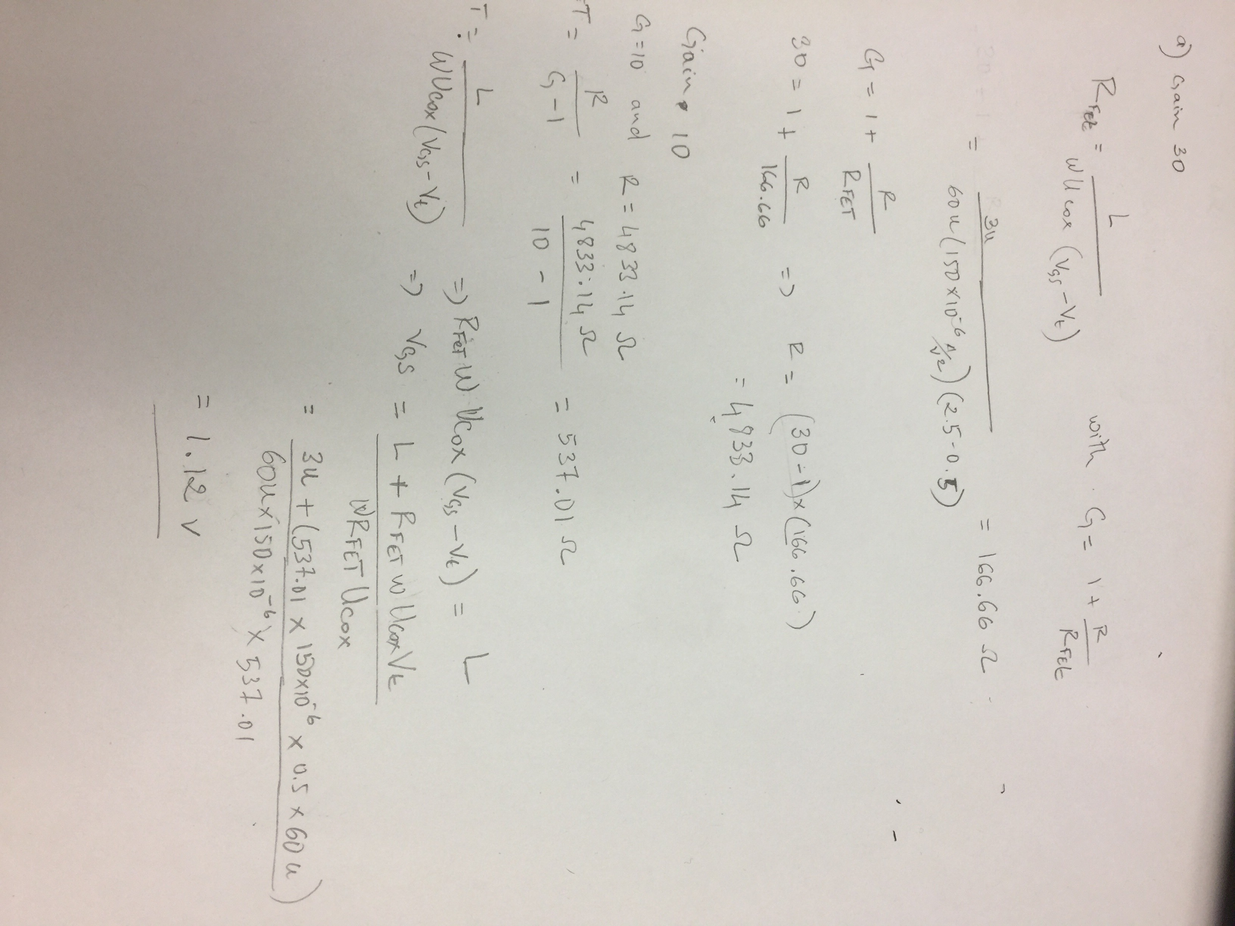

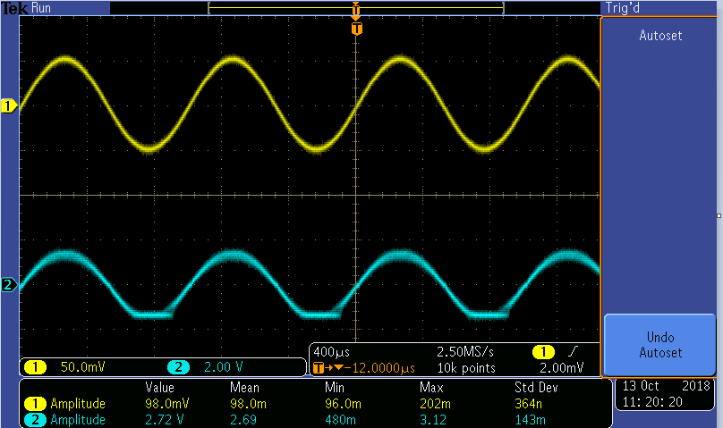**measurements**

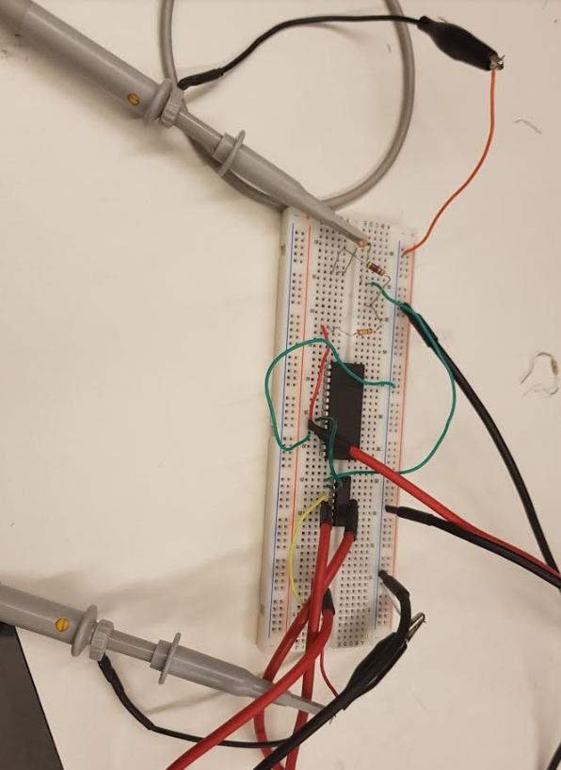

G= Vout/vin = 2.72V/(0.098v) = 27.755

**VCONT need to be around 1.25v in orther for the gain to 10 which is close to my calculation**

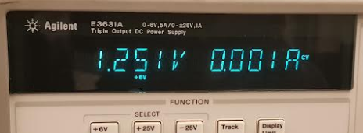

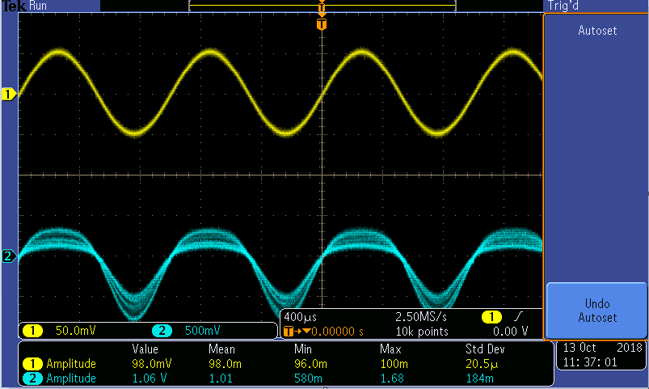

In this case my output was a little bit instable but I was able to calculate the gain to be:

G = 1.06/0.98 =10.81

**Part 2 A Nonlinear Application**

In this part of the lab, we will be applying two circuits below to determine the relationship between VOUT and VIN when VIN is sinusoidal waveform within -2V and 2V (total of 4V) with 1KHz frequency. The circuit bellow

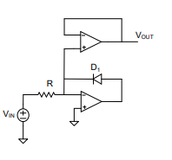

Figure 2

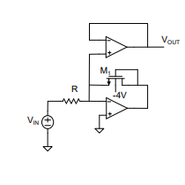

Figure 1

**For figure 1**

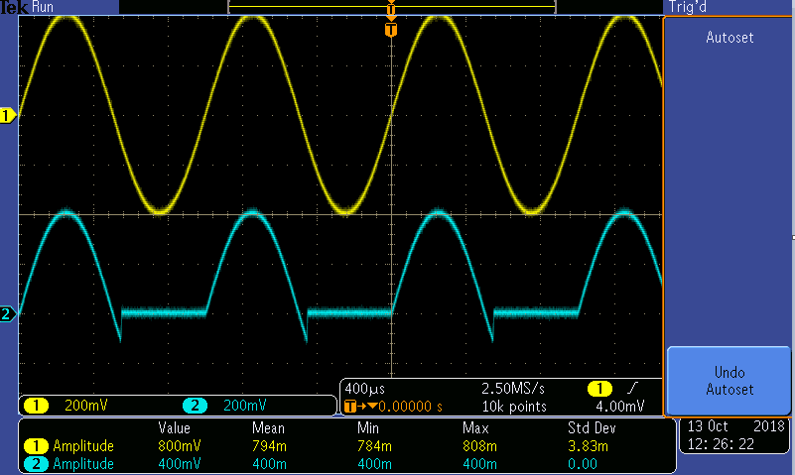

From the graph above we can see the gain is about 794/400=1.98 which means there’s not much amplification and also from the waveform we can easily identify that the MOSFET is functioning as a half-wave rectifier to convert from AC current to DC.

**For figure 2**

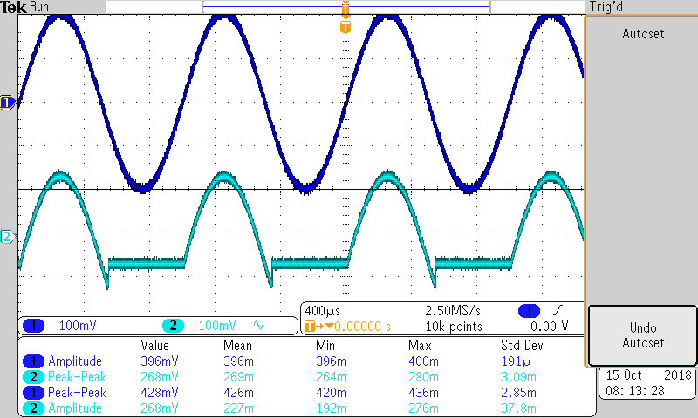

From this second graph we can see that the gain is 396/192 = 2 which is almost the same as the one from figure 1 so we can conclude that the MOSFET function exactly like a diode with such kind of connection to perform half-wave rectifier.

**Part 3 Common-Emitter Amplifier**

we are given a Common-Emitter amplifier and we will need to determine the value of β for the BJT (PN2222) when it varies within the same model of device. I will be using:

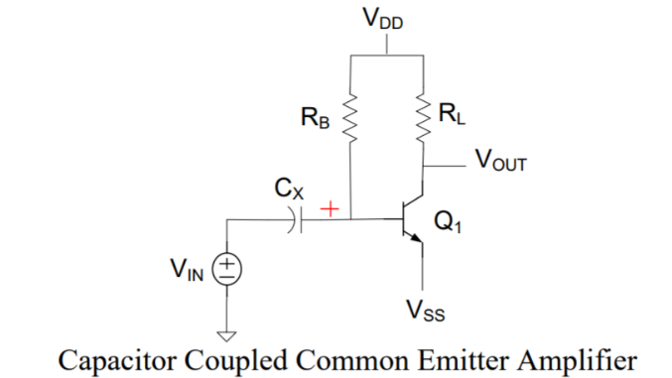capacitor= 1uF

RB = 440 kOhm

VDD = 12V

VSS = 0V

RL = 5 kOhm.

1. **Measure** IC and IB

IC = 0.64125 mA

IB=0.103808 mA

Calculate Beta using 𝐼C = 𝛽𝐼B

β = IC/ IB = 6.17727

1. 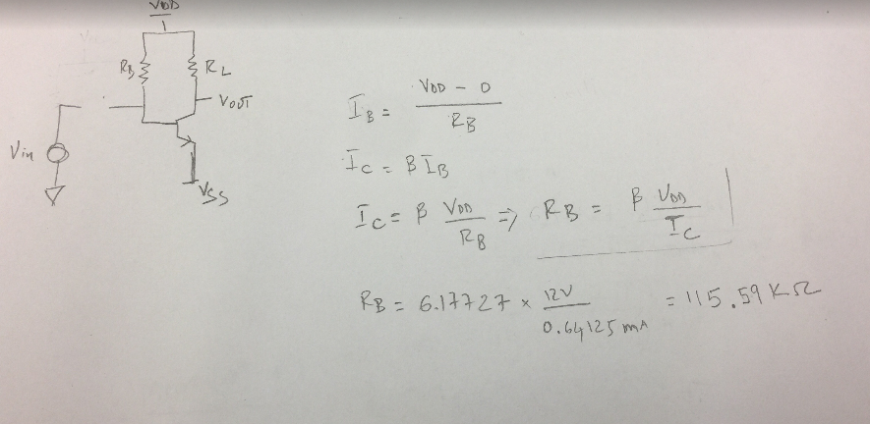**Calculate RB necessary to establish a quiescent collector current of 1mA.**
2. **Compare the theoretical small-signal voltage gain with what is measured for this circuit.**

we will have to redraw the small signal analysis circuit diagram and find out the small signal gain.

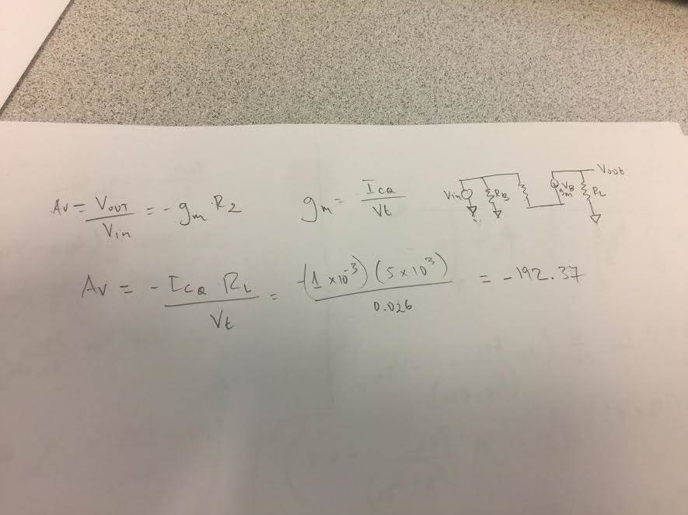

With the following information:

ICQ = 1mA, RL = 5KΩ, Vt = 0.026 (By default in room temperature)

We find that AV = -192.37.

1. **Gradually increase the amplitude of the input until clipping distortion is observed on the output.**

**Before clipping**

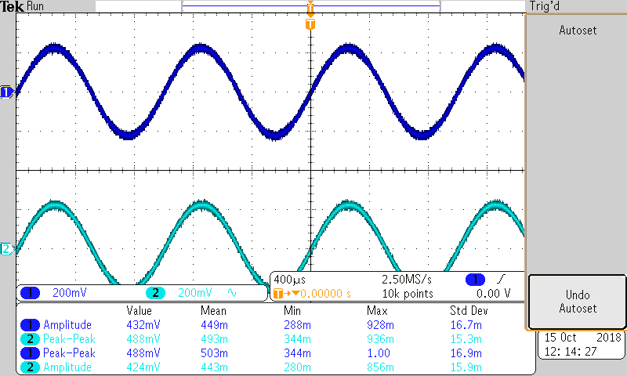

**After clipping**

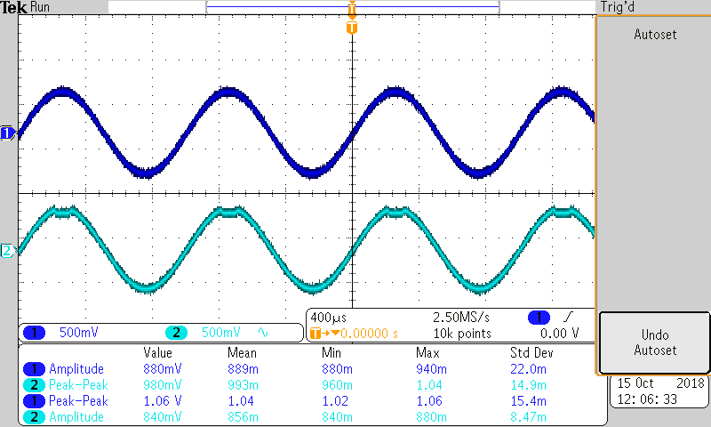

The maximum of voltage my voltage can reach before it starts clipping is 449 mv amplitude voltage. The clipping started early and was not very stable.

1. **Change the frequency to 440 Hz and listen to the output signal**

When I listen to the sound of the signal using speakers given. I was able to hear a significant difference as the voltage of VIN increases. The sound becomes distorted and I think it might be due to the clipping at the output VOUT as input increases.

**Part 4 Common Source Amplifier**

In this part we will be Deriving an expression for and comparing the voltage gains of these two amplifiers if the transistor is operating in the saturation region.

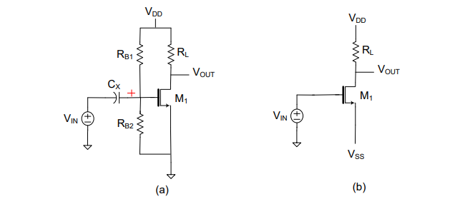

Comparison of the gain of “a” and “b”. the calculations of the gain are showing below. The gain of the “b” is 7.5 if the voltage divider part in the equation of “a” is 0. We can observe that the equations are the same except for the resistance value. “a” has two resistances to the input we have to account for but “b” does not.

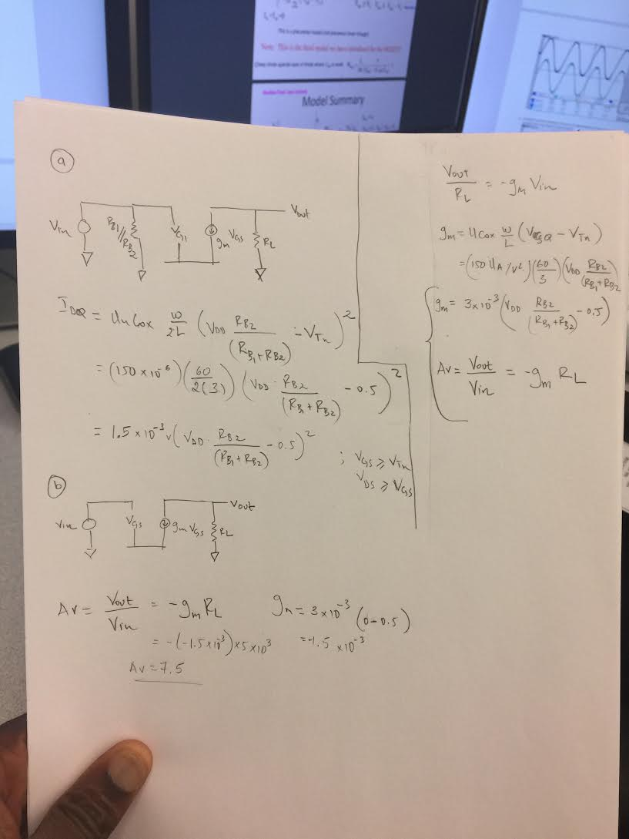

**I built circuit the b and test it**

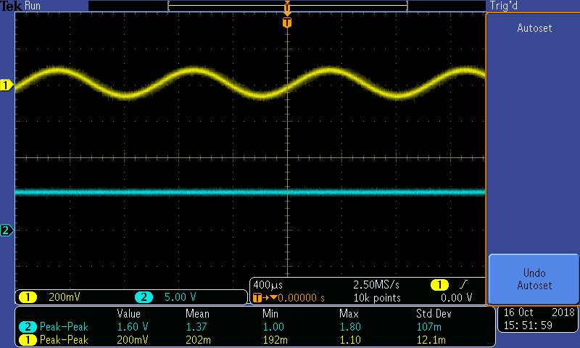

**Gain = 1.37 / (202*10^-3) = 6.88**

The gain is almost 7 which is not exactly what I calculated but it is close. I think the lost might be due to the non-ideality of the transistor. My output appears like a DC signal but when I increase the amplitude of the input signal the output become a clipped wave form.

**Part 5 Amplifier Design**

In this part of the lab I will be designing an amplifier circuit using BJT which gives a small-signal gain as desired, I used a circuit similar to the one in part 3 to construct my design. I also used similar parameter as the part 3 circuit.

The calculation for my design are showing bellow and the parameter in the left upper corner.

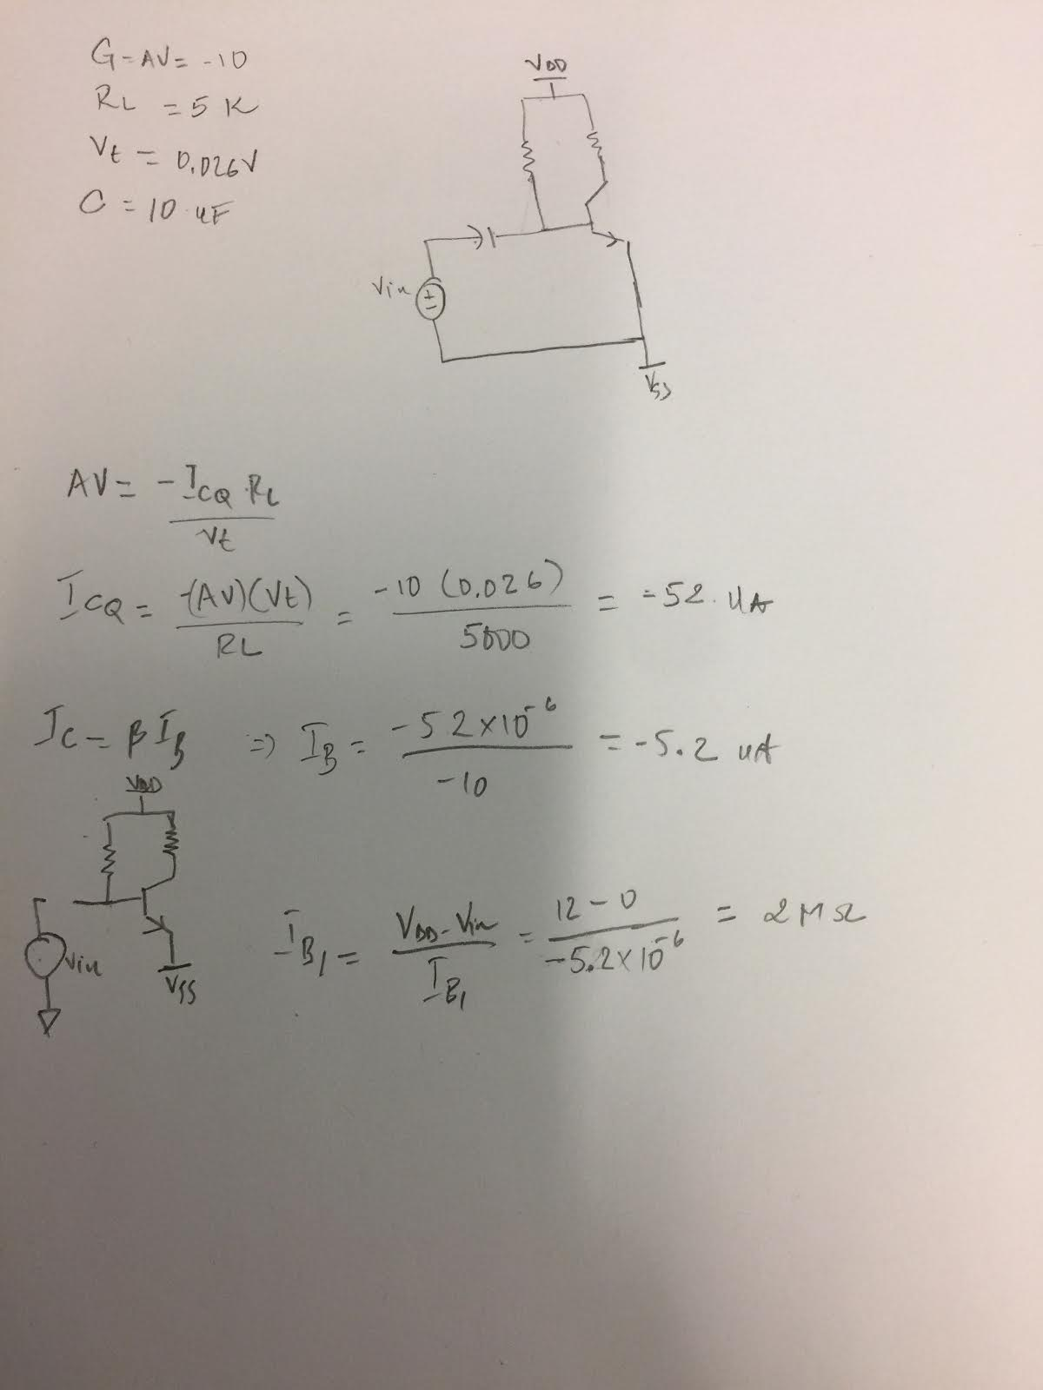

The picture below was my actual circuit I used 5k resistor for my load (since I don’t have an actual 5k resistor I put to resistor in parallel to form my 5 k resistance).

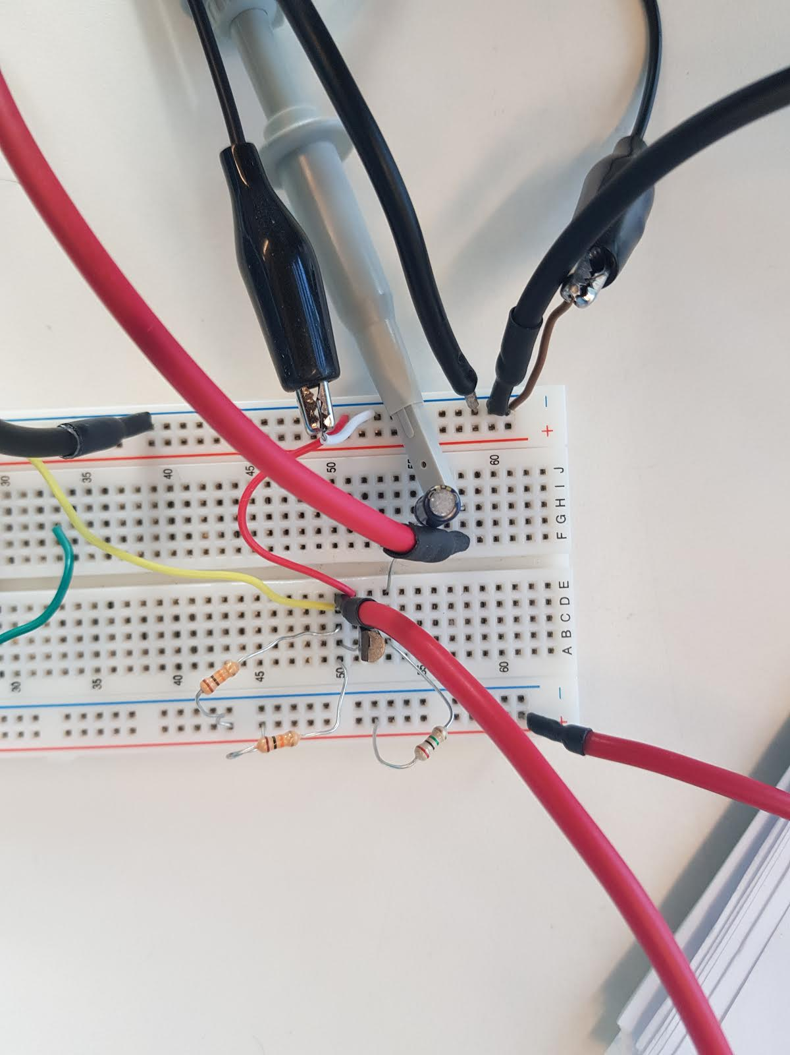

**Conclusion**

We learn from the lab some application of MOSFET and BJT operating on small signal. I also learned how configure them to be an adjustable amplifier, a half-wave rectifier by calculations method and hardware experiments. to compare the differences between reality results and the calculated results and they are not always the same or very close but shouldn’t be too much different if both are being done correctly unless hardware parts are faulty.