Mohamed Gesalla EE 330

Lab 9

Bipolar Devices and Applications

# Introduction

In this lab, I will be looking at developing different measurement methods for extracting device parameters of the Bipolar Junction Transistor and investigating the applications of discrete BJTs.

## Part 1

In this part I looked into comparing the small-signal model parameters gm, g0, and gπ with those given in one of the data sheet for the PN2222 provided by onsemi.com.

I used the Semiconductor Parameter Analyzer to obtain the small signal parameters of the BJT in my lab kit and compare them to the parameters form the data sheet.

The figure blow shows some of the data obtained by the Semiconductor Parameter Analyzer.

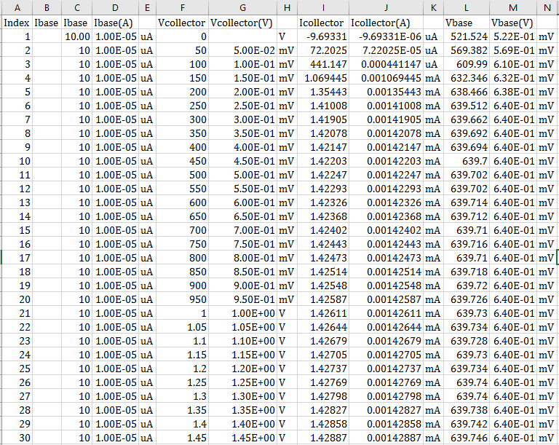

Below are the calculations done to determine the values of my BJT’s parameters.

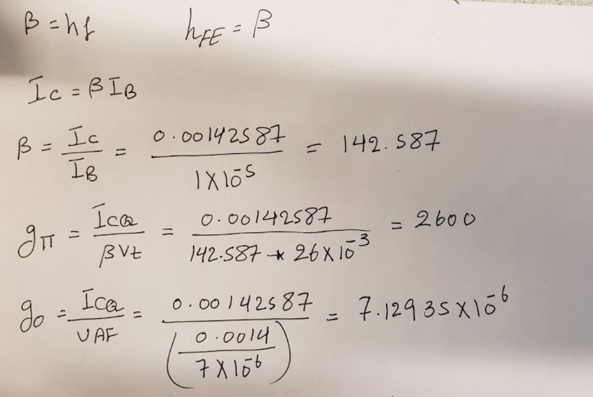

Below is the forward active plot. I used the slope to calculate the VAF

Below table shows the analyzer values VS the datasheet values

|  |  |  |
| --- | --- | --- |
| Parameter | Analyzer Value | Datasheet Value |
| β = hfe | 142.587 | 50-375 |
| 𝑔𝜋 = ℎ𝑖𝑒 (k.ohms) | 2.7 | 2-8 |
| 𝑔0 = ℎ𝑜e (µMnos) | 7.12935 | 5-200 |

## Part 2

Design a circuit that will drive a 500Ω load between 0V and 10V when a Boolean signal goes between 0V and 5V.

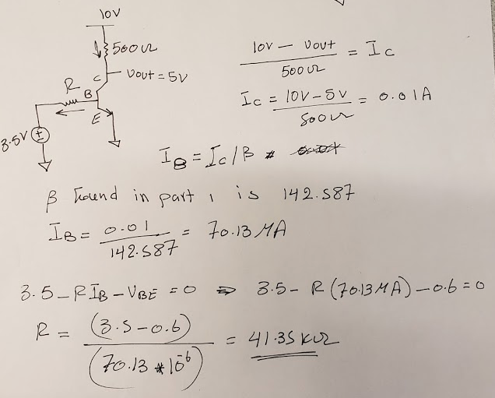

## Part 3

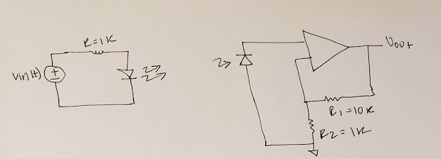

The circuit above showed the design of my wireless optical link that will transmit an audio (music) signal over at least 6 inches. As shown in the figure blow this design is composed of two circuits. The first circuit is the transmitter end which consists of a resistor and a photodiode. The audio signal is connected to vin(t). The receiver end is made of LM324 op amp, two (10k and 1k) resistors and photodiode receiver. The signal received across the photodiode was very small and needed to be amplify before it was connected to the speakers. I built a non-inverting amplifier with enough gain to amplify the sound received from the photodiode receiver. The graph below shows the input signal vs the output signal. of the design.

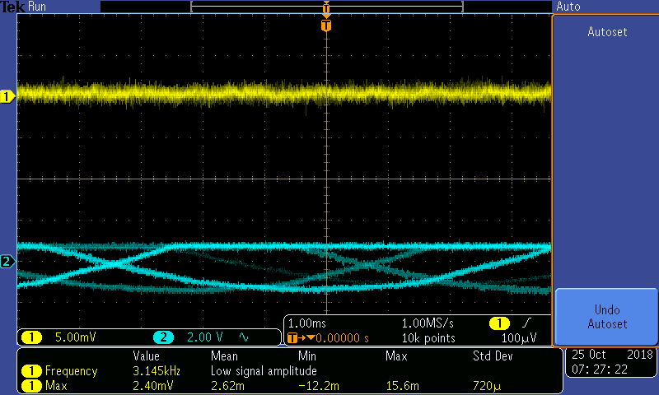

# Conclusion

This lab was very beneficial and fun at the same time. I looked at comparing the small-signal model parameters gm, g0, and gπ with those given in one of the data sheet for the PN2222. I also looked at design a circuit that will drive a particular load using certain voltage. I designed a wireless optical link that will transmit an audio (music) signal over at least 6 inches.