**Olouwole Eteka**

**EE330**

**Lab 9**

**Bipolar Devices and Applications**

**Introduction**

In this lab we will working with the BJT’s and it parameters. The purpose is to develop measurement methods for extracting device parameters of Bipolar Junction Transistors (BJTs) and investigate some applications of discrete BJTs. We will also be comparing the BJT’s parameters.

**Part 1 Measurement of Small-Signal BJT Parameters**

I started by the design of the hardware and measure the values of voltage to calculate the R1 but I quickly realized it was a bad idea:

I got from the graph the gain is 10v/5v=2. The gain was too small and the Gpie paramiter was to small. And also

The graph wasn’t refleting the resulte that I wanted so I will use the anylyzer method below instead.

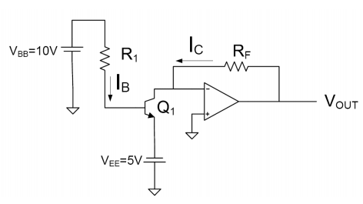

**VBB = 10v**

**VBE = 5v**

**Rf = 10k**

.

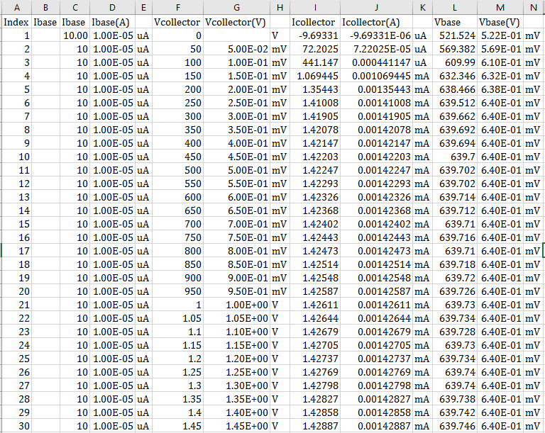

β = 𝐼C /𝐼𝐵 = 0.001426 mA / (1*10^-5) mA = 142.58

From the anylizer I have a gain of 142.58 (this is definetely better)

PN2222 BJT:

gπ =ICQ/β*Vt = 0.0014258 / (142.58*26*10^-3) = 2600

gm = (142.58) * (2600) = 370708

then I used to excel to plot the values from the analyzer then I can determine the slop of the graph. It will serve to calculate the VAf so I can calculate the Go using the formula 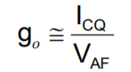



go = 0.0014258/ (0.0014/7*10^-6) = 7.129*10^-6

I can compare now the value from the data sheet to the value I found.

|  |  |  |
| --- | --- | --- |
| Parameter | Datasheet Value | Analyzer Value |
| β = hfe | 50-375 | 142.58 |
| 𝑔𝜋 = ℎ𝑖𝑒 (k.ohms) | 2-8 | 2.7 |
| 𝑔0 = ℎ𝑜e (µMnos) | 5-200 | 7.129 |

The small table above is made to compare the values of measurement to the values provided by the datasheet. We can see that all my values are in the ranges mentioned by the datasheet. Even if some range are very big I can conclude that my measurements are now valid.

**part 2 Application of BJT to driving large loads**

Design a circuit that will drive a 500Ω load between 0V and 10V when a Boolean signal goes between 0V and 5V.

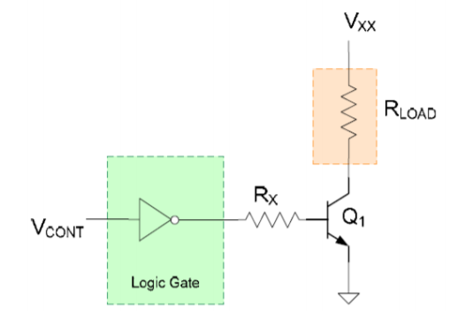

And with the circuit above, all we have to do is to find out the parameters that we need to use for the circuit above. the circuit should also be able to drive the load with voltage between 0V and 10V. the equivalent of the circuit is drawn below and the calculation to find the resistance is done.

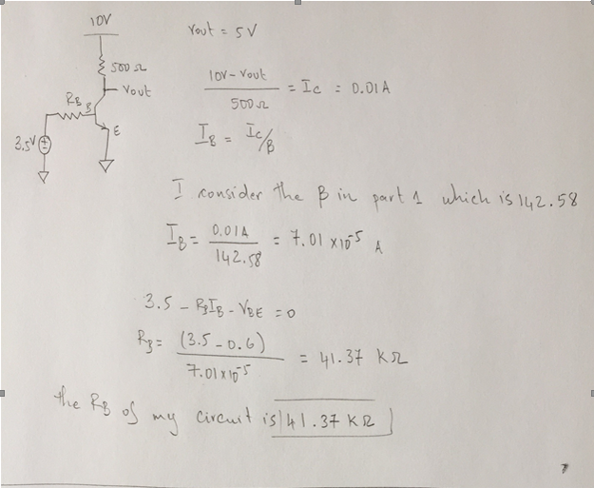**Calculations**

**part 3**

For this last part of the lab, we are asked to design and test ad wireless optical link that transmit audio signal >6 inches’ distance. And from the lab manual we know that this can be done by the following circuits:

**For the design is used** LED Photodiode Light Channel and an op amp powered using DC voltage supplies of 10V and -10V. The whole circuit consist of the two circuit. The first circuit on the left is the transmitter end which consists of a resistor and a photodiode. The second on the right is the receiver. It is made of LM324 op amp, two (10k and 1k) resistors and photodiode receiver.

The audio signal was going through the vin(t) port (MP3 music from my phone). The output was connected to the speakers. The signal received across the photodiode was very small. It was being amplified by the receiver thought the op amp.

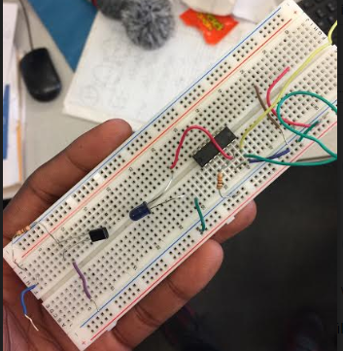

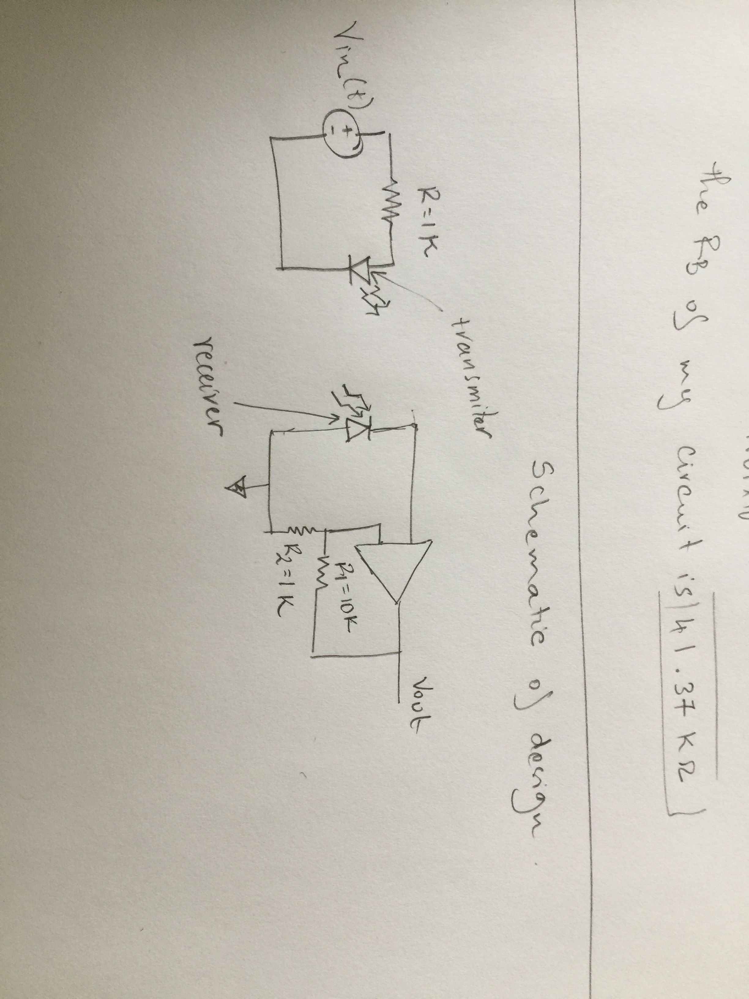

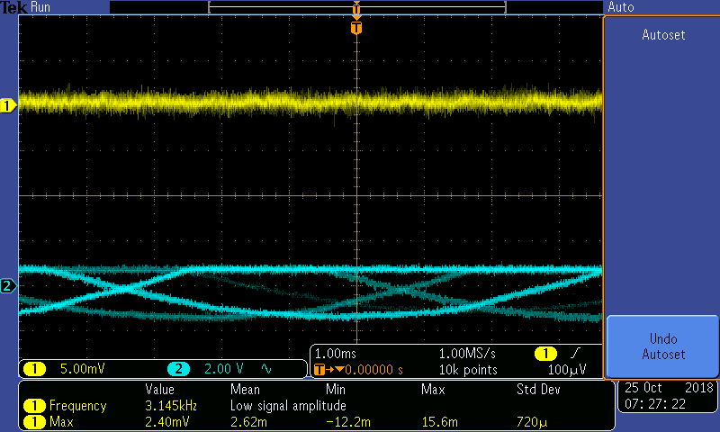

We can observe the input signal vs the output signal from the graph above. The signal in the blue is the input signal and we can see it got amplified at the output (output) and it was not stable because the signal was changing constantly.

**Conclusion**

This lab was interesting especially the design part. In this lab I learned a lot on implementing the concepts of using BJTs, diodes, and Op-Amps on practical situations as well as learning how to get the parameters using just the measurement devices and setting inputs. I looked at comparing the small-signal model parameters gm, g0, and gπ with those given in one of the data sheet for the PN2222.