**Windows user**

1. Download the neo4j community server
   1. Go to <https://neo4j.com/download-center/#community> to download the corresponding neo4j

* 1. Make sure you have JDK installed on your laptop. You can get it with <https://www.oracle.com/java/technologies/javase-jdk13-downloads.html> Also download Java for windows at <https://www.java.com/en/download/win10.jsp>. Both of these downloads will be needed to run the neo4j server.
  2. Once you have JDK and neo4j downloaded, go to the directory you saved your downloaded file. Unzip your neo4j folder. The folder you save your unzip file is referred as <NEO4J_HOME> in this document.

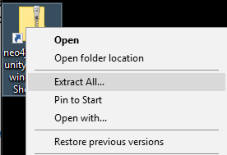

* 1. Once the file is unzipped, cd to the folder directory of the file. When you get into your home folder, cd all the way into the bin folder then run the command neo4j install-service. I showed an example of the commands below, but keep in mind your home directory for your neo4j service may be different. You will know when your server got installed when it says Neo4j service installed.

The following steps use neo4j-community-3.5.11 which is different with the one you need to download that is neo4j-community-3.5.16. But the steps are the same.

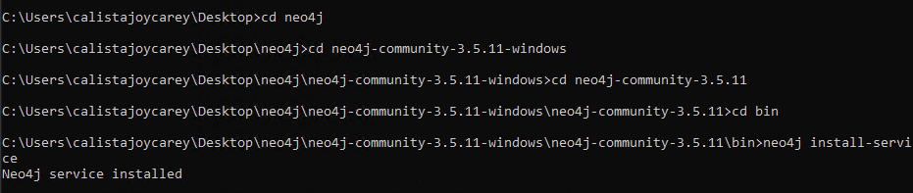

**Potential issues:** You may get an error that the server cannot find the java files. If this is the case, cd into **C:\Program Files** and run the command **set JAVA_HOME C:\Program Files\Java\jdk-13**

* 1. Once the service is installed, run the command **neo4j start** from the command prompt. Open <http://localhost:7474/browser/> in your browser. You should be prompted with this screen:

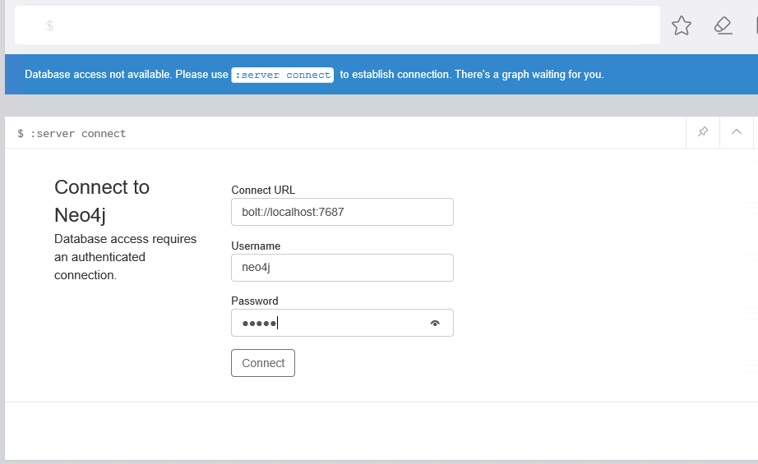

Username: neo4j

Password: neo4j

When you enter these credentials, you will be redirected to a webpage that allows you to choose a new password. Remember this password!!

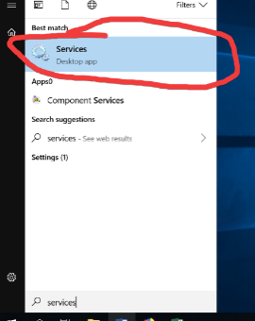

Screenshot of services running on your computer; click on the service name and click “Start”, “Stop”, or “Restart” accordingly.

* 1. Stop the Neo4j server by searching for Services and finding Neo4j Graph Database service. Right click on Neo4j and choose stop. The server should no longer be running.
  2. Stop the service and download the tweets database that is provided on canvas.
  3. Copy tweet\graph.db folder to <NEO4J_HOME>\data\databases where <NEO4J_HOME> is the directory where you unzip Neo4j to.
  4. Start the Neo4j service again. Then, check to see if the database is being used by clicking the icon in the top left corner.

**MAC user**

1. Download the neo4j community server
   1. Go to <https://neo4j.com/download-center/#community> to download the corresponding neo4j

* 1. Make sure you have JDK installed in your computer. Also make sure you have **JAVA_HOME** set up.
  2. Extra the folder from the tar file just downloaded.
  3. Open your terminal and cd to the directory of the folder



I have it saved under the directory of ~/Downloads/ComS363Spring2020

Yours may be different and just make sure you are on the correct directory.

* 1. You can use command ./bin/neo4j start to run Neo4j in a background process or use ./bin/neo4j console to run Neo4j as a console application

You can either use ./bin/neo4j stop to stop the server, ./bin/neo4j restart to restart the server.

* 1. Then open <http://localhost:7474/> in your browser.

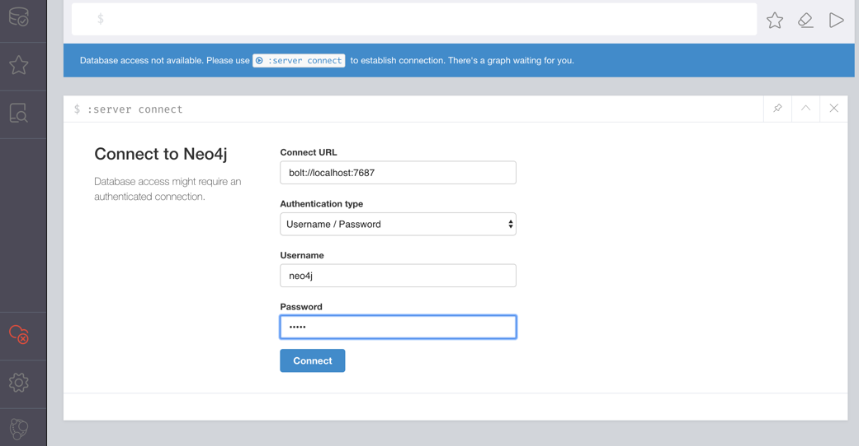

Username : neo4j

Password: neo4j

Then you can set up a new password. Remember this password!!

* 1. Each time you start the neo4j server, the folder named graph.db inside directory neo4j-community-3.5.16/data/databases/ will be used as the fault database.
  2. Stop the server and copy the provided graph.db folder to the directory mentioned in step g.
  3. Start the server, open <http://localhost:7474/> in your browser and you will see the database is loaded and used.

