Q1

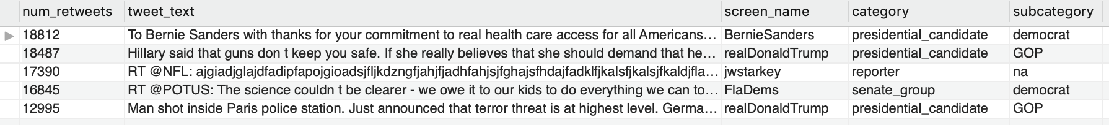

Q2

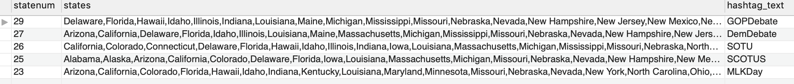

Q3

Q4

When subcategory = ‘GOP’

When subcategory = ‘Democrat’

Q5

Refer to Q5output.csv

Q6

Results are different from SQL and Neo4j

Q7

Refer to Q7output.csv

Q8

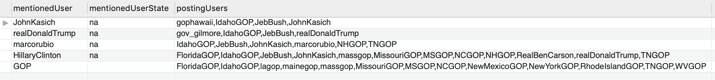

Q9

