Sean Gordon

Arch 321

Module 1, Lecture 2 Response

This lecture focused on the inception and development of Washington DC, and the multitude of problems that it faced on its way to the modern age.

To begin, there was some disagreement about where the capitol should be placed, and the style in which the surrounding area should develop. Thomas Jefferson, although ultimately unsuccessful, pushed for the area surrounding the capitol to be more agrarian focused. He worried that cities were dirty and dangerous, and that there was the possibility of a mob overtaking the capitol. In the end, the surrounding area was decided to be a city, and preparations were made.

Pierre Charles L'Enfant was hired to design the plan for DC, and because of this the capitol bares striking resemblance to the French Gardens layout, with the typical grid like layout of the city cut with a spiderweb of diagonal roads designed to give focus to monuments at a distance. However, there was a falling out, and L’Enfant wasn’t being paid, so he took his plans and left back to France. Afterward, Andrew Ellicott was hired to reproduce L’Enfant’s plans from memory.

After this shaky beginning, Washington DC was placed in a swamp. This gave easy access to water, but the surrounding area was muddy and full of mosquitos. DC was also only a place to house government, and without any economic drive to back it, it had a very hard time developing momentum. Because of this, the capitol project was initially considered to be a failure.

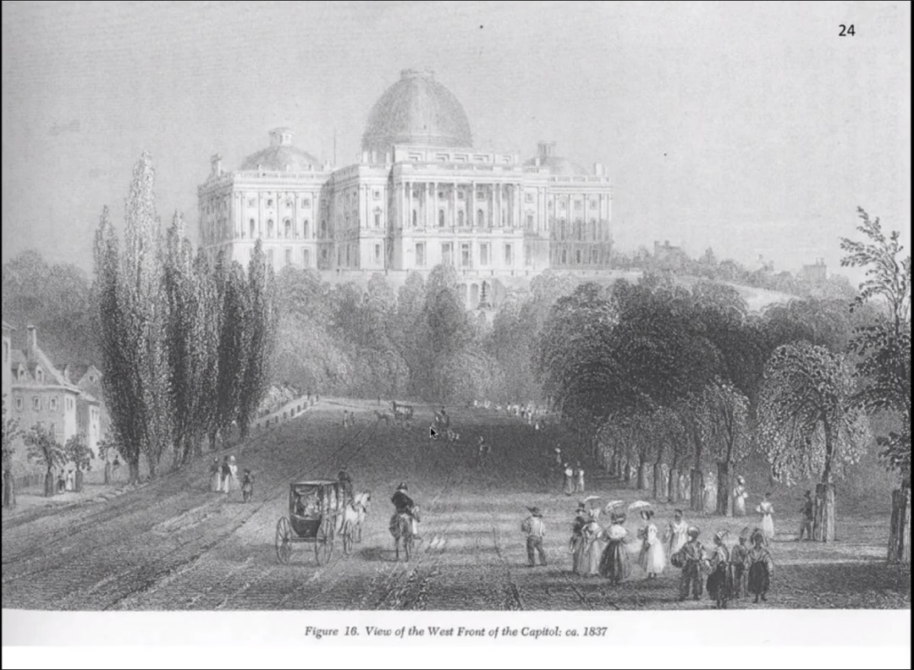

With the grand capitol building sitting atop the hill, the Washington mall was still based in a swamp, and thus was a muddy track where horses were often stuck. I found this amusing, and thought it illustrated the early struggle of the capitol city nicely.

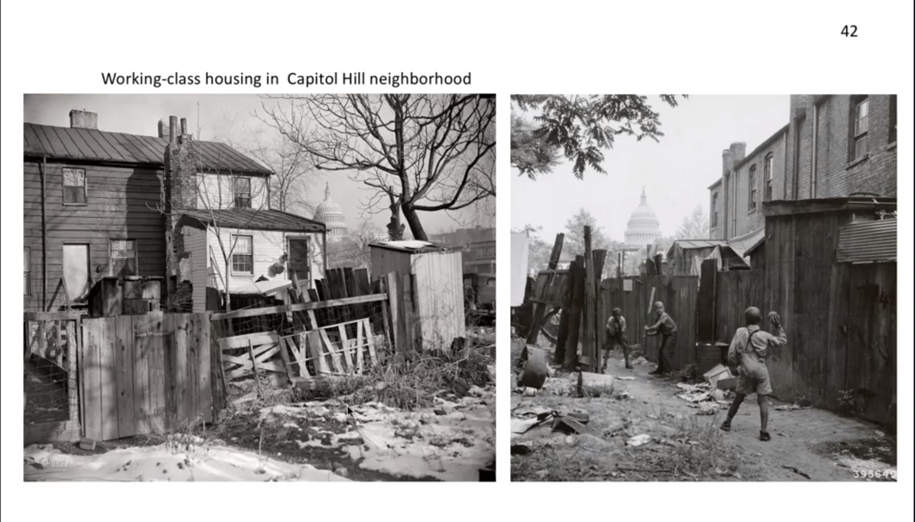

There was a large disconnect between the grand images of the capitol and their projections of strength, and the shoddy minority elsewhere in the city. I liked the contrast between the two areas, and how it showed that the capitol was made by humans and lived in by humans, rather than just instantly becoming a shining beacon of strength made by gods.