Sean Gordon

Arch 321

Module 1, Lecture 3 Response

This lecture focused on the development of cities, as well as the explosion of population in the 1800s and its effect on the cities of North America.

In 1811, the remainder of New York was planned out using the commissioner’s map, creating a more regular, grid like pattern for the city. This would expand along the central island and keep things orderly. A canal from the Hudson river to Lake Erie was built, after which the population of New York exploded, and the plan was put to work. This explosion was mirrored elsewhere, with the population of the United States increasing six fold from 5.3 to 31.4 million people.

In earlier days, the sizes of cities were generally kept around 1 mile in diameter, as this was the limit of how far people would walk to do business or see relatives. There was no universal public education or child labor laws, and there was no code to regulate businesses, so things were often dumped into the streets. Cities were still exclusively on waterfronts and expanded so that they remained on waterfronts. However, once railways and better forms of transportation became widespread, cities grew and expanded more inland. Some of the cities in NA became the sites of ‘impossible’ feats, like the Erie canal, the suspension bridge, lifting buildings using jacks, and moving entire buildings while they were being used with horses and rollers.

As cities grew and became livelier, the idea of living in a ‘pastoral’ became romanticized. A solution for this was found in cemeteries, built to be a slice of tamed nature as a reprieve from city bustle. However, as more and more people began visiting the quiet and peaceful environment of the cemetery, the environment became less quiet and peaceful. This drove the move of the pastoral environment into central parks.

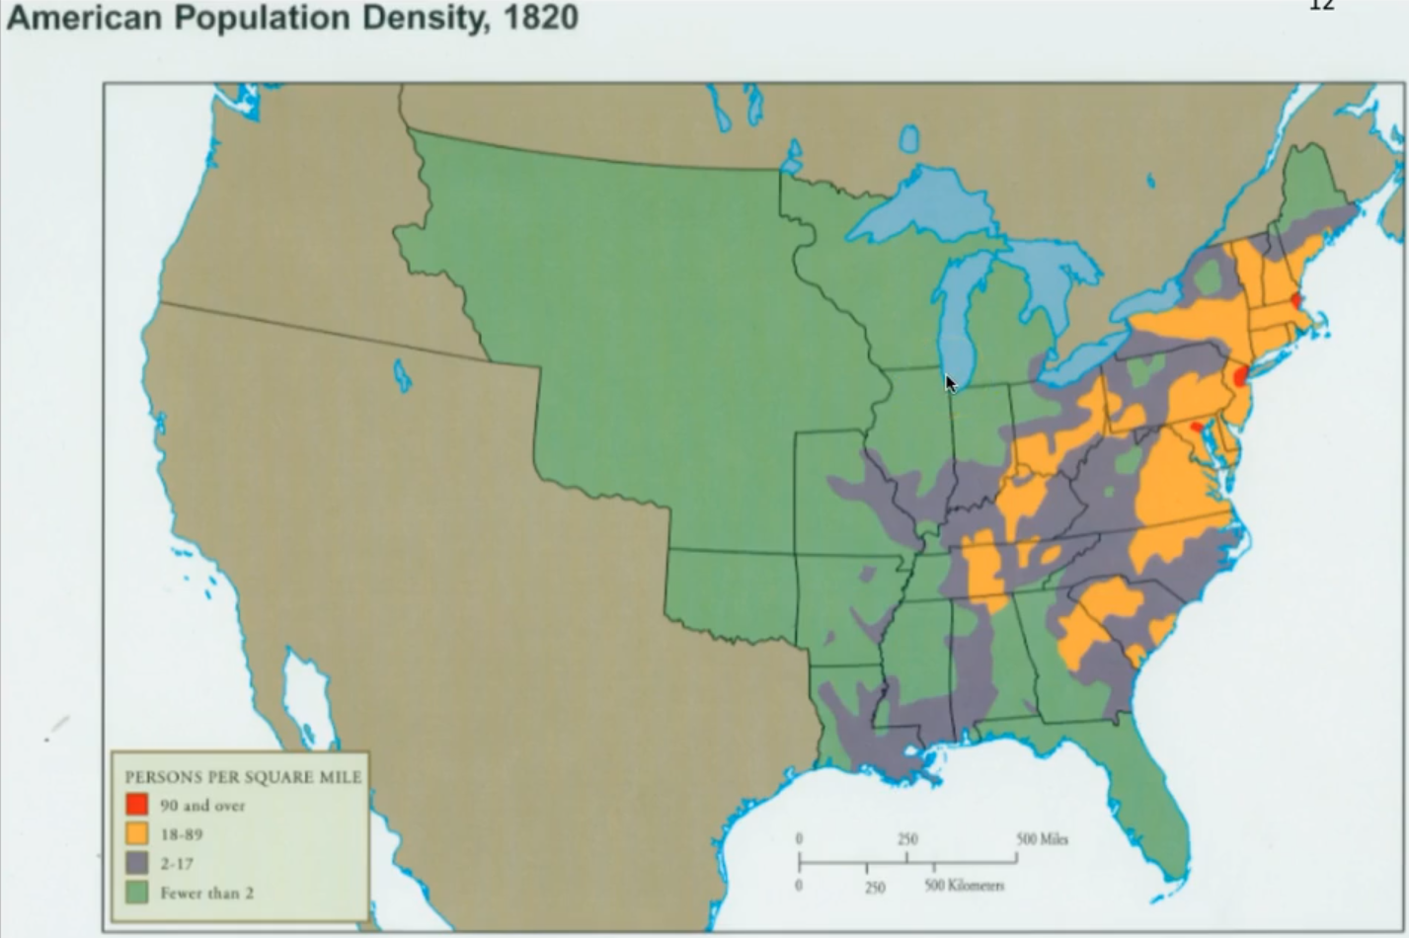 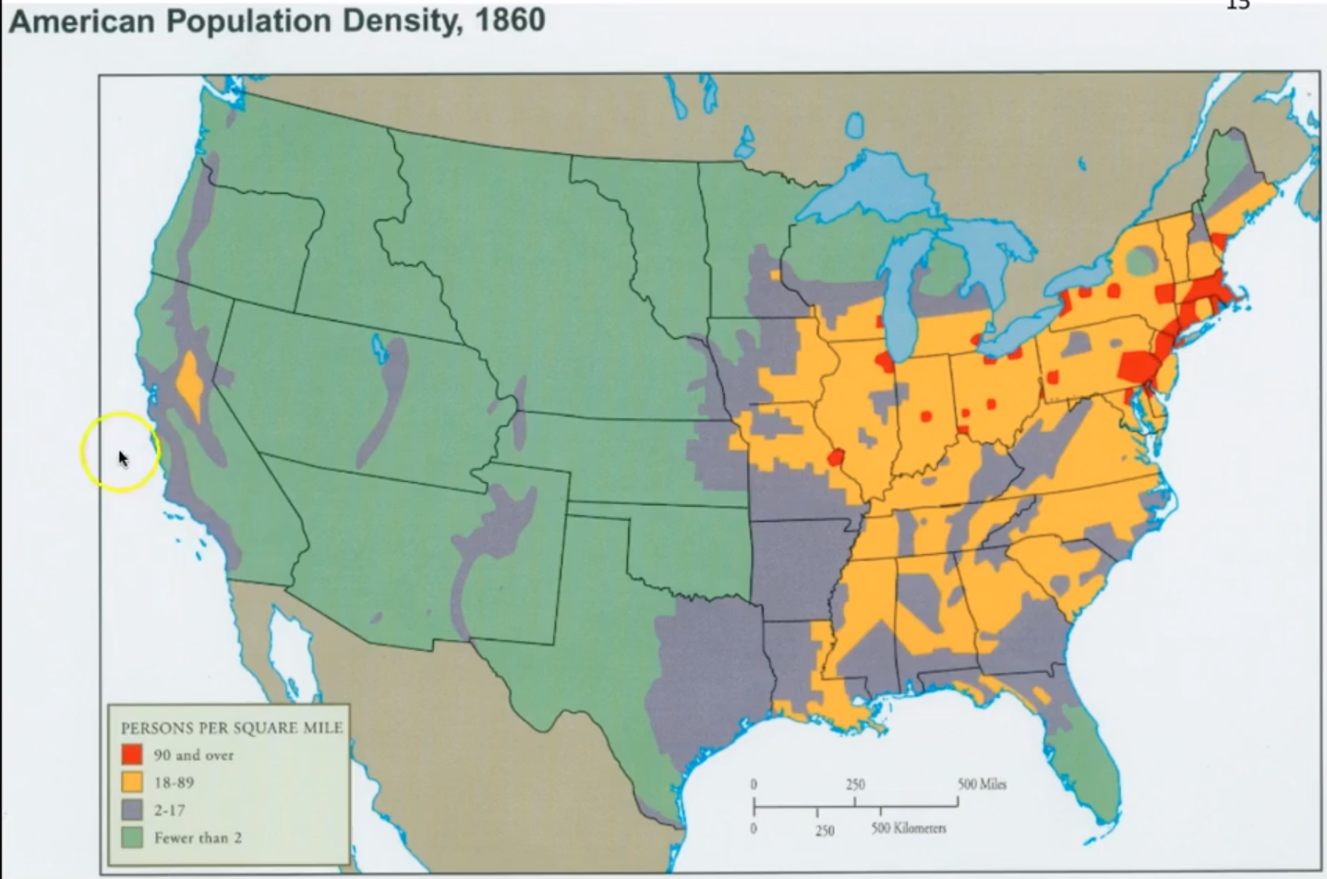

This graphic illustrates the incredible boom in population due to the gold rush and immigration to the Americas. In only 40 years, the land owned by the US covered from coast to coast, and a condensed population now covered nearly half of that area.

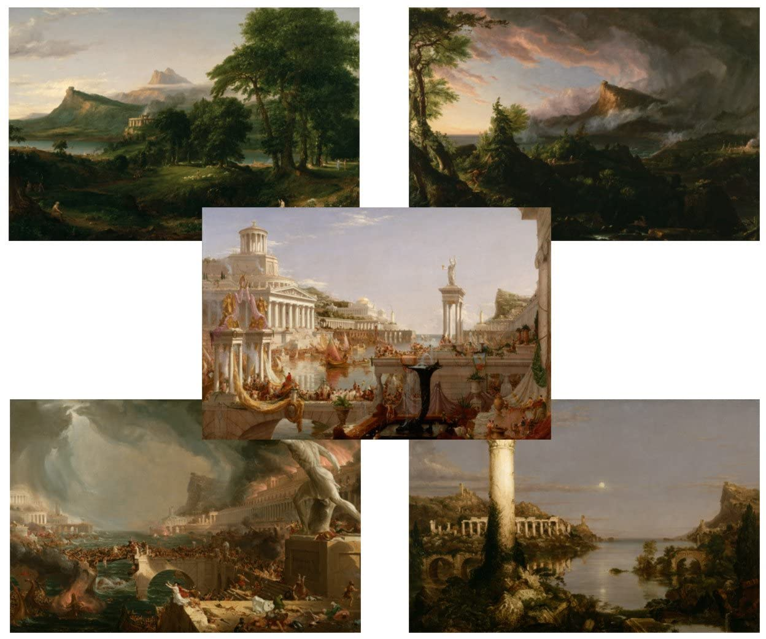

I like how this series of paintings illustrated the perceived link between the people and nature, and the success of the things they build because of that. The set represents the growing need for a more natural element in cities and was followed by the conversion of cemeteries to rural parks.