Sean Gordon

Arch 321

Module 1, Lecture 4 Response

This lecture focused on the development and philosophies of public parks inside cities, and the effects they brought and were hoped to bring.

Public parks, from their inception until now, are viewed as a reprieve from the ‘gridiron’ of the cityscape. In London, they were considered the “Lungs of the City” and were places for free-speech assembly and fair grounds. Disease theory created some drive to build clean, open parks around water sources, hoping it would reduce the ‘miasmas’ in the air. Parks were believed to help with disease and were thought to help the lower classes.

Andrew Jackson Downing’s park philosophies are still visible in parks today, and his ideas for parks were considered stabilizers for the nation’s institutions, and that they could civilize and refine Americans. Frederic Olmsted, while similar in philosophy to Downing, believed in the antithesis that parks were *separate* from cities, and should be a complete escape. He believed them to be for all people, a landscape to meet deep human needs with their wild nature, and a place for communities to develop.

Central park is an example of this as a landscape that employs the art of concealing art, highly curated with minimal changes to the landscape, but feeling completely natural with minimal human touch. While you can still hear the hustle and bustle of the city surrounding the park, it seems far away, and you feel isolated in nature. Sheep served in the parks as well, both as natural lawnmowers for the large open areas, and serving to create a picturesque rural landscape of animals lazily wandering around a field.

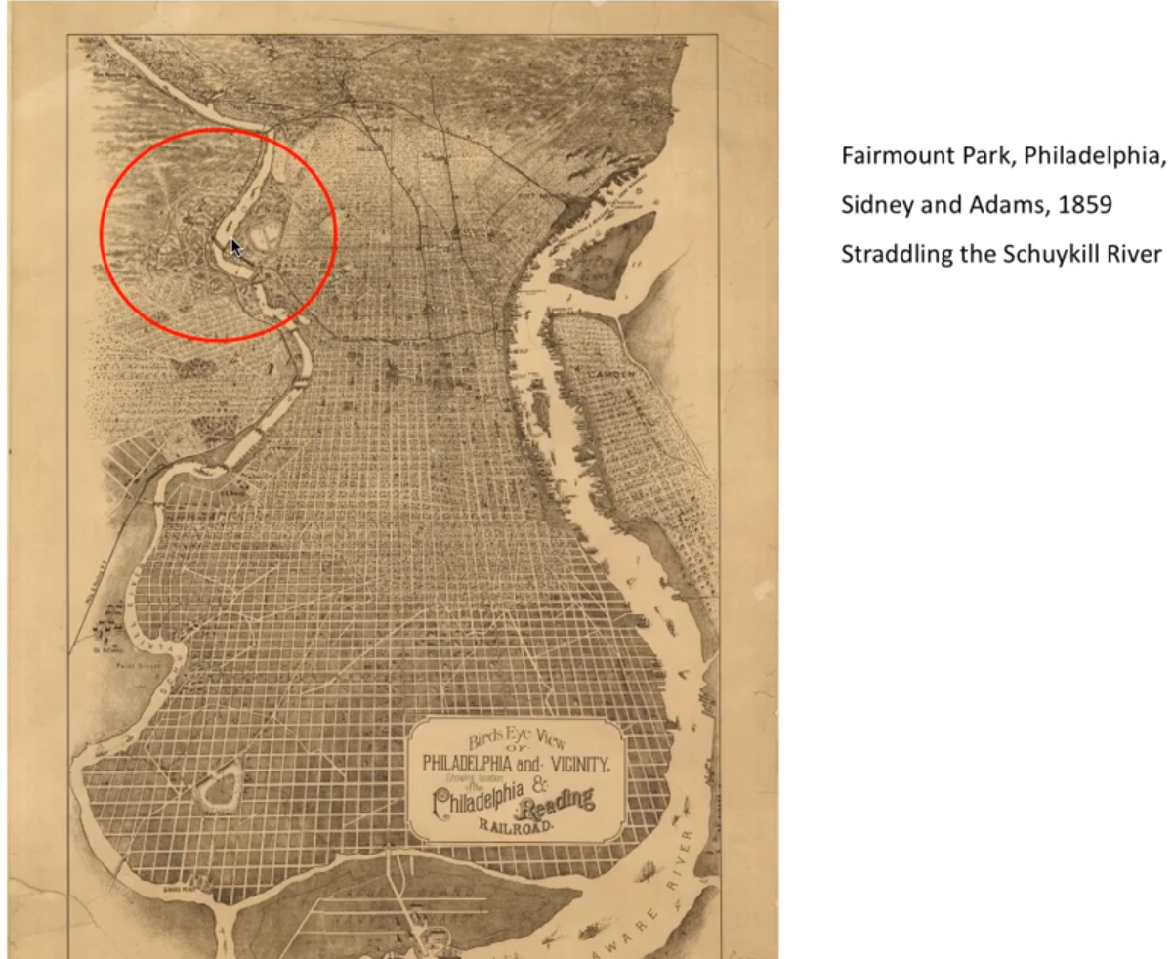

I appreciate the positioning of this park in early Philadelphia, dual use as a getaway for the average city dweller, and as a deterrence for dumping in the river.

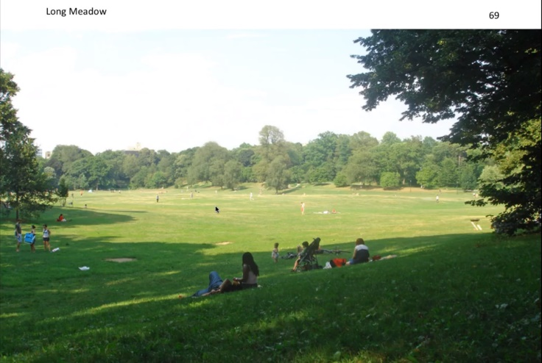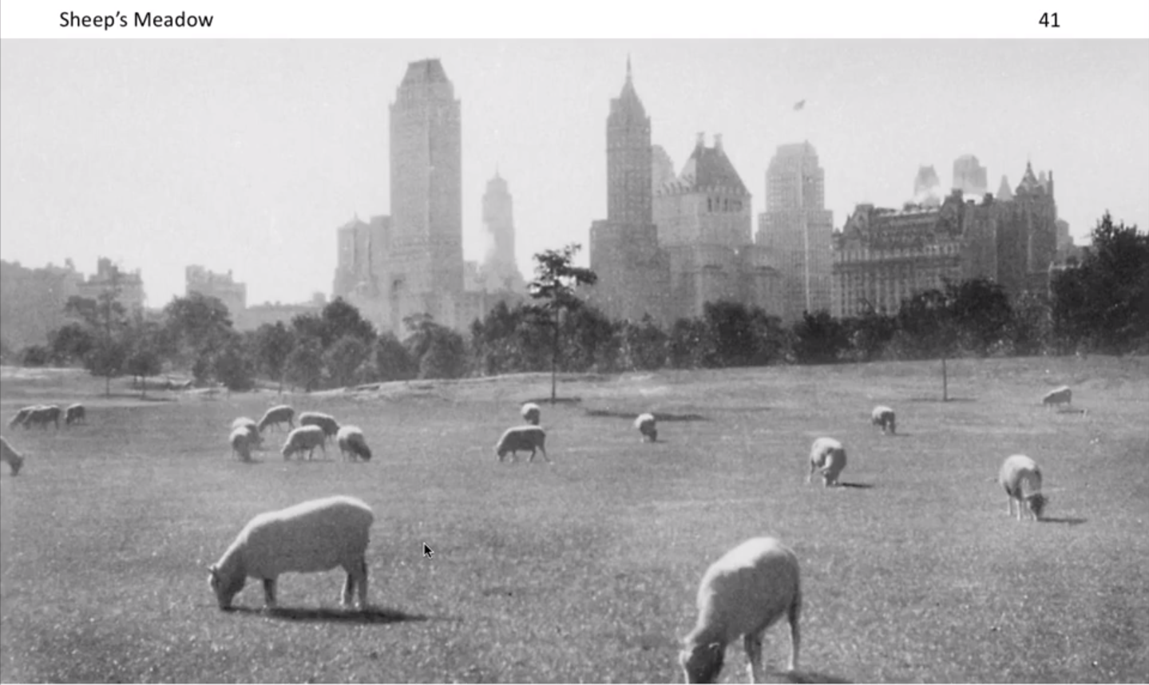 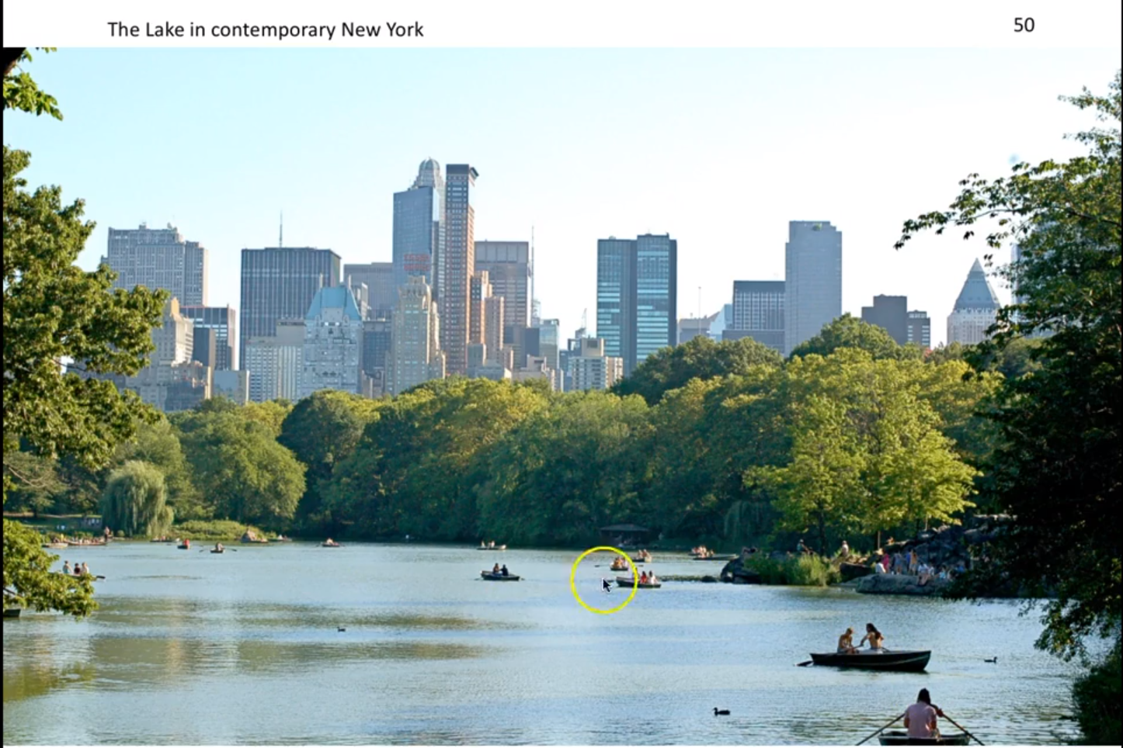

The fact that these are in the center of cityscapes astounds me, with wide, open swathes of land looking to be on the edges of the city, or maybe even nowhere near one in the case of the Long Meadow. In Long Meadow Park, it looks as if there is nothing but trees and maybe a small suburban town for miles.