Sean Gordon

Arch 321

Module 2, Lecture 1 Response

This lecture focused on the development of transportation methods in and between cities in various eras, and its effect on the cities of North America.

Before the 1850s, cities were restricted to a smaller area so that people could walk between facilities and conduct business without travelling more than a mile or two. With the introduction of better transportation in cities like omnibuses, cities were able to expand to a larger area because of the faster speeds of movement. In modern times, this is compounded on with the invention and refinement of automobiles, with cities like Atlanta encompassing more than 130 square miles.

With all the benefits of the new forms of transportation emerging in cities, there were also downsides. Omnibuses and rail cars created even more congestion in already packed cities, sometimes causing more problems than they were worth. Various solutions were attempted, like the raised roadways that lifted busses above the pedestrians, but these were unseemly and blocked both light and advertisements. The best serving solution turned out to be depressed railways, putting rail systems under the streets to minimize impact on the city. These subway systems were created using the ‘cut & cover’ technique, cutting a road out, installing the subway, then covering it back up.

While inner-city transportation was being upgraded, so was inter-city transportation. Railways between major cities and locations began popping up across the country, fueled by the lucrative economy of the northern US. Enormous cities spawned next to railways at halfway points, while already existing ones saw an explosion in population. Railways were quickly replacing waterways as the main form of transportation between cities.

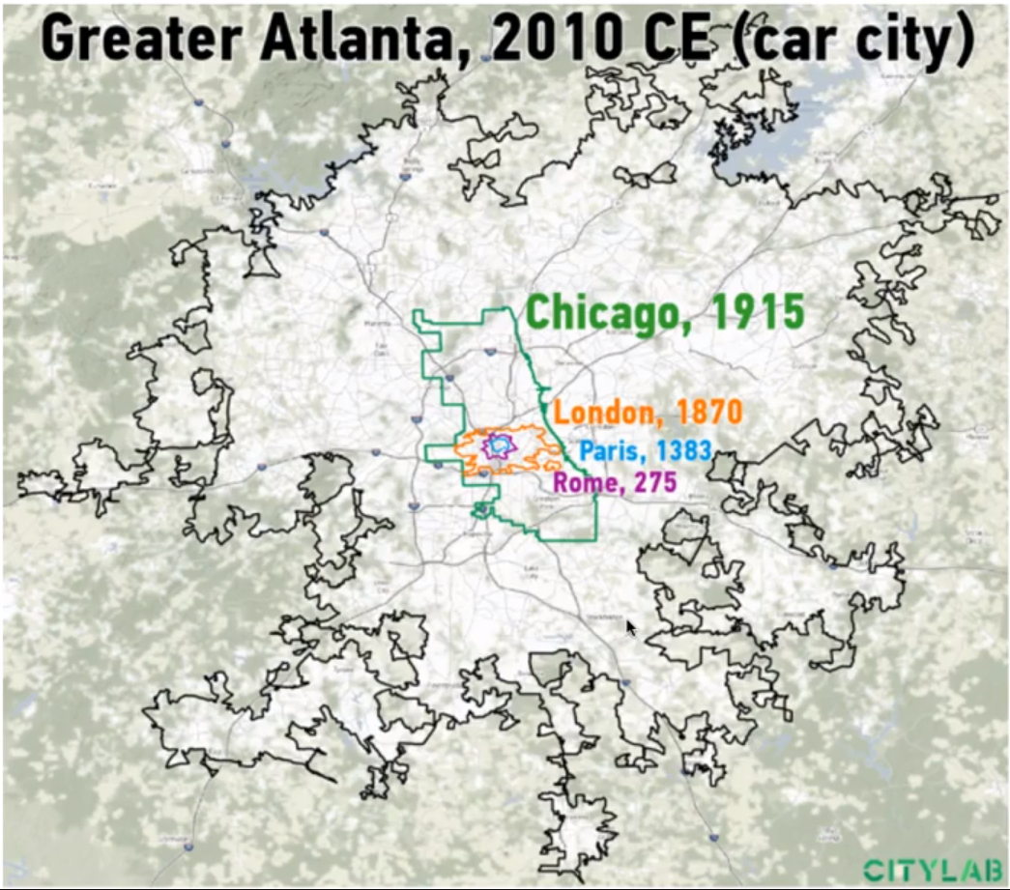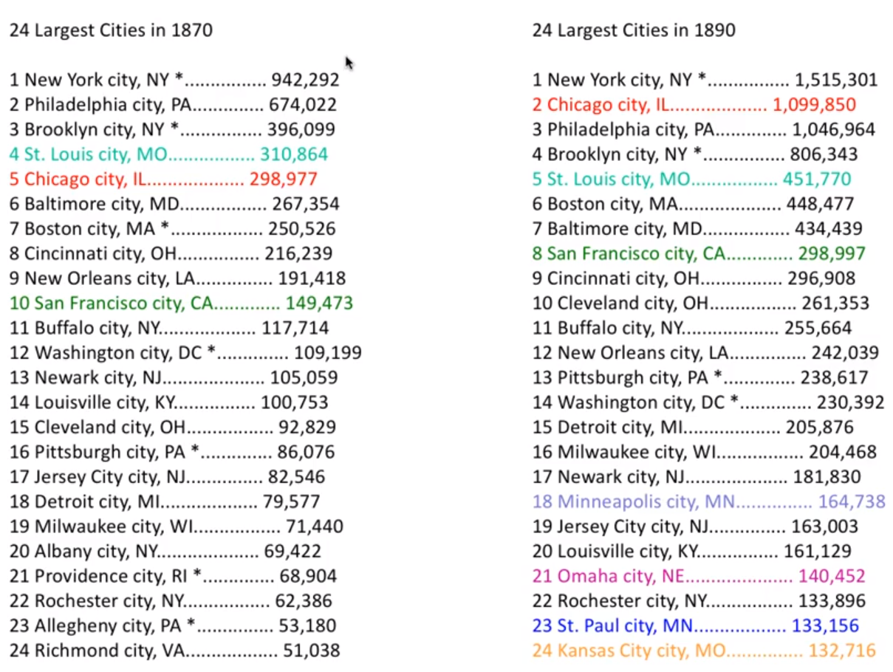

These graphics show the incredible effect transportation has on the growth of cities. From walking, to the use of omnibuses, to the use of the automobile, city reach has grown exponentially.

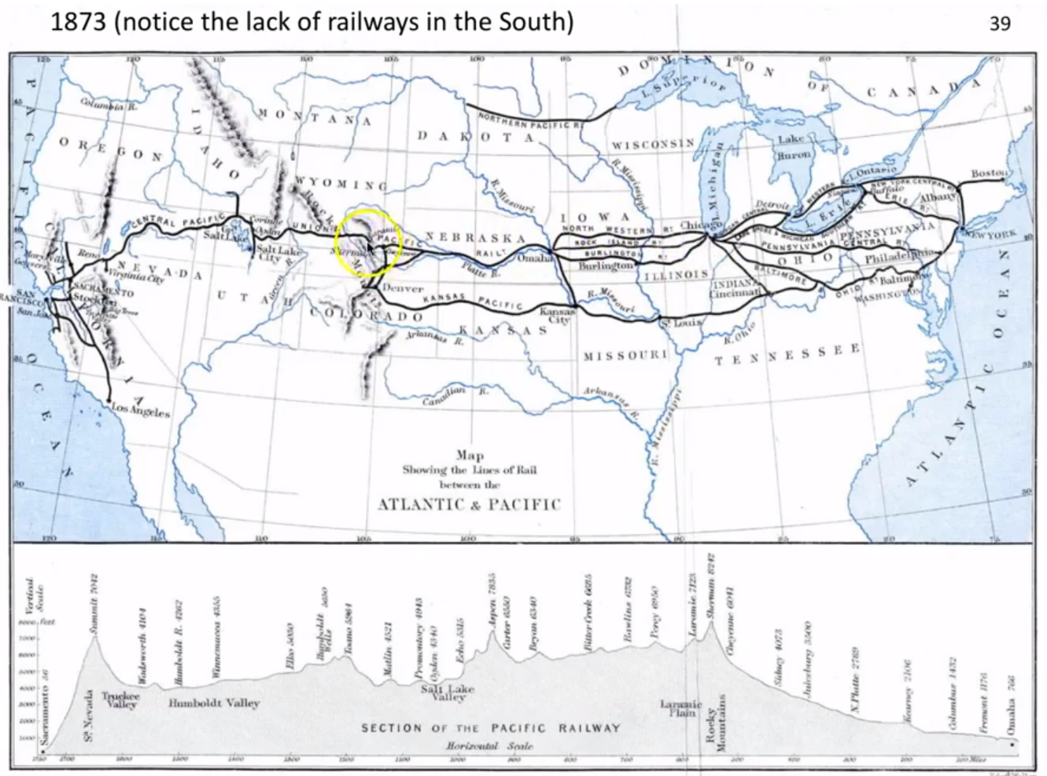

This graphic shows the status of the railways just after the time of the American Civil War. Because of the enormous economic drive of the north, railways were enormously more common above the center line of the US, reaching from coast to coast.