Sean Gordon

Arch 321

Module 2, Lecture 3 Response

This lecture focused on the reform efforts to beautify the cities and improve quality of life in the densest parts of America.

In the late 19th century, cities were having problems with population density and corrupt political machines, and reform was necessary. One of the avenues of reform was the introduction of new architecture to break the gridiron and increase the legitimacy of the cities. Architects at the time were being educated in the neoclassical style, akin to early American government architecture in its sense of grandeur and strength. Buildings in this style were surgically implanted throughout cities to improve scenery and break up monotony.

The need for a newer, cleaner city was visible in the World’s Columbian Exposition in 1939. While only facades, the buildings were clean and white, with wide open spaces for the public to move. The expo promised a bright future with its novel electric lights, and the building heights and coloring created a sense of unity. Each building in the expo represented a different industry, with the women’s building designed by Sophia Hayden, the first female architecture graduate of MIT. The fair attracted a number of people equaling 25% of the current US population, most of them European.

Push for reform created the city beautiful movement, influenced by elites who wanted to make the city more aesthetically pleasing. The movement emphasized buildings of the same height, a counterpoint to possibility of skyscrapers. The movement was moderately successful, with many plans and setups originating from the movement’s philosophy.

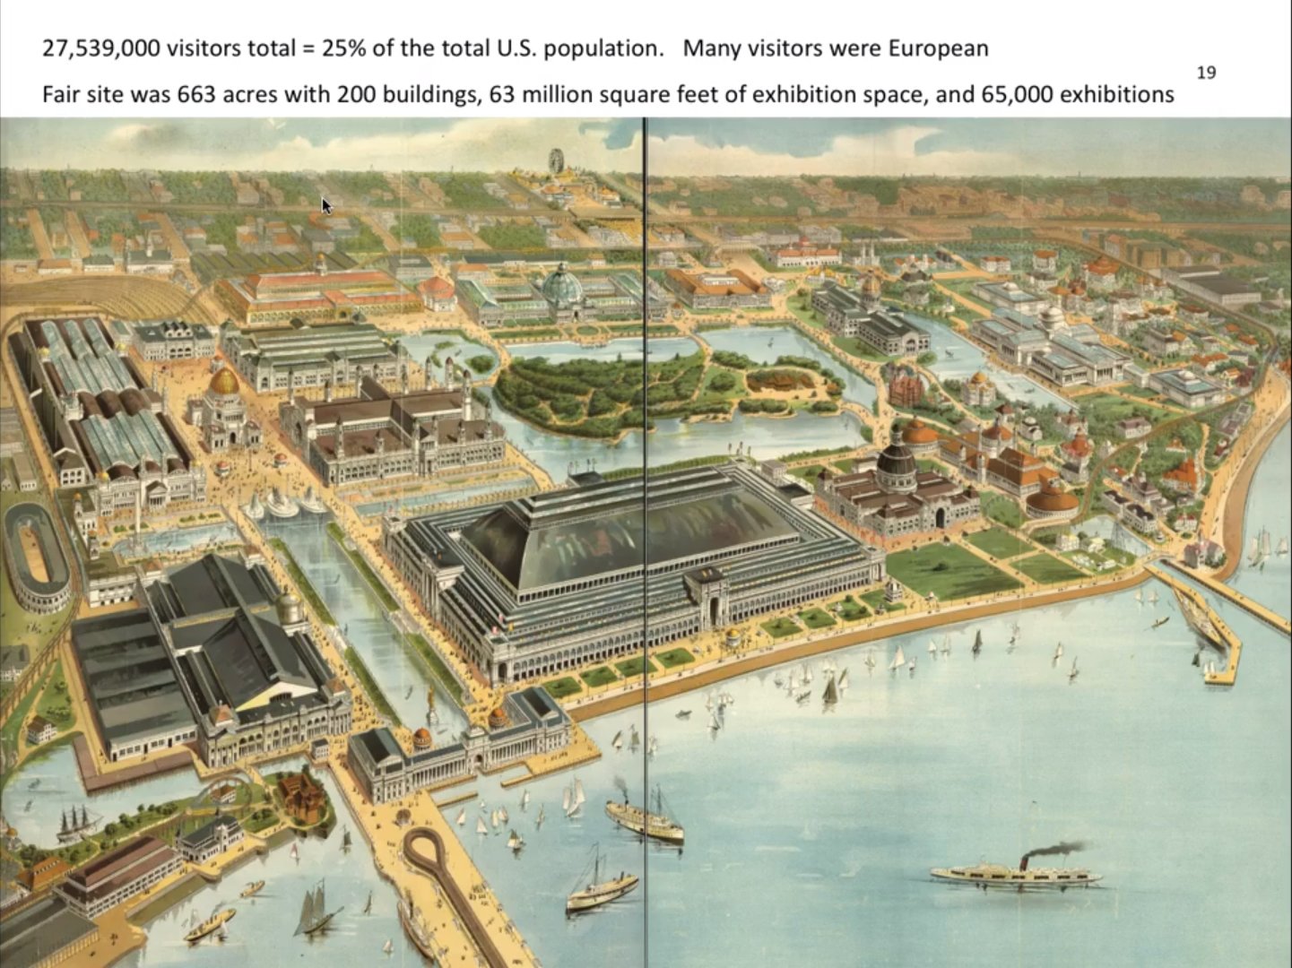

This graphic illustrates the span of the World’s Columbian Exposition. The scale of the buildings and facilities attracted an enormous number of visitors.

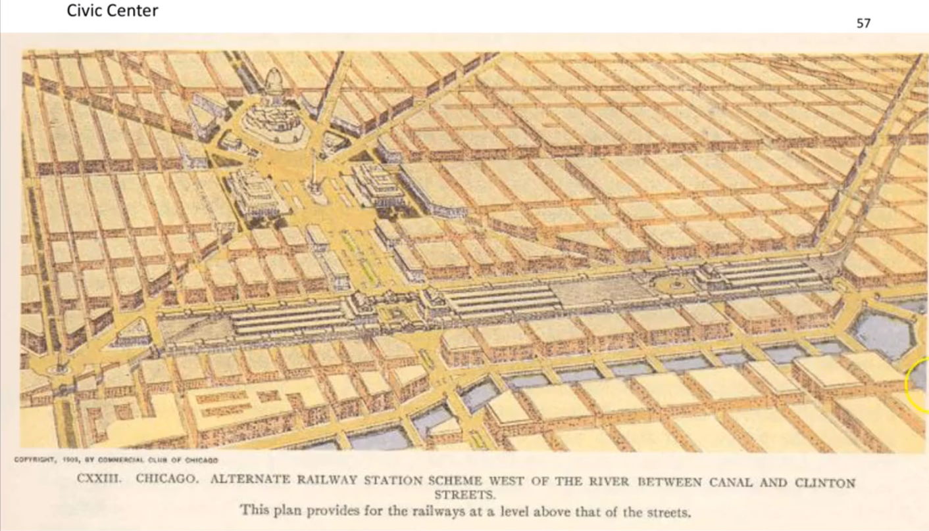

This graphic is an example of a common theme of the time to keep building heights equal to promote a sense of unity. The opening in the center and the diagonal streets were an injection of the European style that influenced early American architecture as well.