Sean Gordon

Arch 321

Module 2, Lecture 4 Response

This lecture focuses on cities’ progression to more modern, safe architecture, and the realization of a central business district.

As earlier cities were built and improved, much of the architecture was unprepared for natural disasters like fire or earthquakes. This was evident in the San Francisco earthquake of 1906, reducing a significant portion of the city to rubble. Rebuilding the city took pointers from Daniel Burnham’s ambitious plan to remake the city earlier. Architecture in the newer city and in other cities now was more resistant to fire and earthquakes after the mistakes of the past.

As the city moved more towards present day and transportation methods improved and became more widespread, the concept of a central business district appeared. The CBD was the heart of the city and moved and resized with economic drive. CBD’s were enormous, with more people working in Boston’s CBD than living in the city itself. Land in this area was highly sought after, with land values 90% higher than elsewhere in the city. Buying real estate just outside the CBD could result in large returns if the CBD moved in that direction. The concentric zone theory was devised for better development of a city, with several expanding rings stationed around the CBD.

Los Angeles, being a temperate area with good access to resources, became a highly sought-after place to live and work. It grew quickly, but as a new city didn’t have many of the same density issues as other, older cities. With the increasing popularity of the automobile, buildings were no longer placed so close together, with designers leaving space for cars to park. The philosophies of city planning were changing, with the advent of better transportation allowing hotspots to move and change.

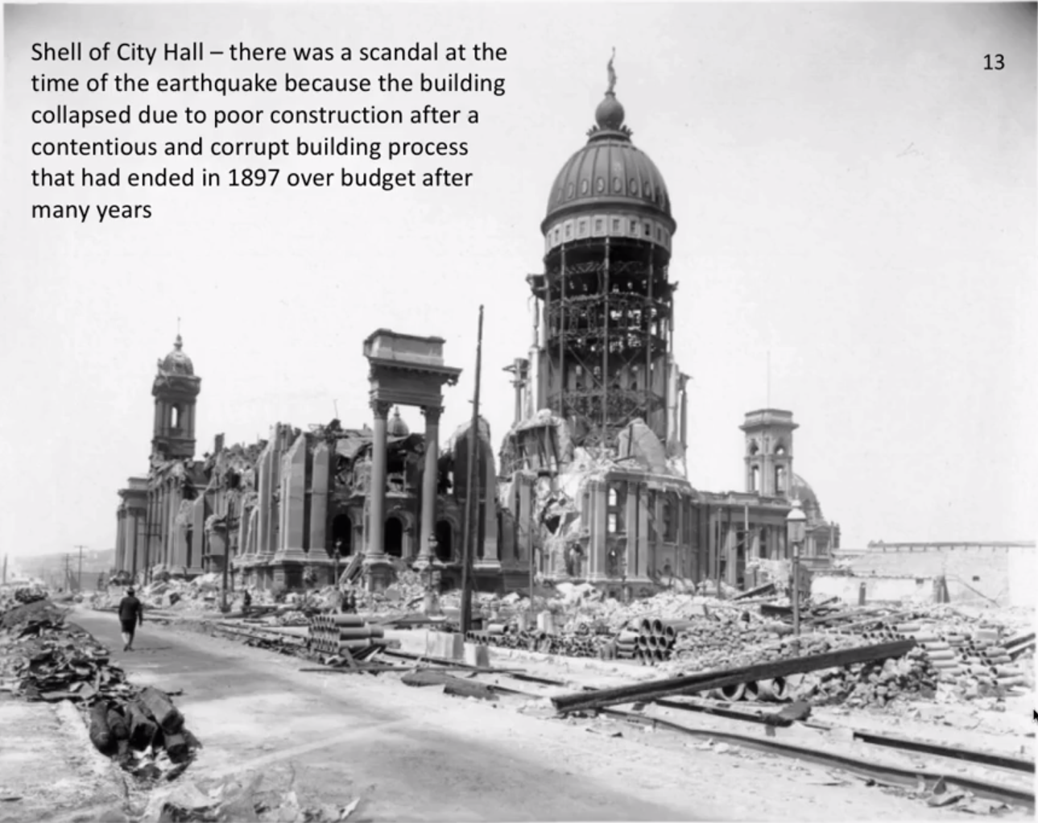

The remains of the San Franciscan city hall were one of many examples that led to more earthquake proof architecture.

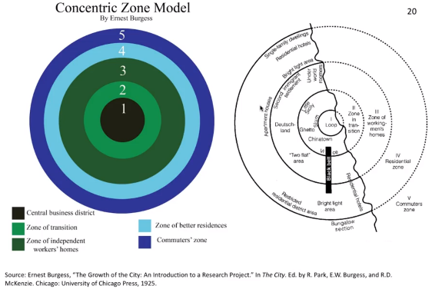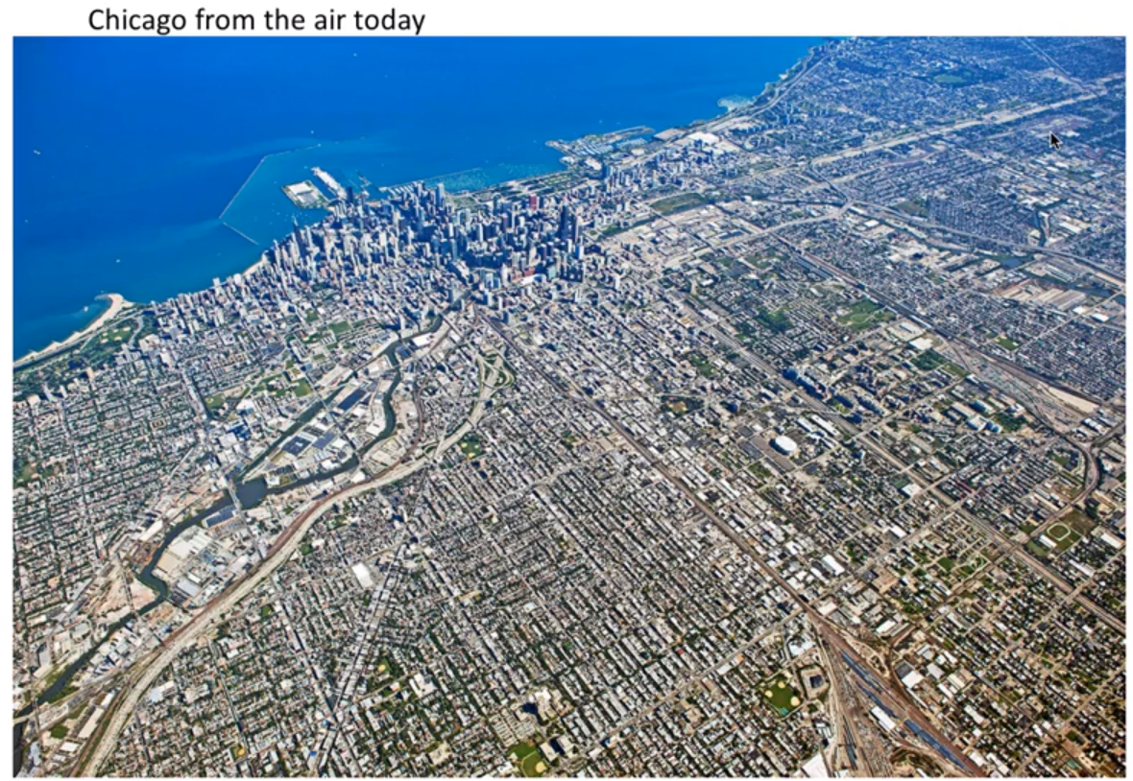

The above images show how the city of Chicago conforms to the concentric zone model, with the CBD surrounded by sections of varying complexity, all the way to more green environments on the outskirts.