Sean Gordon

Arch 321

Module 3, Lecture 2 Response

This lecture focused on efforts to rebuild housing during the Great Depression, especially the case of Pruitt-Igoe.

Well into the Great Depression, various new laws and ideas began to take shape, one of the most notable being the Tower in the Park idea. This pushed for very tall, open housing options, spread apart from each other and built in a cruciform shape to maximize light and air while adding a pastoral aspect to the grounds between. These buildings, being government funded, were built very plainly to minimize cost on unnecessary detail. Many were a huge hit, easing the burdens of many families across the lower and middle classes. Some, however, were lacking in execution, and ended with more problems than they started with.

Pruitt-Igoe was one of these examples, originating from the ambitious St. Louis post-war rebuild, the complex started as a symbol of rebirth and provided an immaculate place for destitute families to live. Beginning its story as an electric, lively place full of communities, lack of funding led to lack of maintenance, and the once shining living space decayed. The complex lost many of its original tenants with a vacancy rate of up to 88%, and plunged into crime, falling at the end as a symbol of the death of the modern architecture dream.

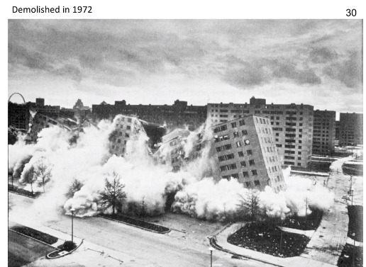

The demolition of Pruitt-Igoe, deemed the symbol of the death of the modern architecture dream. I found this compelling because while the idea behind the buildings were noble and they did a lot of good, architecture alone could not solve the social problems of the day.

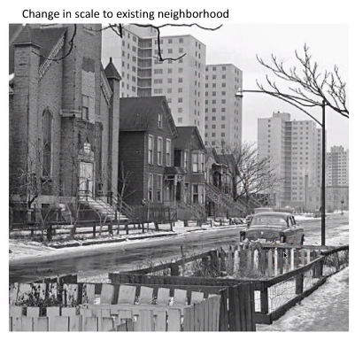

The juxtaposition of older housing next to the new age Tower in the Park buildings truly shows how radical the changes being made really were. Desolate residencies were being demolished and replaced with tall, shining buildings, a giant leap towards quality of life improvements.