Sean Gordon

Arch 321

Module 3, Lecture 3 Response

This lecture focused on housing solutions and changes to the mentality of city planning in the early 20th century.

Rational urban planning developed in response to poor inner-city condition in Berlin and Vienna and emphasized bringing more light and air into the buildings. The solution was Zeilenbau buildings placed in rows, oriented north-south to maximize exposure to the sun. This typology was influential all over Europe, with the individual buildings made in a zigzag pattern for more window space.

Le Corbusier was one of the architects building during this period of reform. He proposed a transformation of cities into open spaces with tall towers and open zones of activity. He also the Five Points towards a New Architecture, elements of which are seen in projects made by others. Le Corbusier wasn’t commonly offered contracts because his ideas were so radical, but elements of his work are still seen today, with his philosophy helping drive the rise of the suburbs.

Frank Lloyd Wright was another influential architect, developing the prairie style that integrated flat housing with nature. With his 4sq mile Broadacre City project, the fusion between city and country goes on forever, with no heavy concentrations of buildings. His grand vision was never implemented, but the suburb isn’t far off, with its endless pastoral housing speckled with city malls and industry buildings.

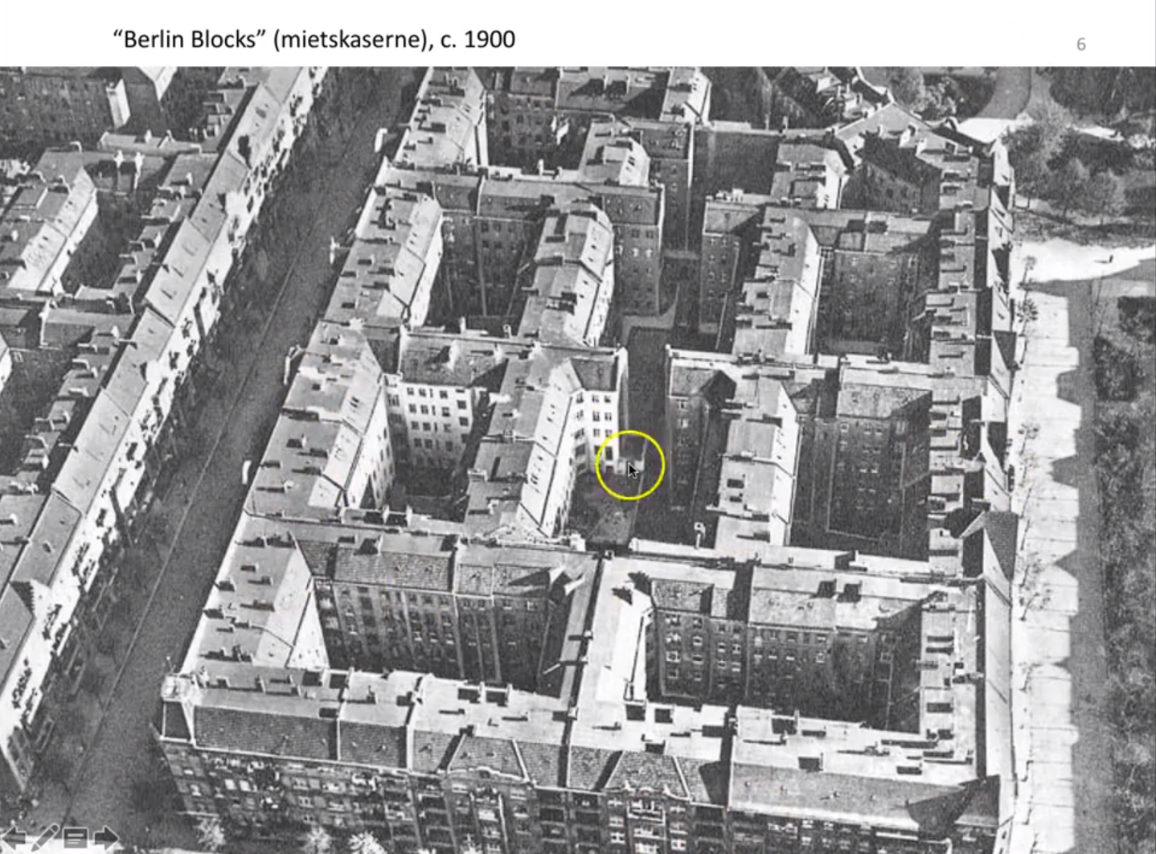 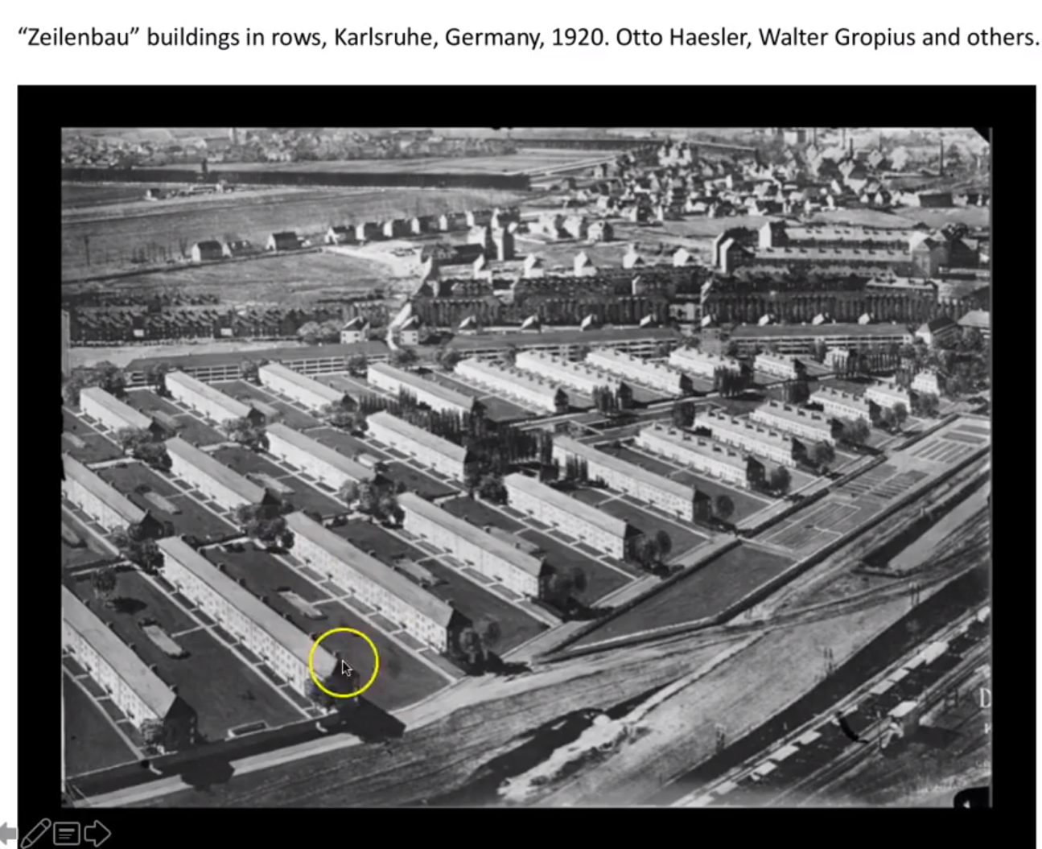

The juxtaposition between the crowded Berlin housing and the newer Zeilenbau style buildings. The vast difference in building style distinctly shows the change in building psychology, and the distances between the newer buildings imply the importance of the automobile as transportation.

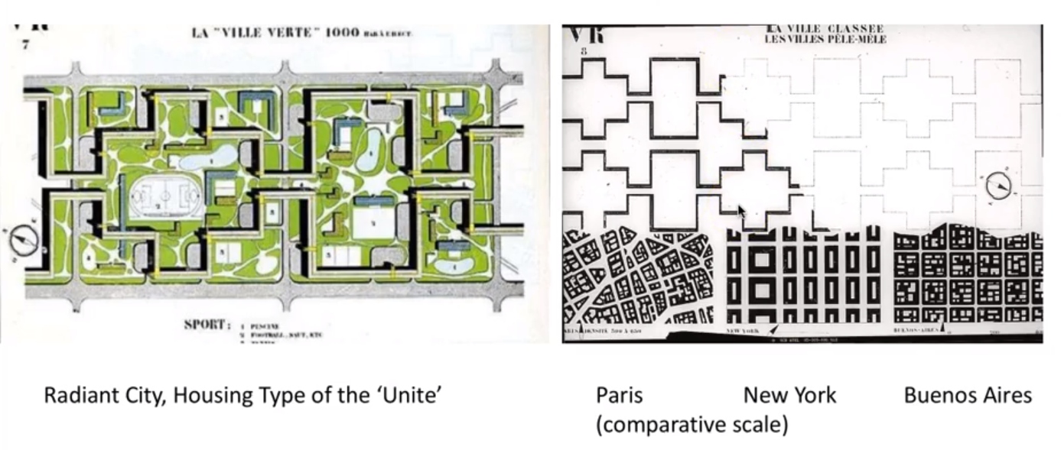

The pattern of the newer style of building with larger green spaces between buildings was exceptionally large and sprawling, contrasting intensely with the tightly packed building stamps of the past. This is an even larger example of the importance of automobiles, abandoning the idea of walking cities in favor of larger spanning building complexes.