Sean Gordon

Arch 321

Module 3, Lecture 4 Response

This lecture focused on the rise of automobile transportation and its effect on the cities, and the eruptions of suburbs.

In the early 20th century, the Federal Housing Administration was established, primarily to insure housing loans. The administration quickly initiated redlining, heavily favoring suburban areas. The 1944 Serviceman’s Readjustment act helped veterans buy homes with a 0% down payment, and this combined with the boon to suburban areas backed by the FHA led to a growth in population in suburban areas. However, these items, along with the current social systems around loaning and real estate, heavily favored white people and prevented blacks from obtaining housing in these suburbs.

As people migrated to suburbs farther away from their places of work, the automobile - particularly the Ford Model T – became very popular. The federal highway act of 1944 spurred roadbuilding, investing $1.5 billion for the first 3 post-war years. This was seen as a military expenditure, allowing ease of mobilization in the case of an attack. However, due to lack of interstate funding, construction was very slow. This was solved when a 1956 act matched every dollar a state put into the roads with another dollar from the government, eventually climbing to a 1:9 ratio.

One man who took advantage of this was Robert Moses. Moses, who had a PhD in political science and wasn’t an architect, shaped the face of New York because he understood intimately how to use the new laws. He was a well-connected man that never backed down and was nicknamed the ‘Power Broker’ for his strength. He had a large, abstract vision which resulted in several large public works like Jones Beach, and most notably the 13 expressways he built straight through the city. Such an immense undertaking left little room for consideration of the communities destroyed by his expressways however, and this resulted in thousands of evictions.

Alongside the rise of road infrastructure came the rise of the suburbs. For their construction, large swathes of farmland were bought for cheap, and homes were put up in an assembly line fashion with forces of carpenters and electricians working in waves one after the other. The homes were built with materials like linoleum flooring and marketed towards housewives to speed up cleaning times, and neighborhoods were heavily segregated, with virtually nobody but white citizens living in suburbs.

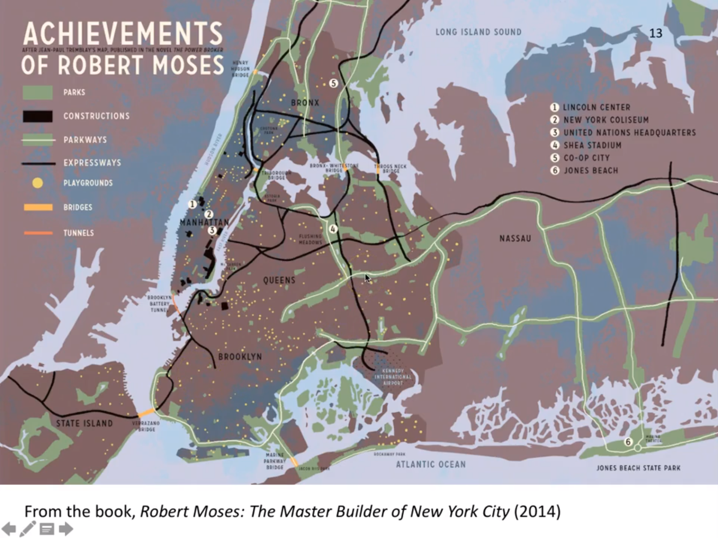

Loved or hated, Robert Moses was monstrously successful in his vision for New York, erecting 13 expressways and many more public works projects. The sheer number of projects listed in this picture and the knowledge of how difficult it is to get large groups of people to agree leaves me in awe.

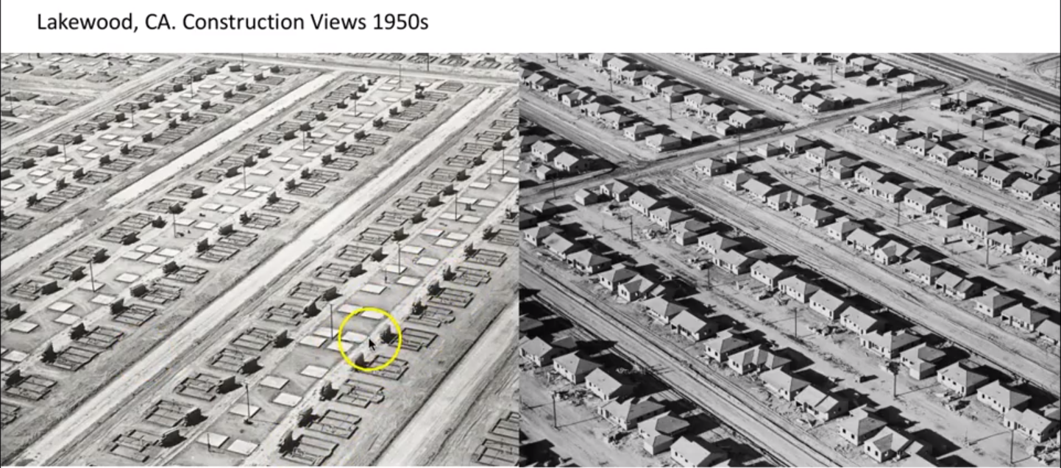

This depiction of suburbs before and after construction leaves a good impression of how quickly these buildings were created. On the left, the foundations of each building can be seen, each in the same state of construction, as they were all masterfully built in assembly line fashion.