Sean Gordon

Arch 321

Module 4, Lecture 1 Response

This lecture focused on attempts at urban renewal, and the less than desirable urban crisis that came afterward.

In the center of the 20th century, the policy of Housing Act of 1954 required organizations to have a workable program before getting money to operate. This consisted of sound designs with a comprehensive community plan, with a plan for relocation. This act stressed neighborhood conservation and slum prevention, a supposed improvement over the previous incarnation.

Certain projects, like that of Scollay Square, stood out more than others. Scollay Square was a longstanding city square in Boston, Massachusetts. An enormous amount was demolished to clear room for a new city center, resulting in the displacement of over 20,000 residents. This center was intended to be a bustling hub of activity but is generally deserted and disliked today. This stands today as one of the most controversial urban renewal projects ever completed.

Another city attempting renewal was Detroit, hemorrhaging its white population to the suburbs. From 1960 to 2010, its steadily growing population was steadily cut in half, with residents leaving homes in the city in favor of living in suburbs and taking highways to their places of work. To rebuild the population, Detroit was reimagined as a commercial center. For this to happen, its disorganized mess of buildings would need to be reorganized, with investigations being done to justify demolition of ‘deficient’ architecture.

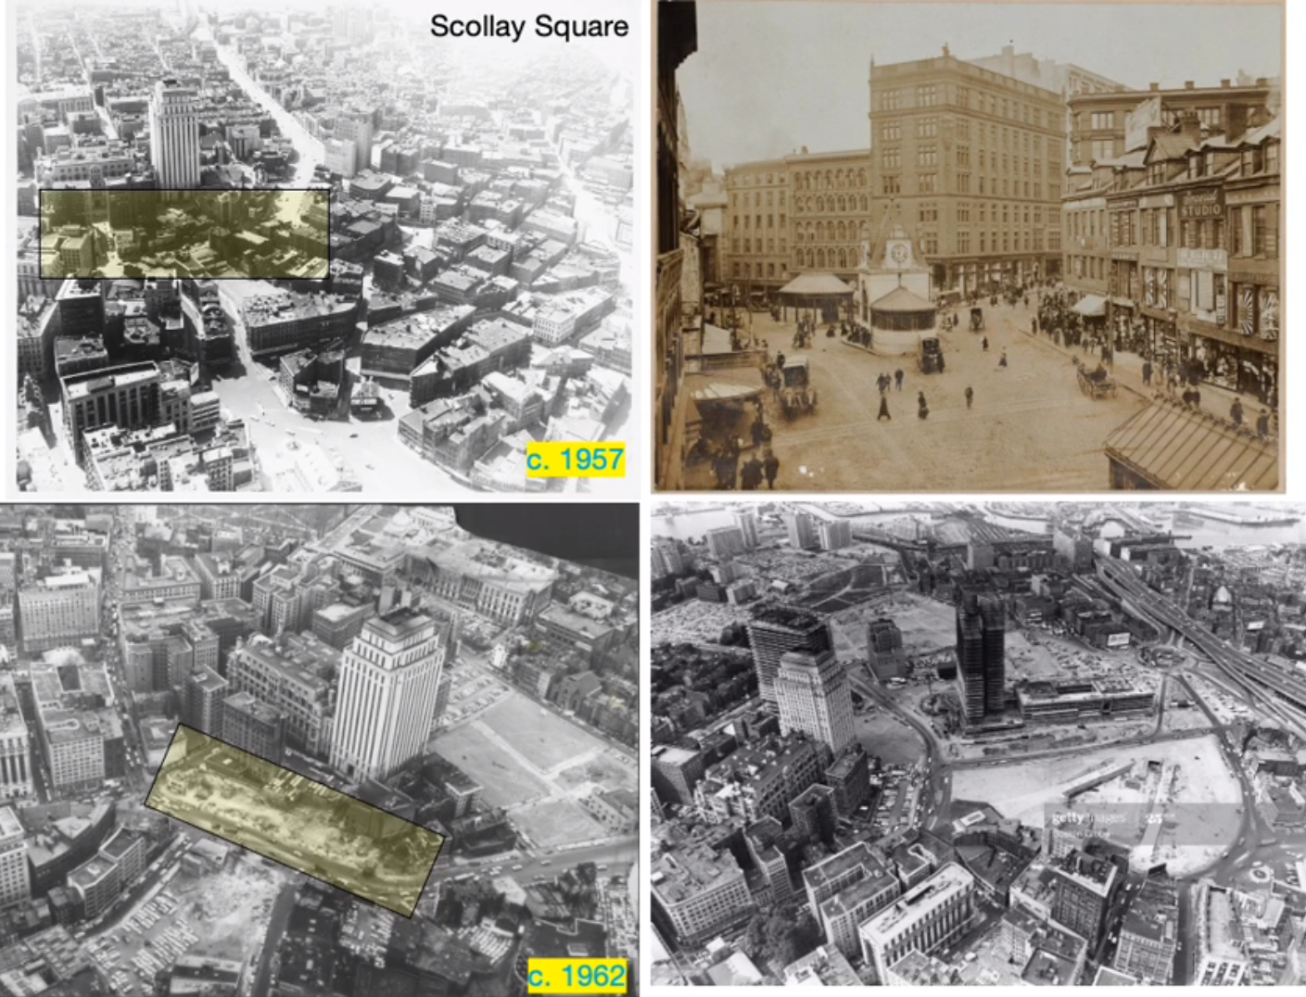

The enormous amount of Scollay Square that was demolished to make room for the new city center. This remains one of the most controversial city renewal projects ever completed.

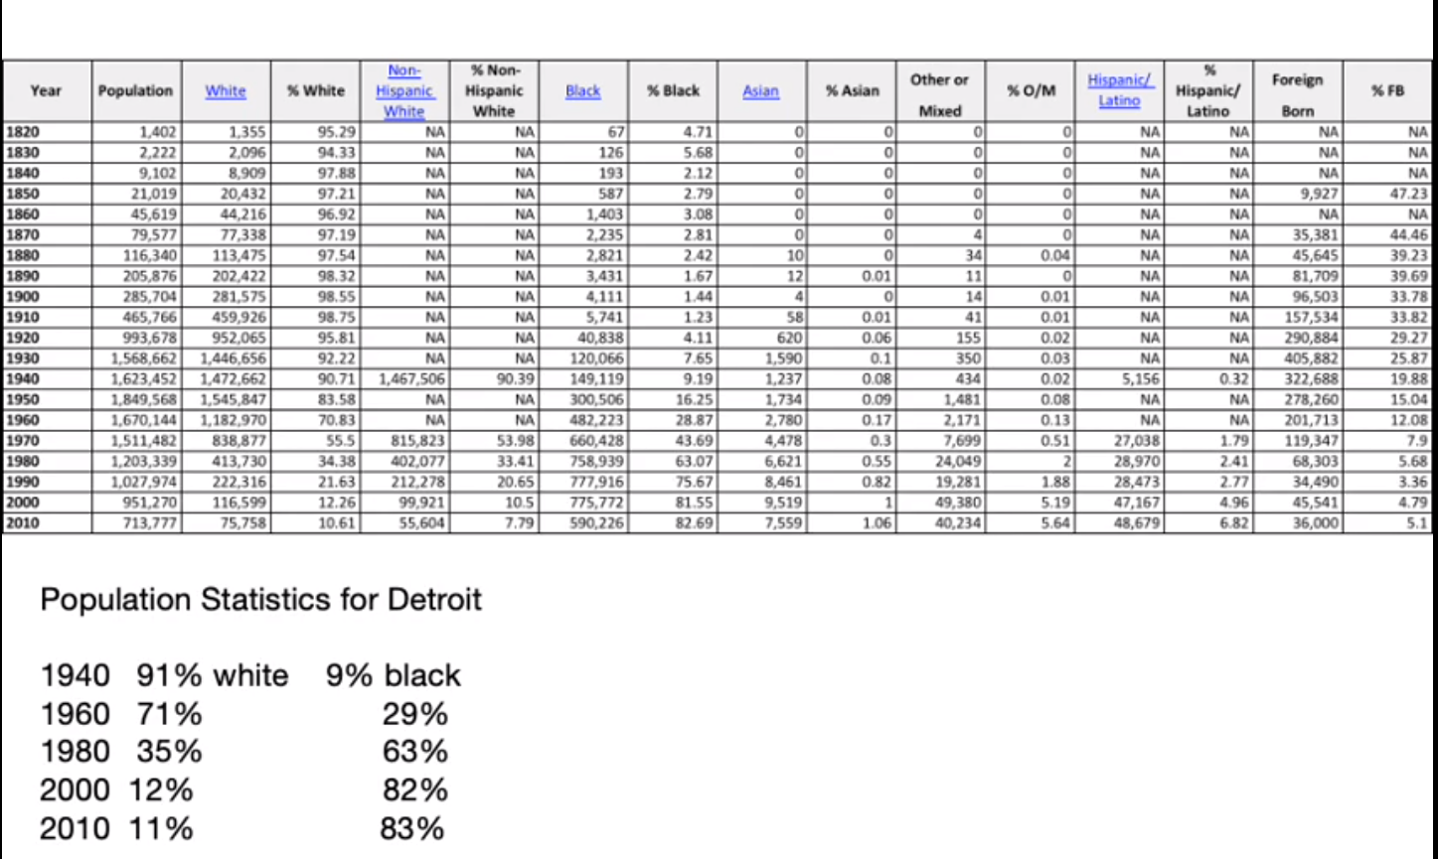

This chart full of population statistics illustrates the fall in population in Detroit. It is alarming to see such a drastic decrease in population, with the population being cut in half from 1950 to 2010.